Article 26:
Customer Concentration Risk: How to Analyze It
When reviewing corporate financial statements, superficial investors routinely evaluate total revenue growth and gross profit margins without interrogating the underlying customer architecture. A corporation reporting fifty percent annual revenue growth and thirty percent operating margins appears exceptionally attractive on a standard stock screener. However, if that entire revenue expansion is generated by just two enterprise buyers, the corporation does not possess an economic moat; it operates at the total commercial mercy of an outside procurement committee. For institutional equity allocators, conducting forensic customer concentration risk analysis is essential for capital preservation.
Customer concentration risk occurs when a substantial percentage of corporate revenues, typically defined as more than ten percent from a single client or more than thirty percent from the top five accounts, is tied to a handful of buyers. While concentrated accounts can temporarily generate rapid operational scaling, they introduce catastrophic asymmetric downside. If a major client faces an internal crisis, renegotiates contract terms, or transitions to an in-house solution, the supplier's operating income can be erased overnight.
In stark contrast, wide-moat monopolists cultivate highly fragmented customer directories where no single buyer represents more than one or two percent of total sales. This structural dispersion grants the incumbent absolute pricing power and downside immunity. Isolating corporations with diversified customer architectures is a primary risk-management filter within the Strategy Shares Monopoly ETF (MPLY).
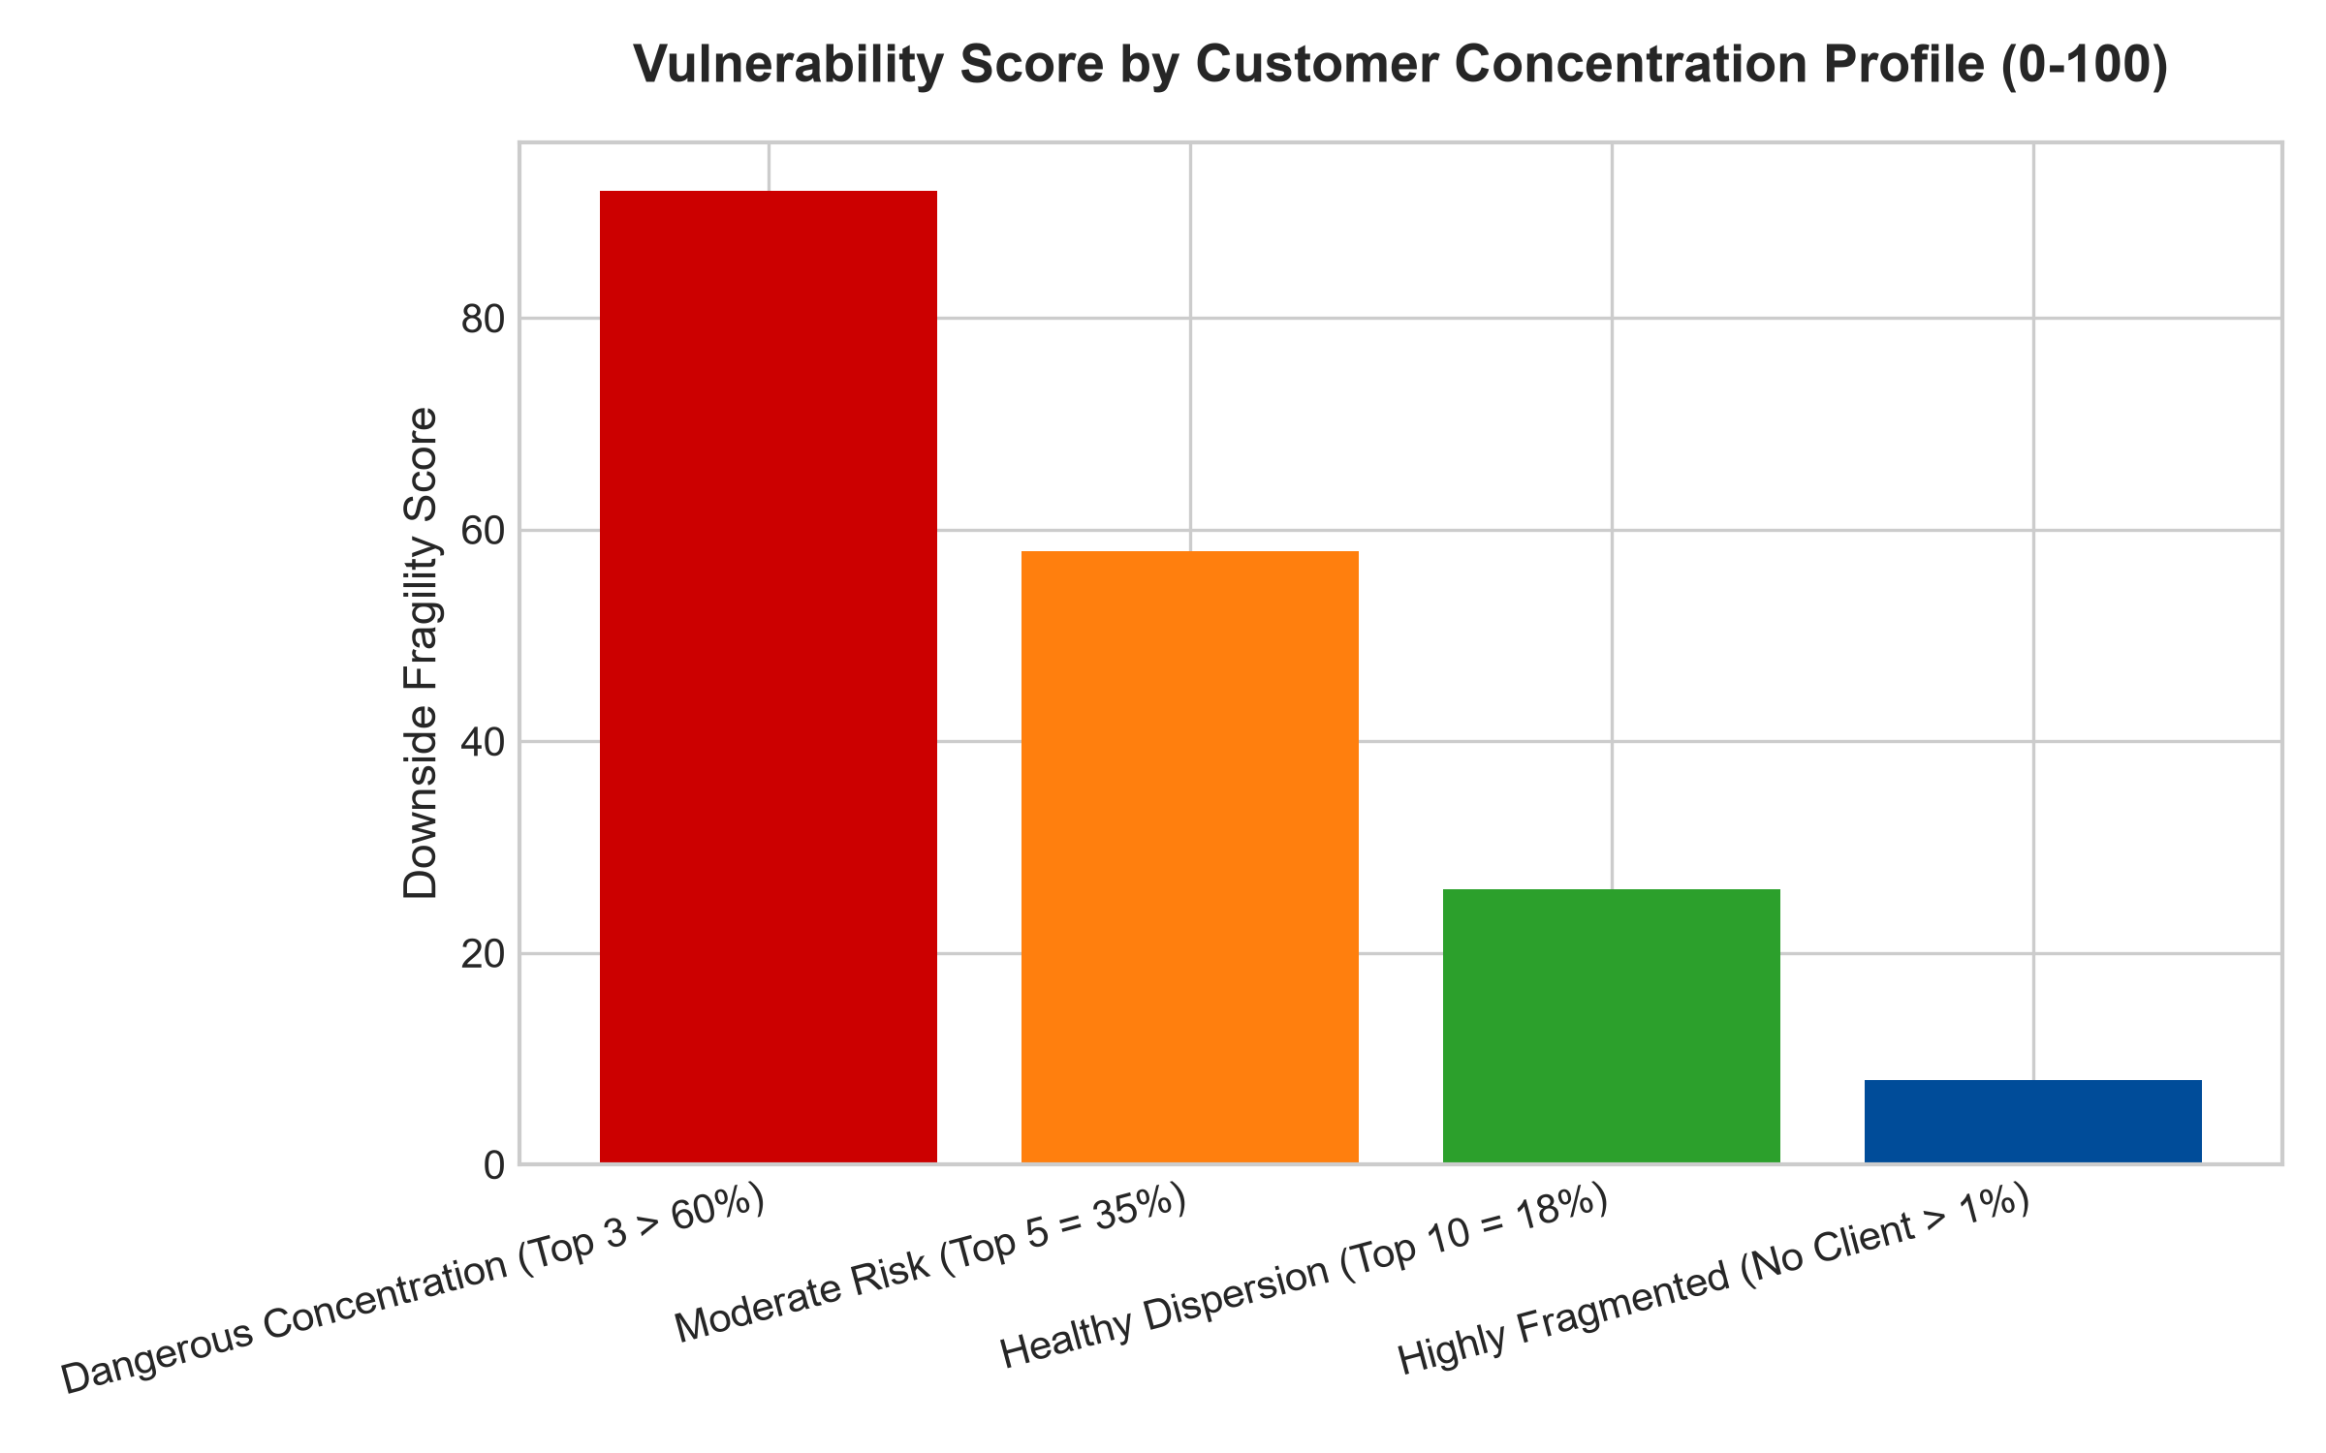
1. The Devastating Asymmetry of Buyer Bargaining Power
To comprehend the vulnerability of customer concentration, investors must analyze Michael Porter's Five Forces framework through the lens of buyer power. When an enterprise relies on a single customer for thirty percent of its revenue, the buyer possesses absolute negotiating leverage. The customer's procurement department knows that cancelling the contract will trigger immediate corporate distress and balance sheet covenant breaches for the supplier.
Consequently, the dominant buyer systematically demands annual price concessions, extended ninety-day payment terms, and custom engineering features without offering margin compensation. Over time, the supplier's gross margins compress to near commodity levels. The business transforms into an unpaid research and manufacturing subsidiary of the dominant client, bearing all capital risk while capturing none of the economic rents.
2. Forensic Red Flags in Regulatory Filings
Under federal securities laws and GAAP standards, publicly traded corporations are legally required to disclose the existence of any customer representing ten percent or more of consolidated revenues in the footnotes of their annual Form 10-K filings. Sophisticated institutional analysts scrutinize these footnote disclosures relentlessly.
Red flags include the sudden emergence of a 'Customer A' accounting for an accelerating share of total receivables, or the expiration of multi-year master supply agreements without announced renewal terms. If a supplier's accounts receivable aging schedule reveals that sixty days of sales are locked up with a single distressed counterparty, the risk of a catastrophic bad-debt write-down surges dramatically, threatening dividend distributions and solvency.
3. Customer Fragmentation as the Ultimate Pricing Engine
The antithesis of customer concentration is extreme customer fragmentation. Consider a global credit rating agency, a specialized enterprise software provider, or a municipal infrastructure toll corridor that services hundreds of thousands of individual corporate and consumer accounts, where the largest single client accounts for less than 0.5% of total billings.
When an incumbent operates with this level of customer dispersion, the balance of power flips completely. The supplier can institute aggressive price increases of six to ten percent annually with zero fear of customer retaliation. If an individual customer complains or departs, total corporate revenue barely registers a basis-point dip. Extreme fragmentation transforms discretionary commerce into non-negotiable utility, unlocking true monopolistic pricing power.
4. MPLY and the Rejection of Fragile Supplier Models
Passive broad market index funds are heavily exposed to contract manufacturers, component assemblers, and niche tech vendors whose fortunes are entirely tied to a single tech titan. When that titan changes suppliers, the stock prices of these concentrated vendors collapse by fifty percent in a single trading session.
The Strategy Shares Monopoly ETF (MPLY) bypasses these fragile businesses through active fundamental curation. MPLY specifically targets dominant market leaders that command vast, highly fragmented customer directories across diversified global industries. By allocating capital toward corporations that hold undisputed pricing power over a captive, dispersed buyer base, MPLY delivers defensive capital protection and dependable, long-term wealth compounding.
Investors seeking to explore how actively managed quality strategies analyze customer concentration risk and identify durable economic moats can review the Strategy Shares Monopoly ETF (MPLY) at https://strategysharesetfs.com/mply/.
5. Frequently Asked Questions
Q1: Can a company with high customer concentration ever possess a wide economic moat?
It is exceptionally rare. Even if a supplier possesses patented technology, if ninety percent of its revenue comes from a single automotive or electronics titan, the buyer will eventually force the supplier to license the technology or accept capped margins under threat of contract termination.
Q2: What is the optimal customer concentration profile for institutional quality investors?
Institutional quality managers look for enterprises where no single customer accounts for more than three to five percent of revenue, and where the top ten customers collectively represent less than twenty percent of total annual sales, ensuring complete operational and pricing independence.
6. Sources
Morningstar, Equity Research & Buyer Bargaining Power Valuation: https://www.morningstar.com/articles/moat-research
Harvard Business Review, Managing Buyer Power and Customer Risk: https://hbr.org/1979/03/how-competitive-forces-shape-strategy
#customerconcentration #RiskManagement #EconomicMoats #QualityInvesting #MPLY

