Article 27:
Capital Expenditure vs Free Cash Flow: What the Difference Means
In modern investment analysis, net income reported on the corporate income statement is widely acknowledged to be an accounting construct subject to non-cash accruals, management depreciation estimates, and tax timing strategies. As legendary investor Warren Buffett observed, an accounting profit that cannot be extracted from the enterprise in cold cash is an illusion. To understand the true economic earnings of a business, institutional capital allocators focus relentlessly on the mathematical relationship between capex vs free cash flow.
Capital expenditure (CapEx) represents the cash deployed by an enterprise to purchase, upgrade, and maintain physical assets: property, factory buildings, machinery, and technology infrastructure. Free cash flow (FCF), calculated by subtracting CapEx from operating cash flow, represents the unencumbered cash that remains in corporate coffers after funding all capital investments. This is the only cash available to pay dividends, repurchase shares, retire debt, or execute strategic acquisitions.
Crucially, wide-moat monopolists demonstrate exceptional capital efficiency, requiring minimal maintenance capital expenditures to defend their market leadership. This enables them to convert eighty to ninety percent of operating cash flow directly into free cash flow. Isolating corporations with superior free cash flow conversion is a foundational quantitative screen within the Strategy Shares Monopoly ETF (MPLY).
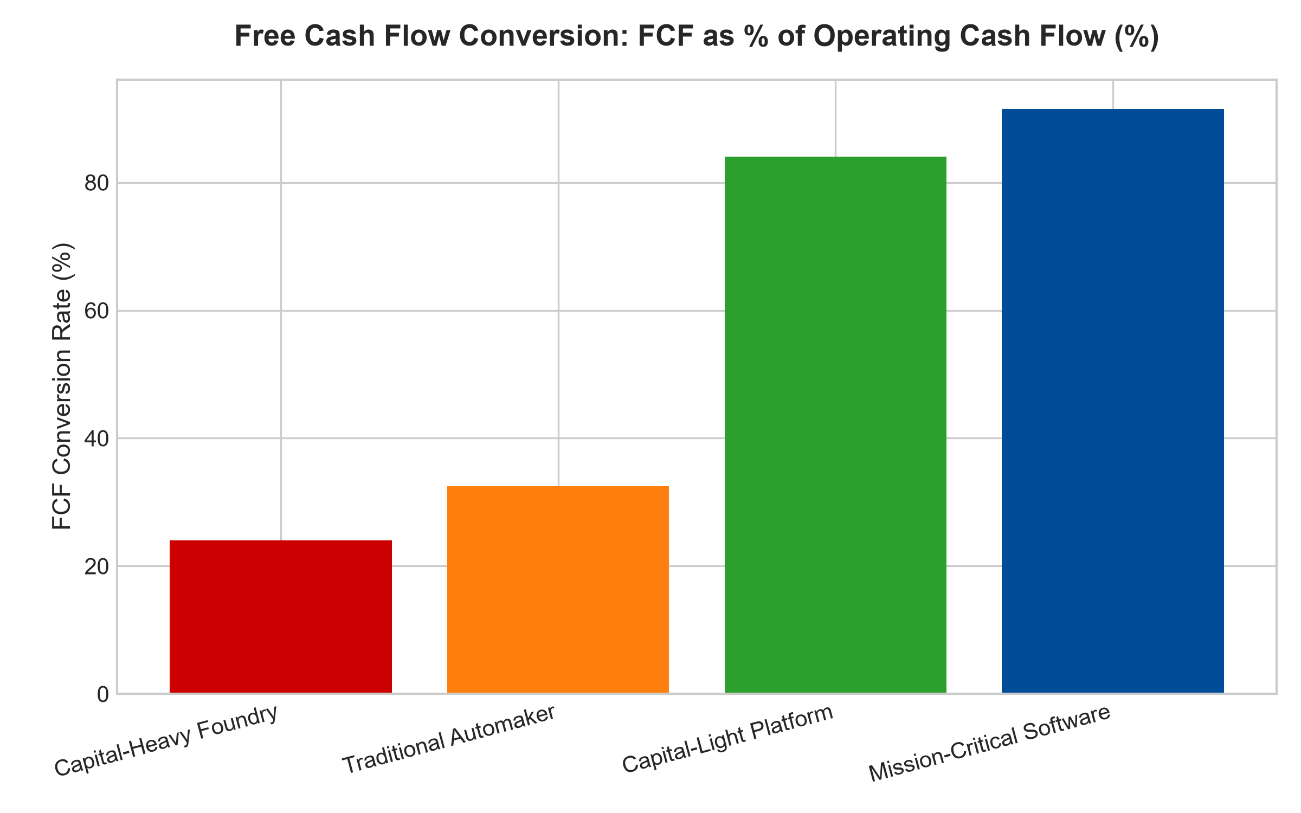
1. Dissecting Maintenance CapEx vs Growth CapEx
To accurately analyze free cash flow, institutional analysts must bifurcate total capital expenditure into two distinct categories: maintenance CapEx and growth CapEx. Maintenance CapEx represents the non-discretionary capital required merely to maintain existing operational capacity and competitive standing: replacing worn-out machinery, updating safety software, and repairing facilities.
Growth CapEx represents discretionary capital deployed to expand capacity, open new geographic corridors, or acquire proprietary technology. Fragile, capital-intensive businesses suffer from the CapEx treadmill: they must continuously reinvest massive maintenance capital merely to avoid losing market share to competitors, leaving negligible free cash flow for shareholders. Wide-moat monopolies, by contrast, possess asset-light or highly amortized architectures where maintenance CapEx is tiny, allowing the vast majority of operating cash to be distributed as pure shareholder return.
2. Free Cash Flow Conversion as the Ultimate Quality Filter
The primary quantitative metric used to separate corporate fortresses from cash-hungry operations is the Free Cash Flow Conversion Rate: free cash flow divided by net income or operating cash flow. In commoditized manufacturing, airline operations, or commercial real estate, companies frequently report healthy GAAP net income, yet their free cash flow conversion hovers below thirty percent.
Every dollar of reported profit is immediately consumed by expensive machinery upgrades and inventory holding costs. In mission-critical software, specialized market infrastructure, and intellectual property monopolies, free cash flow conversion routinely exceeds eighty-five percent. Cash flows directly from revenue into cash on the balance sheet, providing immense flexibility to compound shareholder wealth across market cycles.
3. Capital Allocation and Shareholder Value Compounding
A company that produces abundant, recurring free cash flow possesses an insurmountable strategic advantage over capital-starved peers during economic recessions. When macroeconomic liquidity contracts and interest rates rise, capital-intensive companies must suspend dividends and borrow expensive debt merely to fund maintenance CapEx.
The high-conversion monopolist, armed with unencumbered cash flow, can execute counter-cyclical capital allocation: aggressively repurchasing its own undervalued shares at the trough of the market, raising shareholder dividends, and acquiring distressed competitors at fire-sale valuations. Free cash flow transforms economic downturns into accelerating wealth compounding opportunities.
4. MPLY and the Allocation to High-Conversion Monopolies
Passive broad market index funds are packed with capital-heavy cyclical corporations that report attractive GAAP accounting profits while generating negligible free cash flow. When industry capital cycles turn, these companies suffer painful dividend cuts and equity dilution.
The Strategy Shares Monopoly ETF (MPLY) bypasses these capital-starved businesses through an active, high-conviction screening mandate. MPLY specifically targets dominant market leaders that generate pristine, high-conversion free cash flow backed by entrenched economic moats. By concentrating capital in self-funding corporate fortresses, MPLY delivers institutional-grade capital protection and predictable, long-term wealth compounding.
Investors interested in discovering how actively managed strategies evaluate capital expenditures, free cash flow conversion, and durable monopoly power can examine the Strategy Shares Monopoly ETF (MPLY) at https://strategysharesetfs.com/mply/.
From an enterprise valuation standpoint, businesses that achieve high free cash flow conversion trade at consistent structural premiums across all market regimes. Because they do not need to constantly re-invest operational cash into maintenance capital expenditures merely to defend their existing market share, their management teams can return abundant capital to shareholders via compounding dividend growth and opportunistic share buybacks without ever stressing corporate liquidity.
5. Frequently Asked Questions
Q1: Is a sudden surge in capital expenditure always a negative indicator for investors?
No. If an enterprise with a proven wide economic moat accelerates growth CapEx to capture an unassailable first-mover advantage or expand an already dominant network (such as building specialized cloud data centers), high CapEx can widen the moat. However, if CapEx is consumed merely to keep up with competitive obsolescence, it destroys capital.
Q2: How does inflation affect the accuracy of reported free cash flow?
During inflationary spikes, depreciation expense based on historical asset purchase prices severely understates the true cost of future asset replacement. A capital-heavy company will find that its future maintenance CapEx is twice as expensive as historical depreciation, causing reported free cash flow to collapse when assets are replaced.
6. Sources
Morningstar, Free Cash Flow Conversion & Capital Allocation Research: https://www.morningstar.com/articles/moat-research
Harvard Business Review, The Truth About Capital Expenditure and Real Earnings: https://hbr.org/1979/03/how-competitive-forces-shape-strategy
#capexvsfcf #FreeCashFlow #CapitalAllocation #QualityInvesting #MPLY

