Article 28:
How Stock-Based Compensation Affects Free Cash Flow Analysis
Over the past decade, a profound accounting distortion has permeated the corporate financial reporting of publicly traded technology and high-growth corporations. Corporate management teams routinely promote record free cash flow figures in investor presentations while boasting about non-GAAP operating profitability. However, forensic institutional investors understand that many of these celebrated cash flow numbers are synthetic, manufactured through the aggressive issuance of stock-based compensation free cash flow distortions.
Stock-based compensation (SBC) represents executive and employee remuneration paid in corporate equity, restricted stock units, or options rather than cash. Under standard GAAP cash flow accounting conventions, because SBC is a non-cash expense on the income statement, it is added back to net income in the operating activities section of the cash flow statement. This accounting convention creates the illusion that the company is generating massive unencumbered cash from operations, when in reality, it is substituting real cash employee wages with relentless shareholder dilution.
To determine the true economic profitability of a business, institutional allocators must calculate SBC-adjusted free cash flow, subtracting stock-based compensation as a real operating cash expense. Corporations that generate massive reported cash flow solely through equity dilution lack authentic economic moats. Isolating enterprises that generate real, un-diluted cash returns is a foundational governance discipline of the Strategy Shares Monopoly ETF (MPLY).
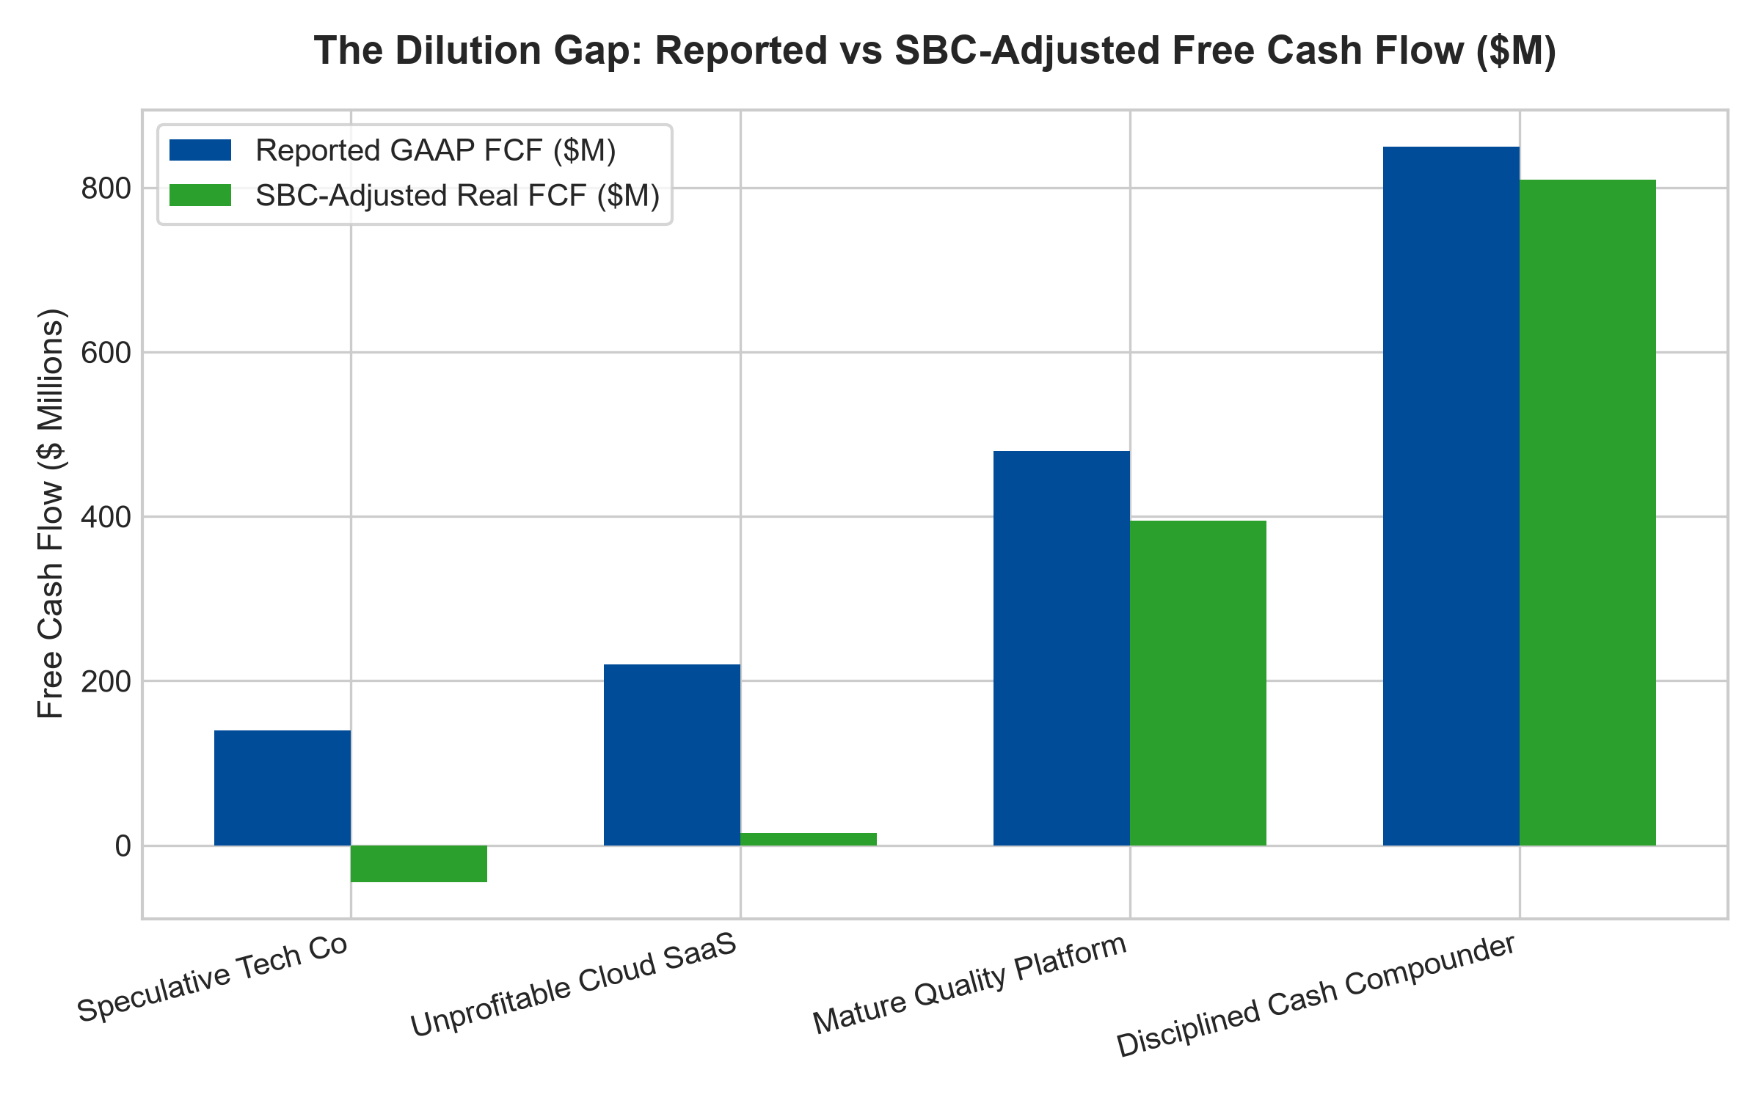
1. The Accounting Mechanics of the Non-Cash Add-Back
To comprehend the distortion of stock-based compensation, investors must trace its path across corporate financial statements. If an enterprise pays its software engineering workforce five hundred million dollars in cash salaries, operating cash flow decreases by five hundred million dollars, and free cash flow declines accordingly.
However, if that same enterprise pays five hundred million dollars in restricted stock units instead of cash, operating cash flow appears completely untouched. The five hundred million dollar non-cash expense is added back on the cash flow statement. The company claims to have generated five hundred million dollars in free cash flow, yet existing shareholders have suffered substantial ownership dilution. Paying employees in stock is simply a financing activity masquerading as operating efficiency.
2. The Share Buyback Treadmill and Dilution Offsetting
The ultimate economic reality of stock-based compensation is exposed when examining corporate share repurchase programs. Management teams often announce multi-billion dollar share buyback programs, marketing them to retail shareholders as proof of capital return. However, forensic analysis of the statement of cash flows frequently reveals that eighty to ninety percent of those share repurchases are deployed solely to absorb newly issued employee shares.
The corporate treasury spends real shareholder cash buying back shares on the open market merely to prevent the share count from exploding, leaving net shares outstanding completely flat. In reality, shareholder cash has been diverted to fund employee compensation rather than returning capital to equity holders. A business caught on this dilution treadmill produces negligible real intrinsic value per share.
3. Real Economic Moats Require Authentic Cash Profits
A genuine economic moat is evidenced by a corporation's ability to attract and retain elite talent while paying competitive cash wages and still generating pristine free cash flow. When an enterprise must issue ten to fifteen percent of its annual revenue in dilutive equity grants merely to prevent employee attrition, it possesses fragile operational economics.
Dominant wide-moat monopolists, such as global financial exchanges, enterprise software fortresses, and specialized infrastructure operators, maintain stock-based compensation as a negligible fraction of total operating revenues, typically below three to four percent. Their cash earnings are genuine, allowing share repurchases to drive permanent, structural reductions in the share count and accelerating dividend compounding per share.
4. MPLY and the Rejection of Dilutive Growth Illusions
Passive broad market index funds are indiscriminate, holding hundreds of speculative technology and cloud firms that report attractive operating cash flows while diluting shareholders by three to five percent annually through exorbitant stock grants. Over full market cycles, this constant equity dilution severely impairs shareholder returns.
The Strategy Shares Monopoly ETF (MPLY) bypasses these dilutive illusions through active fundamental scrutiny. MPLY specifically targets mature, disciplined market dominators that generate real, un-diluted free cash flow. By focusing on businesses that respect corporate governance and return authentic cash profits to shareholders, MPLY delivers institutional-grade capital protection and dependable, long-term wealth compounding.
Investors interested in discovering how actively managed strategies evaluate stock-based compensation, real free cash flow, and durable monopoly power can examine the Strategy Shares Monopoly ETF (MPLY) at https://strategysharesetfs.com/mply/.
5. Frequently Asked Questions
Q1: Is stock-based compensation ever appropriate for a publicly traded company?
Yes, when aligned with long-term per-share intrinsic value hurdles and maintained as a modest percentage of total revenue (under three percent), SBC can align executive incentives with shareholders. However, when it exceeds five to ten percent of revenue, it becomes a structural transfer of wealth from shareholders to employees.
Q2: How can an investor quickly calculate SBC-adjusted free cash flow?
Take reported Free Cash Flow from the cash flow statement (Operating Cash Flow minus Capital Expenditures) and subtract the total Stock-Based Compensation expense disclosed in the operating activities section. This reveals the true economic cash remaining after paying all employee compensation costs.
6. Sources
Morningstar, Equity Research & Share-Based Dilution Analysis: https://www.morningstar.com/articles/moat-research
Harvard Business Review, The True Cost of Stock-Based Compensation: https://hbr.org/1979/03/how-competitive-forces-shape-strategy
#stockbasedcompensation #FreeCashFlow #ForensicAccounting #QualityInvesting #MPLY

