Article 29:
Balance Sheet Strength as a Competitive Advantage
During prolonged economic expansions and bull markets characterized by zero-interest-rate monetary policy, corporate finance teams routinely treat debt as a costless accelerator of return on equity. Companies take on substantial leverage to fund aggressive share buybacks and execute overpriced acquisitions, while conservative capital management is dismissed as uninventive and inefficient. However, when economic liquidity freezes, credit spreads blow out, and interest rates surge, corporate strategy is ruthlessly rewritten by a balance sheet competitive advantage.
A pristine, fortress balance sheet, characterized by massive cash and cash equivalents, minimal net debt to EBITDA, and multi-decade fixed-rate debt maturities, is far more than a defensive insurance policy against bankruptcy. In the hands of elite, disciplined capital allocators, balance sheet strength operates as an aggressive, counter-cyclical weapon that destroys competitors and consolidates entire industries.
When leveraged rivals are forced into defensive survival mode, cutting capital expenditures, laying off key engineering talent, and fire-selling strategic assets to satisfy bank debt covenants, the fortress operator goes on the offensive. Isolating corporations that command impregnable balance sheets and unencumbered liquidity is a core risk-management principle of the Strategy Shares Monopoly ETF (MPLY).
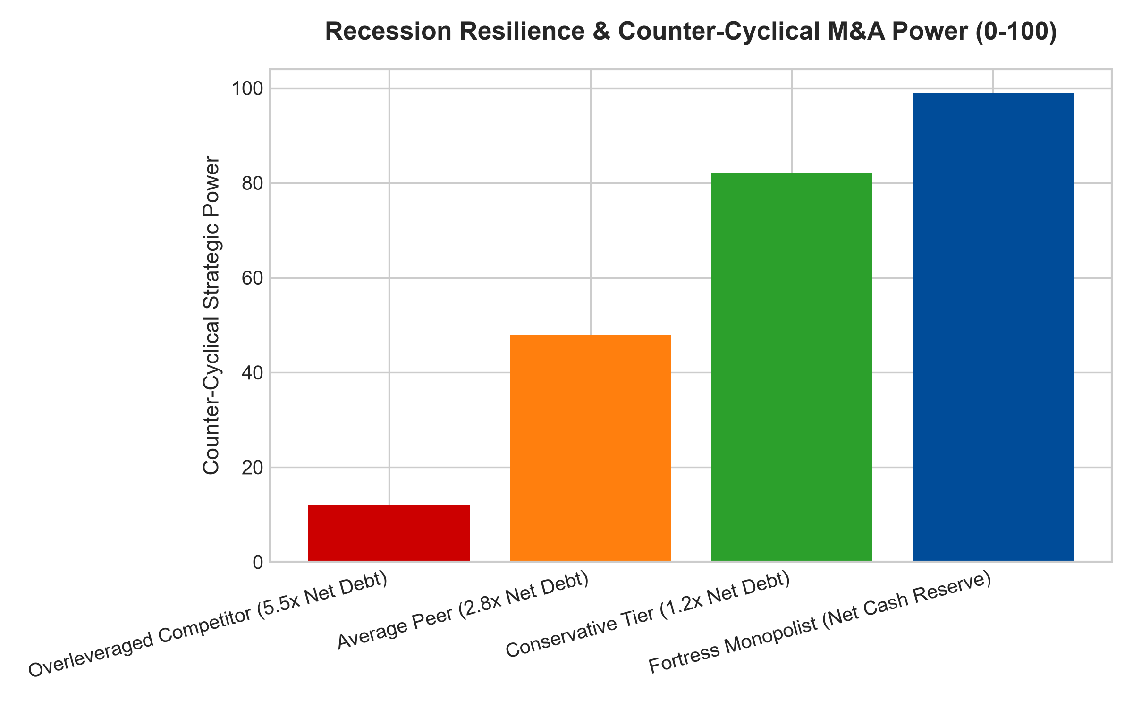
1. Strategic Liquidity as an Offensive Weapon
The profound strategic value of a fortress balance sheet is realized during acute economic downturns and market dislocations. In a severe recession, consumer demand contracts, operating cash flows decline, and commercial paper markets freeze. Highly leveraged corporations, burdened with heavy quarterly interest payments, must prioritize debt service above all else.
They cancel research and development initiatives, halt marketing campaigns, and slash capital investments, immediately degrading their long-term competitive positioning. The enterprise possessing billions in net cash reserves, by contrast, operates with absolute serenity. It maintains its product development roadmap, poaches top-tier engineering talent from struggling competitors, and expands its market share precisely when rivals are forced to retreat.
2. Counter-Cyclical Mergers and Acquisitions (M&A)
The greatest corporate fortunes in financial history are constructed by executing acquisitions at the depths of market panics. When asset prices collapse, distressed competitors, private equity sponsors, and venture syndicates are desperate to sell high-quality assets to raise emergency liquidity.
Because banks refuse to underwrite new debt financing during a panic, only corporations with abundant cash reserves or pristine investment-grade credit ratings can participate in the auction. The fortress operator can acquire prime competitor assets, proprietary intellectual property, and essential infrastructure corridors at fire-sale discounts of fifty to seventy percent below replacement cost. These acquisitions permanently expand the incumbent's economic moat, driving massive per-share intrinsic value growth when markets inevitably recover.
3. Freedom from the Tyranny of Refinancing Risk
A second vital dimension of balance sheet defensibility is debt maturity scheduling. Highly leveraged businesses frequently rely on floating-rate bank loans or short-term commercial debt that must be rolled over every three to five years. When benchmark interest rates rise by five hundred basis points, their annual interest expense doubles or triples, wiping out net earnings and forcing distressed equity issuance.
A fortress corporation, conversely, structures its capital base with fixed-rate, long-term bonds maturing in twenty to thirty years at historically low coupon rates, or operates with a pure net-cash balance sheet where interest income actually expands during high-rate regimes. Rising interest rates act as a competitive tailwind for the fortress monopolist, providing free corporate treasury yield while suffocating its indebted competitors.
4. MPLY and the Allocation to Fortress Monopolies
Passive broad market index funds are indiscriminate, holding hundreds of over-leveraged corporations that carry dangerous debt-to-EBITDA ratios. When credit cycles turn, these debt-laden companies suffer violent share price collapses and catastrophic dividend eliminations.
The Strategy Shares Monopoly ETF (MPLY) differentiates itself by applying an uncompromising quality screen. MPLY specifically targets dominant market leaders that command pristine, fortress balance sheets backed by massive recurring free cash flow and conservative debt metrics. By investing in corporate fortresses that possess the liquidity to thrive during panics and capitalize on distressed opportunities, MPLY delivers institutional-grade capital protection and dependable, long-term wealth compounding.
Investors interested in discovering how actively managed quality strategies evaluate balance sheet strength, liquidity weapons, and durable monopoly power can examine the Strategy Shares Monopoly ETF (MPLY) at https://strategysharesetfs.com/mply/.
Ultimately, the strategic power of a fortress balance sheet is defined by autonomy. When an enterprise operates with zero net debt and abundant cash reserves, its strategic roadmap is dictated entirely by management conviction rather than the restrictive covenants of commercial lending syndicates. The company can fund high-conviction research, expand production capacity counter-cyclically, and outlast leveraged peers during prolonged industry downturns with total confidence.
5. Frequently Asked Questions
Q1: Does maintaining a large net cash reserve drag on return on equity (ROE)?
During prolonged bull markets, excessive idle cash can mathematically depress short-term ROE compared to a company that borrowed heavily to buy back shares. However, this short-term metric ignores risk. Over full economic cycles, the ability to deploy cash into distressed acquisitions during a panic produces far higher long-term compounding than short-term financial engineering.
Q2: What balance sheet metrics best confirm corporate fortress strength?
Institutional analysts look for Net Debt to EBITDA below 1.5x (or negative Net Debt, indicating net cash), an interest coverage ratio exceeding 10x, and long-dated debt maturities with no major refinancing cliffs within the next five fiscal years.
6. Sources
Morningstar, Corporate Credit & Balance Sheet Moat Analysis: https://www.morningstar.com/articles/moat-research
Harvard Business Review, The Strategic Power of Balance Sheet Strength: https://hbr.org/1979/03/how-competitive-forces-shape-strategy
#balancesheetstrength #FinancialFortress #CounterCyclicalInvesting #QualityInvesting #MPLY

