Article 30:
How Working Capital Can Distort Cash Flow Trends
In fundamental financial statement evaluation, operating cash flow is frequently celebrated as the holy grail of corporate reporting, considered by many to be immune to the accrual accounting manipulations that can distort the income statement. However, sophisticated institutional credit analysts and equity forensic specialists understand that even the cash flow statement can produce deeply misleading signals if an investor fails to master working capital cash flow analysis. An apparent surge or collapse in operating cash flow is frequently an optical distortion created by cyclical working capital swings.
Working capital represents the operational liquidity tied up in daily business activities: current assets (such as accounts receivable and unsold physical inventory) minus current liabilities (such as accounts payable to suppliers). When working capital expands, cash is consumed and drained from operating cash flow. When working capital contracts, cash is released, temporarily inflating operating cash flow even as underlying business fundamentals deteriorate.
Crucially, elite wide-moat monopolists operate with structural negative working capital, permanently utilizing supplier and customer float to fund corporate growth. Understanding the mechanics of working capital distortions allows investors to distinguish between ephemeral accounting timing and durable, multi-decade cash compounding. Isolating corporations with structural negative working capital moats is a central quantitative discipline of the Strategy Shares Monopoly ETF (MPLY).
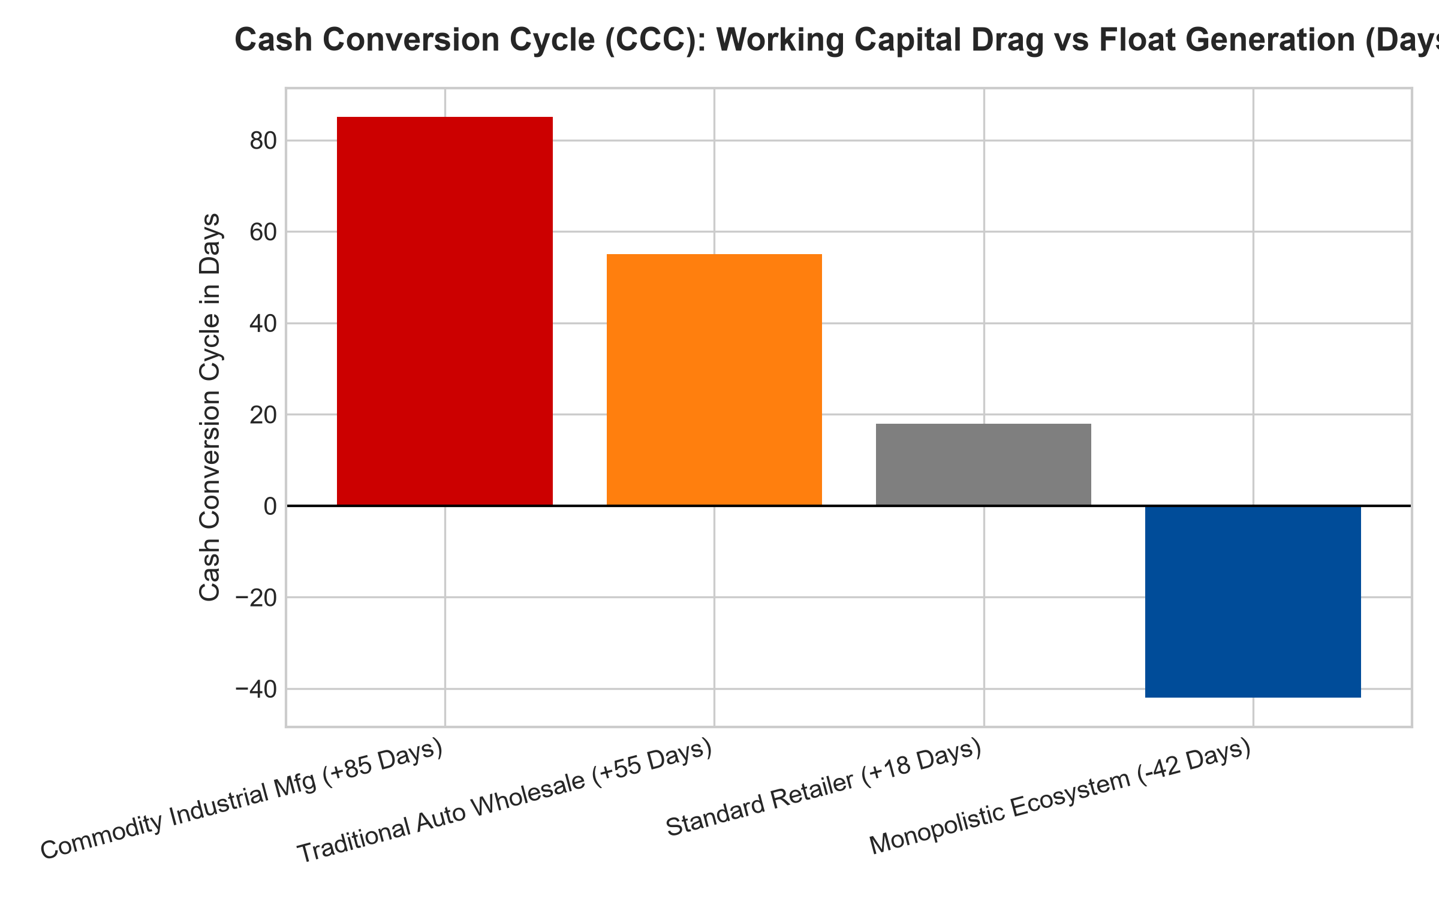
1. The Illusion of Cash Flow Expansion in Declining Businesses
To comprehend how working capital distorts cash flow analysis, investors must examine what occurs when a cyclical manufacturer experiences a severe decline in customer orders. As sales drop, the company halts factory production and stops purchasing raw materials. As existing customers pay off historical invoices, accounts receivable are liquidated into cash, while unsold inventory is slowly liquidated at discounted prices.
This liquidation of working capital produces a temporary, massive surge in operating cash flow. Superficial screening models flag the company as generating record free cash flow, when in truth, the business is liquidating its balance sheet and shrinking into distress. In subsequent quarters, when the working capital buffer is exhausted, cash flow plummets violently, trapping uninformed investors who mistook liquidation for operational strength.
2. The Growth Penalty of Positive Working Capital Businesses
Conversely, in growing businesses characterized by positive working capital architectures, rapid expansion creates an acute cash burn penalty. Consider an industrial distributor or automotive manufacturer expanding sales by thirty percent. To fulfill those new customer orders, the company must purchase millions in raw inventory upfront and extend sixty-day credit terms to new buyers via accounts receivable.
Every incremental dollar of sales consumes twenty to thirty cents of pure working capital cash. Even though the income statement reports surging net income, the corporate bank account is depleted. Management must constantly issue dilutive equity or take on high-interest revolving credit lines merely to finance basic corporate growth. Growth consumes capital rather than producing it.
3. The Negative Working Capital Float Superpower
The absolute pinnacle of financial quality is found in businesses that operate with a negative Cash Conversion Cycle (CCC). Consider a dominant global retail platform, an enterprise subscription software titan, or an essential market infrastructure operator. These monopolists collect customer payments immediately (or upfront via annual prepayments), while commanding such immense bargaining power over upstream suppliers that they negotiate ninety or one hundred and twenty-day payment terms.
In this operating paradigm, the enterprise operates on its suppliers' and customers' capital. The company collects customer cash today, holds it in corporate interest-bearing reserves for three months, and pays its suppliers long after the service has been delivered. Growth produces massive cash windfalls rather than consuming liquidity. The faster the enterprise expands, the more cash piles up on the balance sheet, unlocking an unbreachable compounding advantage.
4. MPLY and the Selection of Negative Working Capital Fortresses
Passive broad market index funds are filled with commoditized industrial and consumer wholesale firms that suffer from punishing positive working capital burdens. When macroeconomic volatility strikes, these capital-drained businesses face severe liquidity distress.
The Strategy Shares Monopoly ETF (MPLY) bypasses these fragile businesses through an active, institutional conviction screening process. MPLY specifically targets dominant market leaders that operate with negative or ultra-lean working capital architectures. By investing in corporate fortresses that generate self-funding cash float and exercise immense bargaining power across the supply chain, MPLY delivers defensive capital protection and dependable, long-term wealth compounding.
Investors seeking to explore how actively managed quality strategies evaluate working capital dynamics, cash conversion cycles, and durable monopoly power can examine the Strategy Shares Monopoly ETF (MPLY) at https://strategysharesetfs.com/mply/.
5. Frequently Asked Questions
Q1: What is the Cash Conversion Cycle (CCC) and how is it calculated?
The Cash Conversion Cycle measures the time in days required for a company to convert its investments in inventory and resources into cash from sales. It is calculated as Days Inventory Outstanding (DIO) plus Days Sales Outstanding (DSO) minus Days Payable Outstanding (DPO). A negative CCC indicates the company collects cash from sales before it must pay its suppliers.
Q2: How does inflation distort working capital cash flows?
In positive working capital businesses, inflation requires the enterprise to spend significantly more cash to replace identical physical units of inventory, triggering a permanent cash drain. In negative working capital monopolies, inflation expands customer prepayments, immediately increasing the company's interest-bearing cash float.
6. Sources
Morningstar, Cash Conversion Cycle & Forensic Financial Analysis: https://www.morningstar.com/articles/moat-research
Harvard Business Review, The Hidden Engine of Negative Working Capital: https://hbr.org/1979/03/how-competitive-forces-shape-strategy
#workingcapital #CashConversionCycle #ForensicAccounting #QualityInvesting #MPLY

