Article 31:
ROIC and Reinvestment: A Framework for Understanding Compounding
In the pantheon of financial metrics, no mathematical relationship governs long-term equity returns more authoritatively than the interplay between return on capital and capital reinvestment. While market commentators obsess over quarterly headline earnings surprises or macroeconomic interest rate forecasts, legendary investors recognize that over a multi-decade horizon, an investor's return will inevitably mirror the fundamental return on invested capital achieved by the underlying business. This principle is codified in equity research as the engine of ROIC reinvestment compounding.
Return on Invested Capital (ROIC) measures the efficiency with which a corporation allocates its debt and equity capital to generate operating profits after taxes. However, an elite ROIC alone is insufficient to build a generational compounding machine; a corporation must also possess a vast runway of high-return reinvestment opportunities. A business that generates a fifty percent ROIC but can only reinvest ten percent of its profits is a fantastic cash cow, but it cannot compound intrinsic value at scale.
The ultimate compounder is an enterprise that simultaneously achieves an extraordinary ROIC while redeploying the vast majority of its free cash flow back into the business at those identical high rates of return. This dual engine produces exponential per-share wealth creation that leaves traditional market benchmarks far behind. Isolating these rare dual-threat compounders forms the core selection criteria of the Strategy Shares Monopoly ETF (MPLY).
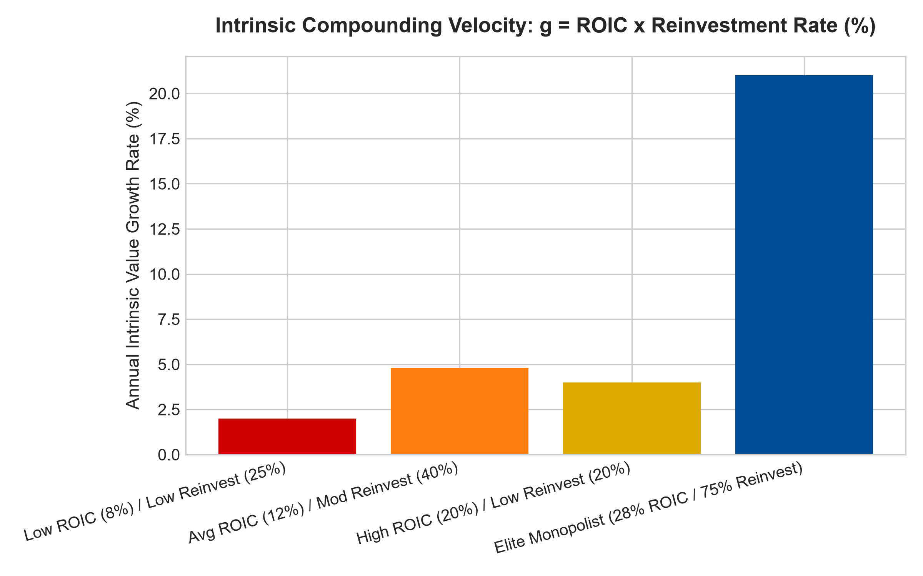
1. The Fundamental Equation of Corporate Value Growth
To comprehend long-term equity compounding, investors must master the fundamental equation of organic growth: the sustainable growth rate of operating profit equals Return on Invested Capital multiplied by the Reinvestment Rate. If a commoditized industrial firm earns an eight percent ROIC and reinvests half of its profits, its intrinsic earnings power compounds at a pedestrian four percent annually.
Conversely, when an entrenched wide-moat monopolist generates a twenty-five percent ROIC and successfully reinvests seventy percent of its cash flow into expanding its captive network, its intrinsic value expands at seventeen and a half percent annually. Over a twenty-year holding period, this mathematical divergence produces an astronomical performance gap. High ROIC acts as the efficiency multiplier, while reinvestment rate functions as the fuel that accelerates corporate intrinsic value.
2. The Reinvestment Runway and Moat Durability
A critical error made by equity analysts is assuming that high past ROIC guarantees future compounding. In traditional economics, high returns on capital act as a beacon that attracts rival capital. Competitors flood the industry, building competing capacity, undercutting prices, and driving industry returns down to the cost of capital.
A corporation can only sustain a high ROIC over long horizons if it is defended by an insurmountable economic moat: high switching friction, sovereign regulatory licenses, network effects, or massive scale cost advantages. Furthermore, the company must possess a massive total addressable market that provides an extended reinvestment runway. Without an economic moat, excess returns are swiftly competed away; without a reinvestment runway, high returns stagnate into ordinary dividend yields.
3. Capital Allocation Discipline: Dividends vs Reinvestment
When an enterprise achieves market maturity and its marginal return on incremental invested capital begins to decline toward its weighted average cost of capital, management faces a critical strategic test. Poorly disciplined executives often succumb to empire-building, deploying cash flow into low-return vanity acquisitions or speculative projects that dilute shareholder capital.
Elite capital allocators recognize when marginal returns are deteriorating and pivot their capital allocation strategy: funding high-return internal initiatives first, and immediately returning excess cash to shareholders through aggressive share repurchases and growing dividends. This disciplined capital stewardship protects the corporate ROIC fortress, ensuring that every dollar of retained capital compounds shareholder wealth.
4. MPLY and the Curation of Elite Compounding Fortresses
Passive broad market index funds are indiscriminate, holding hundreds of low-ROIC corporations that consume massive capital merely to maintain stagnant operating positions. Over full macroeconomic cycles, these capital-dilutive entities severely drag down portfolio performance.
The Strategy Shares Monopoly ETF (MPLY) bypasses these low-return businesses through an active, institutional conviction mandate. MPLY selectively concentrates capital in dominant market leaders that demonstrate extraordinary ROIC defended by unbreachable economic moats, alongside disciplined capital reinvestment frameworks. By allocating capital toward elite corporate compounders, MPLY delivers defensive capital protection and dependable, long-term wealth creation across all market environments.
Investors seeking to explore how actively managed quality strategies evaluate ROIC, reinvestment runways, and durable monopoly power can examine the Strategy Shares Monopoly ETF (MPLY) at https://strategysharesetfs.com/mply/.
5. Frequently Asked Questions
Q1: Why is ROIC a superior metric to Return on Equity (ROE)?
Return on Equity can be artificially inflated through financial engineering and excessive balance sheet debt, making a highly leveraged, fragile business appear exceptionally profitable. ROIC evaluates operating profitability against the total capital base (both debt and equity), providing an unmanipulated measure of true operational efficiency.
Q2: Can a company with a low reinvestment rate still be a fantastic investment?
Yes, if its ROIC is exceptionally high and management returns all un-reinvested cash to shareholders through aggressive dividends and share buybacks. However, it will function as an ultra-high-yielding cash cow rather than an organic compounding growth machine.
6. Sources
Morningstar, ROIC & Economic Moat Valuation Framework: https://www.morningstar.com/articles/moat-research
Harvard Business Review, The Chemistry of Corporate Compounding: https://hbr.org/1979/03/how-competitive-forces-shape-strategy
#ROIC #ReinvestmentRate #CompoundingEngine #QualityInvesting #MPLY

