Article 32:
Earnings Yield vs Free Cash Flow Yield
In traditional equity screening and valuation analysis, retail market participants routinely rely on the price-to-earnings (P/E) ratio or its mathematical reciprocal, the earnings yield (net income divided by market capitalization). A company trading at a low P/E multiple of ten, representing a headline earnings yield of ten percent, is instinctively classified as an undervalued bargain. However, seasoned institutional capital allocators understand that accounting earnings can be profoundly deceptive. Real valuation discipline requires analyzing the divergence between earnings yield vs free cash flow yield.
Earnings yield is derived from GAAP net income, an accrual accounting construct subject to non-cash depreciation assumptions, capitalized software expenses, and working capital distortions. Free cash flow yield (free cash flow divided by market capitalization), by contrast, measures the unencumbered cash that an enterprise actually generates and deposits in its bank account after funding all capital expenditures. While earnings yield tells you what management hopes the business made on paper, free cash flow yield tells you what can actually be distributed to shareholders in cold cash.
In capital-intensive, low-moat businesses, reported earnings yield is frequently an optical illusion, masking massive ongoing capital drains. Conversely, wide-moat monopolists often trade at seemingly premium P/E multiples, yet generate abundant, high-quality free cash flow yields that make them remarkably undervalued. Isolating corporations with superior cash flow yields is an essential analytical filter of the Strategy Shares Monopoly ETF (MPLY).
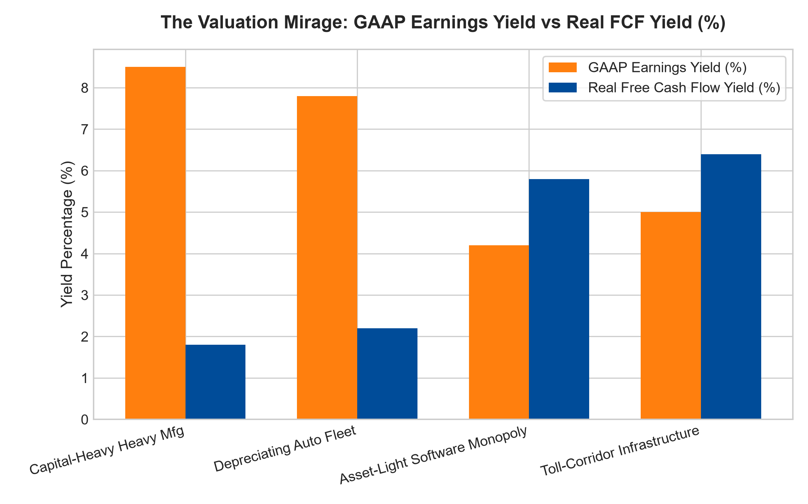
1. The Accounting Trap of the Value Illusion
To comprehend the danger of relying solely on earnings yield, consider a capital-heavy industrial manufacturer or rental car fleet operator. On the corporate income statement, depreciation charges are smoothed over long periods based on historical purchase costs. The company reports healthy accounting profits, presenting an attractive nine percent earnings yield.
However, when examining the cash flow statement, one discovers that replacing worn-out machinery and updating fleet vehicles requires massive annual maintenance CapEx that exceeds reported depreciation. Furthermore, working capital continuously consumes cash to finance unpaid customer receivables. The actual free cash flow yield generated is an anemic two percent. An investor purchasing the stock based on earnings yield has walked into a classic value trap: the company cannot pay dividends or repurchase shares without borrowing debt, despite reporting accounting profits.
2. High-Quality Monopolies and the Cash Conversion Premium
Conversely, wide-moat monopolists, such as mission-critical enterprise software providers, financial exchange clearinghouses, and specialized infrastructure corridors, exhibit the opposite dynamic. Because they operate with minimal maintenance capital requirements and negative working capital architectures, their free cash flow routinely exceeds reported GAAP net income.
A financial exchange or enterprise software titan may appear optically expensive on a superficial stock screener, trading at a twenty-five times P/E multiple (a four percent earnings yield). Yet, because cash conversion is exceptional and customers prepay for services upfront, its real free cash flow yield is six or seven percent. The business is generating more cash than paper profit, providing abundant liquidity to compound intrinsic value while superficial value screens overlook it.
3. Cross-Asset Valuation and the Equity Risk Premium
From a macro allocation perspective, institutional portfolio managers utilize free cash flow yield to compare equities directly against risk-free sovereign debt. When evaluating a corporate bond yielding five percent against an equity asset, comparing the bond yield to an accrual earnings yield is fundamentally flawed.
A bond pays real cash interest, not accounting accruals. Comparing bond yields directly to free cash flow yields establishes the true Equity Risk Premium (ERP). When an investor identifies a dominant monopoly generating a stable, inflation-protected free cash flow yield of six percent with organic growth, they are securing equity upside alongside fixed-income-like cash flow safety, creating an unbeatable risk-adjusted investment profile.
4. MPLY and the Allocation to Real Cash Flow Fortresses
Passive broad market index funds are packed with cyclical manufacturing, commodity, and financial firms that showcase attractive accounting earnings yields while generating negligible free cash flow. When credit conditions tighten, these paper-profit businesses suffer devastating dividend cuts.
The Strategy Shares Monopoly ETF (MPLY) bypasses these accounting mirages through active fundamental curation. MPLY specifically targets dominant market leaders that generate pristine, high-yield free cash flow backed by unbreachable economic moats. By concentrating capital in corporations that produce verifiable cash returns rather than accounting promises, MPLY delivers institutional-grade capital protection and dependable, long-term wealth compounding.
Investors interested in discovering how actively managed quality strategies evaluate free cash flow yields, earnings distortions, and durable monopoly power can examine the Strategy Shares Monopoly ETF (MPLY) at https://strategysharesetfs.com/mply/.
5. Frequently Asked Questions
Q1: Can a company's free cash flow yield be negative while its earnings yield is positive?
Yes, this occurs frequently in capital-intensive or rapid-growth businesses where massive CapEx and surging working capital consume all incoming cash, leaving negative free cash flow despite positive GAAP net income. Unless the business is funding high-return growth CapEx, this is a severe financial red flag.
Q2: How can an investor calculate Free Cash Flow Yield quickly?
Take Free Cash Flow (Operating Cash Flow minus Capital Expenditures) from the statement of cash flows and divide it by the total Market Capitalization (or Enterprise Value for a debt-neutral view). This reveals the percentage cash yield generated per dollar of market valuation.
6. Sources
Morningstar, Equity Valuation & Free Cash Flow Yield Analysis: https://www.morningstar.com/articles/moat-research
Harvard Business Review, The Primacy of Cash Flow Over Net Income: https://hbr.org/1979/03/how-competitive-forces-shape-strategy
#earningsyield #freecashflowyield #ValuationAnalysis #QualityInvesting #MPLY

