Article 33:
How to Think About Valuation When a Company Is Growing Quickly
In the domain of equity valuation, fast-growing enterprises represent both the greatest potential sources of generational wealth creation and the most lethal minefields for unseasoned capital allocators. Traditional valuation heuristics, such as trailing price-to-earnings or forward enterprise-value-to-EBITDA multiples, routinely fail when applied to companies growing at thirty, forty, or fifty percent annually. An enterprise that appears exorbitantly overvalued on next year's earnings can prove to be deeply undervalued over a ten-year horizon if its growth is durable. For institutional investors, mastering valuing high growth companies requires looking beyond current financial multiples to interrogate the competitive longevity of the corporate economic moat.
The fundamental reality of high-growth valuation is that the vast majority of an enterprise's current value resides in cash flows that will not be generated until year five, ten, or fifteen. In financial mathematics, this is known as the duration of cash flows. A company whose growth is fleeting and vulnerable to competitive entry will see its growth rate collapse before ever achieving operating leverage. Conversely, a high-growth business fortified by an insurmountable economic moat can reinvest capital at high returns for decades, justifying seemingly exorbitant initial valuation multiples.
Understanding the crucial distinction between transient, capital-destructive growth and durable, moat-protected compounding is essential for navigating market cycles. Isolating high-growth compounders with structural monopoly protections is a core qualitative discipline of the Strategy Shares Monopoly ETF (MPLY).
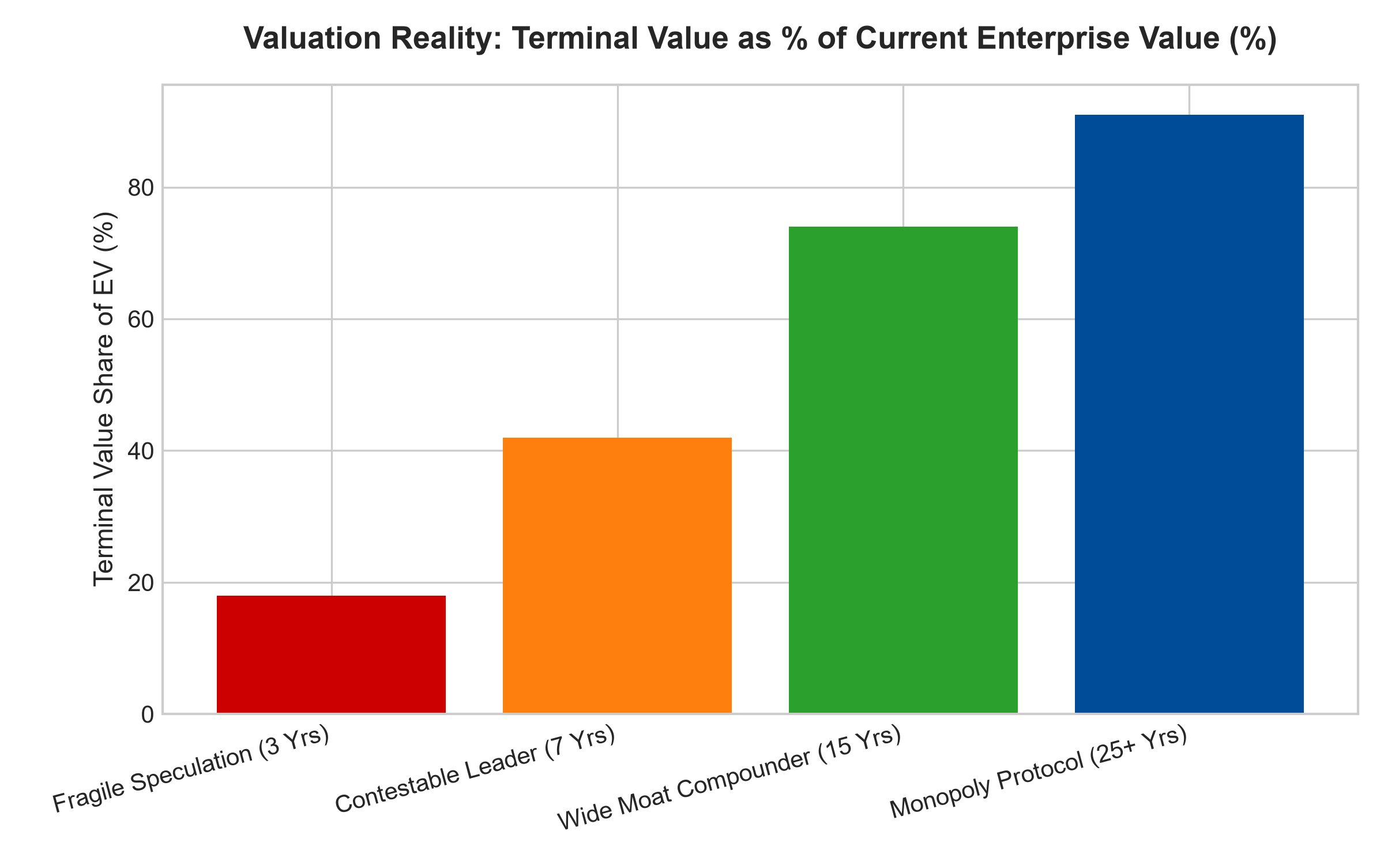
1. The Reverse DCF Framework: Deconstructing Expectations
Rather than attempting to forecast precise financial statements ten years into the future, institutional allocators utilize a Reverse Discounted Cash Flow (DCF) framework. Instead of asking what a high-growth stock is worth, the reverse DCF asks: what operational performance, revenue growth rate, and terminal operating margin must this company achieve to justify its current stock price?
If a reverse DCF reveals that a high-growth enterprise must capture one hundred and twenty percent of the global market and maintain ninety percent gross margins for fifteen consecutive years to justify its current enterprise value, the stock is pricing in a mathematical impossibility. If, however, the reverse DCF indicates that the market is pricing in only modest market penetration while the company commands an expanding economic moat, the stock presents substantial asymmetric upside despite optically high multiples.
2. Moat Durability Over Headline Growth Velocity
A critical error made by retail growth investors is prioritizing growth rate over moat durability. A company growing at sixty percent in a contestable, low-barrier market (such as consumer food delivery or buy-now-pay-later lending) will attract dozens of venture-backed copycats. Competitors engage in predatory discounting, marketing customer acquisition costs explode, and operating margins collapse before the business ever reaches profitability.
In stark contrast, a business growing at a more measured twenty-five percent, but protected by deep switching friction, proprietary software protocols, or network effects, can sustain that growth rate for fifteen consecutive years without competitive decay. In compound interest mathematics, the duration of growth is vastly more powerful than the initial growth rate. Durability, not velocity, is what drives multi-decade wealth compounding.
3. Unit Economics and Marginal Return on Invested Capital
To determine whether rapid growth is actually creating intrinsic value, institutional analysts evaluate Marginal Return on Invested Capital (Marginal ROIC). Growth only creates shareholder value if the return generated on each incremental dollar of capital deployed exceeds the company's weighted average cost of capital.
If a company expands revenue by spending two dollars on digital advertising and customer acquisition for every one dollar of lifetime gross profit captured, growth is actively destroying shareholder capital. A high-growth enterprise is only worth paying a premium multiple for if its unit economics demonstrate expanding operating leverage: sales and marketing expense declining as a percentage of revenue, customer lifetime value expanding, and gross margins holding pristine.
4. MPLY and the Curation of Sustainable Growth Monopolies
Passive market index funds and speculative growth ETFs are heavily exposed to unproven, unprofitable tech companies that trade at extreme valuations despite possessing fragile barriers to entry. When interest rates rise or market sentiment cools, these speculative entities suffer devastating eighty to ninety percent drawdowns.
The Strategy Shares Monopoly ETF (MPLY) differentiates itself by applying an active, institutional conviction mandate. MPLY selectively targets businesses that combine rapid commercial expansion with proven, cash-generative economic moats and unyielding pricing power. By focusing on durable market dominators whose growth is structurally protected from competitive disruption, MPLY delivers defensive capital protection and superior long-term wealth compounding.
Investors interested in discovering how actively managed quality strategies evaluate high-growth valuations, cash flow duration, and durable monopoly power can examine the Strategy Shares Monopoly ETF (MPLY) at https://strategysharesetfs.com/mply/.
5. Frequently Asked Questions
Q1: Why do traditional valuation multiples like P/E fail for high-growth software companies?
High-growth software companies typically expense all customer acquisition costs immediately on the income statement while collecting multi-year cash flow streams over decades. This depresses current accounting net income, artificially inflating the P/E multiple and obscuring underlying economic profitability.
Q2: What is the single most important factor when evaluating a fast-growing company?
Customer retention and switching costs. If customers remain captive and expand their spending over time (Net Revenue Retention > 115%), growth is organic and compounding. If retention is low, the company is on an expensive marketing treadmill that will collapse when funding dries up.
6. Sources
Morningstar, Equity Valuation & High-Growth DCF Modeling: https://www.morningstar.com/articles/moat-research
Harvard Business Review, The Truth About Valuing High-Growth Platforms: https://hbr.org/1979/03/how-competitive-forces-shape-strategy
#growthvaluation #ReverseDCF #EconomicMoats #QualityInvesting #MPLY

