Article 34:
Valuing Asset-Light vs Asset-Heavy Businesses
In institutional equity research, one of the most fundamental structural divides separating business models is capital intensity. Investors routinely categorize corporations into asset-light and asset-heavy architectures, applying divergent valuation multiples, balance sheet hurdles, and return expectations to each. However, applying simplistic valuation rules without interrogating the underlying economic moat leads to catastrophic errors. Navigating asset light vs asset heavy valuation requires understanding how physical capital interacts with competitive defensibility, inflation resilience, and cash flow conversion.
Asset-light businesses operate with minimal tangible property, plant, and equipment, generating revenues through intellectual property, proprietary software protocols, brand licensing, or digital market orchestration. They boast astronomical return on invested capital and convert nearly every dollar of operating profit into unencumbered free cash flow. In contrast, asset-heavy businesses require billions of dollars in physical infrastructure, factories, rights-of-way, or heavy machinery to produce their revenue.
While asset-light models command premium valuation multiples due to cash flow efficiency, asset-heavy models often possess physical barriers to entry that digital code cannot replicate. The pinnacle of institutional investing occurs when an investor identifies dominant monopolies within both categories that combine high return on capital with permanent competitive moats. This balanced quality perspective informs the portfolio construction of the Strategy Shares Monopoly ETF (MPLY).
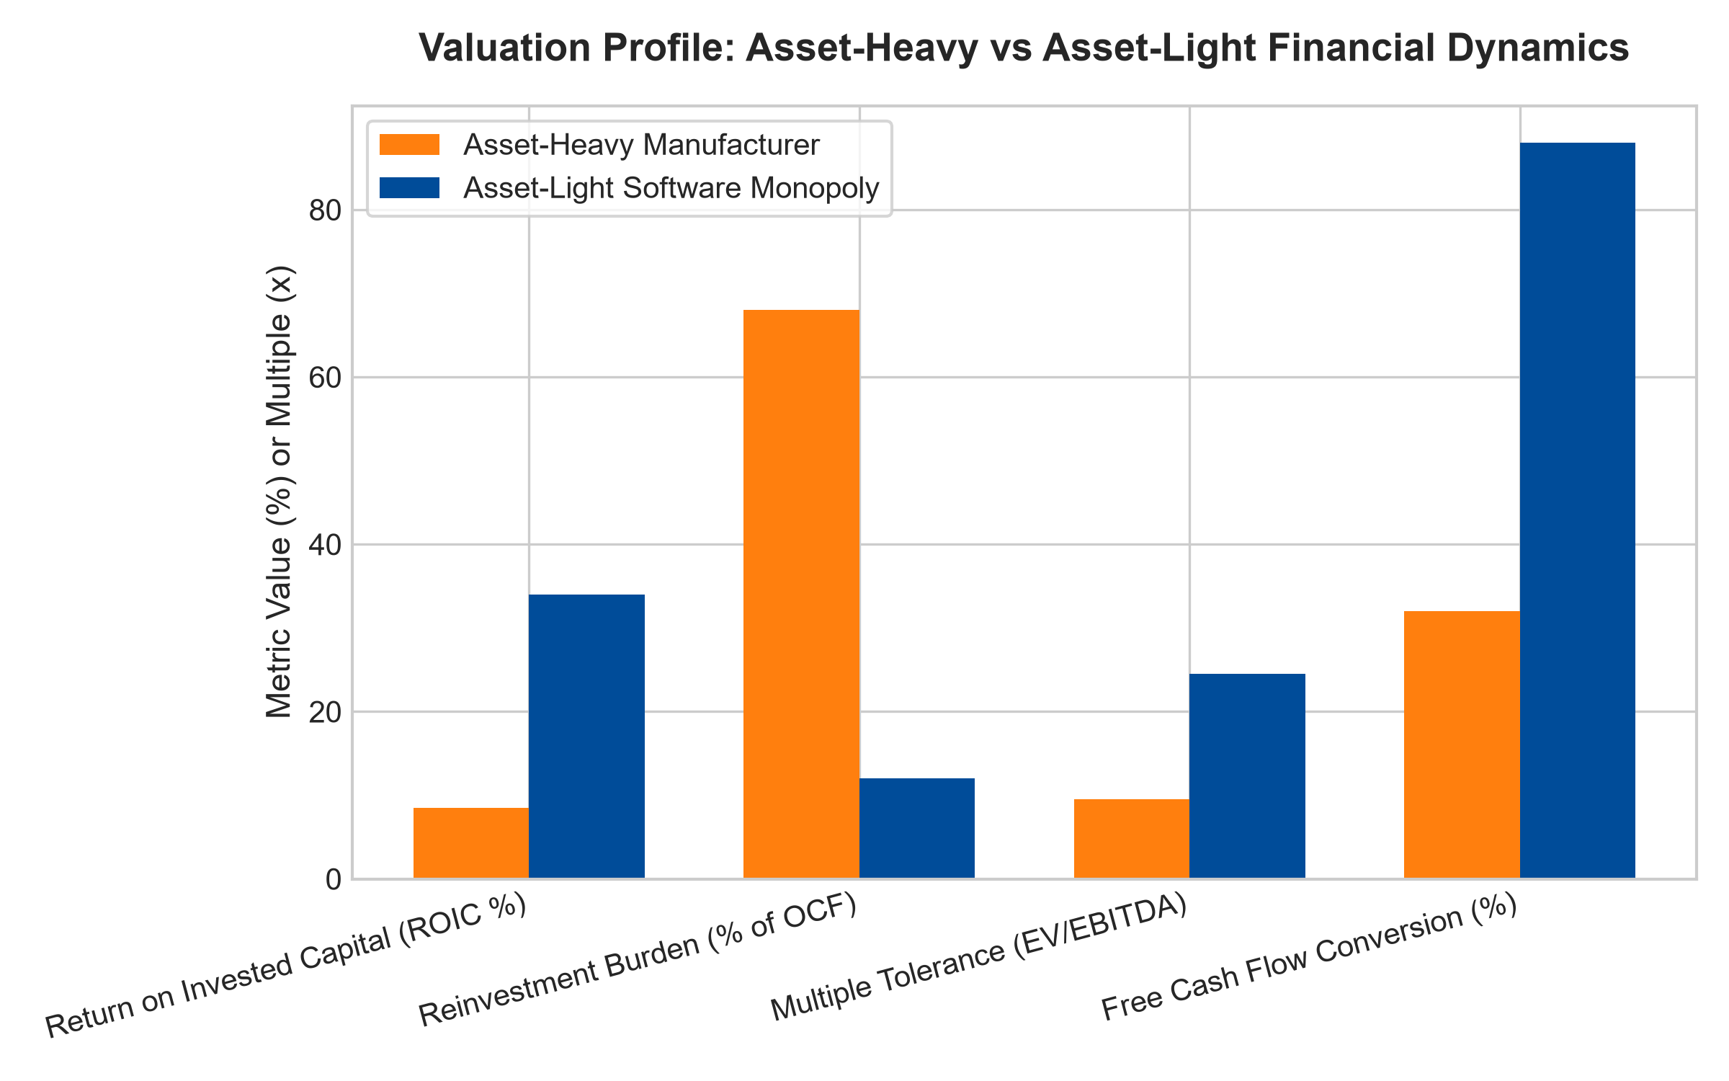
1. The Compounding Physics of Asset-Light Models
The primary appeal of an asset-light corporate model is capital efficiency. A dominant enterprise software provider or financial clearinghouse can expand revenues by five hundred percent without constructing a single new factory or purchasing industrial machinery. The incremental capital expenditure required to serve additional clients approaches zero.
Consequently, operating cash flow converts almost entirely into free cash flow. The company does not need to hoard cash for maintenance CapEx, allowing it to pay growing dividends and execute large-scale share buybacks. Because capital is unencumbered, the business commands high price-to-earnings and EV/EBITDA valuation multiples. However, asset-light businesses carry an inherent vulnerability: because they lack physical barriers, they must constantly defend their perimeter against innovative digital copycats.
2. Greenfield Replacement Costs and Asset-Heavy Defensibility
In asset-heavy businesses, valuation multiples are structurally lower, with EV/EBITDA multiples often hovering in the high single digits. This discount reflects the heavy maintenance CapEx required to update physical machinery and repair infrastructure, which reduces free cash flow conversion.
However, asset-heavy businesses often possess an unassailable physical moat that asset-light models lack: greenfield replacement cost. A Class I transcontinental freight railroad or interstate natural gas pipeline cannot be duplicated by any venture capital syndicate, no matter how much capital they raise. The physical rights-of-way, regulatory approvals, and specialized geography create a permanent, legally sanctioned monopoly. While their multiples are lower, their cash flows resemble regulated economic toll booths that are immune to technological disruption.
3. Inflation Dynamics: The Heavy Asset Paradox
A critical consideration when valuing asset-heavy versus asset-light companies is macroeconomic inflation. During periods of sustained price inflation, asset-light companies can adjust software subscription prices easily, but their underlying assets do not appreciate in physical value.
Asset-heavy monopolies with grandfathered physical assets benefit from a powerful accounting paradox. Their physical assets were constructed with historical, pre-inflation dollars. As replacement costs soar, the barrier to entry against prospective competitors strengthens exponentially. Meanwhile, the incumbent raises its user tariffs in lockstep with CPI inflation, driving structural operating margin expansion on an asset base that has already been amortized. The physical asset becomes an indispensable inflation fortress.
4. MPLY and the Balanced Selection of Monopoly Assets
Passive broad market index funds are indiscriminate, holding capital-starved manufacturing firms that suffer from high CapEx without possessing physical moats, alongside speculative asset-light software firms with zero customer retention. Over full economic cycles, this lack of conviction dilutes shareholder returns.
The Strategy Shares Monopoly ETF (MPLY) differentiates itself by applying an active, institutional conviction mandate. MPLY selectively targets the elite tier of both worlds: asset-light software and platform dominators that generate pristine free cash flow, alongside asset-heavy infrastructure fortresses that command irreplaceable physical rights-of-way. By assembling a concentrated portfolio of true economic monopolies, MPLY delivers defensive capital protection and dependable, long-term wealth compounding.
Investors interested in discovering how actively managed quality strategies evaluate asset-light platforms, physical infrastructure fortresses, and durable monopoly power can examine the Strategy Shares Monopoly ETF (MPLY) at https://strategysharesetfs.com/mply/.
From an institutional capital allocation perspective, the compounding asymmetry between asset-light and asset-heavy enterprises becomes starkest during inflationary spikes. While asset-heavy enterprises face escalating replacement capital expenditures simply to maintain existing physical machinery, asset-light monopolists expand revenue without corresponding equipment depreciation inflation. Consequently, portfolio managers often grant asset-light businesses premium multiple tolerance, knowing their free cash flow conversion rates remain insulated from physical replacement cycles.
5. Frequently Asked Questions
Q1: Is an asset-light business always a better investment than an asset-heavy business?
No. Capital efficiency must be balanced against competitive defensibility. An asset-light business with weak switching costs can be displaced rapidly by competing software. An asset-heavy business with an irreplaceable physical right-of-way possesses a permanent monopoly that can compound safely for generations.
Q2: How do institutional valuation models adjust for capital intensity?
Analysts normalize capital expenditures by subtracting estimated maintenance CapEx from operating cash flow, evaluating companies on Free Cash Flow Yield and Return on Invested Capital rather than misleading GAAP net income multiples.
6. Sources
Morningstar, Capital Intensity & Corporate Valuation Research: https://www.morningstar.com/articles/moat-research
Harvard Business Review, The Strategy of Capital Intensity: https://hbr.org/1979/03/how-competitive-forces-shape-strategy
#assetlight #assetheavy #ValuationAnalysis #EconomicMoats #QualityInvesting #MPLY

