Article 35:
Price-to-Book vs Price-to-Earnings: When Each Metric Matters
For nearly a century, fundamental equity valuation was anchored by the tenets of classical value investing pioneered by Benjamin Graham and David Dodd. During the industrial era of the mid-twentieth century, evaluating corporate solvency and intrinsic worth centered on tangible book value: the physical balance sheet value of factories, railcars, machinery, and raw inventory. However, over the past fifty years, the global economy has undergone a structural transformation from physical manufacturing toward an intellectual, software, and network-driven architecture. Understanding price to book vs price to earnings is essential for modern institutional capital allocators.
The Price-to-Book (P/B) ratio evaluates an enterprise's market capitalization against its historical accounting net worth (total assets minus total liabilities). The Price-to-Earnings (P/E) ratio measures market value against net operating profits. In modern corporate valuation, book value has become largely obsolete for wide-moat compounders because GAAP accounting conventions forbid recording internally generated intangible assets, such as proprietary software code, brand equity, specialized engineering culture, and network effects, on the corporate balance sheet.
Consequently, elite businesses that generate extraordinary cash flows routinely trade at optically astronomical Price-to-Book multiples, or even negative book values due to aggressive share buybacks, while remaining deeply undervalued on cash earnings power. Isolating businesses with powerful intangible moats that defy outdated book-value metrics is a core analytical competency of the Strategy Shares Monopoly ETF (MPLY).
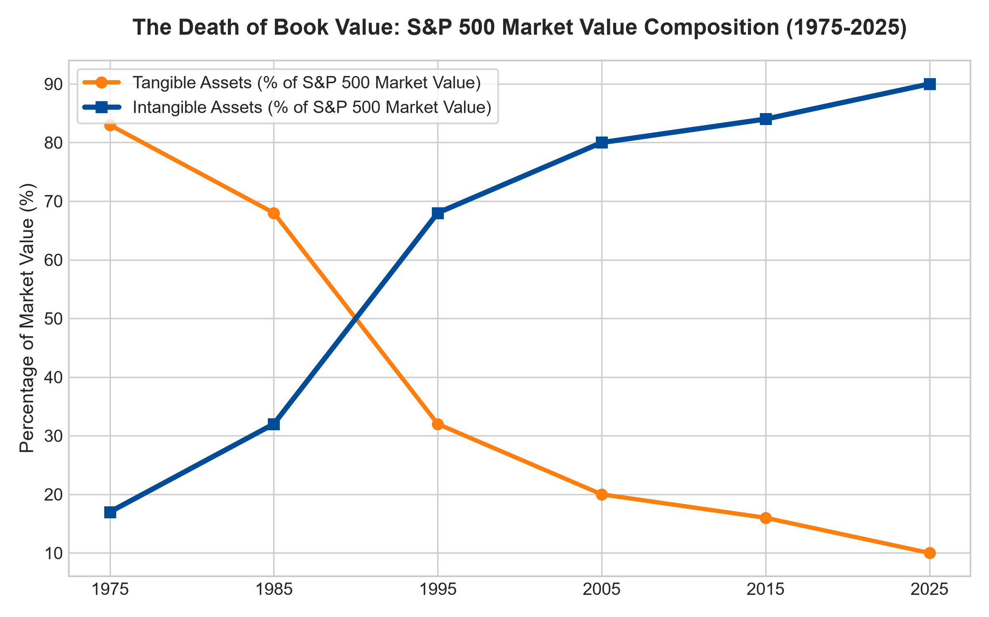
1. The Structural Collapse of Tangible Book Value
In 1975, tangible physical assets, factories, real estate, and physical inventory, accounted for over eighty percent of the total market capitalization of the S&P 500. In that industrial environment, Price-to-Book was a highly effective screening tool. If a steel mill or textile manufacturer traded below book value, an investor was buying physical replacement assets at a substantial discount.
Today, intangible assets account for over ninety percent of the total market value of the S&P 500. An enterprise software giant or global payment processing platform requires minimal physical assets to generate billions in cash profit. Because conservative GAAP accounting mandates that research and development be expensed immediately on the income statement rather than capitalized on the balance sheet, the true economic engine of the business is completely invisible in book value. Screeners searching for low Price-to-Book stocks today primarily isolate distressed banks, commoditized manufacturing, and obsolete industrial operations.
2. When Price-to-Book Still Matters: Financial Institutions
Despite its obsolescence for modern technology and service platforms, Price-to-Book remains an indispensable analytical metric for commercial banking institutions, insurance underwriters, and real estate investment trusts (REITs). In financial institutions, the balance sheet consists of financial assets, commercial loans, treasury bonds, and mortgage securities, that are marked to market continuously.
For a commercial bank, book value represents real, quantifiable equity capital. Evaluating whether a bank trades at 0.8x or 1.5x tangible book value provides direct insight into asset quality, credit reserve adequacy, and Return on Tangible Common Equity (ROTCE). However, applying Price-to-Book to non-financial operating businesses is an analytical category error.
3. Price-to-Earnings and the Primacy of Earning Power
For wide-moat operating companies, Price-to-Earnings, and specifically cash-flow-adjusted earnings metrics, is the premier valuation standard. A business is worth the discounted present value of the cash flows it will generate over its remaining economic life, not the historical liquidation value of its used office furniture.
Dominant monopolists that possess deep customer lock-in and high pricing power generate massive return on equity precisely because they require minimal physical assets to operate. When these businesses execute massive share buybacks, accounting equity can shrink to near zero or turn negative, causing the Price-to-Book ratio to mathematically explode to infinity. Savvy institutional investors ignore the book value optical distortion and focus on cash earnings yield and ROIC.
4. MPLY and the Allocation to Intangible Monopoly Fortresses
Passive broad market index funds and mechanical value strategies are often trapped holding capital-intensive, low-return businesses simply because they trade at low Price-to-Book multiples. These value traps suffer chronic capital impairment as physical assets deteriorate without generating adequate cash returns.
The Strategy Shares Monopoly ETF (MPLY) bypasses these outdated accounting screens through an active, institutional conviction mandate. MPLY specifically targets dominant market leaders whose economic fortresses are built on irreplaceable intangible assets, sovereign licenses, mission-critical software, and network coordination. By concentrating capital in corporations that command unmatched cash earning power rather than idle book value, MPLY delivers institutional-grade capital protection and superior long-term wealth compounding.
Investors interested in discovering how actively managed quality strategies evaluate intangible moats, cash earning power, and durable monopoly advantages can examine the Strategy Shares Monopoly ETF (MPLY) at https://strategysharesetfs.com/mply/.
5. Frequently Asked Questions
Q1: Why do some of the highest-quality companies on earth have negative book values?
When an enterprise generates massive free cash flow and requires minimal CapEx, management often returns cash to shareholders through aggressive share buybacks. Under GAAP rules, repurchasing shares at market prices well above historical book value reduces accounting equity, eventually turning book value negative while cash earning power reaches record highs.
Q2: How can an investor identify if a low P/E stock is an authentic bargain or a value trap?
Interrogate the economic moat and free cash flow conversion. If a company trades at eight times earnings but its revenue is contracting, its customer retention is falling, and its CapEx exceeds depreciation, it is a value trap. If free cash flow conversion is above eighty percent and retention is high, it is a genuine bargain.
6. Sources
Morningstar, Intangible Assets & Modern Equity Valuation Research: https://www.morningstar.com/articles/moat-research
Harvard Business Review, Accounting for Intangibles in the Modern Economy: https://hbr.org/1979/03/how-competitive-forces-shape-strategy
#pricetobook #pricetoearnings #IntangibleMoats #QualityInvesting #MPLY

