Article 36:
How Share Buybacks Can Change Per-Share Value
In fundamental corporate finance, few executive capital allocation decisions generate more heated controversy among financial commentators than share repurchases. Skeptics routinely label buybacks as short-term financial engineering designed to manipulate executive compensation benchmarks, while corporate enthusiasts celebrate every repurchase announcement as unmitigated shareholder value creation. Through the rigorous lens of institutional equity analysis, neither extreme captures reality. Understanding share buybacks per share value requires analyzing the price paid relative to intrinsic business worth.
Share buybacks are an exercise in capital stewardship and corporate ownership concentration. When an enterprise repurchases its own shares on the open market, it retires those shares from existence, dividing the future operating profits of the business among a permanently smaller pool of remaining shares. If a business repurchases shares below intrinsic value, each remaining share experiences an immediate, permanent accretion in intrinsic earnings power and asset ownership.
However, if an undisciplined executive team repurchases shares at the peak of a bull market at exorbitant valuation multiples, the buyback destroys shareholder capital just as surely as an ill-advised acquisition. Elite wide-moat monopolists understand this mathematical law, utilizing repurchases with ruthless, counter-cyclical precision. Isolating businesses that compound per-share intrinsic value through disciplined buybacks is an essential quantitative priority of the Strategy Shares Monopoly ETF (MPLY).
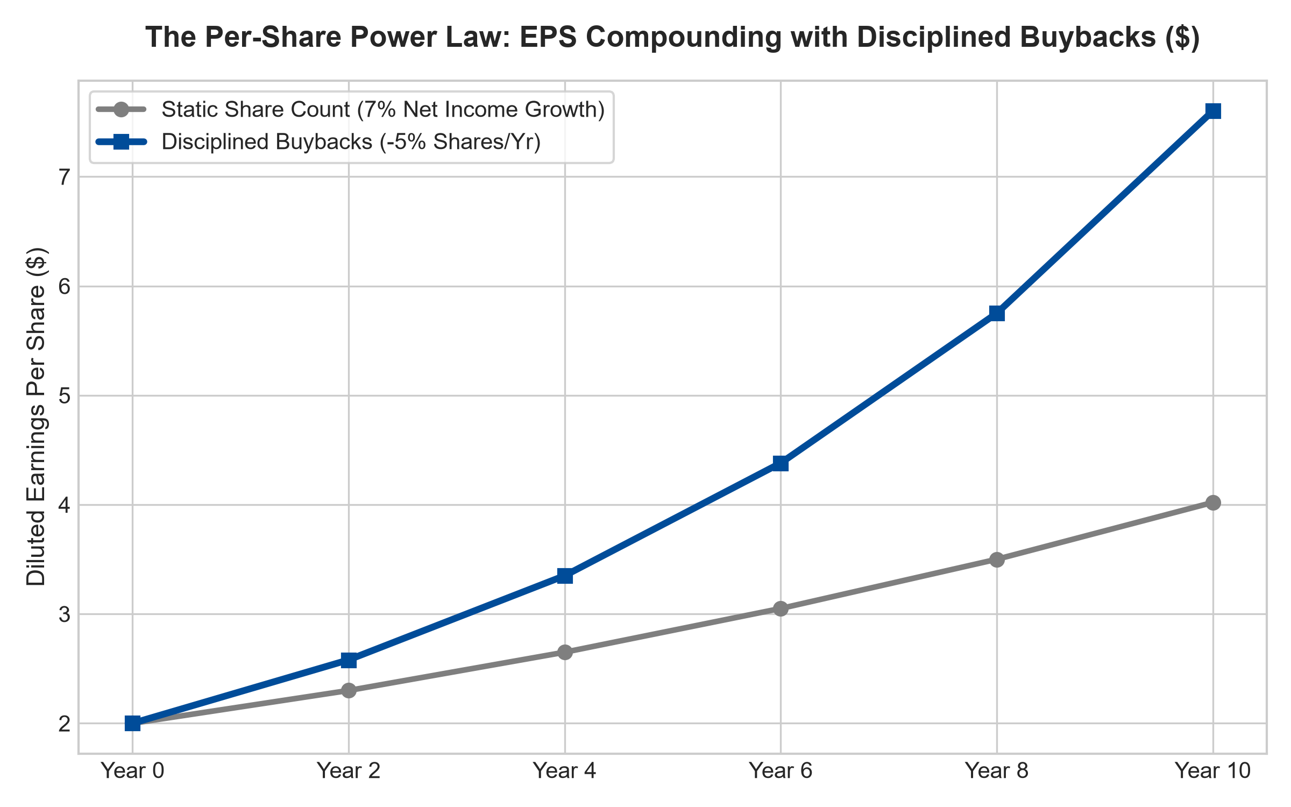
1. The Mathematics of Ownership Concentration
To comprehend the power of disciplined buybacks, consider a mature enterprise generating modest net income growth of seven percent annually. In a business with a static share count, an investor's per-share earnings power compounds at that identical seven percent rate, roughly doubling per-share earnings over a ten-year holding horizon.
Now consider that identical business possessing an unassailable economic moat that generates immense free cash flow, allowing management to retire five percent of its outstanding shares each year. While aggregate corporate net income grows at seven percent, diluted earnings per share compounds at over twelve and a half percent annually. Over a decade, per-share earnings power nearly quadruples. The shareholder owns a dramatically larger percentage of the enterprise without ever committing an incremental dollar of capital.
2. Valuation Discipline: Price Dictates Value Creation
The absolute determinant of whether a buyback creates or destroys value is the relationship between the purchase price and intrinsic business value. When a wide-moat monopolist experiences an irrational market panic and trades at a depressed ten-times free cash flow multiple, repurchasing shares generates a ten percent cash return on capital.
Every dollar deployed at that discount transfers massive intrinsic wealth from departing shareholders to long-term owners. Conversely, when an overconfident executive team repurchases stock during a frothy valuation bubble at fifty times earnings, the effective return on that capital is an anemic two percent. Management is effectively burning corporate treasury cash to provide liquidity to exiting shareholders, permanently destroying value for continuing owners.
3. Counter-Cyclical Execution and Balance Sheet Firepower
A critical differentiator separating elite capital allocators from mediocre corporate managers is execution timing. Mediocre executives execute pro-cyclical buybacks: repurchasing vast quantities of stock at bull-market peaks when corporate cash is high, and abruptly suspending repurchases during economic downturns when the stock is cheap to conserve liquidity.
Elite wide-moat compounders, armed with fortress balance sheets and uninterrupted recurring cash flows, execute counter-cyclical repurchases. When macroeconomic panics cause share prices to collapse, these managers aggressively deploy treasury reserves, cannibalizing their own share count at deep discounts. When market euphoria returns, they scale back repurchases, accumulating cash reserves for the next market dislocation.
4. MPLY and the Curation of Disciplined Share Cannibals
Passive broad market index funds are packed with corporations that dilute shareholders through excessive executive stock grants while wasting capital on pro-cyclical peak-market share repurchases. Over full economic cycles, this undisciplined capital stewardship severely impairs long-term equity returns.
The Strategy Shares Monopoly ETF (MPLY) differentiates itself by applying an active, institutional conviction mandate. MPLY selectively targets dominant market leaders that practice disciplined, counter-cyclical capital allocation. By concentrating capital in wide-moat corporate fortresses that systematically retire their share count below intrinsic value, MPLY delivers defensive capital protection and superior, per-share wealth compounding across all market cycles.
Investors interested in discovering how actively managed strategies evaluate share buybacks, capital stewardship, and durable monopoly power can examine the Strategy Shares Monopoly ETF (MPLY) at https://strategysharesetfs.com/mply/.
5. Frequently Asked Questions
Q1: Why do some investors prefer share buybacks over cash dividends?
Share buybacks are tax-efficient. A cash dividend forces an immediate taxable event on all taxable shareholders, regardless of whether they need current income. A share buyback allows shareholders to defer taxation until they choose to sell shares, while concentrating their ownership stake in a compounding corporate engine.
Q2: How can an investor verify if a buyback is genuinely reducing the share count?
Examine the Diluted Shares Outstanding metric on the corporate income statement over a three-to-five-year period. If shares outstanding are not declining, the buyback program is merely offsetting employee stock-based compensation dilution rather than retiring shares for the benefit of existing owners.
6. Sources
Morningstar, Capital Allocation & Shareholder Buyback Analysis: https://www.morningstar.com/articles/moat-research
Harvard Business Review, The True Economics of Corporate Share Repurchases: https://hbr.org/1979/03/how-competitive-forces-shape-strategy
#sharebuybacks #CapitalAllocation #PerShareValue #QualityInvesting #MPLY

