Article 37:
Dilution and Per-Share Economics: What Investors Should Watch
In corporate earnings press releases and executive presentations, management teams naturally emphasize aggregate enterprise figures: record total revenue, expanding gross profit, and surging headline net income. However, institutional equity investors do not purchase an entire corporate enterprise; they purchase individual fractional shares of common stock. If aggregate corporate earnings double while total outstanding shares triple through secondary stock offerings and rampant executive equity grants, the individual shareholder has grown significantly poorer. Mastering stock dilution per share economics is vital for capital preservation.
Stock dilution occurs whenever an enterprise issues incremental shares of equity, thereby reducing the proportional claim of existing shares on corporate earnings, voting power, and balance sheet assets. Dilution arises through three primary mechanisms: secondary equity offerings to raise capital, stock-financed corporate acquisitions, and excessive executive stock-based compensation programs.
When dilution outpaces operating profit growth, it acts as a silent wealth confiscator. The corporate pie expands, but each shareholder's slice shrinks continuously. Wide-moat monopolists demonstrate exceptional per-share stewardship, avoiding equity dilution and focusing solely on expanding intrinsic value per share. Isolating corporations with pristine per-share economics is a foundational governance discipline of the Strategy Shares Monopoly ETF (MPLY).
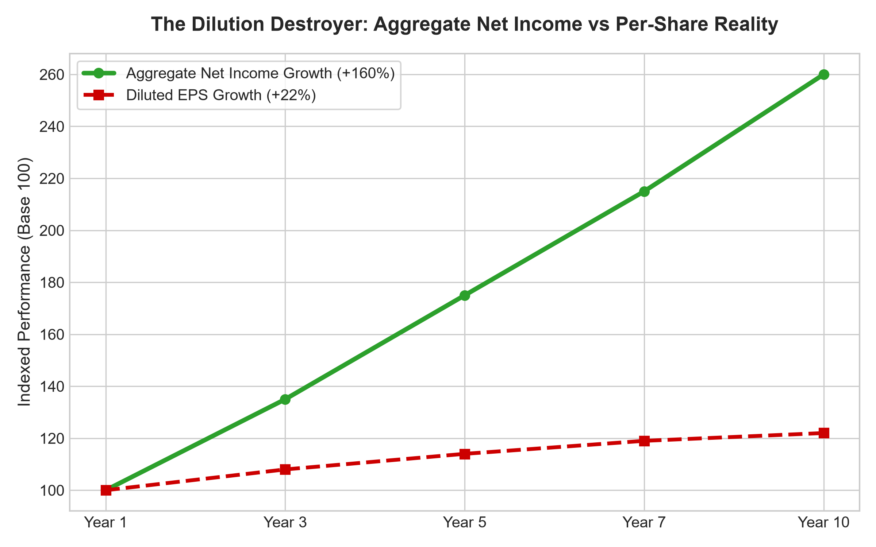
1. The Devastating Mathematics of Equity Dilution
To comprehend how dilution destroys shareholder value, consider a growth company that increases its aggregate net income from one hundred million dollars to two hundred and sixty million dollars over a decade, an impressive one hundred and sixty percent expansion. An uncritical investor celebrating top-line growth assumes their investment has performed spectacularly.
However, if that same enterprise issued five to six percent more shares each year to fund acquisitions and pay employee stock compensation, total outstanding shares more than doubled over that period. When dividing net income by the expanded share count, diluted earnings per share expanded by a meager twenty-two percent. The individual shareholder captured virtually none of the operational growth; the value was transferred entirely to newly issued share recipients.
2. Stock-Financed M&A as a Cover for Poor Returns
A common trap in corporate finance is the empire-building acquisition strategy funded through equity issuance. Executive leadership teams routinely announce large-scale acquisitions, boasting of newly acquired revenue and expanded global presence.
However, if management issued twenty percent more corporate shares to acquire a business that contributes only fifteen percent in incremental earnings, the transaction is immediately dilutive to existing shareholders on an intrinsic value per share basis. While the CEO commands a larger corporate empire, the existing shareholder's per-share earnings power has been permanently degraded. Forensic analysts evaluate every acquisition strictly through the lens of accretive per-share cash generation.
3. Per-Share Compounding as the Ultimate Quality Filter
The hallmark of an authentic economic moat is the ability to fund corporate growth entirely from internally generated operating cash flow, completely eliminating the need for dilutive equity issuance. When a business commands high pricing power and superior return on invested capital, it self-funds research and development, capacity expansion, and dividends with cash.
Dominant monopolists, such as mission-critical software fortresses, specialized transport corridors, and proprietary financial networks, maintain completely flat or systematically declining share counts over decades. Every dollar of operational expansion flows directly into expanding intrinsic value per share, delivering pure, unadulterated compounding to long-term equity owners.
4. MPLY and the Rejection of Dilutive Empire Building
Passive broad market index funds are packed with speculative, cash-hungry technology, biotech, and retail companies that dilute their shareholders by three to five percent every single year. Over multi-decade investment horizons, this chronic dilution severely impairs passive index returns.
The Strategy Shares Monopoly ETF (MPLY) differentiates itself by applying an active, institutional conviction mandate. MPLY specifically targets dominant market leaders that respect per-share economics, self-fund growth, and maintain strict dilution discipline. By concentrating capital in corporations that focus relentlessly on compounding per-share intrinsic value, MPLY delivers institutional-grade capital protection and superior long-term wealth creation.
Investors interested in discovering how actively managed strategies evaluate per-share economics, dilution risks, and durable monopoly power can examine the Strategy Shares Monopoly ETF (MPLY) at https://strategysharesetfs.com/mply/.
In institutional portfolio governance, dilution analysis extends beyond standard options into convertible debt tranches and complex milestone-based executive performance equity units. When equity compensation vests during market downturns, the structural dilution to existing equity holders accelerates dramatically because more shares must be issued to fulfill the same nominal dollar compensation target. Experienced fundamental analysts model this reflexive dilution dynamic directly into downside bear-case discounted cash flow valuations.
5. Frequently Asked Questions
Q1: Is share issuance ever beneficial for long-term shareholders?
Yes, if an enterprise's stock is trading at an extraordinarily high, overvalued multiple, and management issues shares to acquire a high-quality, wide-moat asset at a bargain valuation, the transaction can be heavily accretive to per-share intrinsic value. However, such disciplined execution is exceptionally rare.
Q2: Where can an investor track corporate share dilution trends?
Review the Weighted Average Diluted Shares Outstanding reported at the bottom of the corporate income statement in Form 10-K filings over a five-to-ten-year period. A consistently rising share count indicates ongoing shareholder dilution.
6. Sources
Morningstar, Equity Governance & Per-Share Value Compounding: https://www.morningstar.com/articles/moat-research
Harvard Business Review, The Danger of Equity Dilution in Corporate Growth: https://hbr.org/1979/03/how-competitive-forces-shape-strategy
#stockdilution #PerShareEconomics #CapitalStewardship #QualityInvesting #MPLY

