Article 38:
How Margin Expansion Changes a Valuation Model
In discounted cash flow modeling and equity research, valuation outcomes are fundamentally driven by three core quantitative inputs: top-line revenue growth, capital expenditure intensity, and operating profit margin. While retail market participants obsess over revenue growth trajectories, seasoned institutional capital allocators understand that operating margin is the ultimate financial multiplier. A modest, structural shift in corporate profit margins produces a massive, non-linear explosion in enterprise valuation. Understanding margin expansion valuation is the key to identifying transformational corporate compounders.
Margin expansion occurs when an enterprise increases its operating income as a percentage of total revenue over time. This phenomenon arises through two distinct mechanisms: structural operating leverage (where fixed overhead costs are spread across expanding revenue volume) and pricing power (where an incumbent raises prices faster than underlying input costs without sacrificing customer volume).
When a corporation combines moderate revenue growth with structural margin expansion, operating earnings compound at double or triple the rate of headline sales. Furthermore, because the market rewards higher-margin, more cash-generative businesses with elevated valuation multiples, shareholders benefit from a powerful twin-engine effect: surging per-share earnings combined with multiple expansion. Isolating enterprises capable of sustained margin expansion is a core operational priority of the Strategy Shares Monopoly ETF (MPLY).
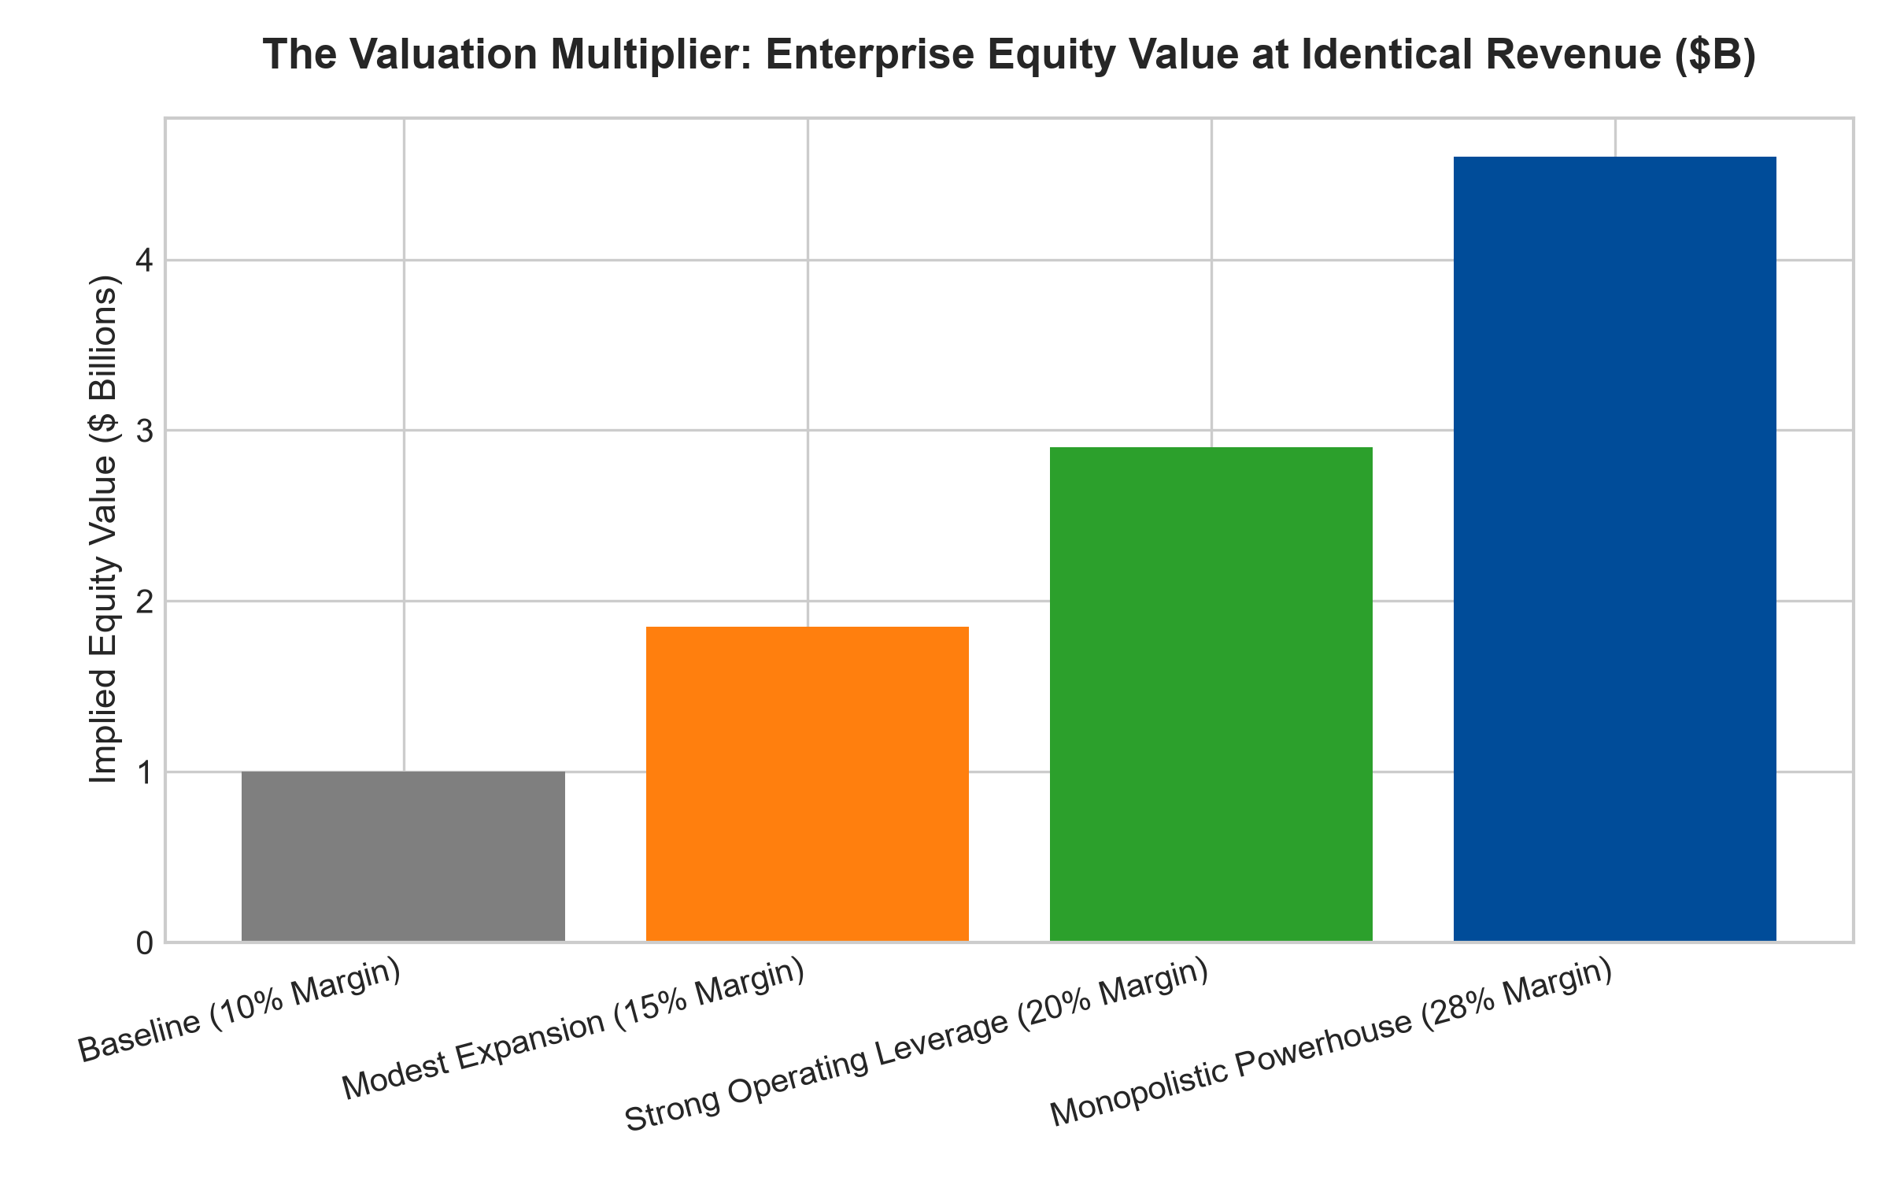
1. The Non-Linear Mathematics of Operating Leverage
To comprehend the explosive power of margin expansion, consider a corporation generating one billion dollars in revenue with a ten percent operating margin, producing one hundred million dollars in operating profit. An analyst values the business at ten times operating profit, yielding a one billion dollar valuation.
Now imagine that over the subsequent five years, revenue expands by fifty percent to 1.5 billion dollars, while operating margins expand from ten percent to twenty percent due to scale leverage and pricing power. Operating profit surges from one hundred million to three hundred million dollars, a two hundred percent expansion in cash earnings from a fifty percent expansion in sales.
Furthermore, because the market now recognizes the business as a higher-margin, wide-moat compounder, its valuation multiple expands from ten times to fifteen times operating profit. The enterprise valuation explodes from one billion to 4.5 billion dollars. Margin expansion acts as an exponential mathematical lever on equity value.
2. Pricing Power as the Purest Driver of Margins
While operational cost-cutting can produce temporary margin improvements, authentic, multi-year margin expansion is driven by pricing power. In commoditized, low-moat industries, intense competition forces companies to pass through any operational efficiencies to customers in the form of lower prices, leaving corporate margins permanently depressed.
In wide-moat monopolies defended by high switching costs or regulatory barriers, the incumbent retains all efficiency gains and exercises pricing autonomy. When the enterprise raises prices by five percent on a customer base that cannot leave, that incremental price hike flows directly to operating income with zero offsetting cost of goods sold. Gross margins expand, operating margins compound, and intrinsic value explodes higher.
3. Terminal Value Sensitivity in Valuation Models
In institutional Discounted Cash Flow (DCF) valuation models, the terminal value typically accounts for sixty to eighty percent of total estimated enterprise value. Terminal value is calculated by applying a multiple to the enterprise's steady-state operating cash flow in year ten.
A three hundred basis point difference in terminal operating margin completely transforms the DCF output. An analyst modeling a business at a permanent fifteen percent operating margin will arrive at a target price that is fifty percent lower than an analyst correctly forecasting a twenty percent margin. Recognizing which corporate fortresses possess the pricing power to expand margins into perpetuity is what allows institutional managers to spot massive valuation mispricings.
4. MPLY and the Allocation to Margin Expansion Monopolies
Passive broad market index funds are heavily exposed to cyclical, price-taking corporations whose operating margins are perpetually squeezed by inflation, labor costs, and competitive discounting. These businesses suffer severe margin contraction during economic downturns.
The Strategy Shares Monopoly ETF (MPLY) differentiates itself by applying an active, institutional conviction mandate. MPLY selectively targets dominant market leaders that possess the structural pricing power and operating leverage required to expand margins over multi-decade horizons. By concentrating capital in corporations that benefit from the twin engines of earnings growth and multiple expansion, MPLY delivers defensive capital protection and superior long-term wealth compounding.
Investors interested in discovering how actively managed quality strategies evaluate margin expansion, pricing power, and durable monopoly advantages can examine the Strategy Shares Monopoly ETF (MPLY) at https://strategysharesetfs.com/mply/.
5. Frequently Asked Questions
Q1: Can operating margins expand indefinitely for a monopoly?
No, operating margins eventually approach theoretical ceilings dictated by customer affordability, potential regulatory scrutiny, and the physical costs of customer service. However, dominant software and infrastructure monopolists routinely sustain operating margins in the forty to sixty percent range for decades.
Q2: How can an investor identify if margin expansion is sustainable versus temporary?
Interrogate the source of the margin increase. If margins expanded due to temporary corporate travel cuts or delayed maintenance CapEx, the expansion is ephemeral and dangerous. If margins expanded due to contractual software price increases and scale route density, the expansion is structural and permanent.
6. Sources
Morningstar, Operating Leverage & Corporate Valuation Modeling: https://www.morningstar.com/articles/moat-research
Harvard Business Review, The Strategy of Pricing Power and Margin Expansion: https://hbr.org/1979/03/how-competitive-forces-shape-strategy
#marginexpansion #ValuationModeling #OperatingLeverage #QualityInvesting #MPLY

