Article 39:
ETF Premium and Discount to NAV: What Investors Should Know
In modern retail and institutional wealth management, exchange-traded funds (ETFs) have become the premier vehicle for liquid capital allocation, offering low-cost diversification, continuous intraday trading, and superior tax efficiency compared to traditional mutual funds. However, because ETFs trade on secondary exchanges like individual common stocks, their market price fluctuates continuously throughout the trading day based on immediate supply and demand. Understanding ETF premium discount to NAV is essential for ensuring institutional trade execution quality.
An ETF's Net Asset Value (NAV) represents the exact per-share fair market value of all underlying constituent securities held in the fund's portfolio at the close of trading, minus fund liabilities. When sudden market buying pressure pushes an ETF's exchange trading price above its NAV, the fund trades at a premium. Conversely, when heavy selling pressure pushes the exchange price below the underlying portfolio's value, the fund trades at a discount.
Crucially, ETFs possess a unique structural mechanism known as the creation and redemption process, executed by institutional market participants called Authorized Participants (APs). This arbitrage mechanism continuously forces the secondary market price back into near-perfect alignment with underlying NAV. Understanding this institutional machinery provides complete confidence when allocating capital to high-conviction vehicles like the Strategy Shares Monopoly ETF (MPLY).
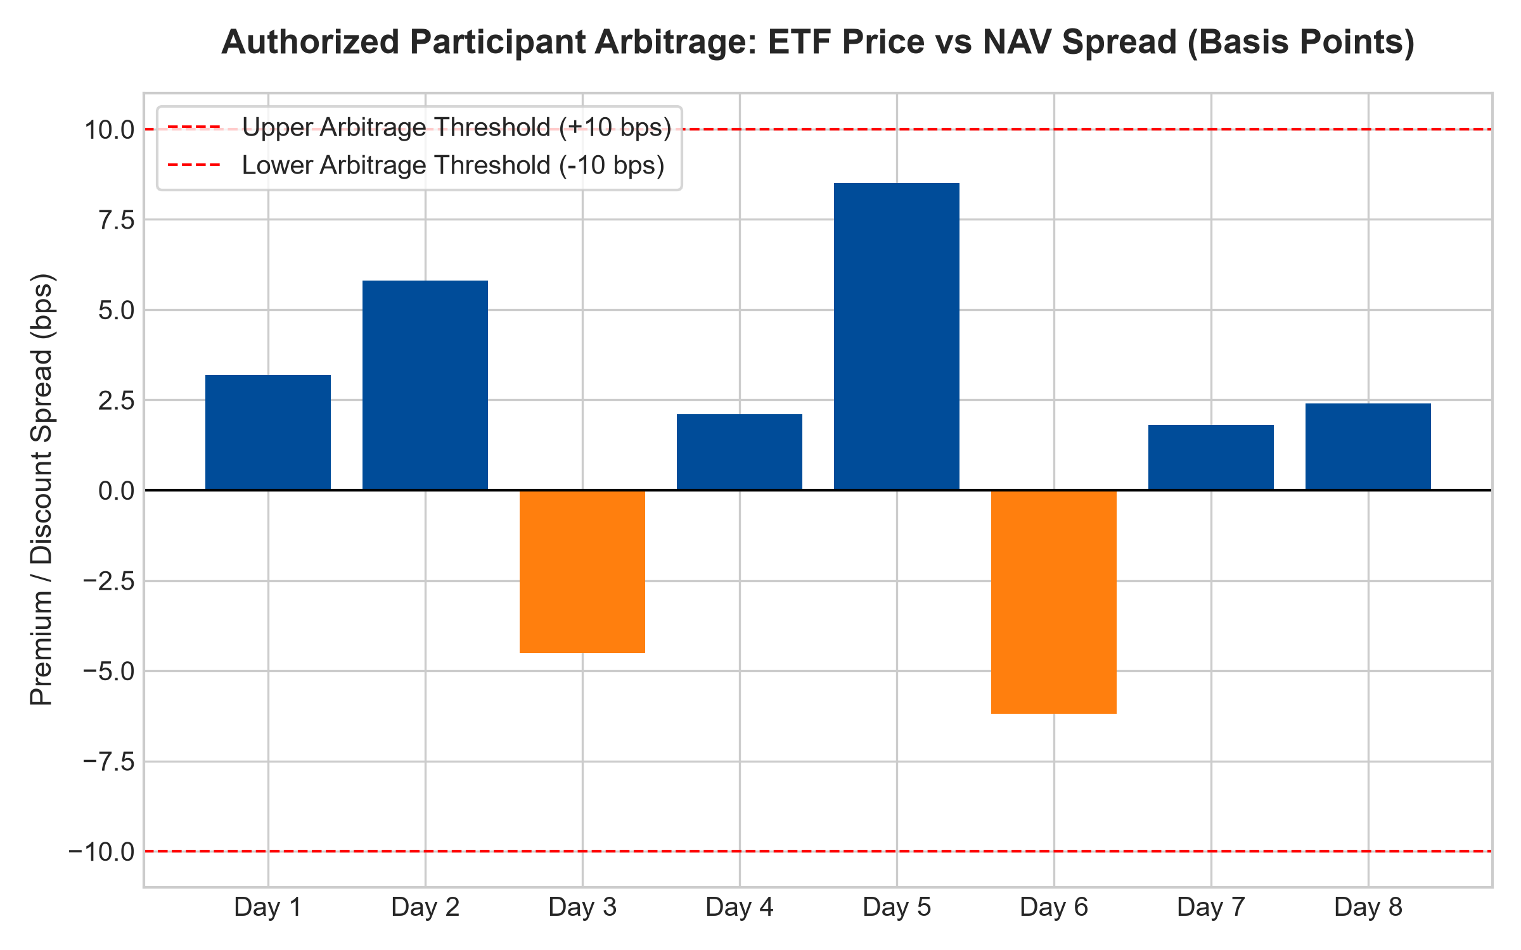
1. The Mechanics of Authorized Participant (AP) Arbitrage
Unlike traditional closed-end funds, which frequently trade at massive, persistent discounts of ten to twenty percent below NAV for years, open-end ETFs are structurally tethered to their underlying asset value through institutional arbitrage. This tether is maintained by Authorized Participants: major institutional broker-dealers and market makers that hold contractual agreements with the ETF fund sponsor.
When an ETF trades at a significant premium to its NAV, an Authorized Participant immediately executes a riskless arbitrage trade: purchasing the basket of underlying constituent stocks on the open market, delivering those shares to the ETF issuer in exchange for newly created ETF shares (in-kind creation), and immediately selling those new ETF shares on the exchange. The surge in ETF share supply instantly extinguishes the premium, driving the market price back down to NAV.
Conversely, when the ETF trades at a discount, the AP buys the undervalued ETF shares on the exchange, redeems them with the issuer for the underlying constituent securities, and sells the underlying stocks at full value. The reduction in ETF share count extinguishes the discount, pushing the price back up to NAV. In liquid domestic equity ETFs, this arbitrage ensures that premiums and discounts rarely exceed five to ten basis points.
2. Market Volatility and Cross-Time-Zone NAV Optical Illusions
A common misconception among retail market participants is interpreting an apparent ETF premium or discount as a structural market failure. In international equity ETFs, for example, substantial optical discounts frequently occur because underlying foreign stock exchanges are closed while US equity markets remain open.
If European markets close at 11:30 AM Eastern Time and US markets subsequently experience an afternoon rally, the international ETF's market price will trade higher in anticipation of the foreign market's next open. The calculated NAV is frozen at the foreign market's earlier close, creating an optical premium. In truth, the ETF price is functioning as a real-time price discovery mechanism, accurately reflecting current global information while static NAV lags behind.
3. Execution Best Practices: Avoiding Unnecessary Slippage
To protect capital and ensure optimal execution when trading ETFs, institutional portfolio managers adhere to disciplined trading rules. First, investors should avoid placing market orders during the first and last fifteen minutes of the trading day. During market opens, underlying constituent stocks are still opening and establishing bid-ask spreads, causing AP arbitrage bands to widen temporarily.
Second, investors should consistently utilize marketable limit orders rather than market orders. A limit order establishes a firm boundary, preventing unexpected execution slippage during temporary volatility spikes. For institutional block trades, executing via an institutional trading desk or engaging directly with an Authorized Participant ensures block-size liquidity at the exact prevailing NAV.
4. MPLY and Institutional Execution Efficiency
The Strategy Shares Monopoly ETF (MPLY) is constructed specifically to ensure pristine trading liquidity and minimal premium-to-NAV deviation. By concentrating its portfolio in mature, liquid market dominators that trade on major US exchanges with immense daily transaction volume, MPLY facilitates frictionless Authorized Participant creation and redemption activity.
Investors allocating capital to MPLY benefit from continuous intraday liquidity, tight bid-ask spreads, and reliable price alignment with underlying portfolio value. MPLY combines the tax efficiency and liquidity of the modern ETF structure with the unyielding fundamental compounding of wide-moat economic monopolies.
Investors interested in discovering how the Strategy Shares Monopoly ETF (MPLY) delivers liquid, transparent access to wide-moat corporate monopolies can review the official fund prospectus at https://strategysharesetfs.com/mply/.
5. Frequently Asked Questions
Q1: Can an individual investor execute ETF creation and redemption units directly?
No. Creation and redemption units are executed exclusively by institutional Authorized Participants in large institutional blocks (typically 25,000 to 50,000 ETF shares). Individual investors buy and sell existing ETF shares on secondary public exchanges, benefiting indirectly from the tight pricing maintained by AP arbitrage.
Q2: What is the Indicative Optimized Portfolio Value (IOPV)?
The IOPV (often reported under ticker symbols ending in .IV) is an intraday calculation of an ETF's net asset value published every fifteen seconds by the exchange. Comparing the current ETF market price to the IOPV allows investors to monitor real-time premium and discount spreads during the trading day.
6. Sources
Morningstar, ETF Structure & Creation-Redemption Mechanism Analysis: https://www.morningstar.com/articles/moat-research
Harvard Business Review, The Mechanics of Liquidity in Modern ETFs: https://hbr.org/1979/03/how-competitive-forces-shape-strategy
#ETFpremiumdiscount #NAV #AuthorizedParticipant #ETFLiquidity #MPLY

