Article 40:
Why ETF Trading Volume Does Not Tell the Whole Liquidity Story
When evaluating financial securities for investment portfolios, retail capital allocators naturally carry habits formed from trading individual common stocks. In single-stock investing, daily trading volume is the primary proxy for liquidity: if a small-capitalization company trades only ten thousand shares a day, an investor attempting to execute a hundred-thousand-share purchase order will trigger severe price slippage, driving the stock price up against themselves. However, applying this single-stock liquidity heuristic to exchange-traded funds represents a profound category error. In reality, ETF trading volume liquidity represents merely the visible tip of an immense liquidity iceberg.
The fundamental reason ETF liquidity diverges from single-stock liquidity is that an ETF is an open-ended investment vehicle with a flexible share count. While a common stock has a fixed number of shares outstanding, an ETF's share count expands and contracts dynamically throughout the day in response to investor demand. The true liquidity of an ETF is not determined by how many ETF shares traded on the exchange today; it is determined by the underlying liquidity of the constituent securities held in the portfolio basket.
An ETF that trades only fifty thousand shares per day on-screen can effortlessly absorb a multi-million dollar institutional block trade with negligible price impact, provided its underlying holdings are large-capitalization, highly liquid equities. Understanding this two-tiered liquidity structure is vital for institutional allocators evaluating high-conviction vehicles like the Strategy Shares Monopoly ETF (MPLY).
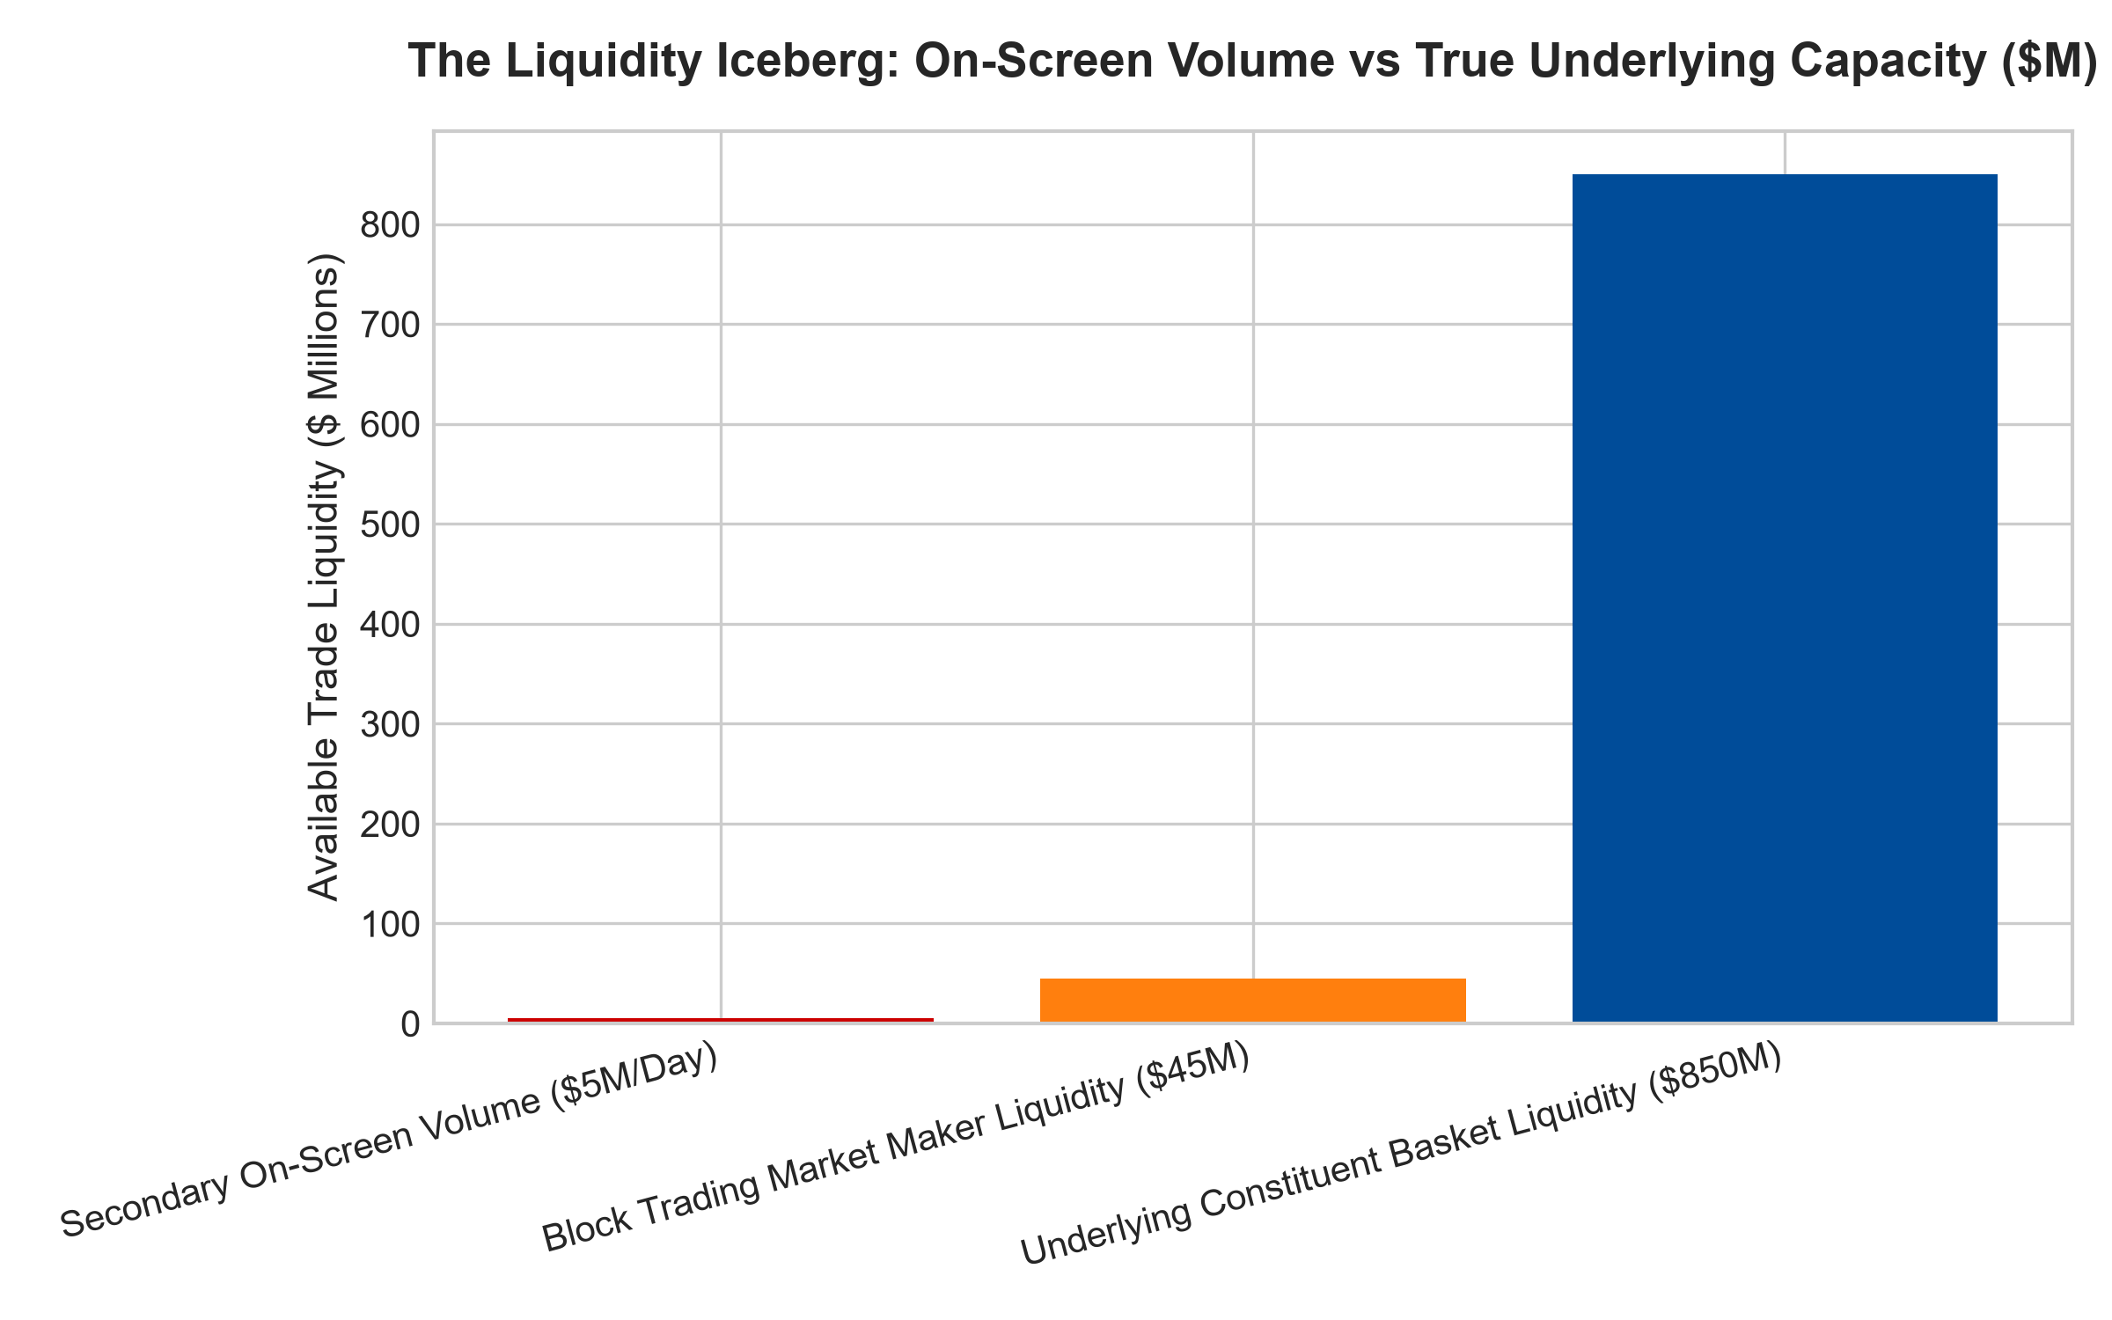
1. Primary Liquidity vs Secondary Liquidity: The Two Layers
To comprehend true ETF liquidity, investors must distinguish between secondary liquidity and primary liquidity. Secondary liquidity is the visible on-screen trading volume displayed on financial terminals: individual investors, asset managers, and algorithmic traders buying and selling existing ETF shares directly with one another on public exchanges.
Primary liquidity is the deep reservoir of capital residing in the creation and redemption mechanism. If an institutional wealth management firm needs to deploy twenty-five million dollars into an ETF that averages only five hundred thousand dollars in daily on-screen volume, the firm does not simply hit the public order book with a massive market order. Instead, their institutional trading desk contacts an Authorized Participant (AP) or market maker.
The AP buys twenty-five million dollars worth of the underlying constituent stocks in the liquid open market, delivers those stocks to the ETF fund sponsor to create new ETF shares in-kind, and delivers the newly created ETF shares to the institutional investor at the exact prevailing net asset value. The trade executes seamlessly with zero market disruption, despite dwarfing the historical on-screen volume.
2. Bid-Ask Spread as the True Measure of Friction
Because on-screen trading volume does not reflect true liquidity, institutional analysts look to the bid-ask spread as the primary indicator of execution quality. The bid-ask spread represents the cost charged by market makers to facilitate immediate trade execution.
In an ETF holding highly liquid, large-capitalization corporate fortresses, market makers can hedge their exposure effortlessly by trading the underlying constituent equities or related equity index futures. Consequently, the bid-ask spread on the ETF remains penny-tight (one to two cents wide), even if the ETF itself experiences light on-screen trading volume. A tight bid-ask spread confirms that the market maker can execute creation and redemption units at near-zero friction, guaranteeing excellent trade execution.
3. Execution Protocols for Institutional Capital Allocators
To maximize execution quality when allocating capital into high-conviction ETFs, institutional investors follow specific trading protocols. For retail-sized orders (under ten thousand shares), utilizing limit orders pegged near the prevailing midpoint or bid-ask quotes ensures immediate execution without slippage.
For large block allocations (exceeding twenty-five thousand shares), institutional wealth managers leverage electronic Request-for-Quote (RFQ) platforms or direct capital markets desks. Market makers bid competitively to fill the entire block directly against the underlying constituent basket, enabling institutional allocators to execute multi-million dollar positions inside the quoted bid-ask spread without moving the market price.
4. MPLY and the Depth of Underlying Monopoly Liquidity
The Strategy Shares Monopoly ETF (MPLY) is engineered specifically to ensure exceptional underlying liquidity. Rather than investing in illiquid micro-cap equities or opaque debt instruments, MPLY concentrates capital in the undisputed titans of modern commerce: high-conviction monopolies that trade hundreds of millions of dollars in daily liquidity on major US exchanges.
Because MPLY's underlying portfolio consists of heavily traded market dominators, Authorized Participants can create and redeem ETF shares with effortless efficiency. Institutional and private investors alike can deploy significant capital into MPLY, confident that the fund's true liquidity extends far beyond on-screen trading volume to encompass the vast capital depth of the world's most dominant corporations.
Investors seeking to explore how the Strategy Shares Monopoly ETF (MPLY) combines concentrated quality investing with deep institutional liquidity can examine the fund prospectus at https://strategysharesetfs.com/mply/.
5. Frequently Asked Questions
Q1: Can a large institutional buy order push up the price of a low-volume ETF artificially?
No. If a large buy order temporarily pushes the ETF price above the value of its underlying holdings, Authorized Participants immediately create new shares at NAV and sell them into the market, harvesting a small arbitrage profit while extinguishing the price spike within seconds.
Q2: What is the single best metric to check before placing an order in an ETF?
Check the current bid-ask spread and the 30-day median spread. A narrow spread (under five to eight basis points) confirms that market makers are actively quoting and hedging the fund with high efficiency.
6. Sources
Morningstar, Understanding ETF Liquidity Beyond On-Screen Volume: https://www.morningstar.com/articles/moat-research
Harvard Business Review, The Structure of Modern Capital Markets and ETFs: https://hbr.org/1979/03/how-competitive-forces-shape-strategy
#ETFLiquidity #TradingVolume #CreationRedemption #InstitutionalTrading #MPLY

