Article 41:
What Happens to ETF Premiums and Discounts During Market Stress?
During calm market environments, exchange traded funds trade within pennies of their net asset value. Authorized Participants continuously exploit minute fractional differences through arbitrage, ensuring that market prices track the value of the underlying portfolio with mathematical precision. However, when macro shocks strike and volatility surges, this equilibrium fractures, leading many retail investors to wonder what happens to ETF premiums and discounts during market stress.
When panic selling accelerates, on screen ETF prices often decouple from reported net asset values, printing apparent discounts of two, three, or even five percent. Conversely, safe haven funds can trade at persistent premiums as capital scrambles for liquid exposure. Understanding the mechanics behind these dislocations reveals that what looks like structural ETF dysfunction is usually a rational reflection of underlying market friction and price discovery.
This comprehensive analysis unpacks why premium and discount spreads widen during severe market turmoil, how Authorized Participants calculate their hedging risk, and how disciplined long term investors can navigate volatile trading windows without sacrificing capital.
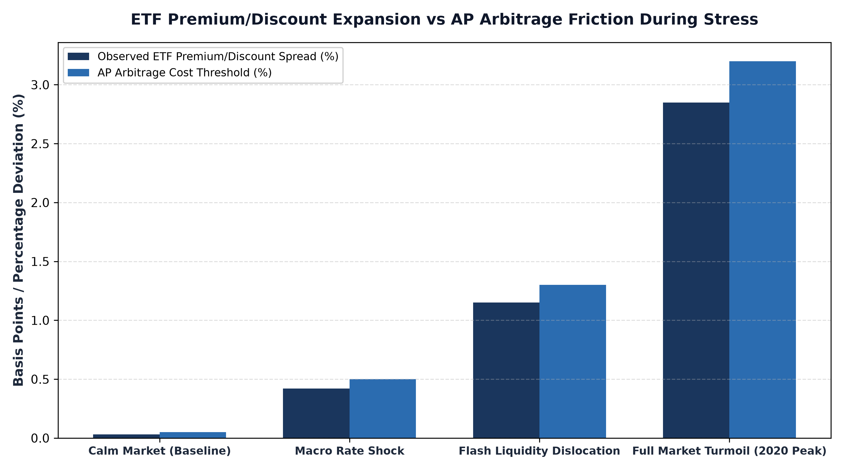
1. The Anatomy of Arbitrage Breakdown During Stress
Under normal conditions, an Authorized Participant creates or redeems ETF shares whenever the market price deviates from net asset value by more than the transaction cost of assembling the underlying basket. If an ETF trades at a fifty cent discount, the AP buys the undervalued ETF shares on screen, redeems them with the fund sponsor for the underlying constituent securities, and sells those securities on the open exchange, pocketing the spread as risk free arbitrage profit.
During severe market stress, this arbitrage mechanism encounters acute friction. The constituent securities inside the portfolio may suffer from severe illiquidity, trading halts, or opaque pricing. When an AP cannot instantly hedge the underlying basket, they refuse to arbitrage minor dislocations. To step in and absorb selling pressure, the AP demands a substantial risk premium. Consequently, the ETF market price drops to a wider discount, reflecting the true execution cost and inventory risk rather than fund insolvency.
2. Price Discovery Vehicle vs Lagged Net Asset Value
One of the most profound misconceptions in financial analysis is assuming that reported net asset value represents real time truth during a panic. In reality, net asset value is a historical snapshot calculated once daily using official closing prices or theoretical matrix evaluations. In fixed income or international equity portfolios, many underlying bonds or foreign stocks may not have traded for several hours.
The exchange traded fund, by contrast, trades continuously every second on public exchanges. Thousands of institutional buyers and sellers interact in real time, factoring in breaking geopolitical news, central bank announcements, and counterparty defaults. As a result, the ETF functions as the true price discovery mechanism for the asset class. The apparent discount during market stress is frequently an indicator that the ETF price is leading the market, while the reported net asset value is simply lagging behind real world market clearing levels.
3. Execution Traps and How Investors Should Respond
For individual and wealth advisory investors, market dislocations present severe execution hazards if orders are mismanaged. The most catastrophic error during market volatility is submitting market orders at the opening bell. Between 9:30 AM and 10:00 AM Eastern, underlying constituent stocks are still completing their opening auctions. Market makers quote intentionally wide bid ask spreads and depressed prices to protect against order flow imbalances.
Investors who execute market orders during these opening dislocations lock in artificial discounts, selling their holdings directly into the predatory pricing of opportunistic liquidity providers. Professional asset allocators enforce strict execution protocols during turbulent trading sessions. They utilize limit orders exclusively, avoid trading during the first forty five minutes of the market day, and cross reference the ETF market price with intraday indicative values to confirm fair valuation before committing capital.
4. Portfolio Resilience and the MPLY Perspective
An ETF's susceptibility to catastrophic premium and discount dislocations is heavily dictated by the liquidity of its underlying holdings. Funds holding small capitalization debt, exotic derivatives, or unlisted instruments experience severe structural dislocations because market makers cannot liquidate the collateral in a liquidity freeze. Conversely, portfolios constructed from world class corporate enterprises with deep secondary markets maintain remarkably resilient trading mechanics.
Investors evaluating how actively managed quality portfolios maintain liquidity resilience through market cycles can study the Strategy Shares Monopoly ETF (MPLY) at https://strategysharesetfs.com/mply/. MPLY focuses on durable corporate monopolies characterized by fortress balance sheets, non discretionary cash flows, and exceptionally deep equity trading volume, ensuring that market makers can continuously hedge and price creation redemption units with minimal friction.
5. Frequently Asked Questions
Q1: Does a wide ETF discount during market stress mean the ETF is going bankrupt?
No. An ETF discount reflects temporary trading friction, liquidity premia, and hedging costs among market makers, not fund insolvency. The underlying securities remain securely held in a segregated custodial trust for the exclusive benefit of fund shareholders.
Q2: Should long term investors sell an ETF when it trades at a significant discount?
Selling an ETF during a temporary discount crystallizes unnecessary losses by transferring wealth to arbitrageurs. Long term investors should either hold through the dislocation or use limit orders to acquire additional shares at discounted market prices.
6. Sources
Morningstar, Understanding ETF Premiums and Discounts Under Stress: https://www.morningstar.com/articles/moat-research
Harvard Business Review, Market Liquidity and the Mechanics of Modern Exchange Traded Funds: https://hbr.org/1979/03/how-competitive-forces-shape-strategy
#ETFInvesting #ETFs #Investing #Portfolio #MPLY

