Article 42:
ETF Rebalancing vs ETF Reconstitution: What's the Difference?
Every investor who allocates capital to exchange traded funds understands that portfolios do not remain static. Over time, underlying asset values fluctuate, market capitalizations shift, and corporate actions alter benchmark weightings. To maintain fidelity to their stated mandates, fund managers execute routine adjustments that are frequently grouped together under general portfolio maintenance terminology.
However, two critical processes govern how an ETF resets its portfolio: rebalancing and reconstitution. While casual investors often treat these terms interchangeably, they represent fundamentally distinct portfolio operations with vastly different implications for trading costs, market impact, and capital compounding. Navigating the nuances of ETF rebalancing vs reconstitution provides vital insight into how passive benchmarks bleed value and how active strategies maintain discipline.
This guide breaks down the core structural differences between rebalancing and reconstitution, explains how scheduled index events expose funds to predatory institutional front running, and outlines how sophisticated managers protect shareholder capital.
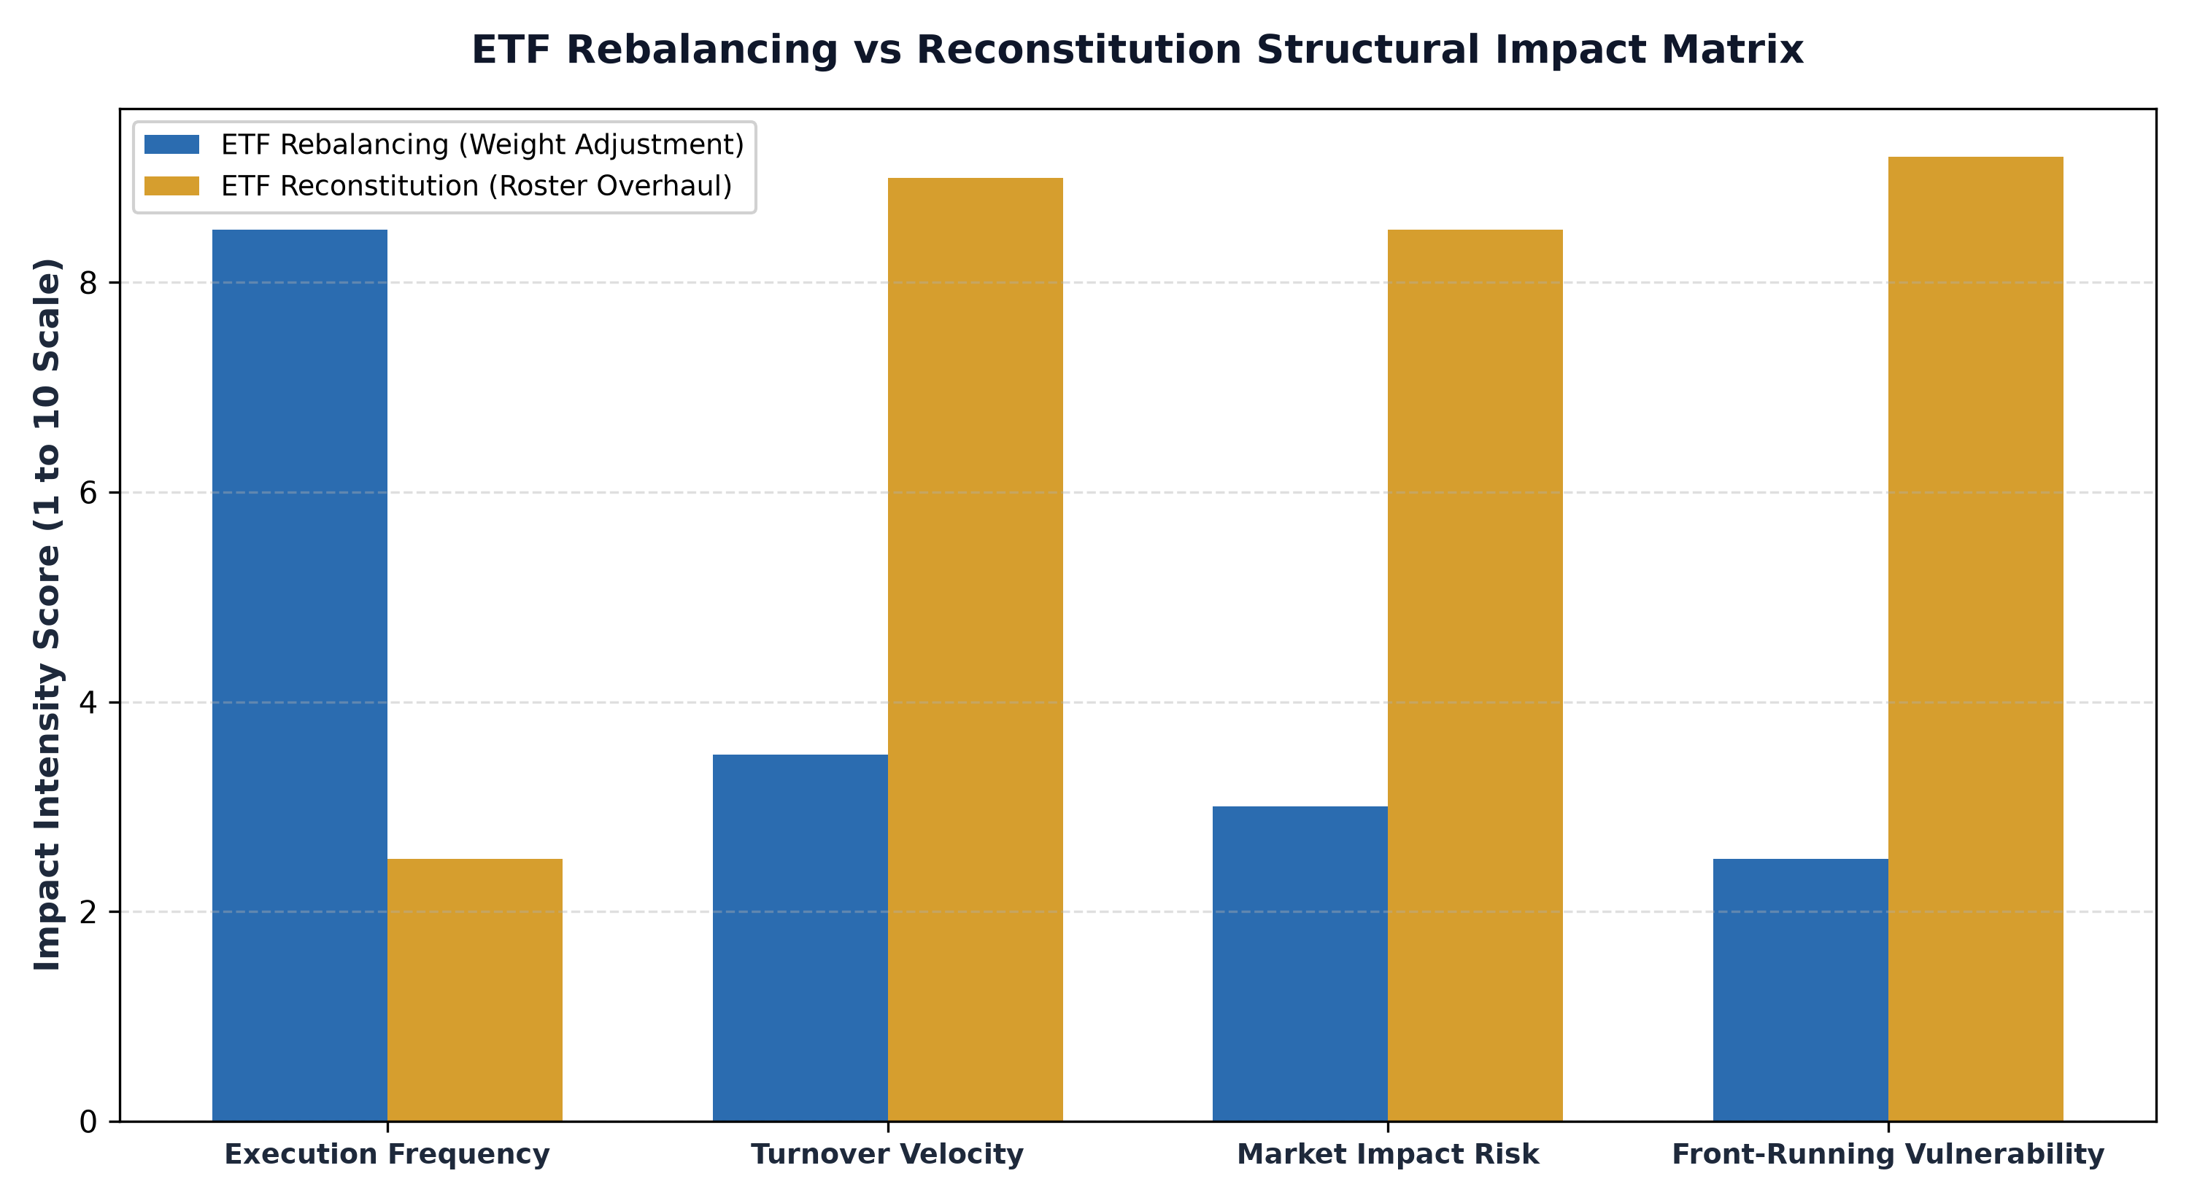
1. Defining ETF Rebalancing: Restoring Target Allocations
Rebalancing is the process of adjusting the portfolio weightings of existing constituent securities back to predetermined benchmark target levels. In an equal weighted index, for instance, a company whose stock has outperformed will see its weighting expand from two percent to three and a half percent. During the scheduled rebalancing window, the fund manager sells off the surplus position and redistributes the proceeds into underperforming constituents to restore each stock to its original two percent target.
Rebalancing does not alter the roster of companies inside the fund; it simply recalibrates their relative proportions. This process occurs on predictable periodic schedules, such as quarterly, semi annually, or annually. In disciplined investment mandates, rebalancing enforces a mechanical buy low, sell high mechanism. However, if executed too frequently, rebalancing can generate excessive transaction friction and prematurely trim winners in high momentum secular growth trends.
2. Defining ETF Reconstitution: Overhauling Fund Membership
Reconstitution, by contrast, is a far more drastic structural event. Reconstitution represents the formal overhaul of the index membership itself. During a reconstitution, the index provider evaluates every security against strict eligibility criteria, adding companies that meet the updated thresholds and entirely removing businesses that have fallen out of compliance.
When a company is added to an index during reconstitution, hundreds of billions of dollars across tracking index funds are legally mandated to buy millions of shares simultaneously on a specific effective date. Conversely, deleted companies face massive institutional liquidation. Reconstitution is usually conducted annually or semi annually, and because the turnover involves establishing completely new positions while totally exiting others, the trading volume and liquidity requirements are substantially higher than routine rebalancing.
3. The Hidden Cost of Predatory Front-Running
The greatest structural flaw of mechanical passive ETF reconstitution is extreme predictability. Benchmark providers publish index inclusion and deletion rules well in advance of the effective execution date. Proprietary trading desks and quantitative hedge funds analyze these rules weeks beforehand, forecasting precisely which stocks will be added or dropped.
Hedge funds aggressively purchase prospective additions ahead of time, driving up share prices. When passive index ETFs arrive on the reconstitution date compelled by mandate to buy regardless of price, they purchase these shares at artificial peaks from the very arbitrageurs who front ran them. Academic studies refer to this hidden friction as the index turnover drag, which quietly siphons tens of basis points of annual performance away from unsuspecting passive index investors.
In institutional equity trading, the closing cross auction on reconstitution dates represents one of the largest liquidity events in global capital markets. Billions of dollars in automated passive index orders converge on the primary exchanges within the final three minutes of the trading day. Sophisticated market makers and quantitative high-frequency trading desks strategically position their books to absorb these massive imbalances, capturing substantial liquidity premiums. For institutional asset allocators, understanding this closing cross mechanism clarifies why passive benchmark reconstitution often suffers from structural transaction drag that does not appear in simple tracking error statistics.
4. The Active Management Advantage and MPLY's Approach
Actively managed ETFs are completely exempt from the rigid reconstitution schedules that handicap passive benchmarks. An active manager possesses full discretion to adjust weightings, accumulate positions gradually during liquidity lulls, and exit holdings without broadcasting their intentions to predatory market participants.
Investors seeking to avoid the mechanical inefficiencies of index reconstitution can evaluate the Strategy Shares Monopoly ETF (MPLY) at https://strategysharesetfs.com/mply/. MPLY employs an actively managed investment framework focused on durable economic monopolies. Rather than adhering to formulaic calendar reconstitutions that trigger forced buying and selling, MPLY's portfolio managers allocate capital based on fundamental business quality, pricing power, and long term cash flow compounding.
5. Frequently Asked Questions
Q1: Does ETF rebalancing generate taxable capital gains for individual investors?
Generally no. ETFs utilize the in-kind creation and redemption mechanism, allowing authorized participants to swap appreciated securities out of the fund basket without triggering taxable capital gains distributions to fund shareholders.
Q2: How often does an actively managed ETF rebalance compared to a passive index fund?
Passive index funds rebalance on rigid calendar dates dictated by the index provider. Active ETFs monitor portfolio weightings continuously, reallocating capital opportunistically whenever fundamental valuations or risk parameters warrant adjustment.
6. Sources
Morningstar, Index Rebalancing and Reconstitution Friction Analysis: https://www.morningstar.com/articles/moat-research
Harvard Business Review, The Economics of Benchmark Tracking and Index Turnover: https://hbr.org/1979/03/how-competitive-forces-shape-strategy
#ETFInvesting #ETFs #Investing #Portfolio #MPLY

