Article 43:
Active ETF vs Index ETF: How the Portfolio Construction Differs
For more than two decades, the exchange traded fund landscape was dominated almost exclusively by passive index tracking funds. Investors embraced low cost beta, buying broad market indices that delivered predictable market returns with minimal operational overhead. However, the investment landscape has experienced an unprecedented structural evolution, with modern capital rapidly shifting toward actively managed ETFs.
While both vehicles share identical tax efficiency and intraday exchange trading advantages, the engine room operating beneath the surface is radically distinct. Examining active ETF vs index ETF portfolio construction uncovers two competing investment philosophies: one governed by rigid market capitalization formulas, and the other driven by intentional security selection and fundamental conviction.
This analysis explores how portfolio construction methodologies diverge across index and active ETFs, how passive weighting rules inadvertently concentrate capital in overvalued assets, and why high conviction active architectures offer superior risk adjusted compounding potential.
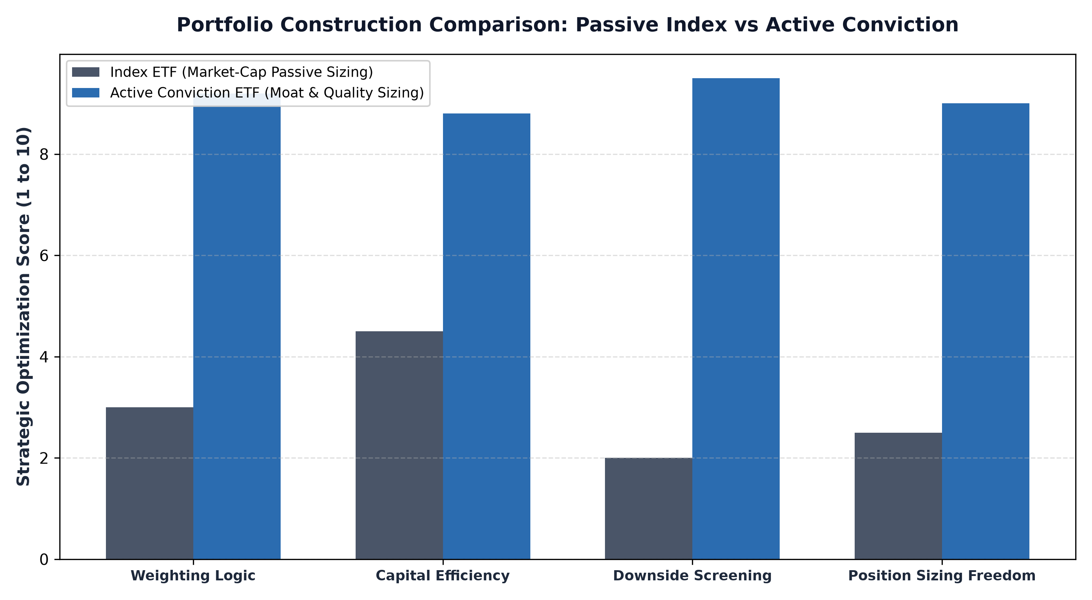
1. Market-Cap Weighting and the Flaw of Forced Buying
The overwhelming majority of index ETFs utilize market capitalization weighting. Under this mathematical formula, a company's representation in the portfolio is directly proportional to its total market value. While this structure minimizes portfolio turnover and keeps expense ratios low, it introduces a severe structural flaw: it forces the fund to allocate the most capital to companies that have already experienced massive run ups in valuation.
When an asset bubble inflates, a market cap index fund mechanically channels incoming investor capital into the most overvalued securities, regardless of underlying corporate health, free cash flow conversion, or competitive durability. Conversely, struggling businesses with deteriorating moats and ballooning debt burdens remain in the index until their market caps collapse completely. Market cap indexing is entirely devoid of valuation discretion or quality filters.
2. Active ETF Architecture: Intentional Security Selection
Active ETF portfolio construction breaks free from mechanical capitalization mandates. Instead of holding hundreds of companies simply because they exist within a geographic border or industry classification, active managers apply rigorous fundamental criteria to select and weight securities. The portfolio construction process begins with a defined investment universe, which is systematically filtered through proprietary quantitative and qualitative frameworks.
Rather than passively mirroring a benchmark, active managers evaluate return on invested capital, economic moat depth, pricing power, balance sheet solvency, and management capital allocation skill. Position sizes are calibrated based on absolute risk reward conviction rather than arbitrary market capitalization. Highly profitable monopolies with durable competitive moats receive meaningful allocations, while vulnerable, debt laden enterprises are completely excluded from the fund.
3. Concentration Risk vs Intentional Diversification
A common criticism leveled against active ETFs is that they hold fewer securities than broad market index funds. Yet, modern financial theory demonstrates that holding five hundred stocks often creates the illusion of diversification while locking in mediocre aggregate performance. When an index holds hundreds of unvetted companies, a significant portion of the portfolio consists of low quality value traps and cyclical laggards.
True diversification is not measured by the sheer quantity of tickers inside a portfolio; it is measured by the economic independence of the underlying cash flows. A concentrated portfolio of twenty five to thirty five non correlated, mission critical corporate monopolies offers far greater structural protection than a five hundred stock index heavily weighted toward volatile, capital intensive cyclical firms. Active construction allows managers to eliminate dead weight while focusing capital exclusively on premier compounders.
From an institutional risk budgeting perspective, benchmark-agnostic active portfolio construction fundamentally redefines how downside volatility is managed. While a passive index fund is mathematically handcuffed to holding plunging sectors during systemic industry declines, active managers possess the tactical flexibility to alter cash allocations, trim vulnerable cyclical exposures, and concentrate capital into defensive cash flow compounders. This structural divergence in portfolio construction ensures that active managers can actively mitigate catastrophic capital impairment rather than passively absorbing benchmark drawdowns.
4. The MPLY Mandate: Active Conviction in Monopolistic Moats
The structural superiority of active portfolio construction is clearly visible in specialized thematic strategies that target companies with dominant economic franchises. By utilizing active management, fund sponsors can maintain uncompromising standards that passive indexes cannot replicate.
Investors interested in discovering how active portfolio construction isolates top tier corporate assets can study the Strategy Shares Monopoly ETF (MPLY) at https://strategysharesetfs.com/mply/. Unlike passive index funds that blindly buy hundreds of constituents, MPLY is an actively managed ETF that purposefully concentrates capital into enduring monopolies possessing insurmountable barriers to entry, superior pricing power, and high cash flow generation.
5. Frequently Asked Questions
Q1: Do active ETFs carry higher expense ratios than passive index ETFs?
Yes, active ETFs generally carry slightly higher expense ratios than ultra low cost passive index funds because they employ dedicated research analysts and portfolio managers. However, active ETF fees are substantially lower than legacy mutual funds while offering intraday liquidity and full tax efficiency.
Q2: Can an active ETF deviate significantly from its benchmark during market downturns?
Yes. Because active managers possess full discretionary freedom, they can eliminate deteriorating industries, increase allocations to defensive moats, and sidestep systemic bubbles that passive index funds are legally forced to hold.
6. Sources
Morningstar, Active vs Passive Portfolio Construction Frameworks: https://www.morningstar.com/articles/moat-research
Harvard Business Review, Strategic Asset Allocation and the Limits of Market-Cap Weighting: https://hbr.org/1979/03/how-competitive-forces-shape-strategy
#ETFInvesting #ETFs #Investing #Portfolio #MPLY

