Article 44:
What to Look for in an ETF Fact Sheet
Before allocating capital to any exchange traded fund, every investor encounters the document that serves as the fund's public calling card: the official ETF fact sheet. Published quarterly by asset managers, the fact sheet is a dense, double sided marketing document designed to summarize the fund's investment mandate, historical performance, portfolio characteristics, and fee structure.
However, most investors glance only at the headline past performance numbers and the total expense ratio, completely missing the critical structural metrics that reveal whether the fund is built for enduring compounding or destined for mediocre tracking error. Conducting a rigorous ETF fact sheet analysis requires knowing where the true analytical signal resides and how to filter out promotional marketing noise.
This guide deconstructs an ETF fact sheet into its essential analytical components, providing a systematic checklist that empowers investors to evaluate underlying portfolio quality, position sizing discipline, and true execution costs.
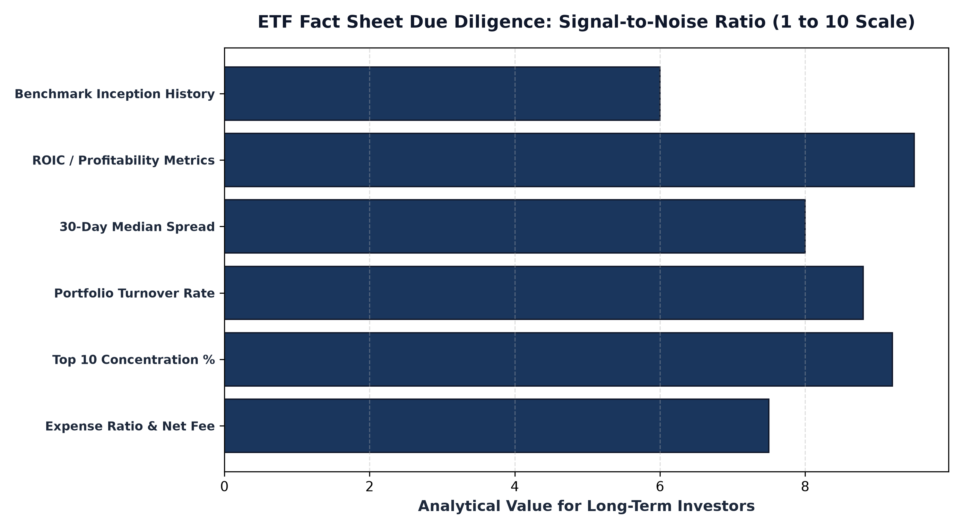
1. Beyond the Headline Expense Ratio: True Total Cost
When reviewing fees on an ETF fact sheet, the first figure that catches an investor's eye is the net expense ratio. While a competitive expense ratio is essential, looking at that number in isolation creates a false sense of security. The true economic cost of owning an ETF encompasses trading friction, bid ask spreads, and internal portfolio turnover costs that never appear in the stated management fee.
Investors must carefully examine the 30 day median bid ask spread, usually reported in the trading characteristics section. A fund with a 0.15% expense ratio that trades with a 0.40% spread and undergoes 80% annual turnover can easily cost an investor significantly more than an actively managed fund with a 0.65% expense ratio that trades with tight two cent spreads and maintains low, tax efficient turnover.
2. Decoding Portfolio Characteristics and Fundamental Quality
The most revealing section of any fact sheet is the portfolio characteristics table. This table summarizes the aggregate financial health of the companies held inside the ETF. Savvy investors look beyond surface level price to earnings ratios and scrutinize deeper profitability metrics, including weighted average return on invested capital, return on equity, and debt to capital ratios.
A high quality fund will demonstrate superior return on invested capital and robust operating cash flow margins compared to its broad benchmark. If a thematic ETF claims to invest in disruptive industry leaders yet exhibits an aggregate return on equity of negative four percent and alarming leverage ratios, the fact sheet has exposed a portfolio of unprofitable speculative businesses disguised as innovation.
3. Top 10 Holdings and Concentration Discipline
The top 10 holdings table reveals a manager's true conviction and risk management philosophy. An investor must calculate the cumulative percentage of assets represented by these top ten names. In high conviction active portfolios, the top ten holdings often represent forty to sixty percent of total assets, demonstrating that the manager is backing their best fundamental ideas with substantial capital.
Conversely, if a fact sheet reveals that the top ten positions each represent tiny one percent allocations across a bloated basket of two hundred stocks, the fund is effectively operating as an expensive index hugger. In addition to position weightings, investors should cross reference the stated sector allocations with the fund's investment narrative to ensure the portfolio is not secretly taking unintended macroeconomic or industry bets.
Furthermore, sophisticated wealth managers scrutinize securities lending policies and cash drag metrics disclosed within the broader fact sheet documentation. Many passive index funds aggressively lend out underlying portfolio securities to short sellers to generate ancillary revenue that offsets low management fees, introducing subtle counterparty and collateral reinvestment risks. In contrast, high-conviction active portfolios prioritize unencumbered custodial ownership of their constituent holdings, ensuring that shareholder assets are never pledged to external borrow markets to subsidize artificial fee competition.
4. Fact Sheet Transparency and MPLY's Standard
A superior ETF fact sheet does not hide behind ambiguous marketing language; it provides clear, verifiable data that illustrates the fund's distinctive competitive positioning and institutional discipline.
Investors looking for an exemplary demonstration of institutional clarity and focused portfolio design can review the Strategy Shares Monopoly ETF (MPLY) fact sheet at https://strategysharesetfs.com/mply/. MPLY's fund documents clearly detail its high conviction focus on companies possessing insurmountable monopoly advantages, highlighting robust fundamental characteristics, concentrated top tier holdings, and a disciplined approach to long term capital compounding.
5. Frequently Asked Questions
Q1: What does the portfolio turnover rate on an ETF fact sheet indicate?
The turnover rate measures the percentage of the portfolio's holdings that were replaced over the trailing twelve months. A turnover rate below 25% indicates a patient, long term buy and hold philosophy, whereas a turnover rate above 100% signals rapid, aggressive trading.
Q2: Can historical performance on a fact sheet guarantee future investment results?
No. Historical performance reflects past market conditions and cannot predict future performance. Investors should prioritize fundamental portfolio characteristics, such as balance sheet durability and pricing power, over backward looking returns.
6. Sources
Morningstar, How to Read and Evaluate an ETF Fact Sheet: https://www.morningstar.com/articles/moat-research
Harvard Business Review, Financial Statement Analysis and Due Diligence in Fund Selection: https://hbr.org/1979/03/how-competitive-forces-shape-strategy
#ETFInvesting #ETFs #Investing #Portfolio #MPLY

