Article 45:
Active ETF Concentration: How to Measure It
Conventional Wall Street dogma has long preached that maximum diversification is the only free lunch in finance. For decades, retail investors were instructed that owning hundreds or thousands of individual stocks was essential to insulate their wealth from single company bankruptcy risk. Yet, as financial markets have grown more sophisticated, allocators have recognized that excessive diversification often degenerates into portfolio bloat and fee heavy benchmark hugging.
In response, an elite class of asset managers has pioneered high conviction strategies that intentionally embrace active ETF concentration. Rather than diluting capital across hundreds of marginal ideas, these managers concentrate substantial resources into their highest confidence investments. However, evaluating concentration requires far more than glancing at the top five holdings on a quarterly report.
This institutional guide explores the mathematical frameworks used to measure active ETF concentration, explains the crucial distinction between beneficial economic concentration and reckless risk exposure, and demonstrates how disciplined concentration compounds shareholder value.
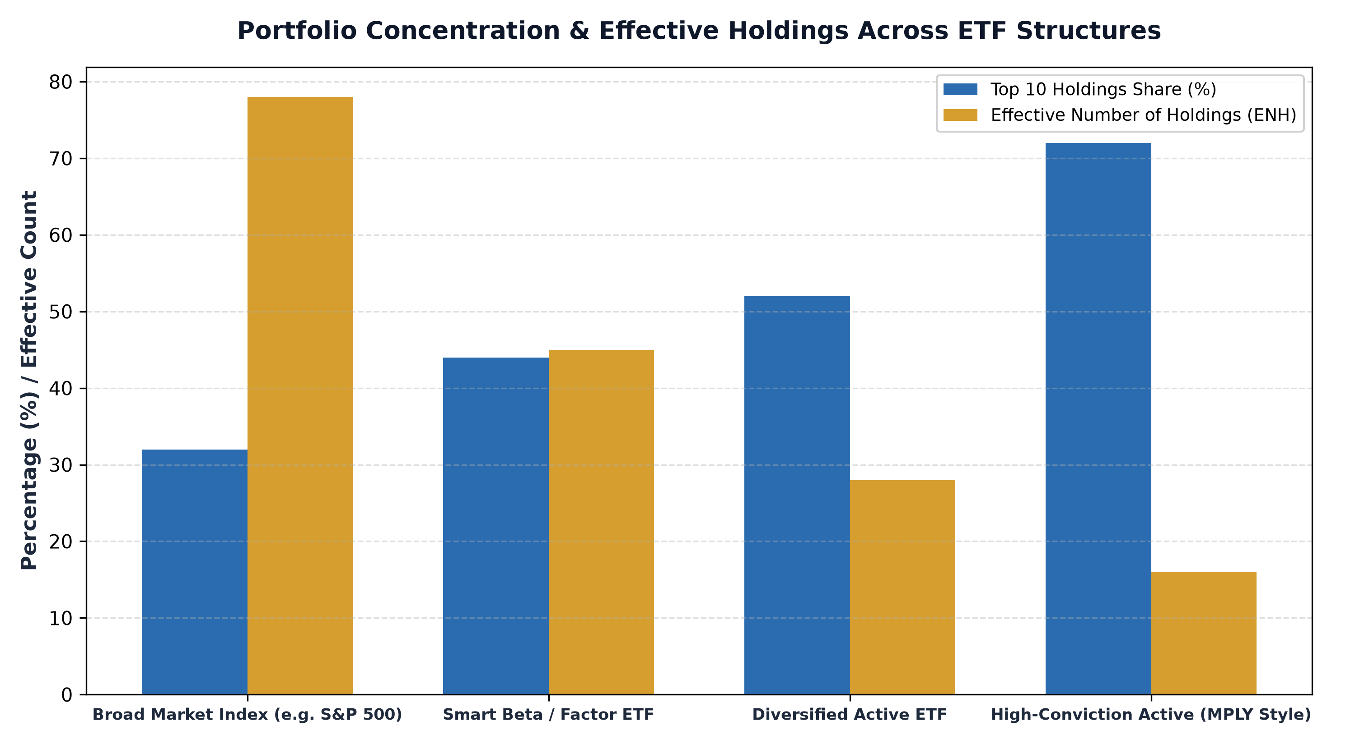
1. The Top-Heavy Fallacy: Why Top 10 Share Is Incomplete
The most common heuristic used to measure portfolio concentration is the cumulative weight of the top 10 holdings. If an ETF allocates 55% of its capital to its ten largest positions, observers immediately label the fund as concentrated. While this metric provides an intuitive starting point, it suffers from severe analytical limitations.
For example, a fund might hold a high top 10 concentration simply because three mega cap technology giants have surged in value, while the remaining ninety holdings are fragmented into meaningless fractions of a percent. Conversely, a fund that allocates four percent equally across twenty five carefully selected companies has a lower top 10 concentration but operates with vastly higher active conviction across every single position. Sophisticated analysts require more nuanced quantitative tools to measure true concentration.
2. Advanced Metrics: The Herfindahl-Hirschman Index and Effective N
To accurately quantify portfolio concentration, institutional allocators rely on the Herfindahl-Hirschman Index (HHI) and the Effective Number of Holdings (ENH). The HHI is calculated by summing the squares of each individual position's portfolio weight. By squaring the weights, larger positions contribute exponentially more to the score, heavily penalizing top heavy distortions.
Taking the reciprocal of the HHI produces the Effective Number of Holdings. For instance, if an ETF officially holds one hundred stocks, but eighty of them represent tiny 0.1% positions while the top twenty represent 92% of the fund, the Effective Number of Holdings might only be twenty two. This calculation strips away the cosmetic appearance of broad diversification and reveals the true economic concentration of the portfolio, allowing investors to evaluate whether the manager is actually practicing high conviction management.
3. True Economic Concentration vs Sector Correlation Risk
Concentration becomes dangerous only when it exposes the portfolio to correlated catastrophic failure. If an active ETF concentrates 70% of its capital into thirty stocks, but all thirty companies are unprofitable semiconductor startups dependent on the same venture debt cycle, the fund is not practicing disciplined concentration; it is engaging in reckless sector speculation.
Disciplined active concentration focuses capital across non correlated economic moats. When a portfolio manager combines a dominant railway network, a mission critical enterprise software platform, an essential healthcare diagnostics provider, and a regulated aerospace supplier, each company operates with independent demand drivers. Even though the portfolio holds only twenty five to thirty five names, the underlying revenue streams are profoundly insulated from shared macroeconomic shocks.
Beyond standard concentration ratios, institutional portfolio risk departments evaluate the liquidation horizon of concentrated active positions. When a high-conviction manager establishes an eight or ten percent position in an elite enterprise, risk managers must verify that the underlying stock possesses sufficient daily trading volume to allow an orderly liquidation without triggering catastrophic market impact. In premier active ETFs focused on mega-cap market leaders, deep secondary equity liquidity ensures that high concentration can be maintained alongside seamless institutional portfolio rebalancing.
4. High Conviction in Practice: The MPLY Approach
High conviction active management demands rigorous screening, unwavering discipline, and the willingness to look distinctly different from standard market benchmarks.
Investors interested in discovering how intentional concentration can be harnessed to invest in exceptional businesses can examine the Strategy Shares Monopoly ETF (MPLY) at https://strategysharesetfs.com/mply/. MPLY is built on the philosophy that true wealth creation stems from owning durable economic monopolies. By maintaining a focused portfolio of 25 to 35 market leaders with pricing power and insurmountable competitive moats, MPLY delivers genuine active conviction without diluting returns across low quality market constituents.
5. Frequently Asked Questions
Q1: Does a concentrated active ETF experience higher volatility than a broad index?
Not necessarily. If the concentrated positions consist of profitable, low debt corporate monopolies with defensive recurring revenue, the fund's cash flows and fundamental earnings volatility can be significantly lower than a broad index containing volatile, highly leveraged cyclical firms.
Q2: How many stocks are needed to achieve optimal mathematical diversification?
Modern portfolio theory research demonstrates that approximately twenty to thirty non-correlated stocks capture over 90% of the mathematical diversification benefits available in equity markets, rendering further portfolio expansion economically marginal.
6. Sources
Morningstar, Measuring Portfolio Concentration and Effective Holdings: https://www.morningstar.com/articles/moat-research
Harvard Business Review, The Logic of High-Conviction Investing and Concentration: https://hbr.org/1979/03/how-competitive-forces-shape-strategy
#ActiveETFs #ETFInvesting #Investing #Portfolio #MPLY

