Article 46:
What Manager Commentary Can Add to ETF Research
In the quantitative era of investing, modern financial analysis is heavily dominated by screening algorithms, backward looking spreadsheets, and statistical factor regressions. Investors routinely analyze historical volatility, trailing earnings multiples, and standard deviations to make portfolio allocation decisions. Yet, these mechanical metrics capture only historical outcomes, offering zero perspective on the forward looking managerial decisions that actually generate returns.
For investors seeking true fundamental insight into actively managed exchange traded funds, one resource provides an irreplaceable qualitative edge: the quarterly manager commentary. Far from being mere promotional marketing collateral, rigorous ETF manager commentary provides a direct window into the minds of the portfolio architects who deploy shareholder capital.
This guide explores what disciplined investors can learn from reading ETF manager commentary, how to distinguish substantive investment theses from generic public relations spin, and why qualitative commentary is essential for evaluating long term portfolio stewardship.
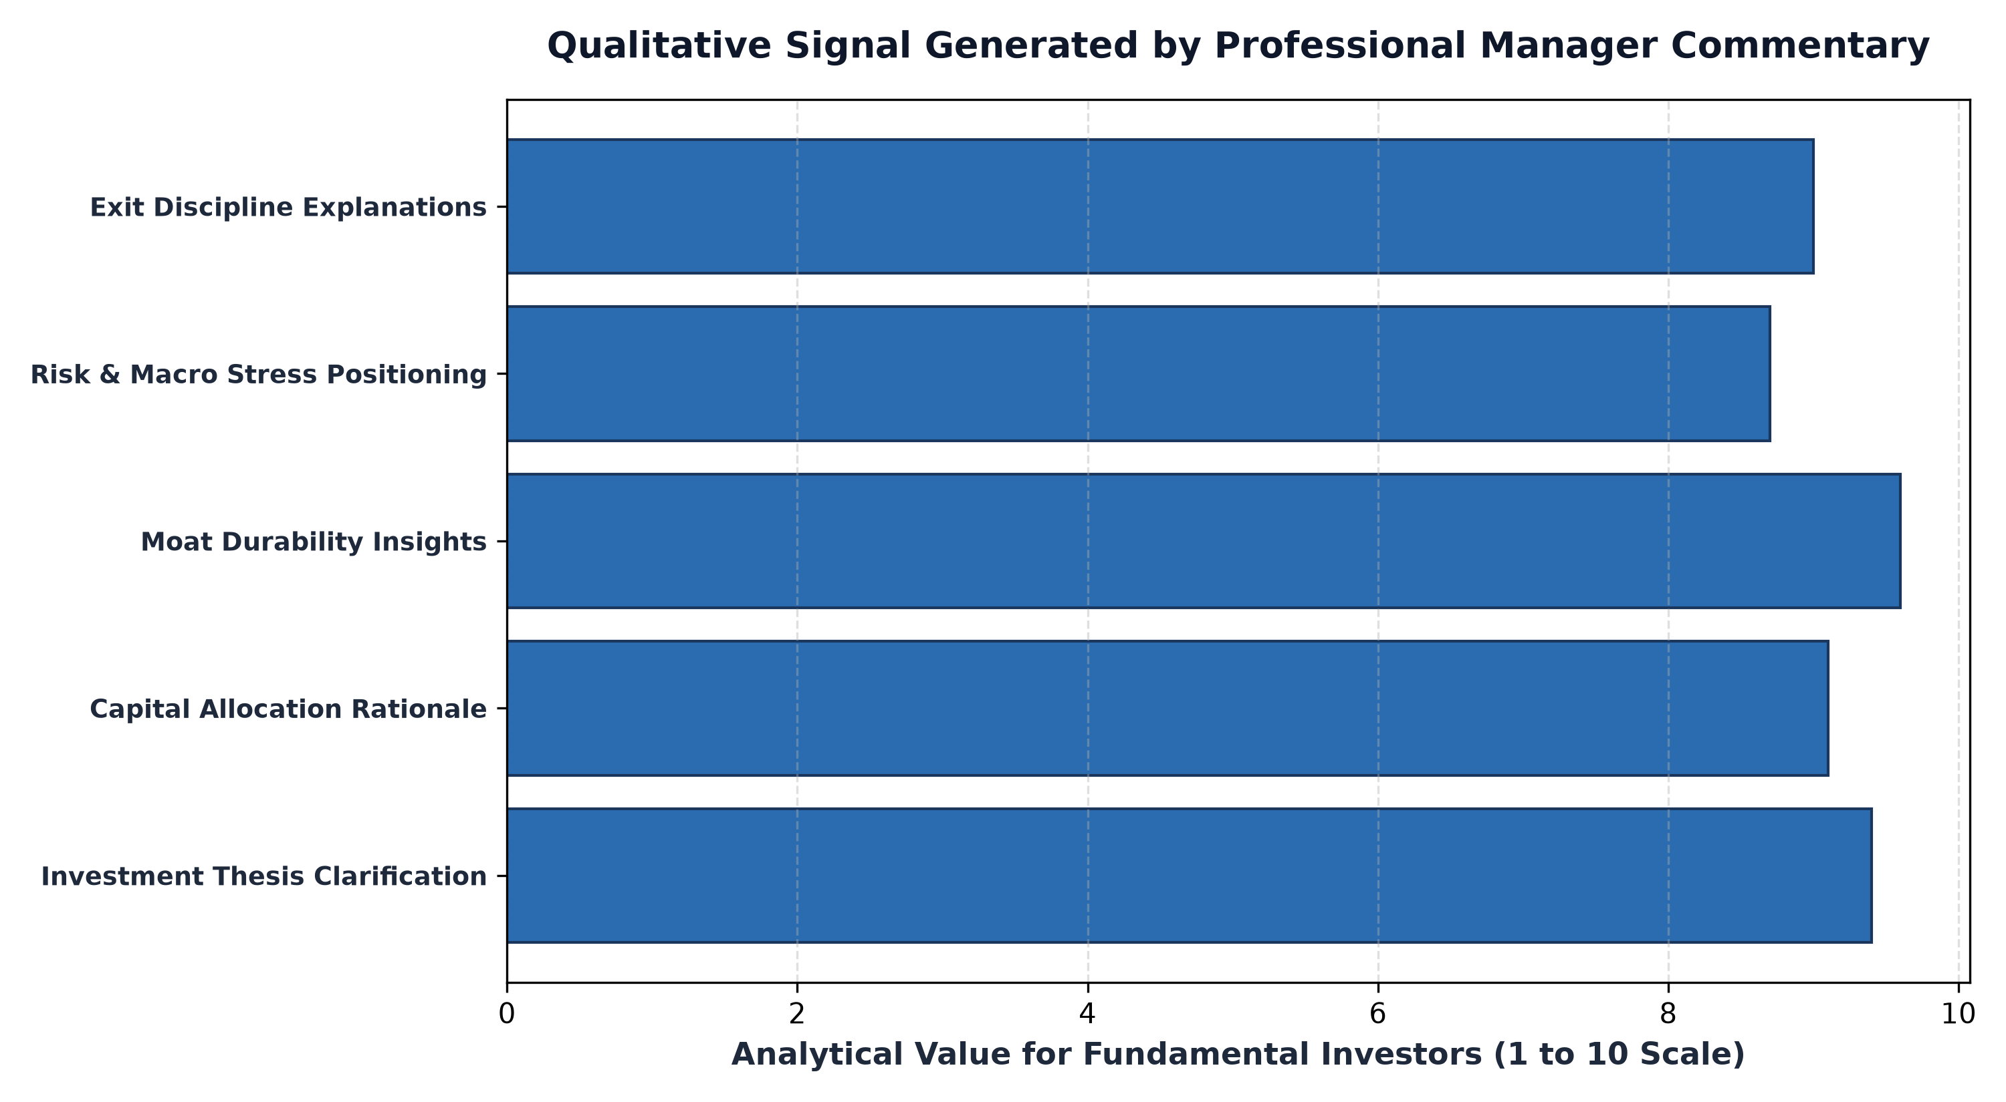
1. Unpacking the Fundamental Investment Thesis
A standard holdings sheet reveals what an active ETF owns, but it cannot explain why those specific businesses were selected over hundreds of alternatives. High quality manager commentary bridges this analytical gap by articulating the precise economic thesis behind individual positions. When a manager writes about a company, they explain the structural mechanics that underpin their conviction.
In substantive commentary, the manager details why a company's return on invested capital is sustainable, how its pricing power protects margins against input inflation, and what specific competitive moat insulates it from technological disruption. By evaluating the coherence and intellectual honesty of these arguments, investors can judge whether the portfolio is grounded in deep fundamental research or opportunistic trend chasing.
2. Accountability, Mistake Post-Mortems, and Capital Realignment
The ultimate test of an active manager's integrity is not how they celebrate their winners, but how they address their underperforming positions. Superficial marketing materials sweep losing investments under the rug, attributing poor performance entirely to broad macroeconomic headwinds or unpredictable market volatility.
World class portfolio managers utilize their commentary to deliver rigorous post-mortems on underperforming holdings. They frankly explain whether an underperformance reflects temporary market mispricing, creating an attractive opportunity to add to the position, or whether the fundamental investment thesis was broken, necessitating a disciplined liquidation. Reading these reflections allows investors to verify whether the manager possesses emotional discipline and intellectual humility under pressure.
3. Macro Positioning vs Microeconomic Reality
While financial news networks bombard investors with daily speculation regarding interest rate movements and inflation data, professional manager commentary provides vital perspective on how macroeconomic conditions actually intersect with corporate operations. Experienced managers explain how their portfolio companies navigate supply chain bottlenecks, regulatory shifts, and labor cost pressures.
Rather than attempting to forecast unpredictable macro events, exceptional active managers explain how their holdings possess durable business models capable of thriving across multiple economic scenarios. This perspective helps long term allocators maintain equanimity during cyclical drawdowns, reinforcing conviction in the structural resilience of the portfolio.
In professional asset allocation, multi-year commentary archives serve as an indispensable forensic tool for testing managerial intellectual honesty. By cross-referencing commentary letters published three to five years earlier with current portfolio holdings, an allocator can determine whether a manager's high-conviction theses materialized as predicted or whether underperforming holdings were quietly abandoned without explanation.
Additionally, institutional allocators review whether manager commentary includes formal Brinson-Fachler attribution analysis. True investment competence is proven when performance attribution demonstrates that excess returns were generated through skillful microeconomic stock selection within durable franchises rather than unhedged sector tilts or accidental macroeconomic factor bets.
4. Manager Insight and MPLY's Commitment to Quality
In focused investment strategies centered on dominant economic franchises, managerial commentary serves as a crucial educational bridge between high level theory and tangible portfolio execution.
Investors seeking transparent, research driven insights into how active managers analyze durable corporate moats can explore the Strategy Shares Monopoly ETF (MPLY) at https://strategysharesetfs.com/mply/. MPLY's regular manager perspectives articulate the core philosophy behind investing in enduring monopolies, highlighting why insurmountable barriers to entry, non negotiable services, and high free cash flow conversion form the bedrock of sustainable compounding.
Moreover, rigorous manager commentary explicitly addresses how the investment team handles valuation extremes. When an elite holding's stock price appreciates far faster than its underlying business earnings, disciplined managers detail whether they are trimming the position to manage concentration risk or allowing the winner to run based on expanding reinvestment runways. This ongoing operational dialogue gives allocators confidence that capital allocation decisions are guided by structured valuation principles rather than emotional complacency.
5. Frequently Asked Questions
Q1: How frequently is ETF manager commentary published?
Most actively managed ETFs publish formal manager commentary on a quarterly basis, accompanied by occasional annual letters or special market insights following major macroeconomic dislocations.
Q2: What is the biggest red flag in an ETF manager commentary?
The biggest warning sign is vague, promotional language that focuses excessively on short term market timing while completely failing to discuss the fundamental operational health, competitive moats, or free cash flows of underlying portfolio companies.
6. Sources
Morningstar, How to Evaluate Qualitative Fund Manager Commentary: https://www.morningstar.com/articles/moat-research
Harvard Business Review, The Art of Capital Allocation and Investment Stewardship: https://hbr.org/1979/03/how-competitive-forces-shape-strategy
#ActiveETFs #ETFInvesting #Investing #Portfolio #MPLY

