Article 47:
Active ETF Transparency: What Investors Can Verify
For nearly a century, the open end mutual fund reigned as the standard vehicle for professional active management. However, mutual fund ownership required investors to accept an opaque operational structure: managers reported their portfolio holdings only once per quarter, typically subject to a thirty to sixty day delay. By the time investors reviewed what they owned, the portfolio had often changed dramatically, leaving allocators blind to hidden style drift and sudden portfolio turnover.
The rise of active exchange traded funds has revolutionized this paradigm by establishing a new benchmark for structural openness. Yet, navigating active ETF transparency requires understanding precisely what data fund sponsors make publicly available, how daily disclosures protect investors from hidden risks, and how allocators can independently verify fund operations.
This comprehensive analysis examines the mechanisms of active ETF transparency, details the exact data points investors can verify on a daily basis, and explains why uncompromised portfolio visibility delivers superior alignment between managers and shareholders.
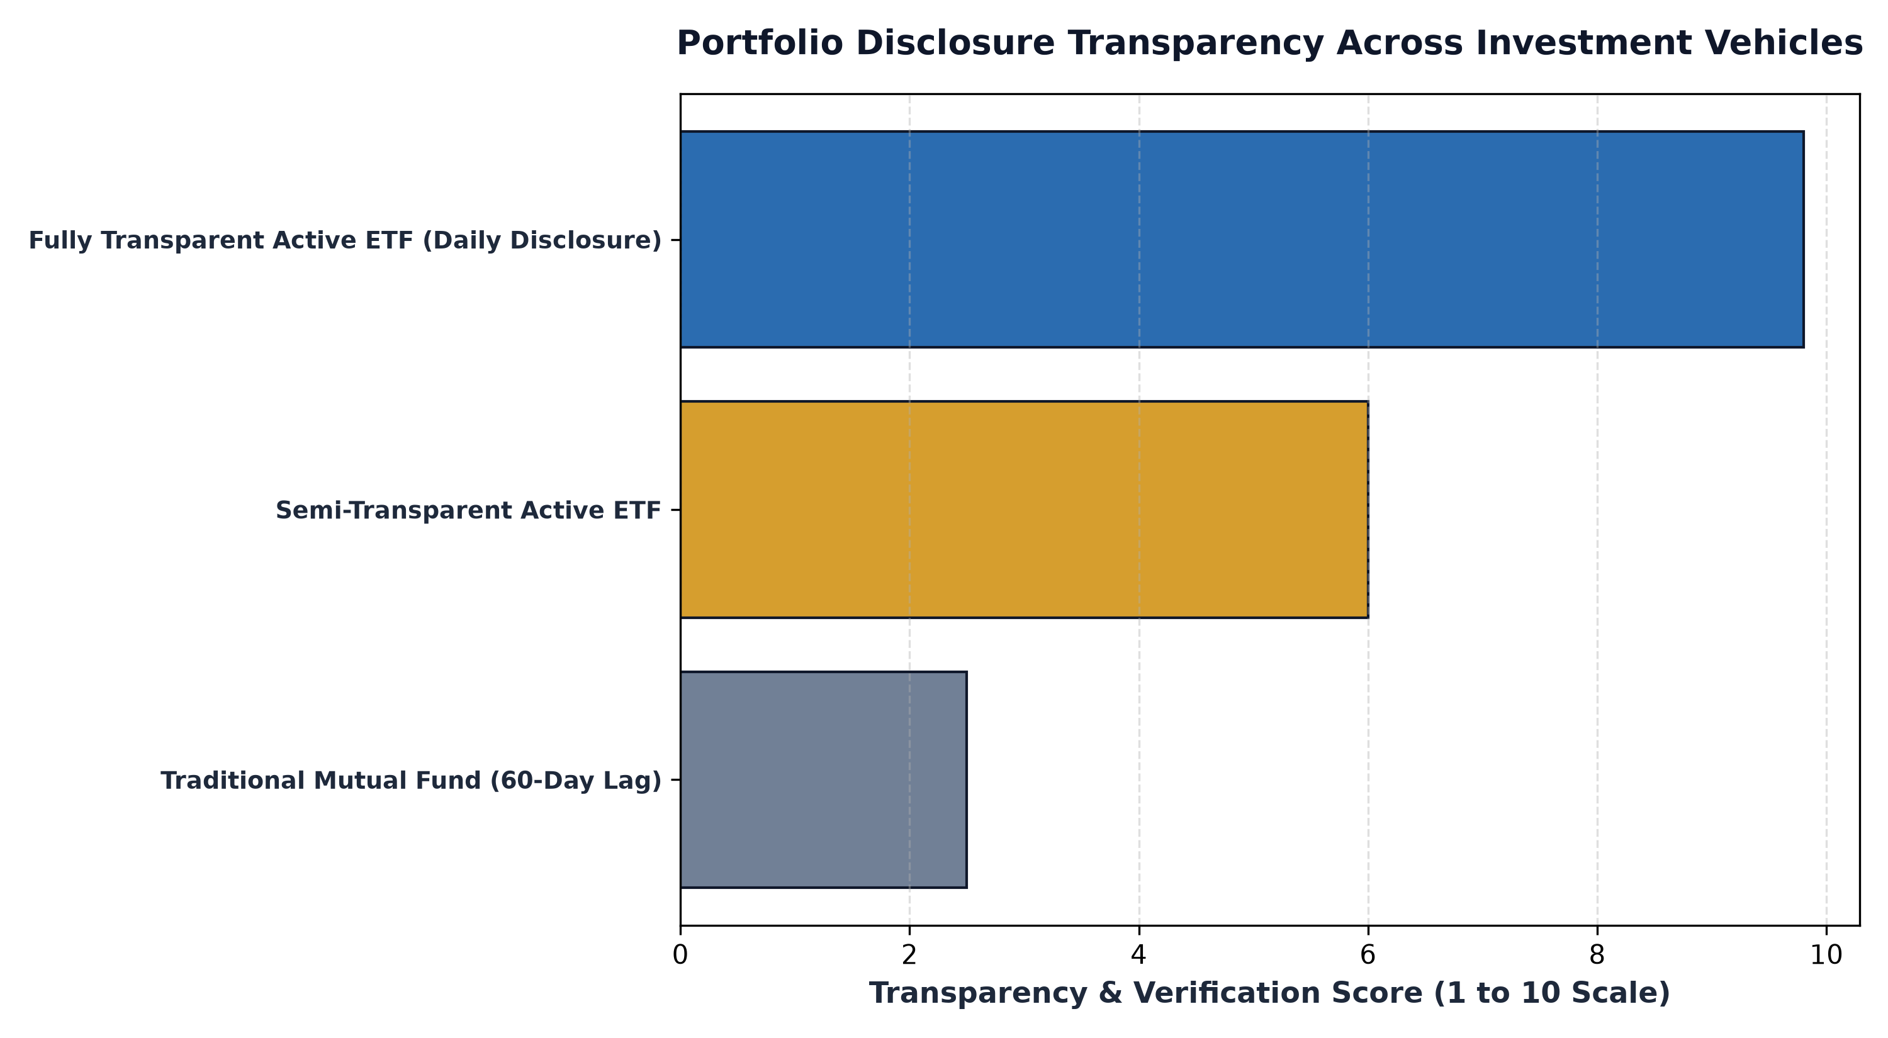
1. Daily Holdings Disclosure: The End of Style Drift
The cornerstone of active ETF transparency is mandatory daily portfolio disclosure. Unlike mutual funds that publish delayed snapshots, fully transparent active ETFs publish their complete constituent roster every morning before the opening bell. Every individual stock, exact share count, ticker symbol, and percentage weighting is available for public inspection on the fund sponsor's website.
This daily visibility completely eliminates the hazard of style drift. Style drift occurs when an active manager quietly strays from their stated investment philosophy, such as a value manager loading up on high flying tech stocks to boost short term performance. In a daily transparent ETF, any deviation from the stated mandate is instantly visible to analysts and shareholders, enforcing total accountability on the investment team.
2. Real-Time Pricing and the Creation-Redemption Basket
Active ETF transparency extends far beyond the list of holdings to encompass real time valuation mechanics. Every fifteen seconds throughout the trading day, the exchange calculates and publishes the fund's Indicative Optimized Portfolio Value (IOPV). This intraday metric reflects the precise, continuous fair value of the fund's underlying securities.
Furthermore, active ETFs publish their daily creation and redemption baskets, which detail the exact portfolio slices required by Authorized Participants to create or redeem fund shares. This transparency guarantees that market makers can hedge their positions with surgical accuracy, keeping bid ask spreads narrow and ensuring that market prices closely track fundamental net asset value even during volatile market sessions.
3. Verifying Fundamental Quality Independent of Marketing Claims
A primary benefit of full daily transparency is empowering individual investors and institutional allocators to conduct independent balance sheet audits. Because the full portfolio is always accessible, an investor does not need to accept marketing claims at face value. They can independently run the portfolio through financial screening tools to examine aggregate metrics.
Investors can verify the portfolio's weighted average return on invested capital, free cash flow conversion rate, net debt to EBITDA ratios, and revenue growth. If a fund markets itself as a defensive portfolio of quality compounders, an independent audit of the daily holdings can quickly verify whether the underlying companies actually generate pristine free cash flows or whether the fund is quietly accumulating risky, debt laden enterprises.
From a regulatory governance standpoint, SEC Rule 6c-11 enacted in 2019 modernized the active ETF ecosystem by granting managers unprecedented flexibility in utilizing custom creation and redemption baskets. Rather than being forced to deliver a pro-rata slice of every portfolio security, active managers can negotiate specialized baskets with Authorized Participants to efficiently inject or remove specific holdings. This regulatory mechanism allows fully transparent active managers to reallocate capital and optimize tax efficiency while maintaining uncompromised daily transparency for public shareholders.
4. The MPLY Standard: Unwavering Transparency in Monopoly Assets
In the realm of high conviction active management, transparency reinforces trust and allows investors to witness high conviction philosophy translated into daily practice.
Investors interested in examining a fully transparent, actively managed portfolio of market leading enterprises can review the Strategy Shares Monopoly ETF (MPLY) at https://strategysharesetfs.com/mply/. MPLY provides complete daily visibility into its focused holdings, allowing allocators to inspect each individual corporate monopoly, verify its balance sheet strength, and confirm that every single portfolio position reflects rigorous moat criteria and pricing power.
Finally, institutional allocators leverage daily transparency to conduct real-time portfolio overlap analysis across their broader multi-asset allocations. When an investor holds multiple active strategies, daily disclosure allows automated portfolio management software to calculate exact factor exposures and prevent unintended concentration in single mega-cap enterprises, ensuring seamless portfolio diversification across the entire balance sheet.
5. Frequently Asked Questions
Q1: Does daily transparency allow competitors to front run an active ETF's trades?
In practice, no. Large institutional active ETFs trade through experienced execution algorithms and specialized market makers who minimize trading footprints. For concentrated portfolios of mega cap, highly liquid monopolies, daily transparency introduces virtually zero front running friction.
Q2: What is the difference between transparent and semi-transparent active ETFs?
Transparent active ETFs publish their full portfolio daily before trading begins. Semi-transparent active ETFs utilize a proxy basket to shield their actual holdings from daily public view, disclosing actual positions only once a month or quarter.
6. Sources
Morningstar, The Evolution of Active ETF Transparency and Disclosure Rules: https://www.morningstar.com/articles/moat-research
Harvard Business Review, Transparency and Institutional Governance in Modern Investment Vehicles: https://hbr.org/1979/03/how-competitive-forces-shape-strategy
#ActiveETFs #ETFInvesting #Investing #Portfolio #MPLY

