Article 48:
How to Research an Active ETF Without Relying on Its Marketing Name
Wall Street marketing departments are master storytellers. Over the past decade, fund sponsors have launched hundreds of thematic and actively managed exchange traded funds branded with evocative names: artificial intelligence pioneers, clean energy revolutionaries, disruptive innovators, and next generation compounders. These compelling titles tap into prevailing investor zeitgeists, attracting billions of dollars in fresh assets based purely on narrative enthusiasm.
However, an investor who buys an exchange traded fund based solely on its marketing label is taking an uncalculated gamble. In finance, there is often a massive chasm between a fund's promotional branding and the actual economic reality of its portfolio holdings. Mastering how to research active ETF opportunities requires stripping away the narrative packaging and conducting forensic due diligence on the fund's underlying architecture.
This investigative guide presents a comprehensive five step research framework that allows allocators to audit an active ETF's true holdings, evaluate its active share, verify its competitive moat criteria, and confirm whether the fund justifies an allocation.
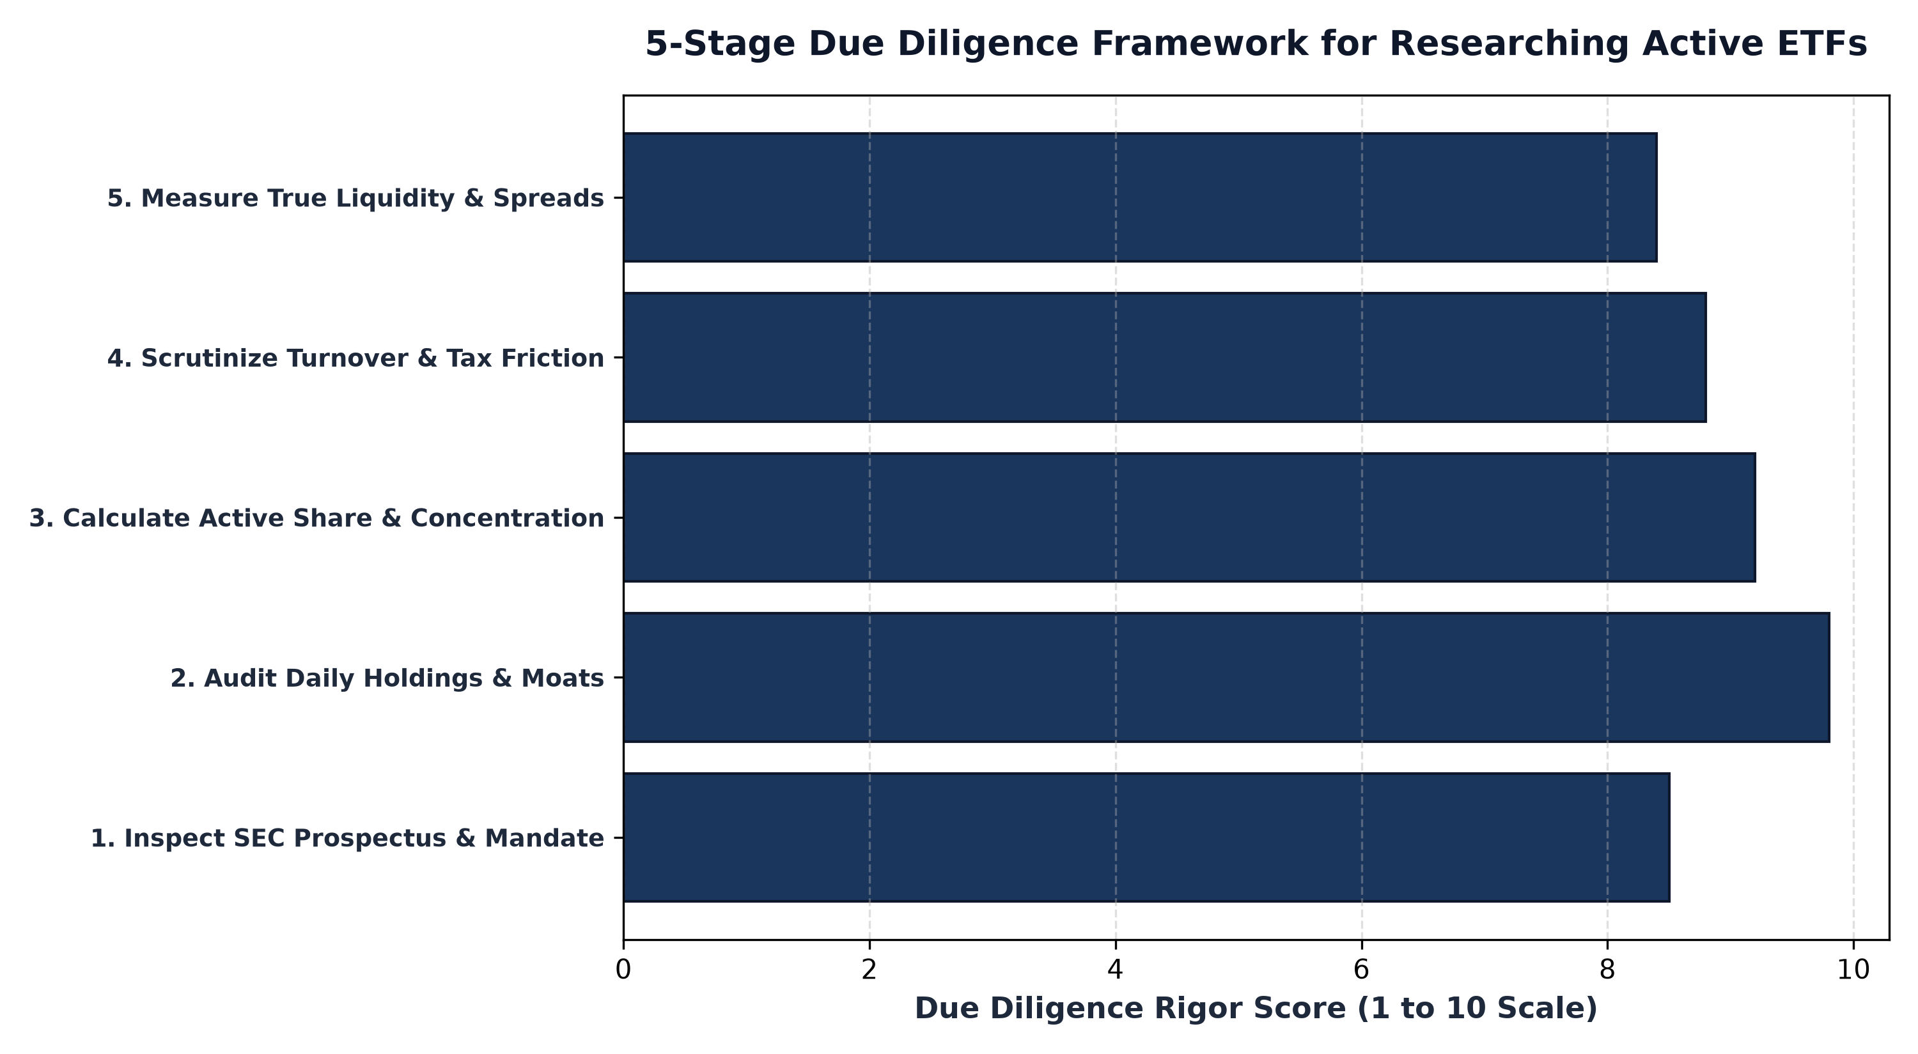
1. Scrutinizing the Legal Prospectus Over Marketing Decks
The first step in researching an active ETF is completely bypassing the marketing presentation and downloading the fund's official SEC Form N-1A prospectus. Marketing brochures highlight aspirational goals, cherry picked historical statistics, and captivating thematic imagery. The prospectus, by contrast, is a binding legal contract drafted under strict regulatory oversight.
In the principal investment strategies section of the prospectus, the fund manager is legally obligated to define their true selection universe, portfolio construction constraints, and risk management parameters. An investor must check whether the manager possesses absolute discretion or is constrained by tracking error limits, whether the fund employs leverage or derivatives, and what specific liquidity rules govern portfolio composition.
2. Calculating Active Share and Closet Indexing Risk
One of the greatest hazards in active fund selection is paying an active management fee for what is essentially a closet index fund. Closet indexing occurs when a manager claims to practice active stock selection but constructs a portfolio that heavily mirrors the benchmark index, holding the same mega cap names in nearly identical proportions.
To detect closet indexing, investors calculate the fund's Active Share. Active Share measures the percentage of portfolio holdings that differ from the benchmark index. An active ETF with an Active Share below 60% is essentially hugging its benchmark, guaranteeing that the fund will underperform after deducting management fees. Truly high conviction active managers maintain an Active Share of 80% to 95%, ensuring that the fund's returns are driven by independent security selection.
3. Forensic Audit of Underlying Corporate Moats
Once the active share is verified, an investor must examine the actual constituent roster. Look closely at the bottom half of the portfolio as well as the top ten names. Does the manager hold businesses with durable economic moats, pristine balance sheets, and proven pricing power, or does the portfolio contain unprofitable concept companies that rely on continuous debt issuance to survive?
A fund that brands itself as an innovation leader but fills its portfolio with unvetted, pre revenue startups exposes investors to extreme speculative risk. Conversely, an active fund that demonstrates disciplined selection will hold businesses with dominant market shares, contractual recurring cash flows, and superior returns on invested capital, regardless of what marketing label is stamped on the cover.
A vital component of forensic active ETF due diligence is examining manager co-investment, commonly known as eating your own cooking. When portfolio managers invest substantial personal wealth directly into the fund alongside outside shareholders, it creates profound psychological and financial alignment. An allocator can verify manager ownership levels within SEC Statement of Additional Information (SAI) filings, ensuring that the management team experiences the identical economic consequences of their portfolio construction choices.
4. The MPLY Mandate: Substance Over Superficial Branding
Rigorous active research requires evaluating whether a fund's holdings genuinely reflect its stated economic thesis in every single position.
Investors looking for an active ETF whose portfolio holdings perfectly mirror its stated investment thesis can review the Strategy Shares Monopoly ETF (MPLY) at https://strategysharesetfs.com/mply/. MPLY does not rely on ephemeral marketing buzzwords; its portfolio construction is strictly governed by fundamental economic reality, holding an actively managed, concentrated roster of 25 to 35 true corporate monopolies that possess insurmountable competitive moats and enduring pricing power.
5. Frequently Asked Questions
Q1: What is the most critical metric to verify when researching an active ETF?
The most critical step is auditing the actual daily holdings to verify the fundamental quality, free cash flow generation, and economic moats of the companies inside the portfolio, rather than relying on the fund's marketing name.
Q2: How does high Active Share impact an investor's portfolio?
High Active Share means the ETF will perform very differently from broad market benchmarks, offering genuine diversification and the potential for long term alpha, though it will experience periods of tracking error relative to broad indexes.
6. Sources
Morningstar, How to Conduct Independent Due Diligence on Active ETFs: https://www.morningstar.com/articles/moat-research
Harvard Business Review, Active Share, Fee Drag, and Fund Manager Conviction: https://hbr.org/1979/03/how-competitive-forces-shape-strategy
#ActiveETFs #ETFInvesting #Investing #Portfolio #MPLY

