Article 49:
Portfolio Turnover in Active ETFs: What It Can Reveal
When investors analyze mutual funds and exchange traded funds, their attention is naturally consumed by the most prominent metrics on the fact sheet: trailing annualized returns, asset class classification, and the net expense ratio. Yet, buried deep in the financial highlights table of every fund prospectus resides a percentage metric that offers profound insight into the manager's true investment philosophy: the annual portfolio turnover rate.
Portfolio turnover measures the velocity at which a fund replaces its investment holdings over the course of a fiscal year. While many investors dismiss turnover as a dry operational detail, in reality, analyzing active ETF portfolio turnover reveals whether a management team operates as patient business owners or hyperactive short term market traders.
This institutional analysis deconstructs what portfolio turnover signals about an active ETF, examines the hidden transaction drag generated by frequent trading, and explains why low turnover compounding represents the gold standard of high conviction investing.
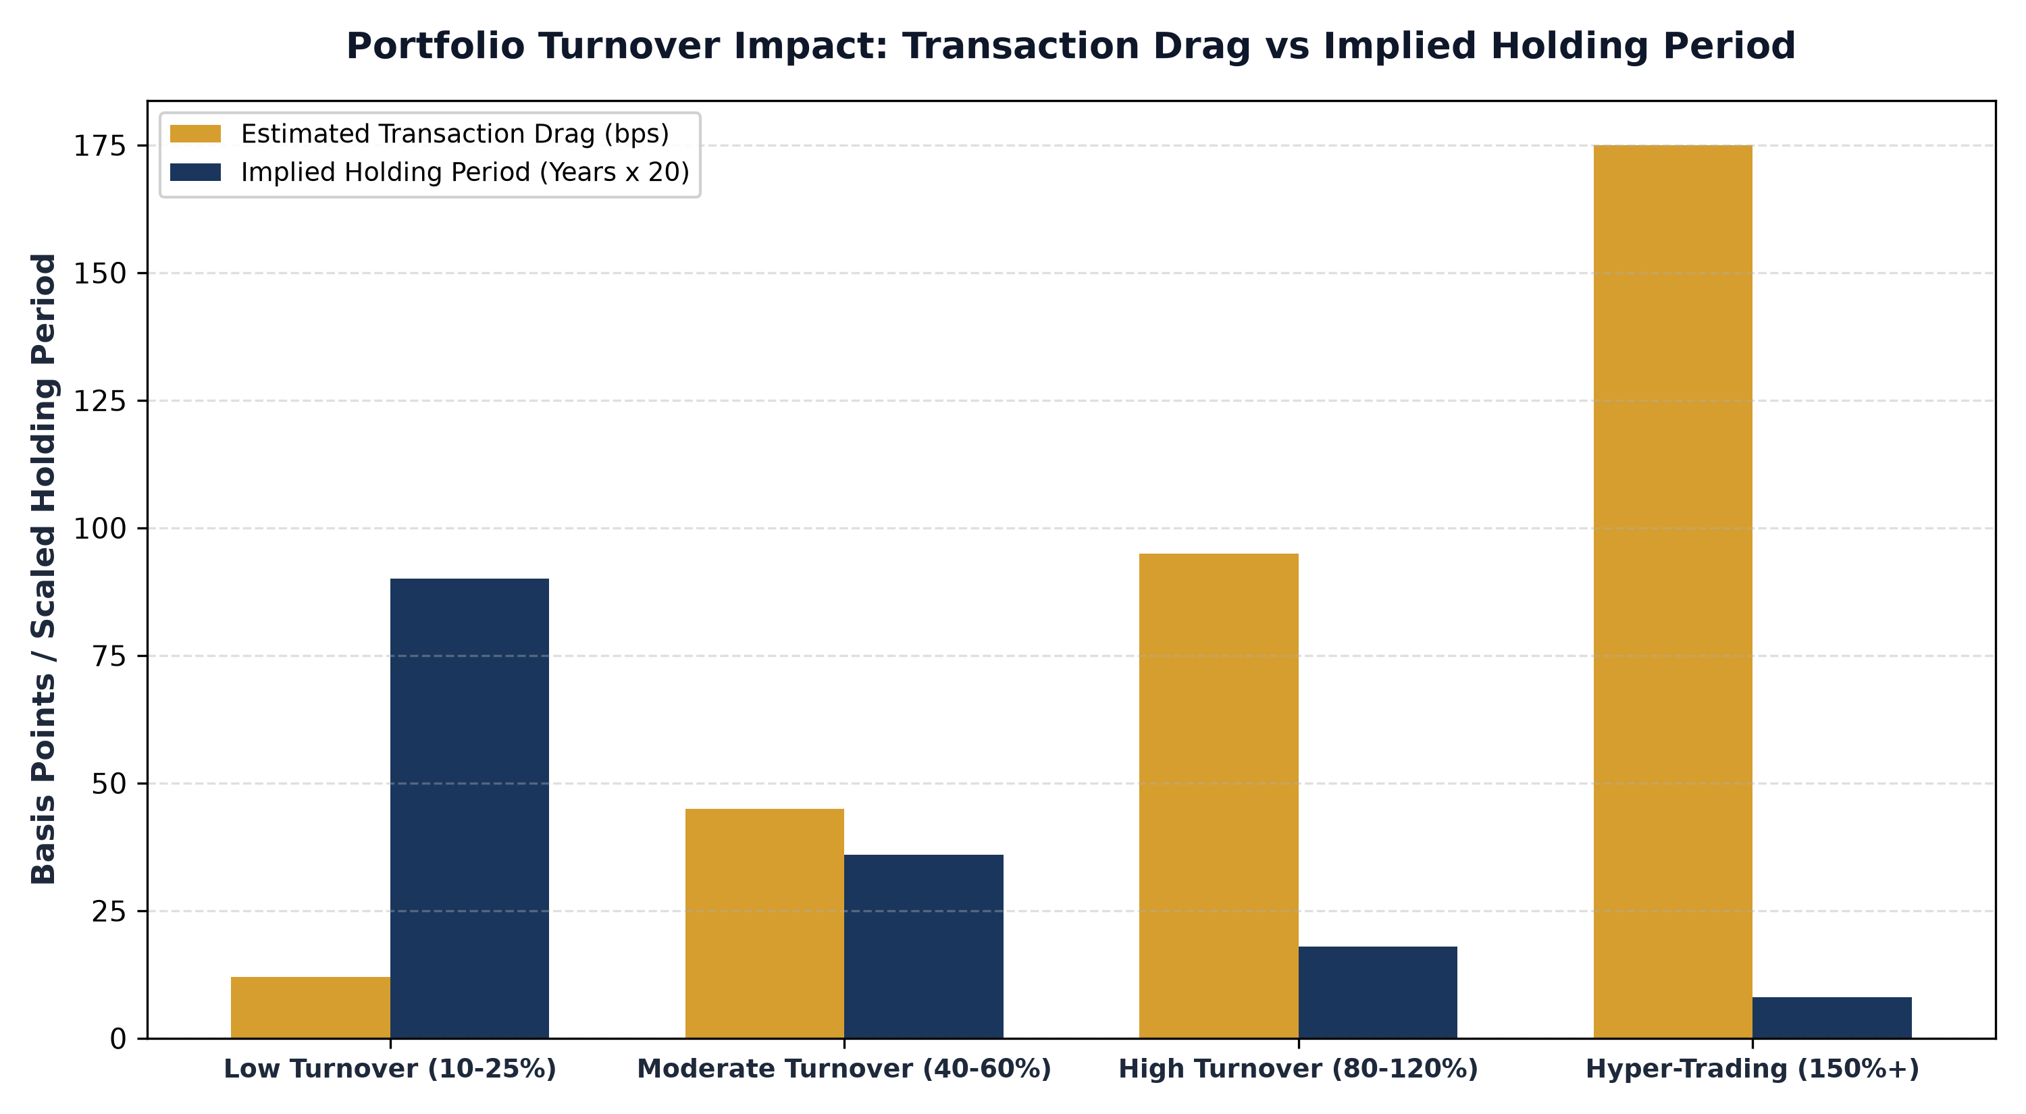
1. The Mathematics of Portfolio Turnover and Holding Periods
Portfolio turnover is calculated by taking the lesser of total portfolio purchases or total portfolio sales over a twelve month period, divided by the fund's monthly average net assets. A turnover rate of 100% indicates that the fund has mathematically turned over the equivalent of its entire portfolio within a single calendar year, implying an average holding period of only twelve months.
Conversely, a portfolio turnover rate of 20% implies an average holding period of five full years. Understanding this relationship is crucial. An active manager who claims to invest for the long term in exceptional corporate franchises but reports a turnover rate of 120% is not practicing long term investing. That manager is engaging in short term swing trading, churning securities based on momentum cues and quarterly earnings noise rather than structural business fundamentals.
2. The Hidden Frictional Tax of Frequent Trading
While ETFs are celebrated for their tax efficiency, excessive portfolio turnover introduces substantial economic costs that never appear in the stated expense ratio. Every time an active ETF buys or sells a position, it incurs transaction friction, including brokerage commissions, exchange fees, bid ask spread crossing costs, and market impact drag.
When an institutional fund holding billions of dollars moves in and out of positions rapidly, its own buying and selling pressure moves market prices against itself, buying at higher prices and selling at lower prices. Institutional finance research estimates that for mid cap and specialized equity funds, each 100% of turnover adds between fifty and one hundred basis points of hidden drag to annual fund performance, quietly siphoning wealth away from shareholders.
3. High Conviction Demands Low Turnover Compounding
True economic compounding takes years to unfold. When a company possesses a genuine economic moat, high return on invested capital, and pricing power, its intrinsic value expands gradually as management reinvests free cash flow into high return growth opportunities. The role of the high conviction investor is not to trade in and out of the stock, but to patiently own the business and allow compound interest to do the heavy lifting.
A low portfolio turnover rate (typically between 15% and 30%) is a hallmark of managerial discipline. It proves that the investment team conducted rigorous fundamental due diligence upfront, built immense conviction in their companies, and possesses the temperament to sit quietly while world class management teams execute their business plans.
In addition to transaction friction, high portfolio turnover in active funds can compromise long-term compounding by truncating the corporate reinvestment cycle. Great businesses require multi-year runways to expand manufacturing facilities, commercialize intellectual property, and integrate strategic bolt-on acquisitions. When an active manager turns over their portfolio every few months, they interrupt this corporate compounding process, substituting high-probability fundamental business expansion with speculative short-term price forecasting.
4. MPLY's Discipline: Patient Ownership of Enduring Monopolies
In specialized active strategies focused on dominant economic franchises, low turnover is not just a stylistic preference; it is the core foundation of the investment strategy.
Investors seeking an active ETF built around patient, long term corporate ownership can study the Strategy Shares Monopoly ETF (MPLY) at https://strategysharesetfs.com/mply/. MPLY is designed for investors who prioritize fundamental compounding over frantic trading. By maintaining a concentrated portfolio of enduring corporate monopolies with insurmountable barriers to entry and durable pricing power, MPLY practices disciplined low turnover investing, allowing the intrinsic value of its holdings to compound undisturbed.
5. Frequently Asked Questions
Q1: Is low portfolio turnover always a positive indicator for an active ETF?
Yes, provided the manager conducts rigorous ongoing due diligence. Low turnover reflects long term conviction and minimizes transaction drag, but the manager must remain vigilant and exit holdings if an economic moat permanently deteriorates.
Q2: How does ETF turnover affect capital gains distributions compared to mutual funds?
Because ETFs utilize the in-kind creation and redemption mechanism, active ETFs can often absorb high turnover without distributing taxable capital gains. However, high turnover still generates market impact drag that erodes gross returns.
6. Sources
Morningstar, The Cost of Trading Drag and Portfolio Turnover in Active Funds: https://www.morningstar.com/articles/moat-research
Harvard Business Review, Patient Capital and the Mathematics of Long-Term Compounding: https://hbr.org/1979/03/how-competitive-forces-shape-strategy
#ActiveETFs #ETFInvesting #Investing #Portfolio #MPLY

