Article 50:
How to Measure Portfolio Concentration Beyond the Top 10 Holdings
In the portfolio construction lexicon, concentration is frequently discussed as a binary condition: a fund is either broad and diversified or focused and concentrated. To establish where a portfolio falls on this spectrum, financial commentators almost universally cite a single headline statistic: the percentage of total fund assets held within the top ten positions. If that number exceeds fifty percent, the fund is labeled highly concentrated.
However, relying solely on the top ten holdings metric provides an incomplete and often misleading perspective on portfolio architecture. An investor who stops their analysis at position number ten remains completely blind to how the remaining fifty, one hundred, or four hundred stocks are distributed across the portfolio. Conducting a thorough portfolio concentration analysis requires looking deep into the entire roster to measure true economic exposure.
This institutional guide details how sophisticated allocators measure concentration beyond the top ten holdings, explains the hidden drag of the portfolio tail, and demonstrates how disciplined tier distribution optimizes risk adjusted returns.
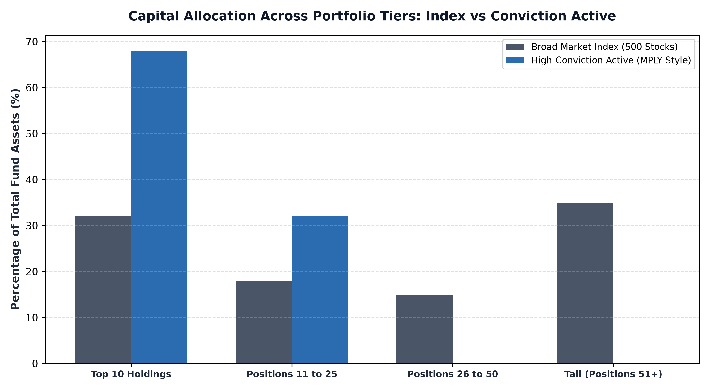
1. The Illusion of the Portfolio Long Tail
When examining broad market ETFs or diversified active mutual funds, investors frequently encounter portfolios holding hundreds of individual companies. On the surface, this structure appears to deliver impregnable diversification. Yet, when an allocator analyzes the distribution of capital, they often discover that positions fifty through five hundred collectively represent less than fifteen percent of the total fund.
A stock held at a 0.08% or 0.15% portfolio weighting is economically irrelevant to fund performance. Even if that company doubles or triples in value, the impact on the investor's total net asset value is negligible. Yet, holding hundreds of tiny micro positions forces the fund to absorb ongoing custodial fees, trading friction, and administrative overhead. This long tail provides no meaningful risk protection; it merely dilutes the returns of the fund's best ideas.
2. Tiered Weight Distribution and the Quartile Framework
To gain an accurate understanding of portfolio structure, institutional analysts divide holdings into distinct analytical quartiles or tiers. The first tier examines positions one through ten, the second tier evaluates positions eleven through twenty five, the third tier covers positions twenty six through fifty, and the fourth tier encompasses the remaining tail.
In a high quality, intentional portfolio, capital is distributed with clear purpose across tiers one and two. Positions eleven through twenty five still carry meaningful weightings of two to four percent, ensuring that secondary ideas can meaningfully contribute to fund alpha. If a fund's capital drops off a cliff after position ten, dropping immediately into fractional percentages, the fund is effectively operating as a high beta barbell rather than a balanced conviction portfolio.
3. Cross-Holding Correlation and Economic Moat Independence
Measuring concentration beyond position size requires analyzing the fundamental economic correlation between holdings. A portfolio might hold fifty stocks with equal two percent weightings, creating the mathematical appearance of perfect diversification. However, if thirty of those fifty companies are dependent on consumer discretionary spending or automotive manufacturing, the portfolio suffers from acute structural concentration.
True portfolio diversification is achieved when capital is concentrated into businesses whose underlying cash flow drivers are mutually independent. When a fund holds twenty five to thirty five non correlated corporate monopolies spanning enterprise software infrastructure, essential railway logistics, specialized medical instruments, and regulated utilities, the portfolio achieves superior downside protection compared to a five hundred stock fund heavily correlated to the broad business cycle.
Institutional risk managers also apply tail-risk factor crowding models to evaluate whether non-top-10 holdings amplify systemic portfolio vulnerabilities. If positions eleven through thirty share identical high-beta characteristics or foreign exchange sensitivities, aggregate portfolio risk can spike unexpectedly during liquidity crunches despite a benign top 10 weighting. Analyzing cross-holding factor covariance ensures that secondary allocations provide genuine economic ballast rather than hidden correlation traps.
4. The MPLY Standard: Focused Conviction Across All Tiers
High conviction active investing demands that every single position in the portfolio earns its place through uncompromising fundamental quality and meaningful capital allocation.
Investors interested in discovering how intentional portfolio design eliminates dead weight and maximizes capital efficiency can examine the Strategy Shares Monopoly ETF (MPLY) at https://strategysharesetfs.com/mply/. MPLY is constructed without an economically irrelevant tail. By maintaining a focused portfolio of 25 to 35 enduring corporate monopolies, MPLY ensures that every single holding represents a meaningful, high conviction allocation backed by pricing power, durable competitive moats, and pristine free cash flow.
5. Frequently Asked Questions
Q1: What is the optimal number of holdings for an actively managed equity ETF?
Empirical financial research indicates that a portfolio of twenty five to thirty five carefully selected, non correlated stocks captures over 90% of maximum mathematical diversification benefits while allowing the manager to concentrate capital exclusively in premier businesses.
Q2: Why do many active funds hold hundreds of tiny positions if they don't impact returns?
Many managers maintain bloated portfolios to suppress tracking error against their benchmark index, prioritizing job preservation and asset gathering over maximizing risk adjusted returns for shareholders.
6. Sources
Morningstar, Portfolio Construction and Concentration Metrics Beyond the Top 10: https://www.morningstar.com/articles/moat-research
Harvard Business Review, The Anatomy of Diversification and Optimal Portfolio Sizing: https://hbr.org/1979/03/how-competitive-forces-shape-strategy
#PortfolioConstruction #Diversification #Investing #Portfolio #MPLY

