Article 51:
How Correlation Changes Portfolio Risk During Market Stress
In portfolio management theory, the fundamental cornerstone of risk reduction is diversification through non correlated assets. Markowitz Modern Portfolio Theory posits that by combining asset classes with low historical correlations, an investor can construct an efficient frontier that maximizes expected return while suppressing portfolio volatility. Mathematical models routinely assume that asset classes will behave independently, providing mutual ballast when turbulence strikes.
However, veteran allocators understand an unsettling market reality: during acute financial panics, historical correlations break down completely. When liquidity evaporates, diverse asset classes that previously traded independently converge toward a correlation of 1.0. Understanding how correlation changes portfolio risk during market stress is essential for investors who wish to protect their capital from devastating systemic drawdowns.
This comprehensive analysis examines the mechanics of correlation breakdown during market turmoil, explains why conventional asset allocation models fail when they are needed most, and outlines structural portfolio strategies that deliver genuine downside resilience.
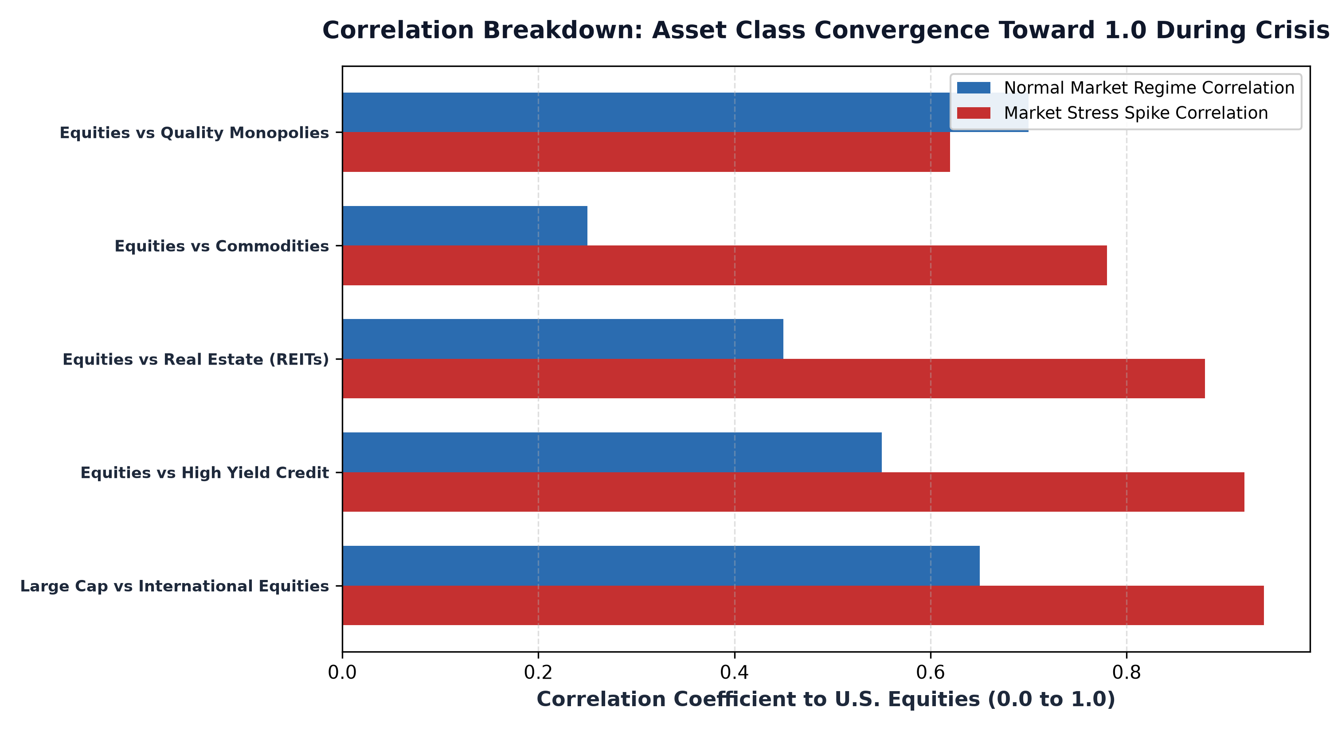
1. The Liquidity Cascade and Forced Selling
The primary mechanism driving correlation spikes during crises is not deteriorating business fundamentals across every sector simultaneously; it is the universal scramble for cash. In modern levered financial markets, institutional hedge funds, risk parity strategies, and systematic trading desks employ substantial debt to magnify returns. When an unexpected macroeconomic shock hits, collateral values plunge, triggering automated margin calls.
To meet margin requirements and prevent insolvency, institutional desks cannot afford to sell only the assets directly affected by the shock. Instead, they are forced to sell whatever assets possess liquid secondary markets. High yield debt, commodities, real estate investment trusts, and international equities are dumped into the market indiscriminately. This forced selling synchronizes price declines across previously uncorrelated sectors, transforming a theoretical diversified portfolio into a single, highly correlated liquidating pool.
2. The Mirage of Statistical Diversification
Most wealth advisory models rely on five year or ten year rolling correlation matrices. These statistical averages blend years of calm, upward trending bull markets with brief volatility episodes, creating the mathematical illusion of permanent diversification. An allocator might look at historical data showing high yield credit possessing a 0.50 correlation to equities and conclude that allocating capital to corporate credit meaningfully mitigates equity risk.
Yet, when a credit event occurs, that correlation instantly spikes above 0.90. The investor discovers that they do not own two distinct asset classes; they own two different manifestations of the same underlying liquidity risk factor. Static statistical models fail precisely because correlation is not a constant physical parameter; it is a dynamic function of market leverage, risk appetite, and banking system solvency.
3. Structural Moats vs Cyclical Correlation Traps
To insulate a portfolio from catastrophic correlation breakdown, allocators must shift their focus from surface level statistical diversification to fundamental economic insulation. Businesses whose cash flows are tied to the broad macroeconomic credit cycle will always suffer correlated selloffs during liquidity panics. Their debt costs surge, consumer demand collapses, and working capital requirements create severe cash crunches.
In contrast, companies possessing impenetrable economic moats and mission critical business models demonstrate remarkable fundamental decoupling. An enterprise that controls an essential railway corridor, a mission critical regulatory data network, or non discretionary healthcare technology continues to generate robust operating cash flow regardless of whether financial asset prices are tumbling. Even if their equity share prices drop temporarily during market panics, their underlying intrinsic value and dividend compounding capacity remain completely intact.
4. The MPLY Mandate: Quality Insulation Through Structural Monopolies
Mitigating correlation risk during severe market dislocations requires allocating to companies that do not rely on external capital markets or debt refinancing to maintain operational dominance.
Investors seeking portfolio resilience through fundamentally insulated enterprises can examine the Strategy Shares Monopoly ETF (MPLY) at https://strategysharesetfs.com/mply/. MPLY is an actively managed ETF that purposefully concentrates capital into enduring monopolies possessing insurmountable barriers to entry and contractual pricing power. Because these market leaders generate fortress like free cash flows and maintain minimal net leverage, they provide essential structural ballast against systemic liquidity cascades.
In modern quantitative capital markets, algorithmic de-risking mechanisms significantly exacerbate correlation spikes during stress episodes. Systematic strategies, including volatility-targeting funds, commodity trading advisors (CTAs), and risk-parity models, manage billions of dollars using automated leverage controls tied directly to market volatility. When equity volatility spikes, these algorithms automatically liquidate non-equity positions, including sovereign bonds, real estate trusts, and commodities, to reduce gross portfolio exposure.
This systematic feedback loop triggers cross-asset contagion, forcing seemingly unrelated markets into mechanical synchronization. For fundamental allocators, understanding this algorithmic transmission channel clarifies why static correlation assumptions fail during drawdowns. The only durable protection against contagion is anchoring portfolio capital to businesses possessing exceptional balance sheet solvency and inelastic demand profiles capable of generating cash flow independent of broader market liquidity.
5. Frequently Asked Questions
Q1: Why do bonds sometimes fail to provide diversification when stocks decline?
When market stress is triggered by inflation shocks or sudden interest rate spikes, both equity multiples and bond prices fall simultaneously, causing equity-bond correlations to turn strongly positive and dismantling the traditional 60/40 balanced portfolio framework.
Q2: How can an investor measure correlation breakdown risk in their portfolio?
Rather than relying on historical correlation averages, investors should conduct historical stress tests modeling portfolio performance during specific liquidity shocks, such as the 2008 global financial crisis or the March 2020 liquidity freeze.
6. Sources
Morningstar, Asset Class Correlation Dynamics Across Stress Regimes: https://www.morningstar.com/articles/moat-research
Harvard Business Review, Systemic Risk, Market Liquidity, and the Breakdown of Diversification: https://hbr.org/1979/03/how-competitive-forces-shape-strategy
#PortfolioConstruction #Diversification #Investing #Portfolio #MPLY

