Article 52:
How to Detect Duplicate Exposure Across ETFs
One of the most widespread retail investing errors in modern wealth management is the illusion of multi fund diversification. An investor frequently constructs a portfolio by purchasing three or four exchange traded funds with distinct marketing titles: a broad market core fund, a growth fund, a thematic technology fund, and an ESG leader. In their mind, owning four separate funds holding a cumulative total of fifteen hundred ticker symbols guarantees robust diversification.
However, when an analyst opens up the underlying holdings of these funds, an alarming reality often emerges. Behind four completely different ticker symbols and marketing labels, the exact same five to seven mega cap corporate giants dominate thirty to fifty percent of every single fund. Conducting a forensic ETF overlap analysis is the only reliable way to uncover hidden portfolio redundancy and prevent unintended risk concentration.
This guide deconstructs how ETF overlap occurs, provides a step by step framework for measuring portfolio duplication across funds, and demonstrates how to build a truly diversified portfolio that eliminates costly structural redundancy.
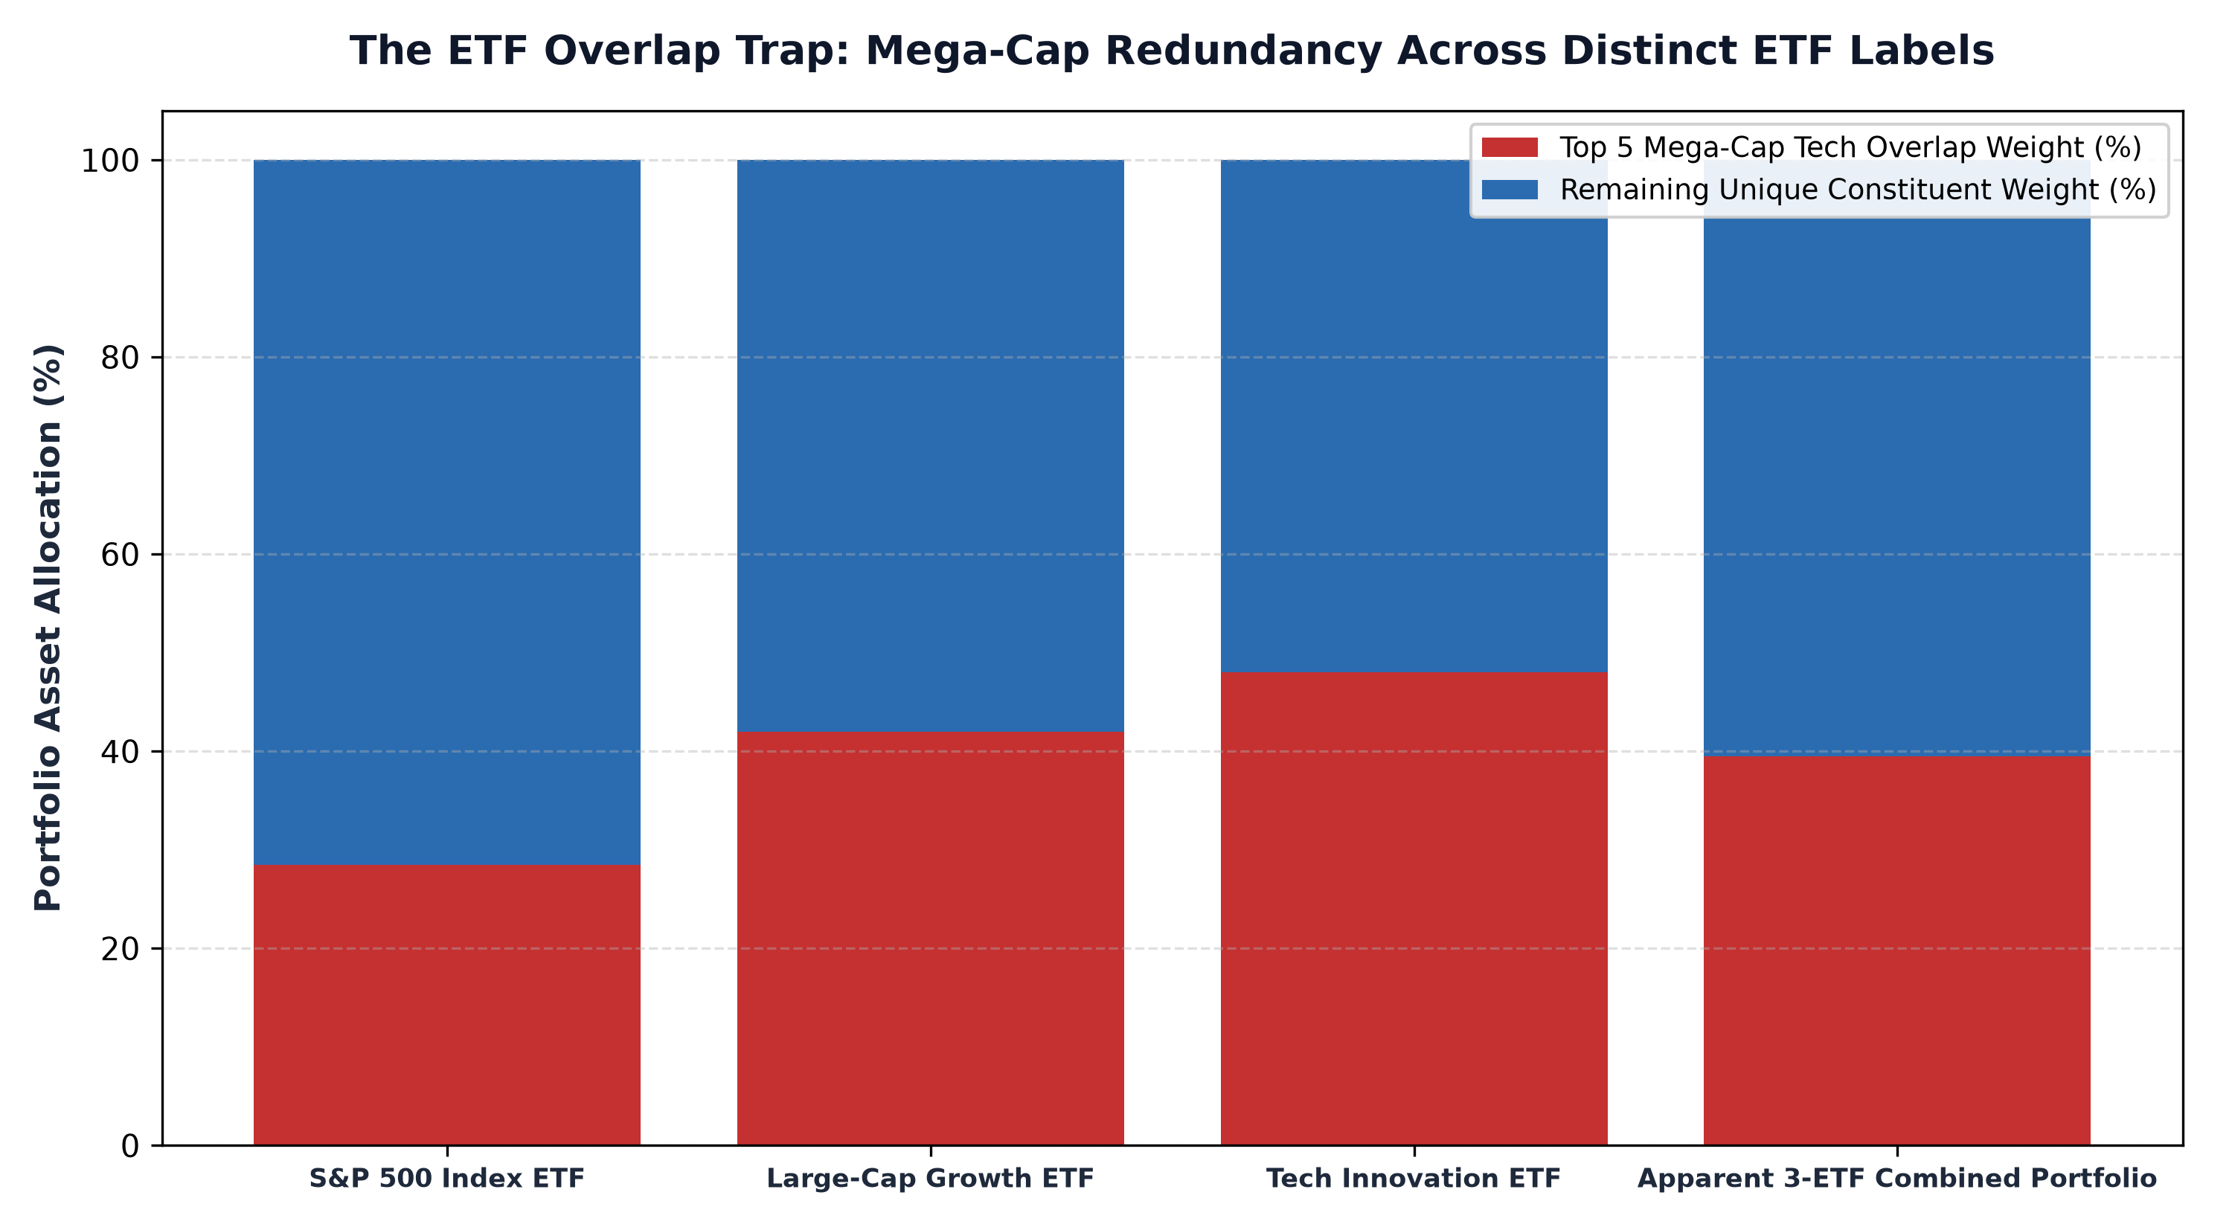
1. Market-Cap Dominance and the Mechanics of Overlap
The root cause of rampant ETF overlap is the ubiquity of market capitalization weighting rules across benchmark indexes. In a market cap weighted index, a company's portfolio allocation is determined strictly by its total equity market capitalization. Over the past decade, a handful of trillion dollar technology enterprises have expanded to represent unprecedented proportions of the broader market.
Because broad market indices, growth indices, quality factor indices, and thematic innovation indices all draw from the same large cap universe and apply capitalization weightings, these massive companies inevitably dominate all of them. An investor who buys an S&P 500 ETF, a Nasdaq 100 ETF, and a mega cap growth ETF has not achieved three layers of diversification. They have simply tripled their portfolio concentration in the same handful of mega cap tech stocks while paying redundant management fees.
2. Quantitative Methods to Audit Portfolio Duplication
To detect hidden overlap, investors must utilize quantitative tools rather than relying on fund summaries. The primary metric to evaluate is the Overlap by Weight percentage, which measures the sum of the minimum weights of shared securities across two funds. If Fund A holds 7% of a stock and Fund B holds 5% of the same stock, the shared overlap is 5%. Summing these minimums across all holdings reveals the true structural duplication.
When two ETFs share an overlap by weight exceeding 50%, holding both in the same portfolio is functionally counterproductive. In addition to weighting overlap, investors should calculate the effective sector correlation. If two funds hold different tickers but both allocate 65% of their capital to enterprise software and semiconductors, their returns will move in near perfect lockstep during industry downturns.
3. The Hidden Cost of Paying Multiple Management Fees
Unintended ETF duplication creates severe economic inefficiency through fee layering. Specialized thematic or active ETFs often charge expense ratios of 0.50% to 0.75%, marketed on the promise of proprietary research and specialized exposures. Yet, if half of the thematic fund's portfolio consists of the same mega cap companies already owned inside a low cost broad index fund charging 0.03%, the investor is paying an exorbitant premium for commodity beta.
By identifying and eliminating redundant holdings, investors can drastically reduce their aggregate fee burden while freeing up capital for genuinely distinct, high conviction investment strategies that hold non overlapping assets.
4. The MPLY Solution: Pure Differentiated Active Conviction
Achieving true portfolio diversification requires adding investment strategies that look radically different from standard capitalization weighted benchmarks.
Investors seeking an active strategy with minimal overlap with conventional index funds can evaluate the Strategy Shares Monopoly ETF (MPLY) at https://strategysharesetfs.com/mply/. MPLY avoids the trap of benchmark hugging by concentrating capital exclusively into 25 to 35 enduring corporate monopolies possessing insurmountable economic moats. Because MPLY's active selection is governed by fundamental monopoly criteria rather than market cap formulas, it provides an authentic, high active share complement that eliminates redundant portfolio overlap.
Furthermore, institutional wealth managers utilize portfolio look-through analytics to evaluate how ETF overlap impairs active factor budgeting. When multiple funds hold overlapping allocations to identical mega-cap companies, an allocator inadvertently concentrates their portfolio into specific valuation factor risks, such as extreme price-to-sales multiples and elevated sensitivity to long-term discount rates.
This inadvertent factor concentration leaves wealth portfolios highly vulnerable to sector-wide multiple compressions. By performing regular cross-fund holding reconciliations, institutional investors can identify overlapping exposures, trim redundant index trackers, and allocate capital to genuinely active, benchmark-agnostic strategies that offer authentic factor diversification.
5. Frequently Asked Questions
Q1: Is holding two ETFs in the same asset class always a mistake?
Not necessarily, provided they utilize fundamentally different portfolio construction methods. For example, pairing a broad market index fund with a high conviction active monopoly ETF can provide efficient market exposure alongside targeted alpha generation without excessive duplication.
Q2: What is an acceptable overlap percentage between two complementary equity ETFs?
In institutional portfolio design, an overlap by weight under 25% to 30% is generally considered acceptable for complementary equity strategies, ensuring that the second fund provides genuine diversification benefits.
6. Sources
Morningstar, The Dangers of Portfolio Redundancy and ETF Overlap: https://www.morningstar.com/articles/moat-research
Harvard Business Review, Portfolio Architecture and the True Geometry of Diversification: https://hbr.org/1979/03/how-competitive-forces-shape-strategy
#PortfolioConstruction #Diversification #Investing #Portfolio #MPLY

