Article 54:
Concentration by Theme vs Concentration by Company
When portfolio managers and financial advisors discuss concentration risk, they often treat the concept as an undifferentiated danger. Investors are warned that having too much capital concentrated in too few positions invariably increases the probability of catastrophic portfolio impairment. Yet, this generic warning conflates two fundamentally distinct forms of portfolio structure: concentration by theme and concentration by company.
While an investor holding thirty stocks across a single speculative technology narrative believes they are diversified by company, in reality, they are acutely vulnerable to theme concentration portfolio risk. Conversely, an investor holding twenty five carefully selected companies across completely independent, non correlated economic moats practices company concentration with superior structural resilience. Dissecting the vital differences between these two approaches reveals where true investment danger resides.
This investigative analysis explores how thematic concentration creates correlated downside cascades, explains why company concentration in durable corporate monopolies delivers superior risk adjusted returns, and provides a framework for evaluating true economic diversification.
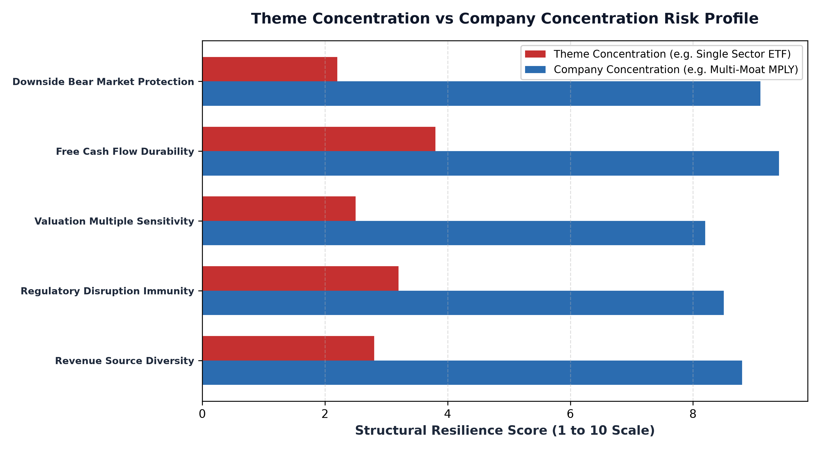
1. The Vulnerability of Thematic Concentration
Thematic investing has become one of Wall Street's most successful marketing engines. Fund sponsors launch specialized ETFs focused on clean energy, artificial intelligence, robotics, blockchain, or genomics, packaging forty to fifty stocks into a single product. Investors purchase these funds believing that owning fifty different companies shields them from single stock bankruptcy risk.
In reality, thematic concentration exposes the portfolio to extreme factor correlation. All fifty companies inside a single theme are tethered to the same macroeconomic variables: identical regulatory scrutiny, shared supply chain bottlenecks, interest rate sensitivity, and common valuation multiple compression. When the hype cycle cools or capital expenditure budgets contract, every stock in the thematic fund collapses simultaneously, often suffering seventy to eighty percent drawdowns.
2. Company Concentration Across Independent Economic Moats
Company concentration, by contrast, operates on an entirely different philosophy. Instead of concentrating capital into a narrow industry narrative, a disciplined active manager concentrates capital into exceptional individual businesses that possess insurmountable economic moats. The portfolio holds a limited number of positions, typically twenty five to thirty five companies, but each position represents a dominant franchise in a totally distinct economic arena.
Consider a portfolio that concentrates capital into a dominant transcontinental freight railway, an essential enterprise database platform, a regulated credit rating agency, and a global medical device provider. While the portfolio is concentrated by company count, the underlying revenue drivers are completely independent. A regulatory change impacting railway freight rates has zero economic bearing on enterprise software subscription renewals or credit rating issuance volume. Company concentration backed by moat diversity eliminates systemic thematic collapse.
3. Intrinsic Value Compounding vs Narrative Hype
The fatal flaw of thematic concentration is that it prioritizes narrative storytelling over cash flow reality. Many thematic funds are stuffed with unprofitable, early stage companies that possess zero pricing power and burn cash relentlessly. When speculative market regimes end, these concept stocks face severe liquidity crunches and aggressive equity dilution.
Company concentration, when executed with institutional discipline, focuses exclusively on proven, cash generative monopolies. These businesses possess massive return on invested capital, pristine balance sheets, and contractual pricing power that allows them to raise prices without shedding customer demand. While thematic funds swing wildly based on investor sentiment, concentrated monopoly portfolios compound intrinsic value steadily through tangible free cash flow generation.
4. The MPLY Mandate: Intentional Company Concentration
The power of active management lies in the ability to practice disciplined company concentration across independent, non correlated economic moats.
Investors interested in discovering how disciplined company concentration outperforms fragile thematic trends can examine the Strategy Shares Monopoly ETF (MPLY) at https://strategysharesetfs.com/mply/. MPLY rejects fragile single industry thematic fads. Instead, MPLY concentrates capital into 25 to 35 enduring corporate monopolies operating across diverse, mission critical sectors. By anchoring the portfolio to proven pricing power, fortress balance sheets, and insurmountable barriers to entry, MPLY captures the compounding power of exceptional businesses while avoiding the correlated risks of thematic concentration.
In institutional portfolio risk modeling, thematic concentration introduces acute obsolescence risk that differs fundamentally from single-company business risk. Specialized thematic funds, such as clean energy or robotics, frequently invest during the peak of the Gartner hype cycle, when market expectations and capital inflows are highest. As venture capital floods into the sector, rapid technological shifts often render early thematic leaders obsolete before they achieve sustainable free cash flow profitability.
Conversely, disciplined company concentration focuses on established market monopolists that have already solved the commercialization puzzle and dominate critical economic bottlenecks. These entrenched enterprises possess the free cash flow and distribution scale necessary to acquire emerging technological innovators, turning potential industry disruption into an accretive expansion of their existing economic moats.
5. Frequently Asked Questions
Q1: Is owning a thematic ETF with 50 holdings safer than owning an active ETF with 30 holdings?
No. A 50-stock thematic ETF is concentrated in a single industry theme with highly correlated risks. A 30-stock active ETF that holds dominant monopolies across diverse, non-correlated industries provides vastly superior economic diversification and downside protection.
Q2: How does company concentration affect long term portfolio turnover?
Disciplined company concentration in durable corporate monopolies typically results in very low portfolio turnover (15% to 25%), allowing intrinsic value compounding to compound without the frictional trading drag common to volatile thematic funds.
6. Sources
Morningstar, The Perils of Thematic ETF Concentration and Factor Correlation: https://www.morningstar.com/articles/moat-research
Harvard Business Review, Competitive Strategy, Moat Durability, and True Business Diversification: https://hbr.org/1979/03/how-competitive-forces-shape-strategy
#PortfolioConstruction #Diversification #Investing #Portfolio #MPLY

