Article 55:
Reinvestment Rate and the Mechanics of Long-Term Compounding
In the pantheon of fundamental equity valuation, few mathematical formulas hold as much profound significance for wealth creation as the simple relationship governing business compounding. In the words of legendary investor Charlie Munger, over the long term, it is hard for a stock to earn a much better return than the business which underlies it earns. If the business earns six percent on capital over forty years, you are not going to make much different than a six percent return, even if you buy it at a huge discount.
However, return on invested capital tells only half of the story. For an exceptional business to compound shareholder capital at extraordinary rates over multiple decades, it must possess two distinct engines: a superior return on invested capital and a high reinvestment rate compounding runway. When an elite enterprise pairs high ROIC with the capacity to redeploy massive sums of cash back into its economic moat, it creates the ultimate wealth compounding machine.
This institutional guide deconstructs the mathematical mechanics connecting reinvestment rates to long term intrinsic value expansion, explains why capital return alone cannot create compounding, and demonstrates how to identify premier corporate franchises capable of sustaining multi decade growth.
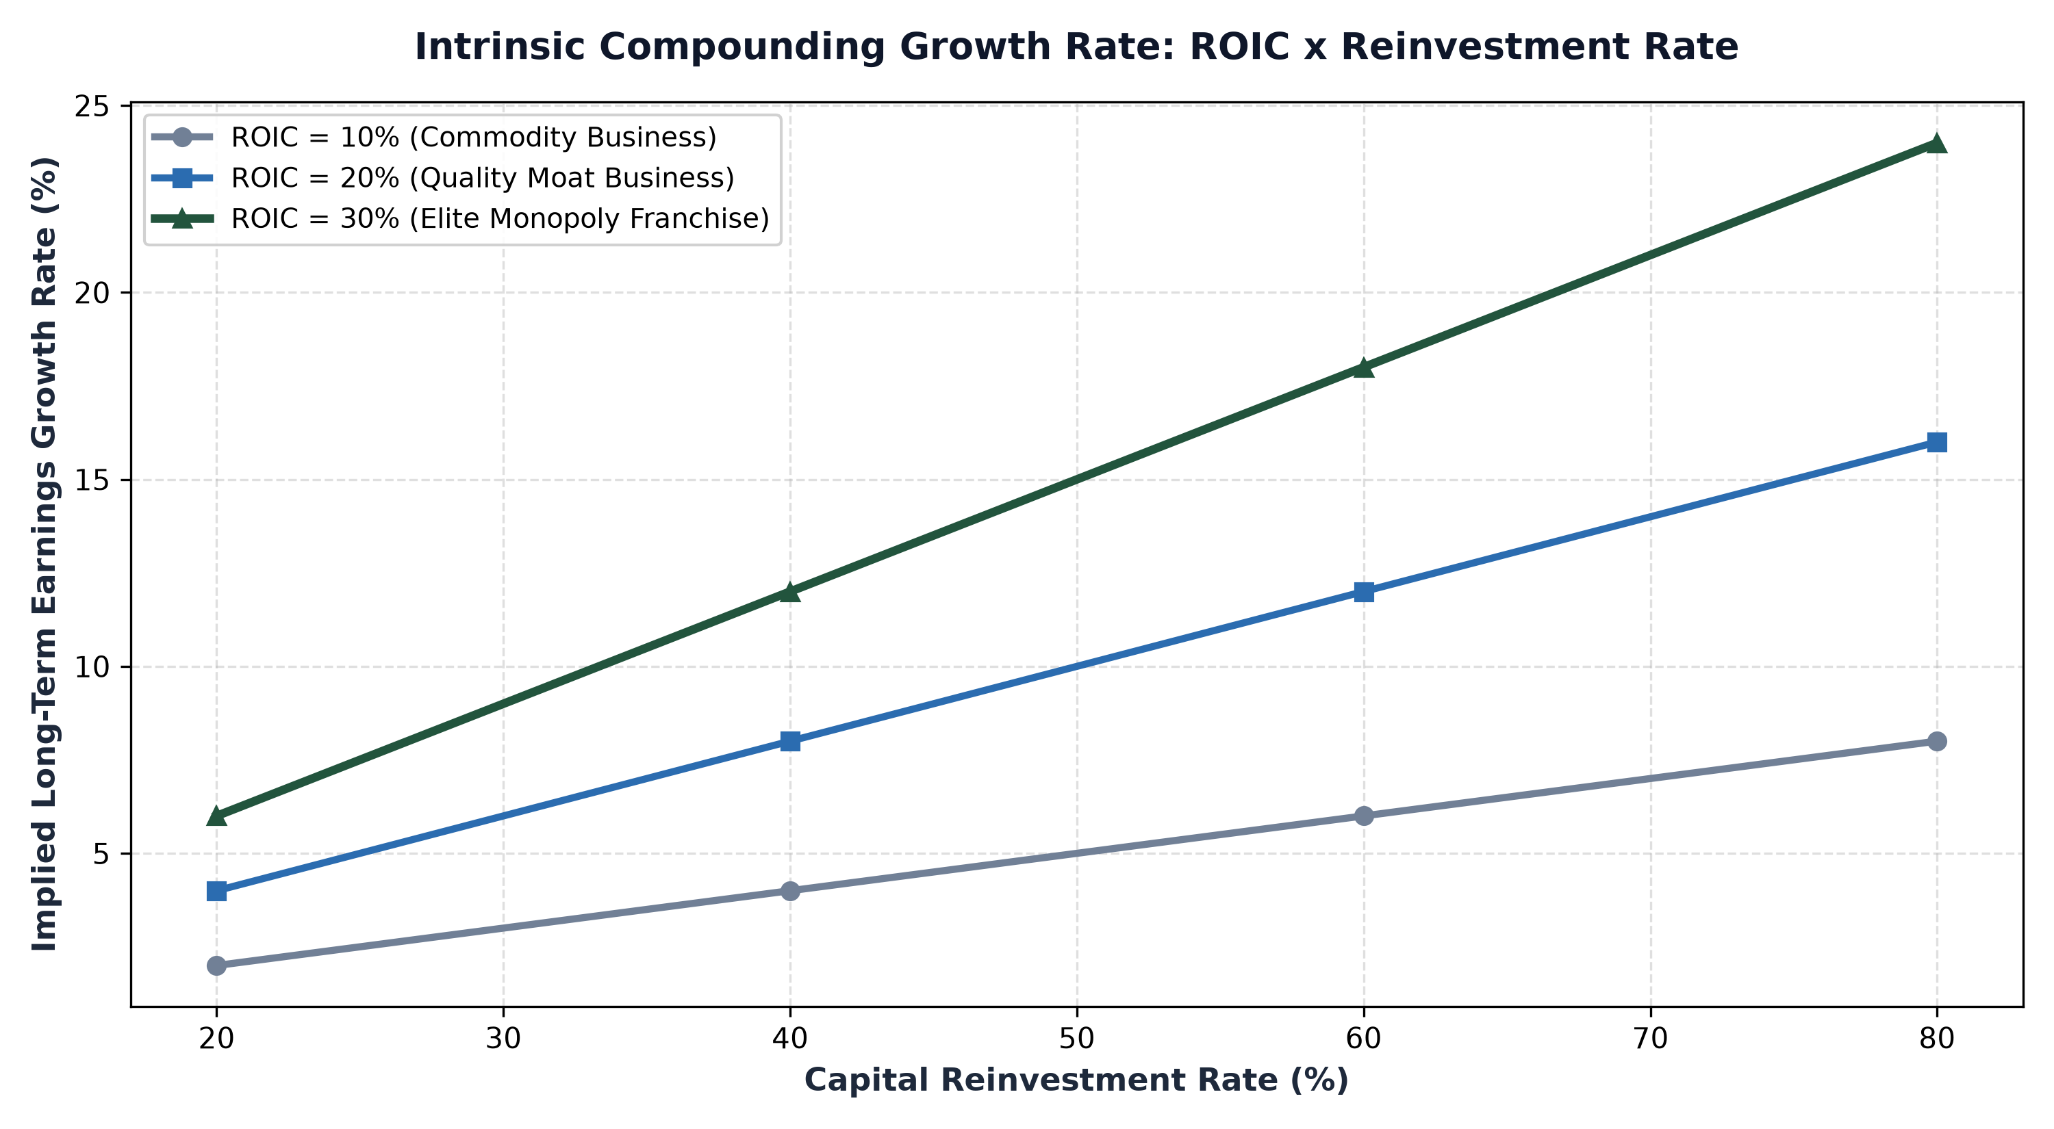
1. The Fundamental Compounding Equation: Growth = ROIC x Reinvestment
In corporate finance theory, the intrinsic growth rate of a company's earnings and free cash flow is governed by a precise mathematical equation: Growth equals Return on Invested Capital multiplied by the Reinvestment Rate. The reinvestment rate represents the percentage of net operating profit after tax that the business retains and reinvests into capital expenditures, research and development, and working capital.
Consider two contrasting enterprises. Company A generates a stellar 30% return on invested capital, but it operates in a saturated niche market where it can only reinvest 10% of its profits. Its intrinsic growth rate is limited to 3% annually (30% times 10%). While it throws off substantial cash, it cannot compound internally. Company B generates a 25% ROIC and possesses massive reinvestment runways, successfully redeploying 70% of its cash flow into expanding its network. Company B's intrinsic growth rate is 17.5% annually (25% times 70%), doubling its intrinsic value every four years.
2. The Dividend Trap vs Reinvestment runways
Many conservative retail investors succumb to the dividend trap. They seek out mature, low growth companies boasting high dividend yields of five to seven percent. While steady dividend income provides psychic comfort, a high dividend payout ratio is often an implicit admission by corporate management that they have exhausted profitable reinvestment opportunities within their business.
When a company distributes eighty percent of its earnings as dividends, its reinvestment rate is capped at twenty percent. Even with a respectable ROIC, the intrinsic growth of the enterprise slows to a crawl, and the investor must pay personal income taxes on the dividend distributions before manually reinvesting the remainder. True long term wealth compounding occurs when an exceptional business retains its cash flow and reinvests it tax free inside the corporate fortress at thirty percent returns.
3. Scaling Moats and the Reinvestment Runway
The rarest and most valuable asset in the corporate world is a long reinvestment runway. As companies grow larger, the law of diminishing returns inevitably exerts immense gravity. Most businesses eventually saturate their addressable markets, causing subsequent capital investments to yield steadily lower returns on capital.
Only enduring economic monopolies can reinvest billions of dollars annually while maintaining or expanding their return on invested capital. Monopolistic software platforms, global payment networks, and specialized healthcare infrastructure providers possess massive total addressable markets and strong network effects. Every dollar reinvested into expanding their ecosystem deepens customer switching costs, solidifies pricing power, and widens the competitive moat against potential entrants.
4. The MPLY Framework: Investing in Elite Reinvestment Compounding
Long term equity compounding requires actively identifying and holding businesses that possess both exceptional returns on capital and durable reinvestment opportunities.
Investors seeking access to premier corporate compounders built on superior capital allocation can explore the Strategy Shares Monopoly ETF (MPLY) at https://strategysharesetfs.com/mply/. MPLY is an actively managed ETF that purposefully concentrates capital into 25 to 35 enduring corporate monopolies. These market leaders combine high returns on invested capital with deep competitive runways, allowing them to redeploy cash flows into high margin growth and compound intrinsic shareholder value across multi decade investment horizons.
5. Frequently Asked Questions
Q1: Can a business with a low ROIC compound shareholder capital effectively?
No. If a company generates a return on invested capital below its weighted average cost of capital, reinvesting cash actually destroys shareholder value, because the cost of capital exceeds the return generated on new projects.
Q2: How can an investor calculate a company's reinvestment rate from financial statements?
The reinvestment rate is calculated by taking net capital expenditures (CapEx minus depreciation) plus the change in non-cash working capital, divided by Net Operating Profit After Tax (NOPAT).
6. Sources
Morningstar, The Mechanics of ROIC, Reinvestment Rates, and Long-Term Compounding: https://www.morningstar.com/articles/moat-research
Harvard Business Review, Capital Allocation Strategy, Reinvestment Runways, and Shareholder Value: https://hbr.org/1979/03/how-competitive-forces-shape-strategy
#LongTermInvesting #Compounding #Investing #Stocks #MPLY

