Article 56:
Revenue Growth Without Value Creation: What Can Go Wrong?
On Wall Street, no financial metric is as universally celebrated as top line revenue growth. When a public company announces twenty or thirty percent annualized revenue expansion, headline financial media outlets laud management, and speculative retail investors rush to bid up the stock price. Growth is intuitively equated with commercial success, corporate vitality, and expanding competitive market share.
Yet, one of the most vital principles in corporate finance is that revenue growth does not automatically equal shareholder value creation. In fact, when growth is pursued without financial discipline, it frequently acts as an accelerant of shareholder destruction. Examining the pathology of revenue growth without value creation exposes why companies can expand their operations dramatically while systematically eroding the intrinsic net worth of their investors.
This investigative analysis explores the mathematical relationship between the cost of capital and return on investment, details how unhedged expansion burns shareholder wealth, and explains why disciplined allocators prioritize profitable economic spread over raw top line scale.
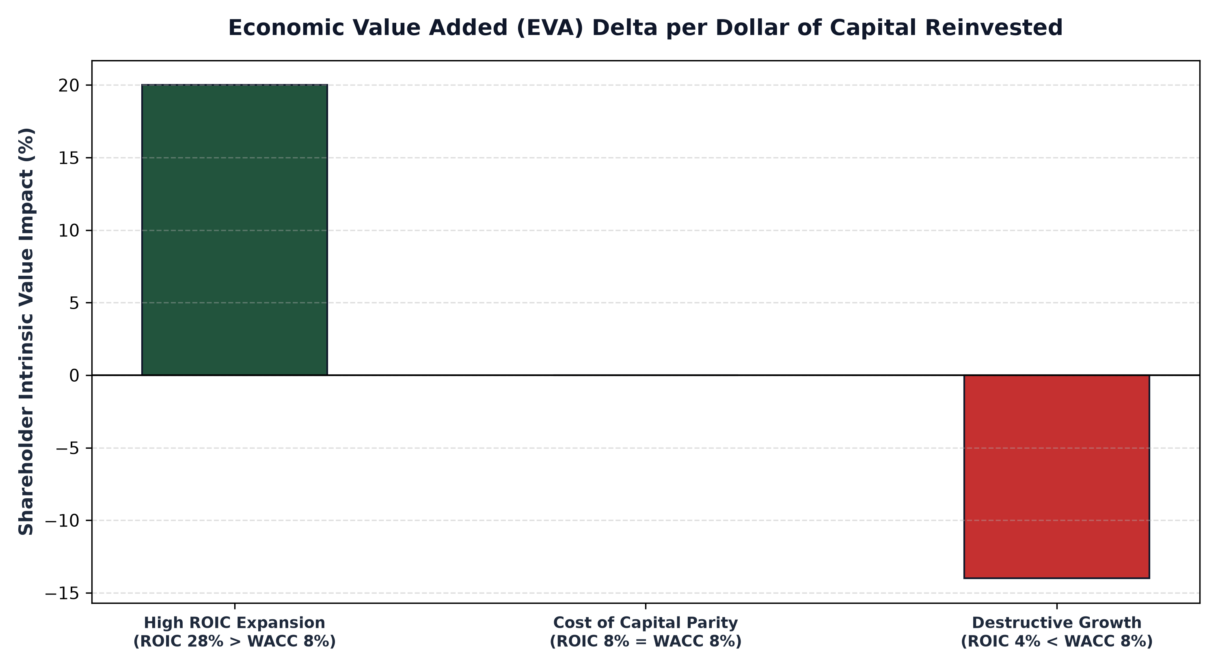
1. The Spread Equation: ROIC vs Weighted Average Cost of Capital
To understand value creation, an investor must evaluate the spread between a company's Return on Invested Capital (ROIC) and its Weighted Average Cost of Capital (WACC). Capital is not free; it carries an explicit cost represented by debt interest and an implicit opportunity cost demanded by equity shareholders. If an enterprise has a cost of capital of 9%, it must earn more than 9% on every new dollar invested to create economic value.
When a business earns 25% on invested capital while facing an 8% cost of capital, every dollar reinvested generates seventeen cents of net economic value added. In this scenario, faster growth is enormously beneficial, compounding intrinsic value exponentially. However, if a company generates an ROIC of only 5% while its cost of capital is 8%, each additional dollar of capital allocated destroys three cents of economic value. Rapid revenue growth in a sub-WACC business simply accelerates the rate of shareholder wealth destruction.
2. Common Traps: Customer Subsidies and Price Wars
How does a company generate massive revenue growth while failing to create value? The most common mechanism is subsidizing customer adoption. In competitive tech and consumer industries, companies frequently sell products or services below their true fully loaded economic cost. By burning hundreds of millions of dollars in venture debt on subsidized pricing and massive advertising campaigns, a firm can easily post 50% year over year revenue growth.
However, this revenue does not reflect genuine customer loyalty or a durable economic moat. The moment management attempts to raise prices to cover their cost of capital, price sensitive customers instantly defect to competitors. Furthermore, companies frequently pursue aggressive market share land grabs by engaging in destructive price wars, driving down industry operating margins and leaving all participants with bloated balance sheets and impaired returns on capital.
3. Capital Intensity and Working Capital Hemorrhage
Another primary driver of value destructive growth is extreme capital intensity. Certain industrial, telecommunications, and manufacturing businesses can grow revenues only by constructing massive physical facilities, purchasing expensive specialized machinery, and carrying enormous inventories. If these heavy investments fail to generate superior unit economics, the business faces a chronic cash flow hemorrhage.
As top line sales expand, the business is forced to continuously tap debt markets or execute dilutive secondary equity offerings just to fund ongoing maintenance CapEx and expanding working capital. The headline income statement shows rising revenues, but free cash flow remains perpetually negative, leaving common equity holders holding the bag when credit markets tighten.
4. The MPLY Framework: Growth Anchored in Economic Monopolies
Sophisticated fundamental investing rejects hollow top line growth, demanding that every percentage of expansion generates superior, durable economic value.
Investors seeking companies that combine robust growth with exceptional economic value creation can evaluate the Strategy Shares Monopoly ETF (MPLY) at https://strategysharesetfs.com/mply/. MPLY focuses exclusively on enduring corporate monopolies that possess massive spreads between ROIC and cost of capital. By concentrating capital into market leaders with contractual pricing power, high barriers to entry, and capital-light business models, MPLY ensures that revenue growth translates directly into expanding per-share intrinsic value.
From an institutional governance perspective, value-destructive revenue growth is frequently driven by misaligned executive compensation structures. Corporate boards often tie executive performance bonuses and stock grant vesting schedules to top-line revenue targets or gross transaction volume rather than return on capital or free cash flow per share. This perverse incentive structure encourages management to pursue dilutive acquisitions and customer subsidization schemes that inflate accounting revenue while destroying shareholder capital.
Experienced fundamental analysts counter this risk by examining corporate proxy filings (Form DEF 14A) to verify whether executive incentives are explicitly benchmarked against Return on Invested Capital and Economic Value Added. When management teams are compensated based on capital efficiency rather than raw revenue scale, corporate capital allocation remains disciplined, ensuring that growth translates into genuine intrinsic value expansion.
5. Frequently Asked Questions
Q1: Can an unprofitable company with high revenue growth ever create shareholder value?
Yes, provided the lack of current profitability is driven by high-return discretionary growth investments that possess clear unit economics, allowing the business to demonstrate massive operating leverage and high ROIC as it scales.
Q2: What is the single best financial metric to confirm that revenue growth is creating value?
Examine the trajectory of Free Cash Flow per share and Return on Invested Capital. If ROIC remains comfortably above the cost of capital while FCF per share expands alongside revenue, the growth is genuinely value accretive.
6. Sources
Morningstar, Economic Value Added and the Pitfalls of Unprofitable Growth: https://www.morningstar.com/articles/moat-research
Harvard Business Review, The Growth Imperative vs Return on Capital: https://hbr.org/1979/03/how-competitive-forces-shape-strategy
#LongTermInvesting #Compounding #Investing #Stocks #MPLY

