Article 57:
Acquisitive Growth vs Organic Growth: What Investors Should Examine
When analyzing corporate earnings announcements, investors routinely scan the headline percentage increase in total revenue. A company that posts 15% top line growth is typically greeted with positive analyst revisions and investor accolades. However, seasoned fundamental analysts know that the critical question is not how fast the business grew, but the exact mechanism through which that growth was achieved.
Corporate expansion occurs through two fundamentally distinct avenues: organic growth generated internally through core product demand, and acquisitive growth purchased externally through corporate mergers and acquisitions. Navigating acquisitive growth vs organic growth is one of the most critical competencies in equity research, separating authentic economic compounders from debt fueled financial engineering schemes.
This comprehensive guide examines the structural differences between organic and acquisitive growth, details the severe accounting traps hidden within M&A rollups, and outlines how disciplined investors evaluate corporate capital allocation.
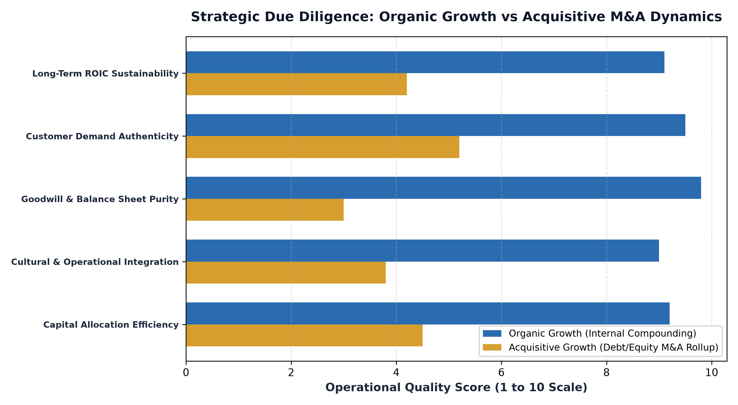
1. The Purity of Organic Growth
Organic growth represents the ultimate validation of a company's product, service, and economic moat. Organic growth occurs when an enterprise expands revenues by winning new customers, expanding volume within existing accounts, launching internally developed products, or raising prices on an inelastic customer base. Because organic expansion is driven by genuine market demand, it requires zero external corporate surgery.
Organic growth is exceptionally capital efficient. When a software provider or payment processor adds millions of transactions to an existing infrastructure, incremental gross margins routinely exceed eighty percent. This operating leverage generates massive free cash flow conversion without burdening the balance sheet with high debt loads, executive retention bonuses, or massive goodwill balances. Organic compounders control their own destiny.
2. The Mirage and Hazards of Serial Acquisitive Growth
Acquisitive growth, by contrast, involves buying revenue from third parties. A company issues debt or dilutes existing shareholders with newly minted stock to acquire smaller competitors, instantly folding their sales figures into consolidated financial reports. On paper, the company appears to be growing at a torrid pace, frequently masking an underlying stagnation in its legacy business.
Serial acquirers, often termed rollups, carry immense structural risks. Academic studies consistently demonstrate that between seventy and ninety percent of corporate mergers fail to deliver their promised financial synergies. Acquirers frequently overpay in competitive bidding wars, saddling the balance sheet with bloated goodwill assets. Furthermore, integrating disparate software systems, incompatible corporate cultures, and misaligned sales forces creates massive friction that often leads to catastrophic post merger customer churn.
3. Accounting Sleights of Hand: Masking Organic Decay
Aggressive corporate executives frequently exploit acquisition accounting to manipulate financial performance. In the quarters immediately following an acquisition, management can write down inventory values, create restructuring reserves, and capitalize operating expenses, artificially suppressing costs to manufacture temporary post closing earnings spikes.
To detect these accounting games, forensic allocators scrutinize pro-forma organic growth disclosures. If a company reports 20% consolidated revenue growth, but pro-forma same store organic sales grew by only 1%, the business is essentially treading water. The moment the company stops acquiring new targets, the illusion of growth evaporates, goodwill impairments hit the income statement, and the stock valuation multiple collapses.
4. The MPLY Standard: Dominant Organic Franchises
Long term compounding thrives when portfolios are built around companies that compound organically through insurmountable competitive moats.
Investors seeking high conviction access to corporate leaders with proven organic compounding power can explore the Strategy Shares Monopoly ETF (MPLY) at https://strategysharesetfs.com/mply/. MPLY is an actively managed ETF that purposefully concentrates capital into 25 to 35 enduring corporate monopolies. These industry titans dominate their respective sectors through essential services, powerful network effects, and unassailable pricing power, driving consistent organic revenue expansion without relying on dilutive or risky corporate M&A rollups.
In forensic M&A auditing, institutional allocators pay particular attention to purchase price allocation (PPA) accounting and the creation of intangible assets. When an acquisitive company pays a large premium over book value, accountants categorize the excess into goodwill and identifiable intangibles, such as customer relationships and proprietary technology. Acquisitive management teams frequently amortize these intangibles over aggressive multi-decade timelines, artificially suppressing annual depreciation expense to boost reported adjusted operating earnings.
To strip away this accounting distortion, disciplined investors evaluate free cash flow conversion relative to reported net income over five-year trailing periods. Pure organic compounders consistently convert over ninety to one hundred percent of net income into tangible free cash flow, whereas serial acquirers show chronic divergences between headline accounting profits and actual cash generated.
5. Frequently Asked Questions
Q1: Are all corporate acquisitions destructive to shareholder value?
No. Disciplined programmatic acquisitions, such as small bolt-on deals that instantly leverage an established global distribution network, can be highly value accretive. Large mega-mergers, however, carry statistically dismal success rates.
Q2: How can an investor calculate true organic growth from SEC filings?
Investors must subtract the revenue contributed by businesses acquired over the trailing twelve months and adjust for foreign currency fluctuations, comparing legacy same-store revenue directly against the prior year baseline.
6. Sources
Morningstar, The Accounting Reality of Organic vs Acquisitive Corporate Growth: https://www.morningstar.com/articles/moat-research
Harvard Business Review, The High Failure Rate of Mergers and the Power of Organic Compounding: https://hbr.org/1979/03/how-competitive-forces-shape-strategy
#LongTermInvesting #Compounding #Investing #Stocks #MPLY

