Article 58:
How to Evaluate Growth After an Acquisition
In the corporate boardroom, the announcement of a multi billion dollar acquisition is greeted with celebration. Press releases boast of transformational market expansion, immediate strategic synergies, and substantial financial accretion. Executive presentations project optimistic models depicting expanded market reach and surging cross selling opportunities. Yet, for independent investors, the closing of an acquisition marks the beginning of an intense period of financial skepticism.
Once the deal closes, the promotional narrative must confront the brutal operational realities of integration. Navigating post acquisition growth analysis requires stripping away corporate public relations and auditing whether the acquisition is genuinely accelerating sustainable intrinsic value or serving as an expensive distraction that dilutes core corporate returns.
This investigative guide presents a forensic framework for tracking corporate growth following an acquisition, details the critical warning signs of botched integration, and explains how disciplined allocators evaluate long term M&A success.
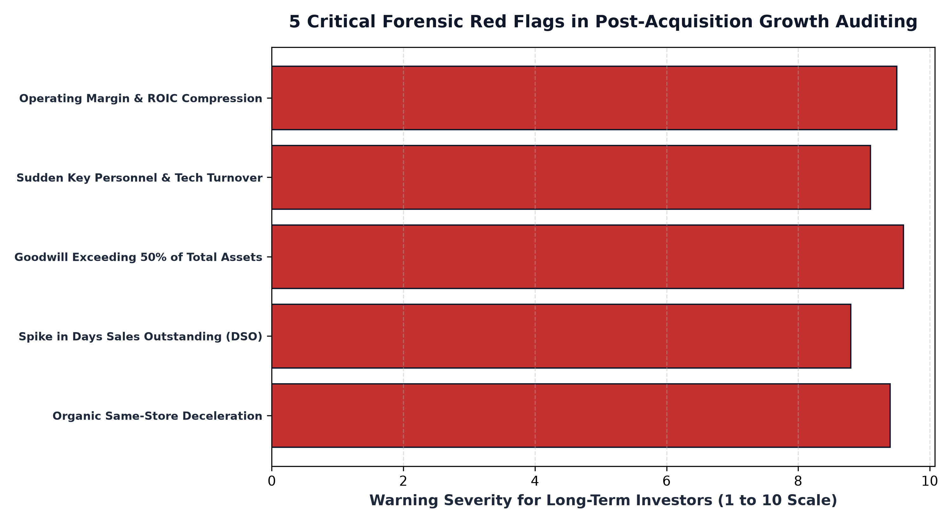
1. Tracking Pro-Forma Organic Revenue Trajectory
The first step in evaluating post acquisition performance is isolating pro-forma organic growth. Under SEC reporting rules, companies must disclose pro-forma financial statements that illustrate what combined revenues would have been had the acquisition closed at the beginning of the prior fiscal period. This baseline allows an investor to calculate true same-store sales growth for the combined entity.
If management projects 15% synergy growth but pro-forma revenues decelerate to 2% within four quarters of closing, integration friction is actively sabotaging customer retention. Acquired sales forces often struggle with new pricing structures or become demoralized by bureaucratic reorganizations, leading key enterprise clients to defect to nimble competitors. A deceleration in pro-forma sales is the earliest warning sign of a failed merger.
2. Forensic Scrutiny of Margins and ROIC Dilution
Synergies are easy to project in pitch decks but notoriously difficult to realize in operations. Corporate acquirers routinely promise tens of millions of dollars in cost savings by eliminating overlapping administrative staff, consolidating data centers, and renegotiating vendor contracts. If these synergies are authentic, operating margins should expand within six to eighteen months following closing.
If operating margins instead compress and return on invested capital declines, the acquisition is eroding corporate quality. When an acquirer pays a massive premium for a target, that premium is capitalized on the balance sheet as goodwill. This expanded capital base means the company must generate significantly higher operating profits simply to maintain its historical ROIC. If profits lag while capital bloats, shareholder value is being systematically diluted.
3. Balance Sheet Quality: Goodwill Ballooning and Working Capital
A healthy business possesses an unencumbered balance sheet dominated by tangible productive assets and cash reserves. When an investor observes goodwill expanding to represent more than forty or fifty percent of total corporate assets, the balance sheet has become highly speculative. Goodwill is essentially accounting air: the capitalized expectation of future excess profits.
If the acquired business fails to deliver on projected cash flows, GAAP accounting requires management to write down goodwill through massive non-cash impairment charges. While commentators dismiss impairments as non-cash historical adjustments, they represent formal corporate confessions that hundreds of millions of dollars of shareholder capital were permanently destroyed in poorly conceived M&A.
4. The MPLY Framework: Focus on Pure-Play Monopolies
Investing in high conviction businesses means prioritizing companies that dominate their fields through internal excellence rather than risky corporate empire building.
Investors looking to avoid the hazards of post acquisition integration failures can examine the Strategy Shares Monopoly ETF (MPLY) at https://strategysharesetfs.com/mply/. MPLY is an actively managed ETF that purposefully concentrates capital into 25 to 35 enduring corporate monopolies. By focusing on market leaders with established economic moats, pristine balance sheets, and proven organic pricing power, MPLY eliminates exposure to fragile corporate rollups, anchoring shareholder capital to sustainable intrinsic value compounding.
A critical warning indicator in post-acquisition forensic analysis is tracking key technical and executive talent retention within acquired subsidiaries. In enterprise software and specialized manufacturing, the primary asset purchased is often the institutional knowledge and engineering capability of key personnel. If an acquirer imposes heavy bureaucratic reporting structures and cultural standardization, key innovators frequently depart within twelve to eighteen months of closing.
This brain drain leaves the parent company with depreciating software assets and deteriorating customer service, leading to silent customer attrition. Sophisticated equity researchers monitor professional networking platforms and industry feedback loops to detect executive departures well before the resulting revenue erosion manifests in quarterly financial statements.
5. Frequently Asked Questions
Q1: How long does it typically take to determine whether an acquisition was successful?
Forensic financial analysts evaluate acquisitions over a full two to three year window. While short term disruptions are normal in year one, by year three, pro-forma organic growth, operating margins, and return on invested capital clearly reveal the true economic outcome.
Q2: What is the significance of rising Days Sales Outstanding (DSO) after a merger?
A sudden spike in DSO indicates that the combined company is having difficulty collecting payments from acquired customers or is offering aggressive credit terms to artificially inflate post-merger sales volume.
6. Sources
Morningstar, Post-Merger Integration and Financial Statement Forensic Analysis: https://www.morningstar.com/articles/moat-research
Harvard Business Review, The M&A Trap: Why Acquisitions Fail and How to Spot It Early: https://hbr.org/1979/03/how-competitive-forces-shape-strategy
#LongTermInvesting #Compounding #Investing #Stocks #MPLY

