Article 59:
A KPI Dashboard for Tracking an Economic Moat
In fundamental equity analysis, the concept of an economic moat is widely celebrated as the ultimate hallmark of investment excellence. Coined by Warren Buffett, an economic moat describes a business's structural ability to maintain sustainable competitive advantages that protect its profits and market share from competing predators. Investors routinely seek out moats, knowing that durable barriers to entry drive multi decade wealth compounding.
However, identifying a competitive moat at a single snapshot in time is not enough. Competitive advantages are dynamic economic organisms: they either widen or narrow over time under the relentless pressure of technological innovation, regulatory changes, and capital competition. Developing a quantitative economic moat KPI dashboard allows allocators to track the structural health of a business with precision, identifying deterioration years before it appears in headline earnings.
This institutional guide deconstructs the five essential financial and operational key performance indicators that form an elite moat monitoring dashboard, explaining how disciplined investors verify competitive durability across market cycles.
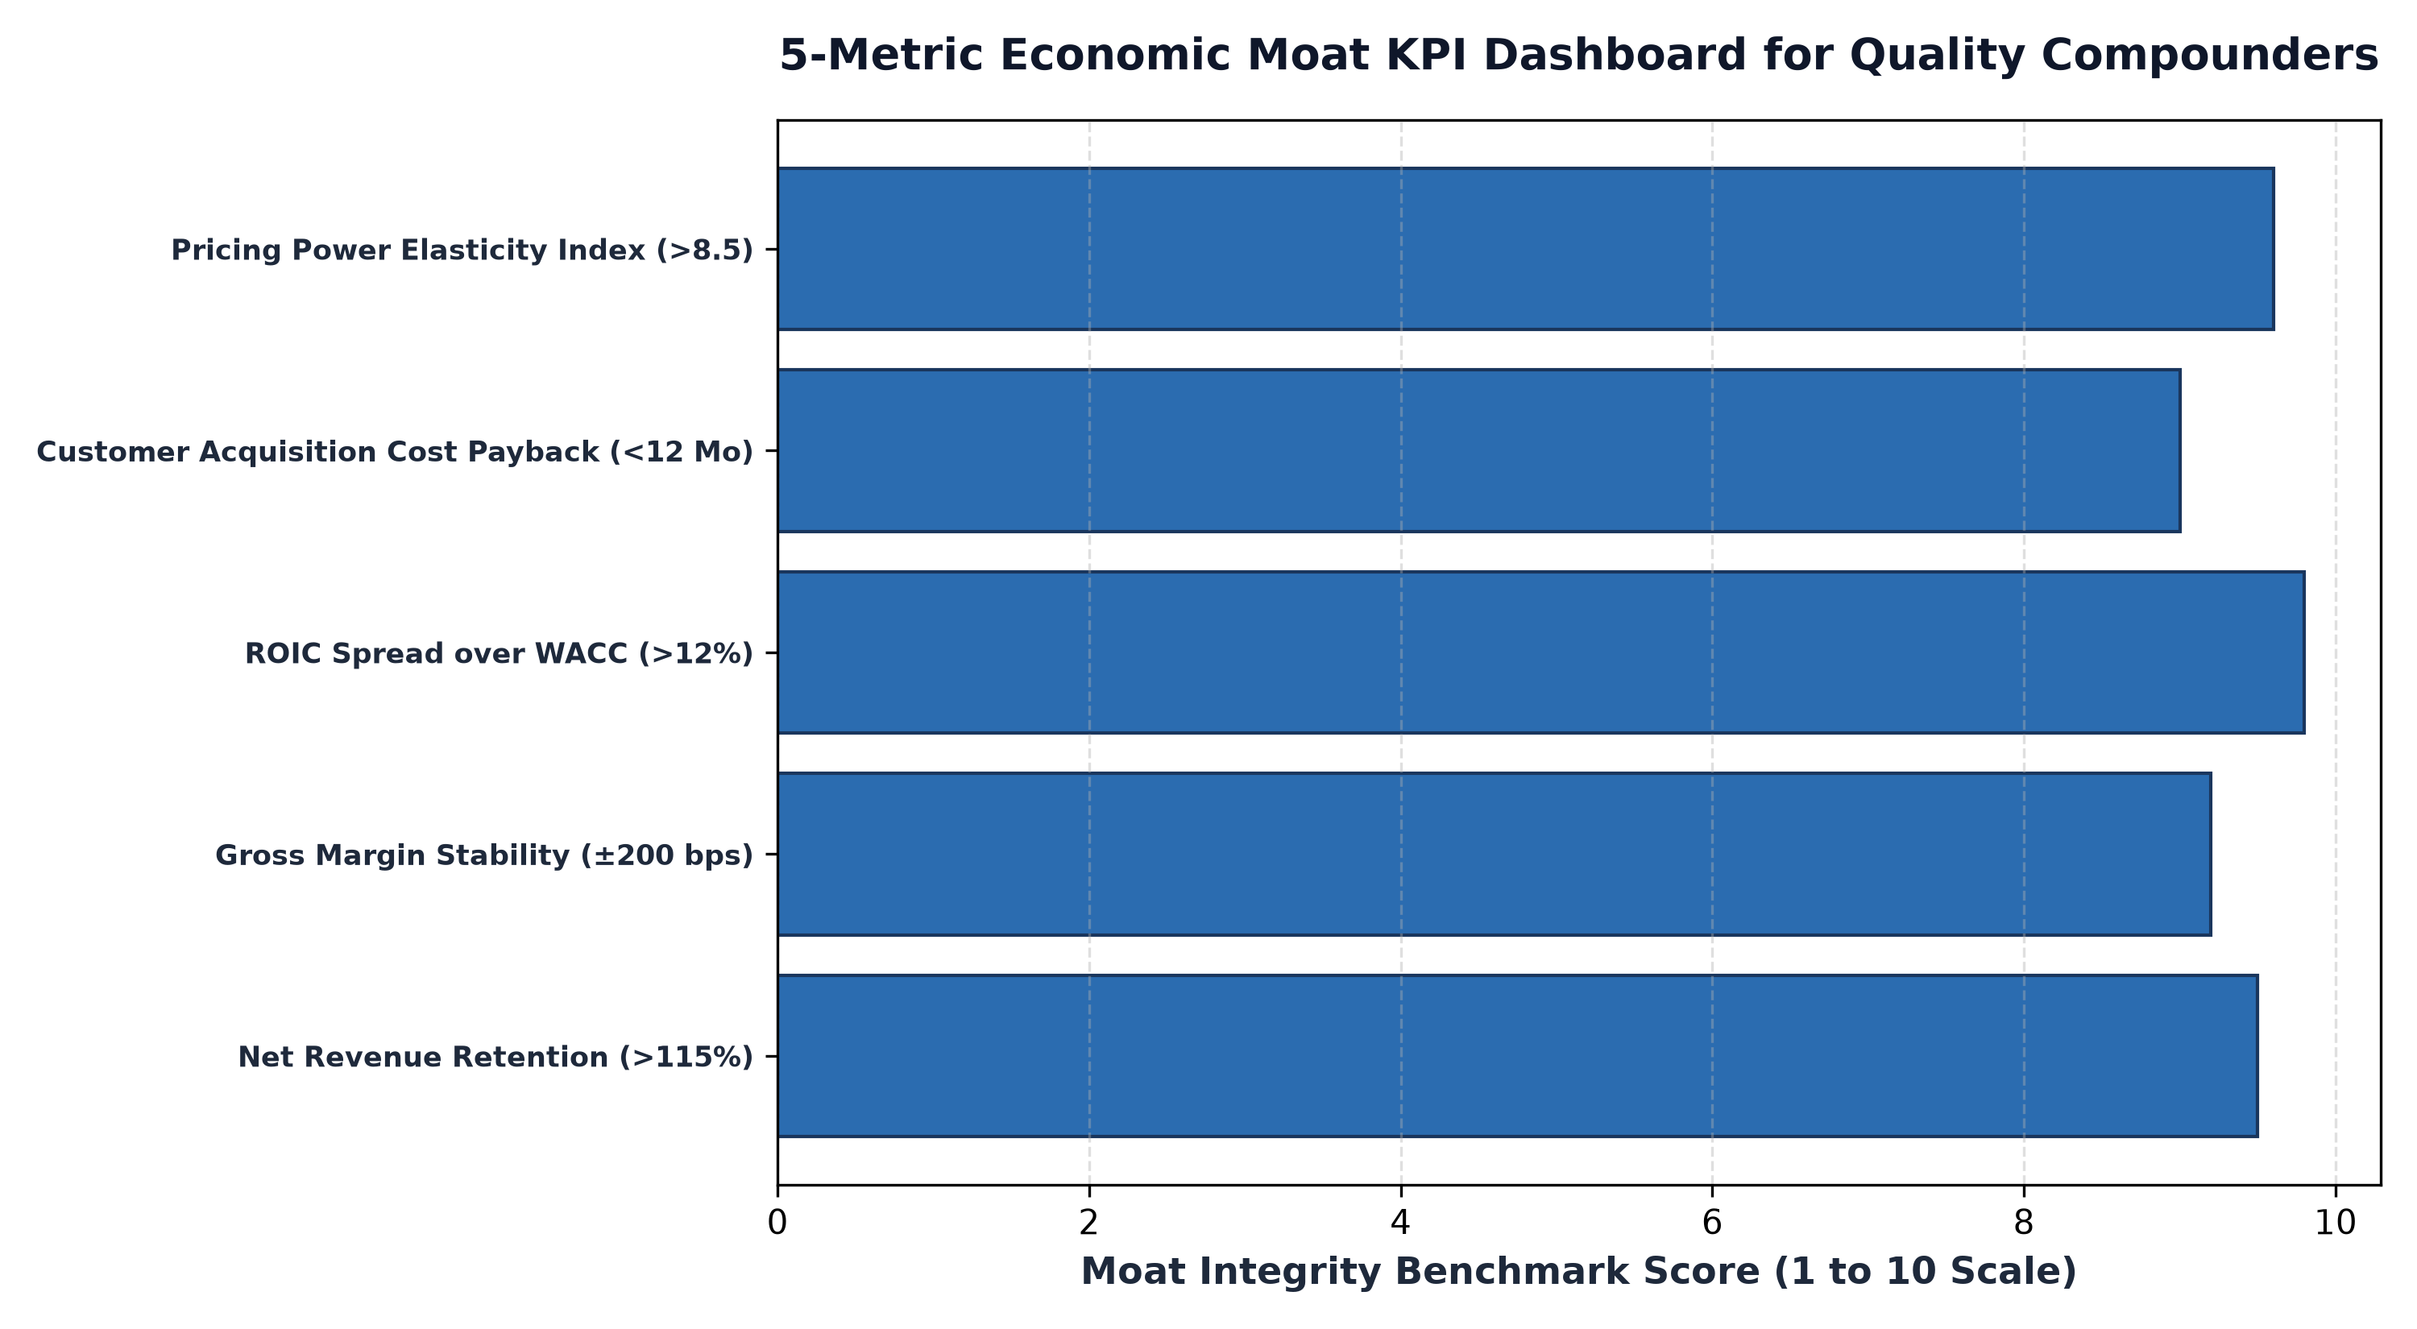
1. Metric 1: Net Revenue Retention and Switching Costs
The most definitive indicator of high switching costs and customer lock-in is Net Revenue Retention (NRR). NRR measures the percentage of recurring revenue retained from existing customers over a trailing twelve month period, accounting for customer expansion, upsells, cross sells, and cancellations. A company with an NRR of 100% is retaining all of its revenue; an NRR above 115% means existing customers are expanding their spending significantly.
When an enterprise demonstrates an NRR of 120% or higher year after year, it confirms that its products are deeply integrated into the client's operational architecture. Ripping out and replacing the software or service would create catastrophic operational disruption, granting the business immense pricing power. If NRR begins to trend downward toward 95%, it serves as a critical warning that competitors are successfully encroaching on the moat.
2. Metric 2: Gross Margin Resilience Under Inflationary Pressure
Pricing power is the acid test of an economic moat. When input costs surge due to labor inflation, raw material shortages, or supply chain bottlenecks, a commodity business is forced to absorb cost increases, suffering severe gross margin compression. By contrast, a business possessing an authentic economic moat passes cost increases onto customers without suffering demand destruction.
Tracking gross margin stability across multi year macroeconomic cycles provides an unvarnished audit of pricing power. An elite corporate monopoly exhibits gross margins that remain stable or expand even during acute inflationary spikes. If a company claims to have an unbeatable brand or proprietary technology but its gross margins contract by four hundred basis points during an inflation wave, its pricing power is illusory.
3. Metric 3: Return on Invested Capital Spread Over WACC
While operational KPIs track customer behavior, the ultimate financial validation of an economic moat is Return on Invested Capital (ROIC) spread over the Weighted Average Cost of Capital (WACC). Economic theory dictates that in competitive markets, excess profits inevitably attract capital, which increases supply and drives returns on capital down toward the cost of capital.
A persistent ROIC spread exceeding ten to fifteen percentage points over a decade or longer is mathematical proof that an insurmountable barrier to entry exists. Capital cannot enter the market to compete away excess returns. Tracking this spread ensures that management is not diluting corporate quality through capital intensive, low return vanity projects.
4. The MPLY Standard: Monopolies Audited by Moat Metrics
High conviction active management requires continuous, rigorous tracking of economic moat health across every single portfolio position.
Investors interested in discovering how disciplined moat tracking is integrated into an active ETF strategy can examine the Strategy Shares Monopoly ETF (MPLY) at https://strategysharesetfs.com/mply/. MPLY is an actively managed ETF that purposefully concentrates capital into 25 to 35 enduring corporate monopolies. By utilizing quantitative and qualitative moat metrics, MPLY continuously audits each holding's pricing power, return on invested capital, and market dominance, ensuring that shareholder capital remains anchored to companies whose competitive moats are actively widening.
Beyond trailing financial metrics, institutional moat analysis incorporates Incremental Return on Invested Capital (iROIC). While standard ROIC measures the return on all historical capital accumulated over the life of the business, iROIC measures the efficiency of capital deployed specifically over the trailing three to five years. It is calculated by dividing the change in Net Operating Profit After Tax by the change in invested capital over the period.
Tracking iROIC reveals whether an economic moat is widening or decaying in real time. If a company boasts a historical ROIC of 22% but its three-year incremental ROIC drops to 8%, it indicates that newly deployed capital is facing diminishing returns, signaling that the competitive moat is beginning to narrow despite strong trailing headlines.
5. Frequently Asked Questions
Q1: How frequently should an investor update an economic moat KPI dashboard?
Investors should update financial metrics quarterly following corporate earnings releases, while monitoring broader industry competitive dynamics and customer retention indicators on an ongoing continuous basis.
Q2: Can an economic moat disappear quickly?
While infrastructural moats (such as railways or pipeline networks) erode very slowly, technological moats can deteriorate rapidly if management fails to anticipate architectural platform shifts or regulatory antitrust interventions.
6. Sources
Morningstar, The Quantitative Framework for Evaluating Economic Moats: https://www.morningstar.com/articles/moat-research
Harvard Business Review, Competitive Strategy and the Dynamics of Sustainable Advantage: https://hbr.org/1979/03/how-competitive-forces-shape-strategy
#LongTermInvesting #Compounding #Investing #Stocks #MPLY

