Article 60:
Industry Structure and Long-Term Competitive Advantage
When investors analyze potential equity investments, they often devote enormous energy to scrutinizing individual management teams, evaluating recent product innovations, or forecasting quarterly earnings beats. These microeconomic factors are important, but they operate within a far more powerful macroeconomic reality: the structural architecture of the industry itself. In business, a brilliant management team operating in a structurally flawed industry will almost always be defeated by industry economics.
As legendary investor Warren Buffett famously observed, when a management team with a reputation for brilliance tackles a business with a reputation for bad economics, it is the reputation of the business that remains intact. Understanding industry structure competitive advantage provides the foundational lens through which allocators can identify which sectors are structurally destined to generate exceptional returns and which are condemned to perpetual capital destruction.
This institutional guide explores the mechanics of industrial economics, explains why fragmented markets destroy capital while concentrated structures generate durable profits, and demonstrates how allocating to structural monopolies delivers superior compounding.
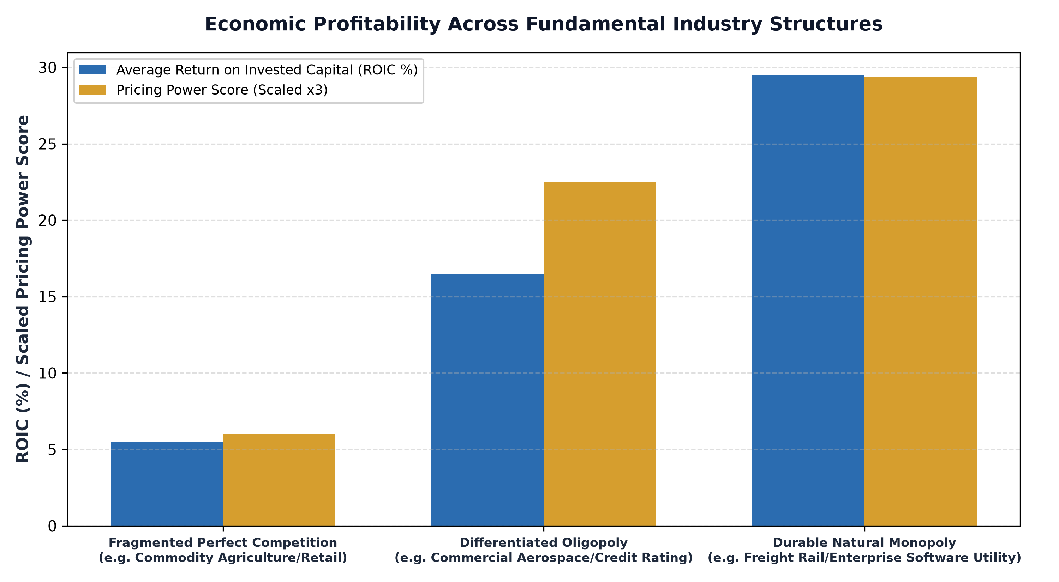
1. The Spectrum of Industry Economics: Fragmentation vs Consolidation
Industrial economics categorizes market structures along a spectrum ranging from perfect competition to pure monopoly. In fragmented industries characterized by hundreds of small competitors, low barriers to entry, and undifferentiated commodity products, no single participant possesses pricing power. Whenever profits rise, new entrants flood the market, expanding supply and driving prices down to marginal cost.
Businesses in fragmented sectors are price takers. They must endure brutal price wars, absorb rising labor and material costs, and earn chronically low returns on capital. By contrast, concentrated industry structures, such as rational duopolies and oligopolies, operate with vastly superior economic discipline. When an industry consolidates to two or three dominant players protected by massive capital barriers, competitive warfare gives way to tacit rational competition, stable pricing power, and superior profit margins.
2. Michael Porter's Five Forces and Economic Rents
The definitive framework for analyzing industrial architecture is Harvard Business School Professor Michael Porter's Five Forces model. Porter demonstrated that industry profitability is not determined by whether the industry is high tech or low tech, growing quickly or slowly; it is determined by the balance of power across five structural forces: threat of new entrants, bargaining power of suppliers, bargaining power of buyers, threat of substitute products, and competitive rivalry.
An industry structure that generates sustainable economic rents exhibits insurmountable barriers to entry (such as massive capital costs or regulatory licenses), highly fragmented buyers who cannot negotiate prices, suppliers with zero leverage, and no viable economic substitutes. When all five forces tilt decisively in favor of the incumbents, the industry functions as a legalized tollbooth, allowing dominant operators to extract superior returns on capital across multiple business cycles.
3. The Durability of Natural Monopolies and Regulated Networks
At the pinnacle of favorable industry structures resides the natural monopoly. A natural monopoly exists when the minimum efficient scale of operation is so large relative to total market demand that a single firm can supply the entire market at a lower average unit cost than two or more competing firms could. Duplicating the physical infrastructure would be economically irrational and practically impossible.
Transcontinental freight railway networks, regional pipeline systems, and specialized financial market exchanges are classic natural monopolies. A competitor cannot build a parallel railway track across North America; the capital expenditure would be astronomical, and environmental permits would never be granted. As a result, the incumbent enjoys permanent structural insulation from competitive entry, translating structural industry dominance into an enduring compounding machine.
4. The MPLY Mandate: Anchoring Capital in Structural Monopolies
Successful long term investing requires prioritizing companies whose business success is guaranteed by the unyielding economics of favorable industry structures.
Investors seeking high conviction access to companies operating within the world's most lucrative industry structures can explore the Strategy Shares Monopoly ETF (MPLY) at https://strategysharesetfs.com/mply/. MPLY is an actively managed ETF that purposefully concentrates capital into 25 to 35 enduring corporate monopolies. By screening for businesses operating in highly consolidated industries with insurmountable barriers to entry and strong pricing power, MPLY ensures that shareholder capital is protected by structural industry economics rather than fragile short term operational execution.
In industrial economics and game theory, consolidated market structures achieve stability through what economists term a repeated-game Nash equilibrium. In concentrated industries with two or three dominant participants, such as commercial aerospace or global credit rating services, each firm recognizes that initiating a price war is mutually destructive. Instead of competing on price, dominant players compete through product reliability, long-term service contracts, and technological integration.
This structural stability creates an enduring pricing umbrella, allowing all industry incumbents to earn economic profits far in excess of the cost of capital. Allocating capital to businesses operating within these consolidated market structures provides investors with an enduring competitive moat that is inherently protected by market architecture rather than transient managerial execution.
5. Frequently Asked Questions
Q1: Can industry structure change over time?
Yes. Technological disruption (such as digital streaming disrupting cable distribution) or major antitrust regulatory shifts can alter industry dynamics, which is why active managers continuously evaluate competitive forces.
Q2: Why do technology platforms often develop into natural monopolies?
Digital technology platforms benefit from powerful network effects and near zero marginal costs. As more users join the platform, the service becomes exponentially more valuable to all users, creating winner-take-all industry structures that lock out competitors.
6. Sources
Morningstar, Industry Structure, Competitive Dynamics, and Economic Moat Analysis: https://www.morningstar.com/articles/moat-research
Harvard Business Review, The Five Competitive Forces That Shape Strategy: https://hbr.org/1979/03/how-competitive-forces-shape-strategy
#LongTermInvesting #Compounding #Investing #Stocks #MPLY

