Article 61:
How Reinvestment Returns Influence Long-Term Business Value
In the domain of long term equity valuation, public market investors often devote disproportionate attention to entry multiples. Financial commentators debate endlessly whether paying twenty times or twenty five times price to earnings is justifiable for a growing company. While purchase price unquestionably impacts near term returns, over multi decade holding periods, an entirely different financial force dominates the equation: the rate of return achieved on retained capital.
Every fiscal year, corporate management faces a profound capital allocation decision: should cash flow be returned to shareholders through dividends and share buybacks, or retained and deployed into business expansion? The economic return achieved on those redeployed dollars determines whether intrinsic value expands exponentially or stagnates into mediocrity. Understanding how reinvestment returns business value separates superficial stock pickers from sophisticated business analysts.
This comprehensive analysis examines the mathematics of incremental capital deployment, explains why high incremental returns create immense shareholder value, and demonstrates how elite corporate monopolies sustain exceptional reinvestment rates over decades.
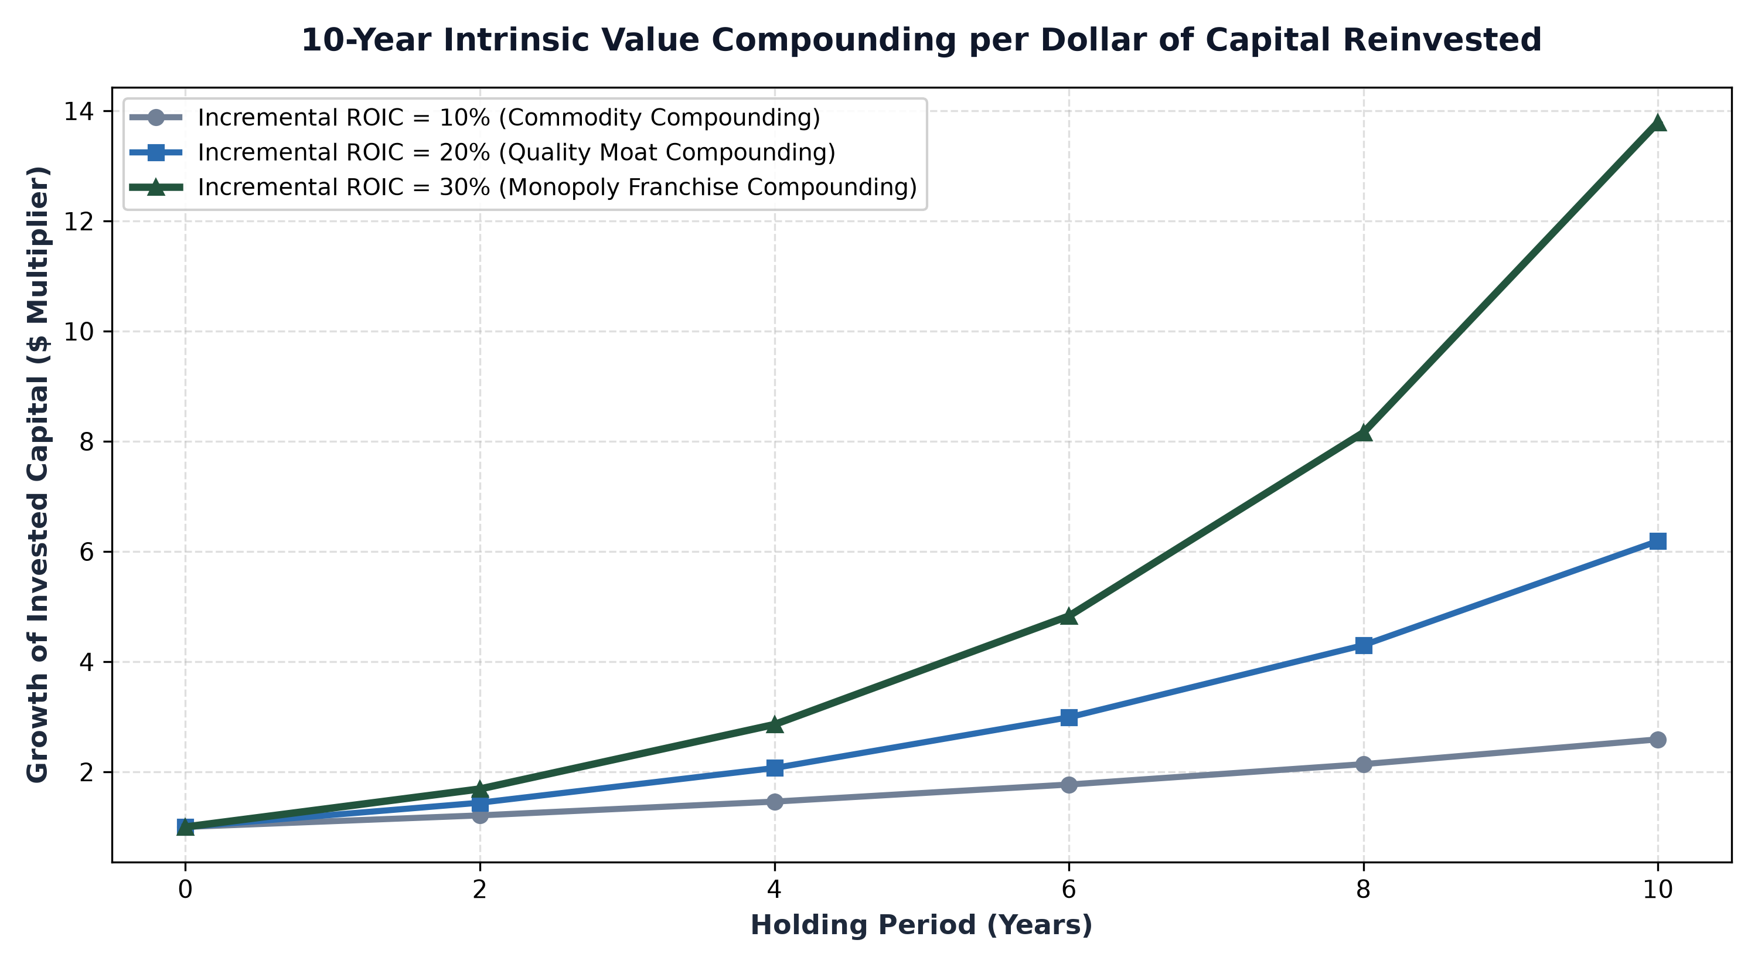
1. The Engine of Incremental Capital: Measuring iROIC
While standard Return on Invested Capital (ROIC) evaluates the aggregate profitability of all historical capital invested in a business, forward looking equity analysis requires isolating Incremental Return on Invested Capital (iROIC). Incremental ROIC measures the additional operating profit generated for every new dollar of capital deployed into capital expenditures, research and development, and working capital over a specific timeframe.
The mathematical divergence between average ROIC and incremental ROIC is where business fortunes are made or lost. A company may show a pristine historical ROIC of 25% built on assets constructed decades ago. However, if modern reinvestment opportunities yield only 8%, the core compounding engine is grinding to a halt. Conversely, a business that consistently generates an incremental ROIC of 25% to 35% on newly deployed capital compounds intrinsic shareholder value at an extraordinary velocity, rendering short term entry valuation multiples secondary to long term earnings power.
2. Capital Retention: Value Multiplier vs Cash Destruction
Corporate capital allocation must always be judged against the corporate cost of capital. When an executive team reinvests retained earnings at rates exceeding twenty percent, retaining cash creates enormous economic value. Each retained dollar is transformed into three, five, or ten dollars of present value, compounding tax free within the corporate fortress.
However, when management retains cash in a business that achieves low incremental returns, the retention actively destroys shareholder net worth. In capital intensive, commoditized industries, management teams routinely reinvest billions of dollars simply to maintain parity with aggressive competitors. Because new investments yield returns below the cost of capital, every reinvested dollar destroys economic value. In such enterprises, true shareholder stewardship demands returning 100% of free cash flow to investors rather than funding low return corporate expansion.
3. The Rarity of the Multi-Decade Reinvestment Runway
Generating exceptional incremental returns for a few years is relatively common; sustaining those returns across twenty or thirty years is extraordinarily rare. Most expanding companies inevitably exhaust their addressable market, forcing subsequent reinvestment capital into marginal, lower return projects. As capital deployment expands, incremental returns decay toward commodity levels.
Only enduring economic monopolies possess the structural runways required to reinvest massive sums while maintaining superior incremental returns. Global payment networks, mission critical enterprise software utilities, and dominant freight corridors operate within expansive, non discretionary markets. When these businesses reinvest capital to expand transaction processing capacity or deepen proprietary software ecosystems, each new dollar reinforces their existing competitive moat, locking in high incremental returns across multi decade horizons.
4. The MPLY Framework: Investing in Superior Reinvestment Compounding
Maximizing multi decade equity compounding requires concentrating portfolio capital into enterprises that possess both exceptional incremental returns and long reinvestment runways.
Investors seeking access to corporate leaders with proven capacity to compound retained capital at premium rates can examine the Strategy Shares Monopoly ETF (MPLY) at https://strategysharesetfs.com/mply/. MPLY is an actively managed ETF concentrating capital in 25 to 35 enduring corporate monopolies. By screening for market leaders with high returns on invested capital, wide competitive moats, and durable pricing power, MPLY ensures that underlying portfolio companies continuously convert retained earnings into expanding per share business value.
In advanced corporate valuation, fundamental analysts evaluate the economic concept of the reinvestment ceiling. When a mature enterprise approaches the physical or statutory boundaries of its core market, redeploying incremental capital within that same geography yields diminishing marginal returns. Disciplined corporate management teams recognize this boundary and pivot their capital allocation strategy toward aggressive share repurchases and selective global expansion.
By contrast, poorly managed companies frequently breach the reinvestment ceiling by engaging in value-destructive empire building, acquiring unrelated businesses at high premiums. Elite corporate monopolies navigate this dynamic by leveraging their dominant digital ecosystems and proprietary software codebases to enter adjacent verticals at near-zero marginal cost, maintaining superior incremental returns on invested capital across multi-decade corporate life cycles.
5. Frequently Asked Questions
Q1: How can an investor calculate Incremental ROIC from public financial statements?
Calculate the change in Net Operating Profit After Tax (NOPAT) over a three to five year period, divided by the total net capital invested (CapEx minus depreciation plus change in working capital) over that same timeframe.
Q2: Why is incremental ROIC more predictive of future stock performance than trailing P/E multiples?
Over long investment horizons, stock price performance gravitates directly toward the return earned on retained business capital, making incremental ROIC the primary mathematical driver of long term intrinsic value expansion.
6. Sources
Morningstar, Capital Allocation Strategy and Incremental ROIC Valuation Modeling: https://www.morningstar.com/articles/moat-research
Harvard Business Review, The Art of Reinvestment: Balancing Capital Allocation and Compounding: https://hbr.org/1979/03/how-competitive-forces-shape-strategy
#LongTermInvesting #Compounding #Investing #Stocks #MPLY

