Article 62:
Why Durable Growth Usually Requires More Than Revenue Growth
In financial market commentary, growth is almost universally treated as an unalloyed virtue. Investors flock to companies reporting rapid expansion, assuming that as long as top line revenue climbs at twenty or thirty percent annually, shareholder wealth will inevitably follow. Wall Street analysts construct valuation models based on linear revenue extrapolations, projecting high growth rates far into the future.
Yet, history is littered with fast growing enterprises that achieved spectacular revenue expansion right up until the moment of financial collapse. From early telecom giants to modern unprofitable software rollups, rapid growth without structural business durability is an optical illusion that masks profound underlying fragility. Embracing durable growth investing requires recognizing that genuine, lasting compounding demands far more than top line sales growth.
This investigative guide deconstructs the multi dimensional anatomy of durable corporate growth, explains why pricing power, high return on capital, and balance sheet strength are essential prerequisites, and outlines how to identify businesses built to endure.
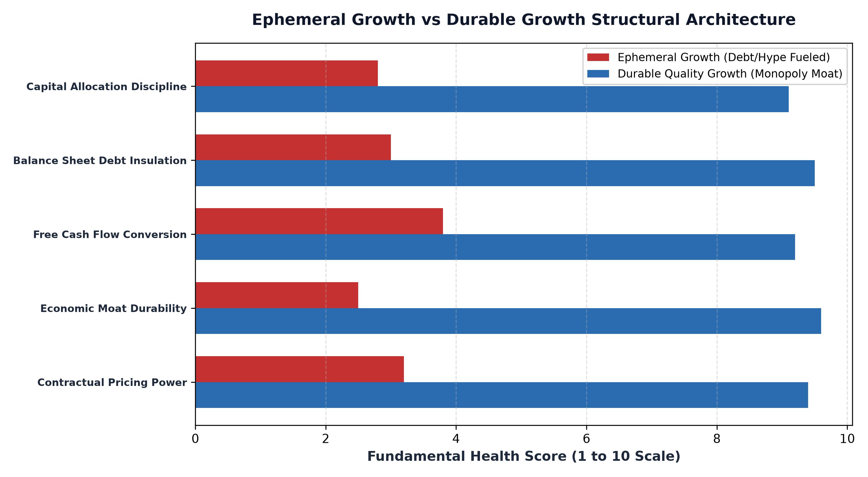
1. The Fragility of Unprofitable Scale
The most pervasive error in growth stock analysis is mistaking temporary customer adoption for a durable business model. A company can easily post dramatic revenue growth by burning venture debt to underprice competitors, spending heavily on customer acquisition marketing, and offering unprofitable terms to win corporate contracts. This strategy creates the cosmetic appearance of rapid market expansion.
However, this form of growth is fundamentally fragile. It relies on the continuous availability of cheap external capital to subsidize daily operations. The moment macroeconomic liquidity tightens or debt markets freeze, the company can no longer fund customer subsidies. Because the business lacks an authentic economic moat, customers defect the second prices are adjusted to realistic economic levels, causing revenue growth to collapse overnight.
2. The Pillars of Durable Growth: Moats and Pricing Power
Durable growth, by contrast, is anchored in unshakeable economic moats. A business exhibits durable growth when its expansion is driven by customer necessity, non negotiable intellectual property, or deep regulatory protections. These companies do not need to discount their offerings to grow; their products are mission critical to client operations.
The definitive test of growth durability is pricing power. A durable compounder can raise prices ahead of inflation year after year without suffering unit volume erosion. Furthermore, durable growth exhibits powerful operating leverage: as revenue expands, fixed costs remain stable, allowing operating profit margins and free cash flow conversion to expand in tandem with top line sales. Every dollar of revenue expansion translates directly into tangible cash generation.
3. Balance Sheet Fortresses and Downside Survival
True compounding is a function of survival. Over a multi decade investment horizon, a company will inevitably encounter recessions, credit crunches, currency devaluations, and geopolitical shocks. Fragile growth companies carrying heavy debt burdens are wiped out during these downturns, forced into predatory restructuring or outright bankruptcy.
Durable growth companies operate with fortress balance sheets. They maintain minimal net debt, substantial cash reserves, and multi billion dollar undrawn credit facilities. When an economic storm arrives, their balance sheet allows them to survive unassisted while fragile competitors drown. Even more crucially, during market panics, durable compounders use their cash strength to acquire distressed competitors at generational discounts, emerging from crises with expanded market share and widened competitive moats.
4. The MPLY Standard: Concentrating in Enduring Monopolies
Durable equity compounding demands rejecting superficial narrative hype and allocating capital strictly to companies possessing structural competitive advantages.
Investors seeking high conviction access to corporate enterprises that embody durable, compounding growth can explore the Strategy Shares Monopoly ETF (MPLY) at https://strategysharesetfs.com/mply/. MPLY is an actively managed ETF that purposefully concentrates capital into 25 to 35 enduring corporate monopolies. By holding dominant market leaders with pristine balance sheets, contractual pricing power, and high returns on invested capital, MPLY delivers durable growth that compounds intrinsic value across all macroeconomic regimes.
From an institutional risk perspective, evaluating growth durability requires measuring customer surplus and value-sharing dynamics. A company that captures all economic surplus by maximizing short-term prices without delivering commensurate utility invites aggressive regulatory intervention and incentivizes customer defection. The most durable corporate compounders intentionally leave substantial economic surplus on the table for their customers, creating immense goodwill and loyalty.
When an enterprise provides software or physical infrastructure that saves a corporate client millions of dollars in operating overhead while charging only a modest fraction in annual licensing fees, the customer relationship becomes unassailable. This asymmetric value proposition ensures that demand remains robust through severe economic contractions, transforming growth into an enduring, multi-decade compounding reality.
5. Frequently Asked Questions
Q1: What is the primary difference between growth investing and durable growth investing?
Standard growth investing focuses primarily on the velocity of revenue expansion, often ignoring profitability and debt. Durable growth investing prioritizes return on invested capital, economic moat depth, pricing power, and balance sheet solvency.
Q2: Can a mature company qualify as a durable growth business?
Yes. An established corporate monopoly that expands revenues at a modest eight to twelve percent annually while generating thirty percent return on capital and pristine free cash flow is far more durable than an unprofitable startup growing at forty percent.
6. Sources
Morningstar, The Structural Anatomy of Durable Compounding in Equity Markets: https://www.morningstar.com/articles/moat-research
Harvard Business Review, Sustainable Growth vs Ephemeral Scale: The Economics of Business Moats: https://hbr.org/1979/03/how-competitive-forces-shape-strategy
#LongTermInvesting #Compounding #Investing #Stocks #MPLY

