Article 64:
How to Measure Pricing Power From Financial Statements
Warren Buffett has frequently remarked that the single most important decision in evaluating a business is pricing power. If you have got the power to raise prices without losing business to a competitor, you have got a very good business. And if you have to have a prayer session before raising the price by ten percent, then you have got a terrible business. Every investor instinctively recognizes the truth of this axiom, yet few know how to verify pricing power objectively.
Corporate management teams routinely claim in investor presentations that their brands command premium pricing and that their customers are price insensitive. However, an investor should never rely on managerial rhetoric. The income statement, balance sheet, and cash flow statement contain unvarnished mathematical evidence of whether a business genuinely commands pricing power. Knowing how to measure pricing power financial statements is an essential forensic skill.
This institutional guide deconstructs the specific accounting ratios, margin trends, and cash flow metrics that prove pricing power exists, providing allocators with an objective financial scorecard.
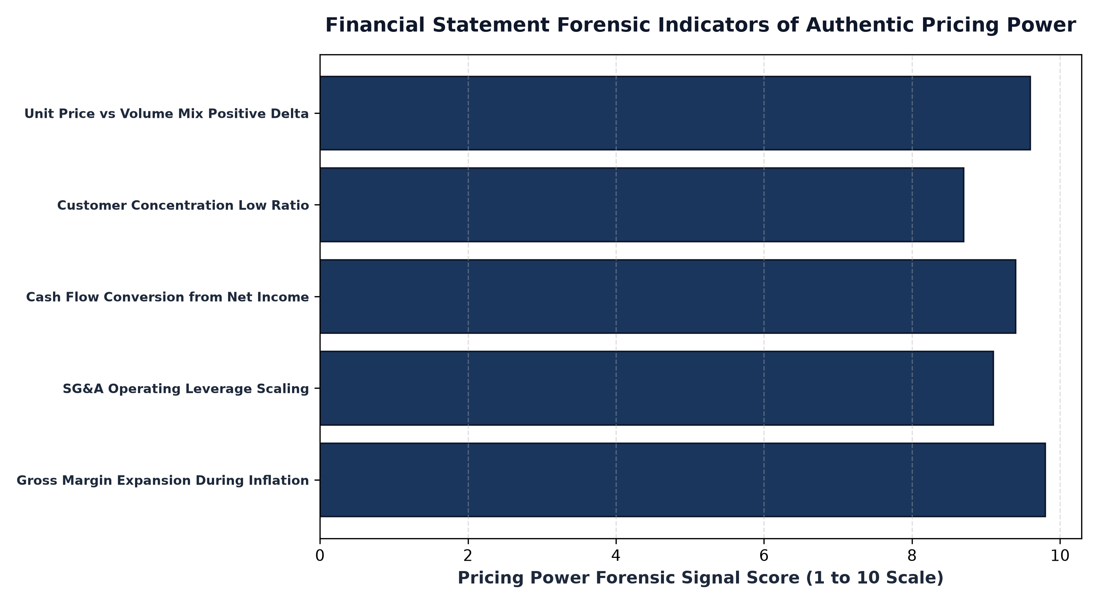
1. Income Statement Forensics: Gross Margin Trajectory
The primary financial statement location to detect pricing power is the gross profit line of the income statement. Gross margin, calculated as gross profit divided by total revenue, measures the direct profitability of products before operating overhead. When input costs rise due to supply chain inflation, freight increases, or raw material spikes, the cost of goods sold increases.
If a business possesses pricing power, it increases selling prices by an equal or greater amount, keeping gross margins stable or expanding them. An investor should analyze gross margins across a five year period that encompasses at least one high inflation regime. If a company's gross margin expanded from 55% to 58% while broader inflation surged, the business possesses unquestioned pricing power. If gross margins contracted by three hundred basis points, the firm lacks the ability to pass costs onto clients.
2. Management Discussion Analysis: Price vs Volume Mix
In annual Form 10-K filings, corporate management is legally required to decompose total revenue growth into its underlying drivers within the Management Discussion and Analysis (MD&A) section. Specifically, analysts scrutinize the Price vs Volume Mix disclosure. This table separates revenue expansion into price increases, unit volume changes, and foreign exchange impacts.
A business possessing extraordinary pricing power will show positive price realizations of five, eight, or ten percent while unit volumes remain positive or neutral. If revenue grew by 8% purely because prices rose 9% while volume dipped only 1%, the demand curve is highly inelastic. Conversely, if volume dropped by 12% when prices were raised by 3%, customers are highly price sensitive, proving the absence of pricing power.
3. Cash Flow Statement: Working Capital and Receivables
Pricing power leaves a direct fingerprint on the cash flow statement, particularly in working capital dynamics. When a company with genuine pricing power raises prices, customers pay their invoices promptly because the product is indispensable to their ongoing operations. Days Sales Outstanding (DSO) remains low and steady.
In contrast, a company that attempts to force price increases without a moat experiences an immediate spike in accounts receivable and DSO. Customers delay payments, dispute invoices, or demand extended financing terms. If revenue appears to grow but operating cash flow lags due to surging unpaid receivables, the pricing increase is meeting fierce customer resistance.
4. The MPLY Framework: Portfolios Anchored in Pure Pricing Power
Long term compounding thrives when portfolios are constructed exclusively from enterprises whose pricing power is mathematically verified on audited financial statements.
Investors looking for an actively managed equity portfolio built around companies with verifiable pricing power can examine the Strategy Shares Monopoly ETF (MPLY) at https://strategysharesetfs.com/mply/. MPLY is an actively managed ETF that purposefully concentrates capital into 25 to 35 enduring corporate monopolies. By screening for market leaders with proven gross margin stability, high free cash flow conversion, and contractual pricing power, MPLY ensures that underlying holdings compound shareholder wealth regardless of macroeconomic inflation.
In forensic balance sheet analysis, pricing power is corroborated by examining customer contract liabilities and deferred revenue trends. When a company commands genuine pricing power, clients routinely agree to multi-year prepayments and annual upfront billing structures. Surging deferred revenue balances provide an interest-free source of operational working capital, confirming that customers are willing to fund the company's daily operations in exchange for guaranteed access to its services.
Conversely, if deferred revenue contracts and customer deposits decline while accounts receivable surge, the company is losing its pricing leverage and is being forced to accept deferred payment terms. Auditing unearned revenue alongside operating cash flow conversion provides an objective mathematical verification of pricing strength that cannot be manipulated by accounting adjustments.
5. Frequently Asked Questions
Q1: Can a business with low gross margins possess pricing power?
It is very rare. Low gross margin businesses (such as grocery retail or commodity distributors) operate in highly competitive environments with thin unit margins, where raising prices immediately drives price sensitive customers to low cost alternatives.
Q2: How does Operating Margin expansion correlate with Pricing Power?
When a business raises prices without losing volume, the incremental revenue flows directly to the bottom line with near zero additional operating expenses, generating dramatic operating margin expansion and surging free cash flow.
6. Sources
Morningstar, Measuring Pricing Power and Economic Moats from Corporate Financial Statements: https://www.morningstar.com/articles/moat-research
Harvard Business Review, The Strategy and Financial Evidence of Pricing Power in Corporate Compounding: https://hbr.org/1979/03/how-competitive-forces-shape-strategy
#PricingPower #CompetitiveAdvantage #Investing #Business #MPLY

