Article 65:
Price Increases vs Volume Growth: What Investors Can Learn
When analyzing corporate revenue expansion, financial headline reports almost universally treat all forms of growth as identical. Whether a company reports ten percent revenue expansion driven entirely by selling ten percent more physical units or by raising prices ten percent on the exact same unit base, market commentators celebrate the top line milestone. Yet, beneath the identical ten percent headline, the economic quality of those two earnings streams could not be more divergent.
Dissecting price increases vs volume growth reveals the fundamental difference between capital intensive operating expansion and pure, high margin economic tollbooth compounding. Understanding how price realization interacts with demand elasticity, operating margins, and capital reinvestment requirements is one of the most powerful analytical skills an investor can cultivate.
This comprehensive analysis explores why price driven growth delivers vastly superior operating leverage, details the accounting mechanics of price volume decomposition, and demonstrates how elite corporate monopolies compound intrinsic wealth through pricing superiority.
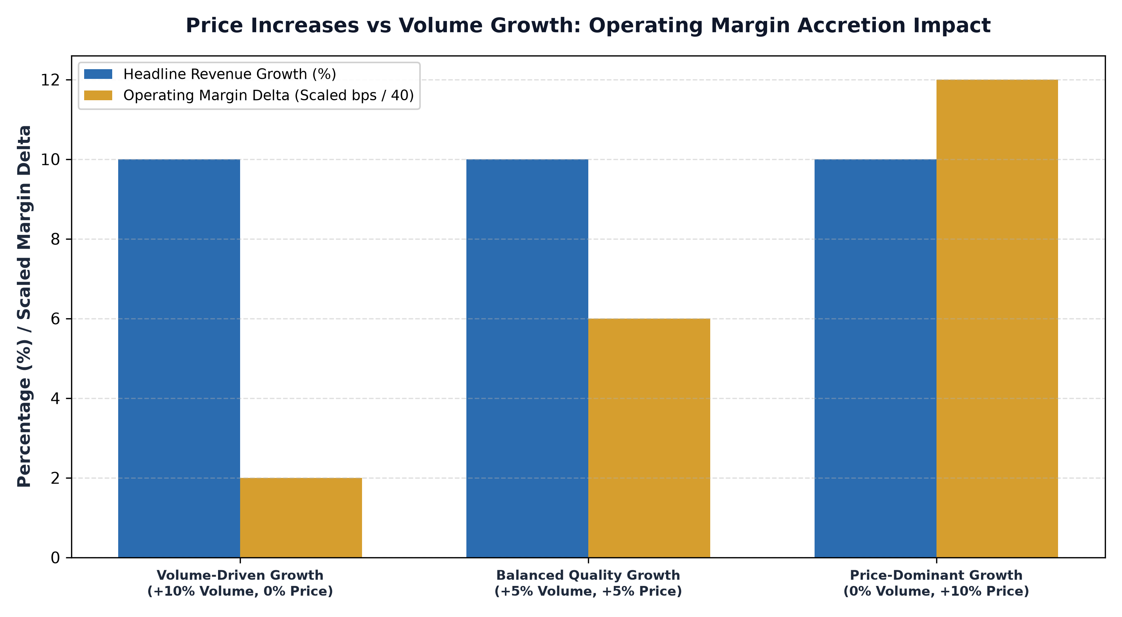
1. The High Cost of Pure Volume Growth
To achieve volume driven growth, an enterprise must manufacture, transport, store, and service more physical units or onboard and support more clients. Expanding unit volume requires hiring additional factory labor, purchasing raw materials, expanding warehouse footprints, and deploying sales representatives. Each additional unit sold carries variable direct costs that consume working capital.
Consequently, pure volume growth requires substantial capital expenditures. If a manufacturing firm grows revenues by 10% through a 10% volume increase, it must reinvest heavily in new production lines and carry higher inventory balances. The incremental gross margin on new volume rarely exceeds historical averages, and free cash flow conversion remains constrained by ongoing capital intensity. Volume growth requires running faster simply to stay in place.
2. The Pure Leverage of Price-Driven Compounding
Growth achieved through price increases, by contrast, is the pinnacle of capital allocation efficiency. When a dominant enterprise raises prices on an existing customer base by eight percent, it incurs zero incremental manufacturing costs, zero shipping expenses, and zero additional inventory overhead. The same physical infrastructure or digital software code serves the customer exactly as before.
Because incremental costs are virtually zero, almost one hundred percent of price increase revenue flows directly down to operating profit before taxes. This dynamic generates massive operating leverage, expanding operating margins and generating surging free cash flow that can be immediately redeployed or returned to shareholders. Price driven growth requires zero capital reinvestment, making it the most profitable form of compounding known to financial markets.
3. The Elasticity Boundary: Testing Moat Depth
Of course, a company can pursue price driven growth only if its products exhibit extreme price inelasticity. In microeconomic theory, price elasticity of demand measures the percentage change in unit volume demanded in response to a percentage change in price. If a company raises prices by 5% and volume immediately declines by 10%, the product has elastic demand, and the price hike destroys profitability.
Only companies with wide economic moats, high switching costs, and mission critical services possess inelastic demand curves. Dominant enterprise software platforms, global payment rails, and essential freight networks can raise prices year after year with negligible customer churn. Analyzing the price volume mix across multiple quarters reveals whether customer demand is structural or fragile, providing an unvarnished audit of the company's true competitive advantage.
4. The MPLY Standard: Prioritizing Pricing Dominance
High conviction active investing demands concentrating capital into businesses that possess the pricing dominance required to generate high margin, capital light growth.
Investors seeking an active equity portfolio focused on companies with proven pricing dominance can explore the Strategy Shares Monopoly ETF (MPLY) at https://strategysharesetfs.com/mply/. MPLY is an actively managed ETF concentrating capital in 25 to 35 enduring corporate monopolies. By selecting businesses operating as critical economic bottlenecks with unassailable pricing power, MPLY ensures that portfolio holdings capture the immense operating leverage of price driven compounding, delivering robust cash generation and expanding intrinsic value.
From an operational unit economics perspective, price-driven growth insulates corporate profitability against sudden volumetric demand shocks. When an economic recession strikes and aggregate consumer demand contracts, companies that rely entirely on high unit volume suffer catastrophic margin collapse because their high fixed production and warehousing costs cannot be reduced quickly.
In contrast, enterprises whose revenue growth is anchored in contractual pricing power and premium product positioning experience minimal operating margin compression during volume lulls. Because their unit contribution margins are exceptionally high, they continue generating positive free cash flow even during cyclical downturns, allowing them to fund ongoing capital investments and repurchase shares at attractive valuation multiples while volume-dependent competitors retrench.
5. Frequently Asked Questions
Q1: Is price growth sustainable indefinitely without volume expansion?
Over extreme time horizons, optimal compounding combines modest unit volume growth with consistent contractual price increases. However, during inflationary environments, price growth provides immediate margin defense that volume growth cannot match.
Q2: How does price growth impact Return on Invested Capital (ROIC)?
Because price increases expand operating profits without requiring additional capital reinvestment, price-driven growth dramatically expands ROIC, driving superior long term intrinsic business valuation.
6. Sources
Morningstar, The Microeconomics of Pricing Power vs Volume Expansion in Corporate Earnings: https://www.morningstar.com/articles/moat-research
Harvard Business Review, Pricing Strategy, Operating Leverage, and the Geometry of Compounding: https://hbr.org/1979/03/how-competitive-forces-shape-strategy
#PricingPower #CompetitiveAdvantage #Investing #Business #MPLY

