Article 66:
Subscription Pricing and Customer Churn
Over the past two decades, the global commercial landscape has experienced a historic transition toward recurring subscription revenue models. Software developers, data providers, industrial maintenance firms, and consumer platforms have shifted away from one-off transactional sales in favor of multi-year subscription contracts. Investors celebrate this transformation, recognizing that predictable recurring revenue commands higher valuation multiples and smooths cyclical cash flow volatility.
However, establishing a subscription billing relationship is only the initial step in corporate moat building. The true acid test of subscription durability is pricing power. When corporate leadership decides to increase annual subscription rates, customer behavior reveals whether the product is an indispensable operational utility or a discretionary luxury. Dissecting subscription pricing customer churn dynamics allows investors to distinguish elite subscription monopolies from fragile commodity software vendors.
This institutional guide explores the mechanics of subscription pricing power, explains how to evaluate net revenue retention against logo churn, and outlines how disciplined allocators identify enduring recurring revenue compounders.
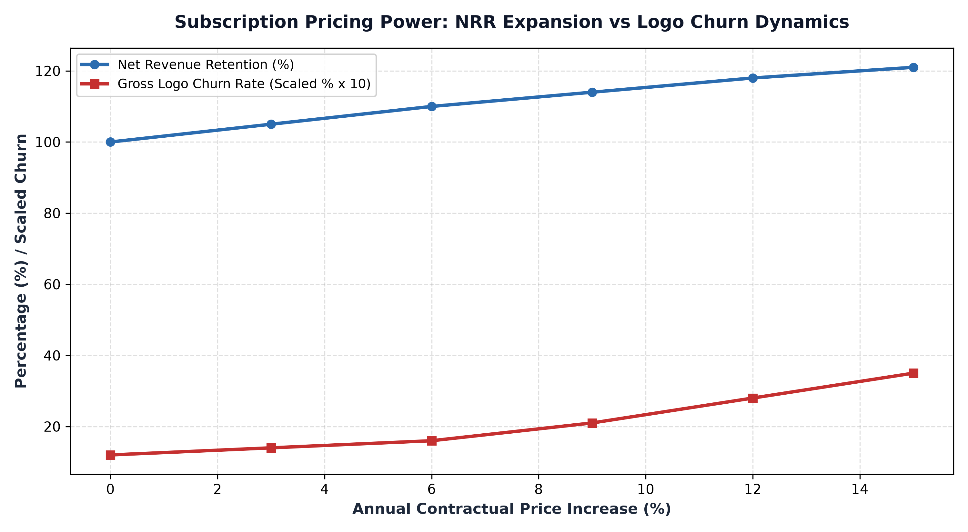
1. The Anatomy of Switching Costs in Subscription Ecosystems
In subscription business models, pricing power is directly proportional to customer switching costs. Switching costs represent the total friction, including financial expenditures, employee retraining time, data migration risks, and operational disruption, required for a customer to abandon an existing vendor and adopt a competing platform.
In commodity software (such as basic project management or marketing design tools), switching costs are near zero. If the vendor raises prices by 10%, clients can export their data and migrate to an alternative service over a weekend. Conversely, in mission critical infrastructure (such as enterprise resource planning, core banking ledgers, or specialized computer aided engineering suites), switching costs are practically insurmountable. Ripping out a core operational platform risks business paralysis, ensuring that clients will absorb consistent mid-single-digit price hikes rather than risk migration catastrophe.
2. Net Revenue Retention vs Gross Logo Churn
To accurately analyze subscription pricing dynamics, investors must scrutinize two distinct metrics: Gross Logo Churn and Net Revenue Retention (NRR). Gross logo churn measures the absolute percentage of individual customers who cancel their subscriptions over a twelve month window. In premier enterprise franchises, annual gross logo churn remains under three to five percent.
Net Revenue Retention, meanwhile, measures the total recurring revenue generated by an existing cohort of customers, accounting for expansion, price increases, and churn. When an enterprise achieves an NRR of 115% to 125%, it confirms that existing customers are spending significantly more each year. If management executes a 7% price increase across the board and gross logo churn ticks up by only twenty basis points, the company possesses immense pricing power, compounding free cash flow with minimal volume attrition.
3. The Dangers of Forcing Price Hikes on Fragile Moats
A critical hazard in recurring revenue analysis is aggressive price hikes by companies lacking genuine moats. Private equity firms and short term management teams often acquire mature software businesses and immediately impose twenty or thirty percent price increases to manufacture temporary EBITDA expansion. While headline revenues jump in the short term, this practice triggers a delayed customer revolt.
Enterprise clients immediately initiate long term replacement projects. Two to three years later, when competitor implementations are complete, customer churn cascades uncontrollably, leaving the acquirer with a hollowed out customer base and impaired terminal value. Sustainable subscription pricing power is characterized by patient, predictable contractual escalations of four to eight percent annually, perfectly matching customer value delivery.
4. The MPLY Framework: Focus on Mission-Critical Subscriptions
High conviction active investing demands concentrating capital into companies whose subscription revenues are protected by insurmountable switching costs.
Investors seeking exposure to premier subscription monopolies with proven pricing resilience can explore the Strategy Shares Monopoly ETF (MPLY) at https://strategysharesetfs.com/mply/. MPLY is an actively managed ETF that purposefully concentrates capital into 25 to 35 enduring corporate monopolies. By holding dominant platforms with mission critical software, high customer retention, and unassailable pricing power, MPLY ensures that underlying holdings compound shareholder wealth through predictable, high margin recurring cash flows.
In subscription financial modeling, institutional allocators evaluate cohort retention decay curves over three to seven year customer lifecycles. In commodity software services, cohort retention charts show a steep negative slope, with half of all initial customers churning within twenty-four months. This high customer mortality rate forces the company into an expensive customer acquisition treadmill just to replace lost revenues.
In mission-critical enterprise platforms, cohort retention curves exhibit net negative churn, meaning the revenue generated from a specific customer cohort expands over time despite occasional logo cancellations. The contractual expansion of seats, additional software modules, and automated price escalators outpaces attrition, creating a self-compounding revenue baseline that provides permanent operational stability.
5. Frequently Asked Questions
Q1: What is considered a world-class Net Revenue Retention rate for enterprise software?
In institutional software investing, an NRR above 115% for mid-market clients and above 120% for enterprise customers is considered world-class, confirming strong pricing power and product expansion.
Q2: How does annual price escalation in subscription contracts protect against inflation?
Mission critical subscription contracts routinely incorporate contractual inflation escalators tied to CPI, guaranteeing automated annual price increases that protect corporate gross margins from input cost pressures.
6. Sources
Morningstar, Subscription Economics, Customer Churn, and Pricing Power in Software: https://www.morningstar.com/articles/moat-research
Harvard Business Review, Customer Retention, Switching Costs, and the Economics of Recurring Revenue: https://hbr.org/1979/03/how-competitive-forces-shape-strategy
#PricingPower #CompetitiveAdvantage #Investing #Business #MPLY

