Article 67:
Input Costs and Pricing Power: Who Bears the Inflation?
During prolonged periods of macroeconomic stability and low interest rates, almost every corporate business model appears functional. Capital is abundant, supply chains operate smoothly, and raw material expenses remain predictable. However, when geopolitical shocks, labor shortages, or central bank balance sheet expansions ignite broader inflation, the corporate landscape undergoes a brutal stress test.
As input costs surge across energy, transportation, commodities, and specialized labor, an urgent economic question confronts every corporate boardroom: who bears the inflation? In unmoated industries, the answer is always the shareholder, as companies absorb rising expenses and suffer severe margin collapse. Understanding input costs pricing power reveals which companies possess the structural capacity to pass inflation directly onto customers without sacrificing profitability.
This institutional guide examines the mechanisms of corporate inflation pass-through, details why commodity producers face margin devastation during inflationary spikes, and explains how monopolistic franchises turn inflation into a net financial tailwind.
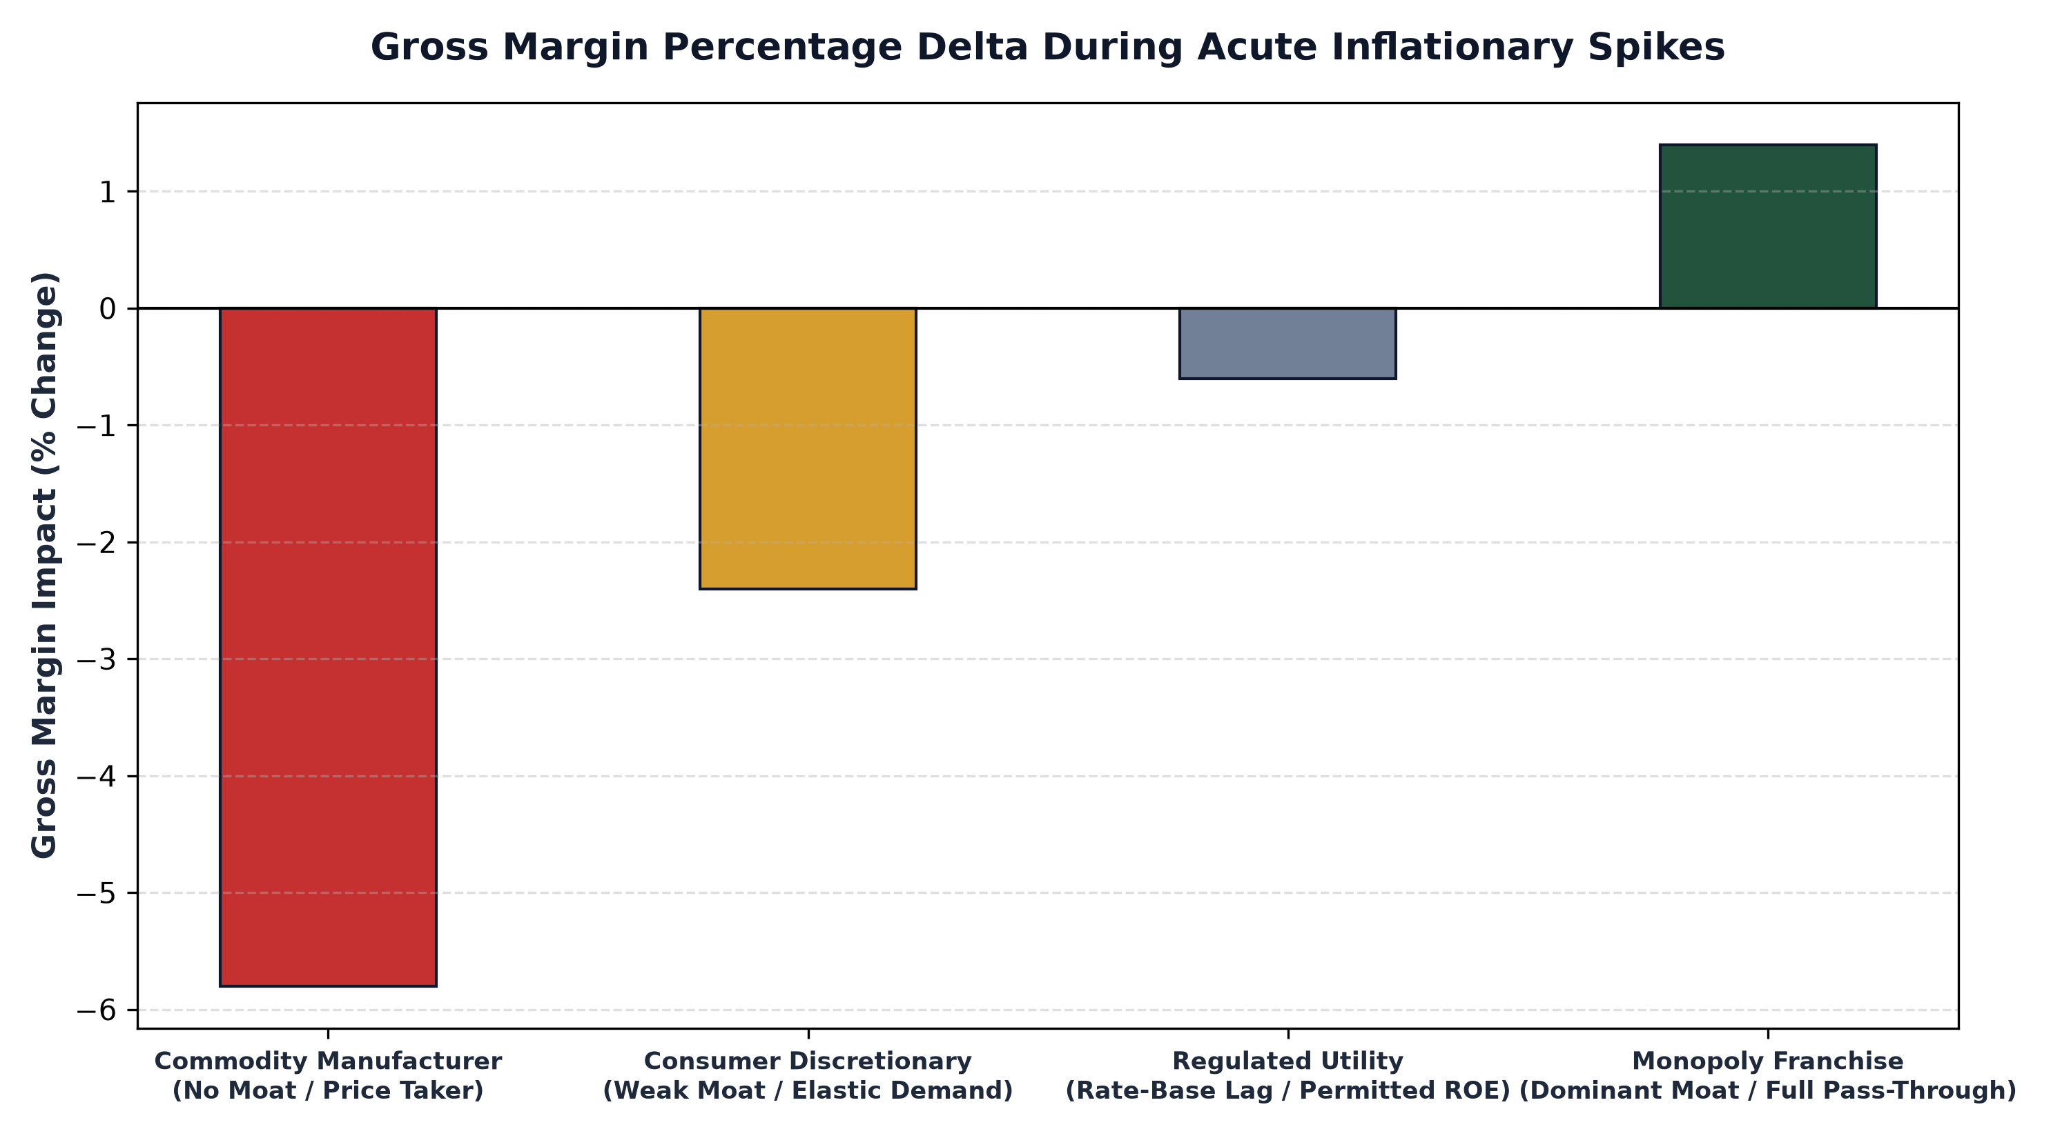
1. The Vulnerability of Price Takers in Inflationary Regimes
In competitive, fragmented markets, companies operate as price takers. Whether producing auto parts, basic chemical compounds, or consumer goods, these enterprises buy their raw materials and labor in competitive markets where prices are dictated by macro inflation. When their input costs surge by twenty percent, their cost of goods sold increases instantly.
However, because these companies produce undifferentiated products, attempting to raise selling prices by twenty percent is commercial suicide. Customers immediately defect to competitors who are willing to absorb cost increases to protect market share. As a result, price takers are forced to eat the inflation, experiencing catastrophic gross margin compression, plunging operating cash flows, and severe valuation downgrades on public exchanges.
2. Contractual Pass-Through and Fuel Surcharge Mechanics
At the opposite end of the spectrum reside corporate monopolies that integrate automated pass-through mechanisms directly into their master commercial agreements. Consider dominant transcontinental freight railways, regulated pipelines, or specialized industrial logistics networks. These businesses do not negotiate prices on an ad-hoc basis; their customer contracts feature formulaic inflation adjusters and automated fuel surcharge indices.
When diesel fuel or electricity costs double, the railway's billing software automatically recalculates customer shipping rates, adding the exact dollar surcharge to the following month's invoice. Because shippers have no viable alternative transportation routes, they must pay the surcharge or halt their own production. The company's operating margin remains completely insulated, transferring one hundred percent of the inflationary burden onto customers.
3. Inflation as an Asset-Light Revenue Multiplier
In capital light digital and financial monopolies, inflation does not merely leave margins unharmed; it actively accelerates corporate earnings growth. Consider global payment processing networks or regulatory rating agencies whose transaction fees are charged as a basis point percentage of nominal gross transaction value or total debt issuance.
When broader inflation causes the dollar price of consumer goods, travel, and corporate debt to surge by eight percent, the total dollar volume flowing through payment networks expands by eight percent automatically. The network incurs near zero additional operating expenses to process higher dollar numbers on digital ledgers. Consequently, the company's revenues and operating profits expand in tandem with nominal inflation, transforming macroeconomic inflation into an organic compounding catalyst.
4. The MPLY Mandate: Permanent Inflation Insulation
Allocating capital during inflationary cycles requires prioritizing businesses whose structural economic positioning renders them immune to input cost volatility.
Investors seeking high conviction access to corporate franchises with unassailable inflation pass-through power can explore the Strategy Shares Monopoly ETF (MPLY) at https://strategysharesetfs.com/mply/. MPLY is an actively managed ETF that purposefully concentrates capital into 25 to 35 enduring corporate monopolies. By screening for market leaders with contractual pricing power, non negotiable essential services, and capital light business architectures, MPLY ensures that underlying holdings pass inflation directly through to end markets, preserving profit margins and expanding intrinsic per share value.
In corporate supply chain economics, companies possessing authentic pricing power also command immense monopsony purchasing leverage over their own upstream suppliers. Because an industry-leading corporate monopoly controls vast distribution channels and purchases massive quantities of raw materials or components, it dictates payment terms and negotiates volume rebates that smaller competitors cannot secure.
This dual economic moat protects the enterprise from both directions: upstream suppliers absorb raw material price volatility to maintain high-volume corporate contracts, while downstream corporate clients accept automated price escalators. By squeezing input costs while expanding selling prices, the dominant monopoly expands gross margins during inflationary periods that devastate fragmented competitors.
5. Frequently Asked Questions
Q1: Can a company possess pricing power if its unit volume declines slightly during a price increase?
Yes, provided the price increase exceeds the volume decline. If prices rise by 8% and unit volume drops by 1%, total revenue expands by roughly 7% with lower variable operating expenses, resulting in higher net operating profits.
Q2: Which sectors suffer the worst margin degradation during sudden inflation spikes?
Low-margin retail, automotive assembly, and commoditized industrial manufacturing experience severe margin degradation because they face massive raw material and labor inflation while lacking the pricing power to pass costs through.
6. Sources
Morningstar, Input Cost Inflation, Corporate Pricing Power, and Gross Margin Defense: https://www.morningstar.com/articles/moat-research
Harvard Business Review, Who Bears the Inflation? Pricing Strategy and Competitive Moats: https://hbr.org/1979/03/how-competitive-forces-shape-strategy
#PricingPower #CompetitiveAdvantage #Investing #Business #MPLY

