Article 68:
Pricing Power by Industry: What Changes From Sector to Sector
When investors discuss pricing power, they often treat the concept as an individual corporate attribute. Equity analysts praise exceptional chief executives for their pricing discipline, attributing strong gross margins to visionary management. While managerial competence is essential, corporate pricing ability is fundamentally constrained or enabled by the economic structure of the industry in which the company competes.
A brilliant management team operating in a commoditized retail sector with razor thin margins and perfect price transparency cannot unilaterally impose price increases without triggering customer defection. Conversely, even mediocre leadership operating within a consolidated regulatory monopoly can raise prices year after year with impunity. Analyzing pricing power by industry reveals the structural rules that govern profitability across different economic sectors.
This institutional guide surveys the pricing power spectrum across major global industries, explains why software, rails, and rating agencies dominate pricing metrics, and outlines how allocators navigate sector specific competitive dynamics.
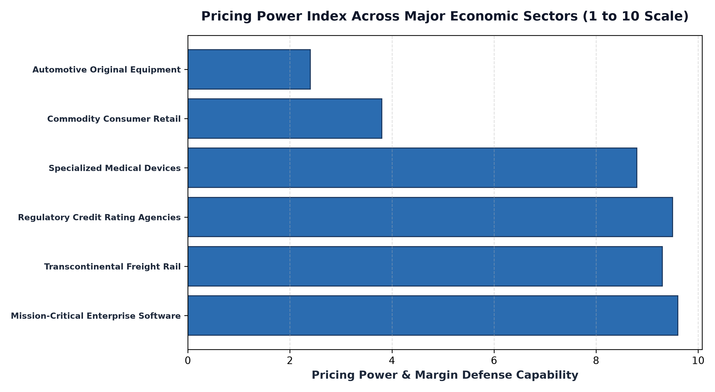
1. Enterprise Software and Platform Utilities: Extreme Inelasticity
At the absolute pinnacle of pricing power resides mission critical enterprise software. In modern corporate operations, enterprise resource planning, database architectures, and compliance platforms function as the central nervous system of global commerce. These digital utilities exhibit near total customer lock-in.
Replacing an enterprise database requires hundreds of millions of dollars in engineering consulting, years of operational risk, and severe business disruption. Consequently, software monopolists routinely enforce annual contractual price escalators of 5% to 8%, and enterprise clients pay without hesitation. The cost of the software is an insignificant fraction of total corporate operational expenditures, but the cost of its failure is catastrophic, giving software vendors virtually unlimited pricing power.
2. Physical Natural Monopolies: Freight Rail and Pipeline Infrastructure
Physical natural monopolies represent another fortress of industry pricing power. Transcontinental freight rail networks and regulated utility pipelines control irreplaceable geographical rights of way. A competitor cannot construct a parallel railway corridor across the Midwest; land acquisition costs would be prohibitive, and environmental regulatory clearance would never be granted.
Heavy industrial shippers transporting grain, coal, chemicals, and intermodal freight have no viable economic alternative to rail. Shipping freight by long haul truck costs three to four times more per ton-mile and suffers from acute driver shortages. Because rail maintains an insurmountable cost advantage over alternative transit modes, freight rail monopolists exercise substantial pricing discretion, consistently expanding operating ratios and free cash flow generation.
3. The Barren Landscape: Retail and Automotive Price Takers
At the opposite end of the spectrum reside consumer retail and automotive manufacturing. These sectors operate under brutal competitive dynamics characterized by high fixed capital costs, cyclical consumer demand, and total price transparency. The rise of digital comparison shopping allows consumers to cross reference commodity prices in seconds, instantly punishing retailers who attempt to protect margins through price hikes.
In automotive assembly, original equipment manufacturers battle cutthroat global competition, high union labor costs, and severe capital intensity. When an automaker raises prices by a few hundred dollars, consumers readily substitute alternative brands. As a result, automotive and retail companies suffer chronically low returns on capital, frequently resorting to destructive financing incentives and discounts that destroy shareholder value.
4. The MPLY Standard: Concentrating Exclusively in High-Power Sectors
Building an elite compounding portfolio requires strictly avoiding structurally disadvantaged price taking industries and focusing capital exclusively on sectors with insurmountable pricing power.
Investors seeking high conviction access to companies operating in the world's most lucrative pricing environments can explore the Strategy Shares Monopoly ETF (MPLY) at https://strategysharesetfs.com/mply/. MPLY is an actively managed ETF concentrating capital in 25 to 35 enduring corporate monopolies. By purposefully screening out commodity retailers, cyclical automakers, and capital intensive price takers, MPLY anchors its portfolio in software utilities, freight monopolies, and regulatory tollbooths, ensuring that every constituent holding commands decisive pricing power.
From an industrial organization standpoint, sector pricing power is heavily reinforced by statutory regulatory barriers and institutional credentialing requirements. In industries such as global credit rating agencies, financial market exchanges, and specialized aerospace manufacturing, legal charters and government oversight formally limit the number of permitted market operators.
A potential entrant cannot simply raise capital and launch a competing credit rating service; regulatory authorities require decades of verified historical default data and sovereign recognition before granting official Nationally Recognized Statistical Rating Organization (NRSRO) status. This legal exclusivity insulates incumbents from competitive entry, granting them permanent structural pricing power that is entirely absent in unregulated, open-access commercial sectors.
5. Frequently Asked Questions
Q1: Can a company possess pricing power in an otherwise competitive sector?
Yes, if it has created an iconic luxury brand with immense social prestige (such as ultra-luxury fashion) or holds proprietary patented technology that cannot be replicated by competitors.
Q2: How does government regulation impact pricing power in natural monopolies?
While utilities face regulatory rate caps, unregulated or lightly regulated infrastructure assets (such as freight rail and commercial data networks) maintain substantial pricing flexibility within broad statutory boundaries.
6. Sources
Morningstar, Industry Structure, Sector Pricing Power, and Competitive Moat Distribution: https://www.morningstar.com/articles/moat-research
Harvard Business Review, Competitive Advantage Across Sectors: The Determinants of Industry Profitability: https://hbr.org/1979/03/how-competitive-forces-shape-strategy
#PricingPower #CompetitiveAdvantage #Investing #Business #MPLY

