Article 69:
MPLY ETF Methodology Explained: What Investors Should Examine
In an exchange traded fund ecosystem saturated with thousands of passive index products, smart beta formulas, and thematic marketing vehicles, discriminating wealth managers and fundamental allocators continuously seek authentic differentiation. The vast majority of equity ETFs are governed by mechanical market capitalization weighting schemes that force funds to allocate the most capital to whatever securities have recently experienced the largest price momentum.
Breaking away from passive benchmark conventions, the Strategy Shares Monopoly ETF (MPLY) establishes a distinctive, high conviction investment framework built entirely around fundamental business quality. For allocators evaluating a core equity allocation, understanding the MPLY ETF methodology requires examining the multi-pillar screening process, active portfolio construction rules, and economic criteria used to identify the world's most durable corporate franchises.
This comprehensive product research guide examines the core tenets of the MPLY methodology, details the four pillars of monopoly franchise selection, and outlines what institutional investors should examine when auditing the strategy.
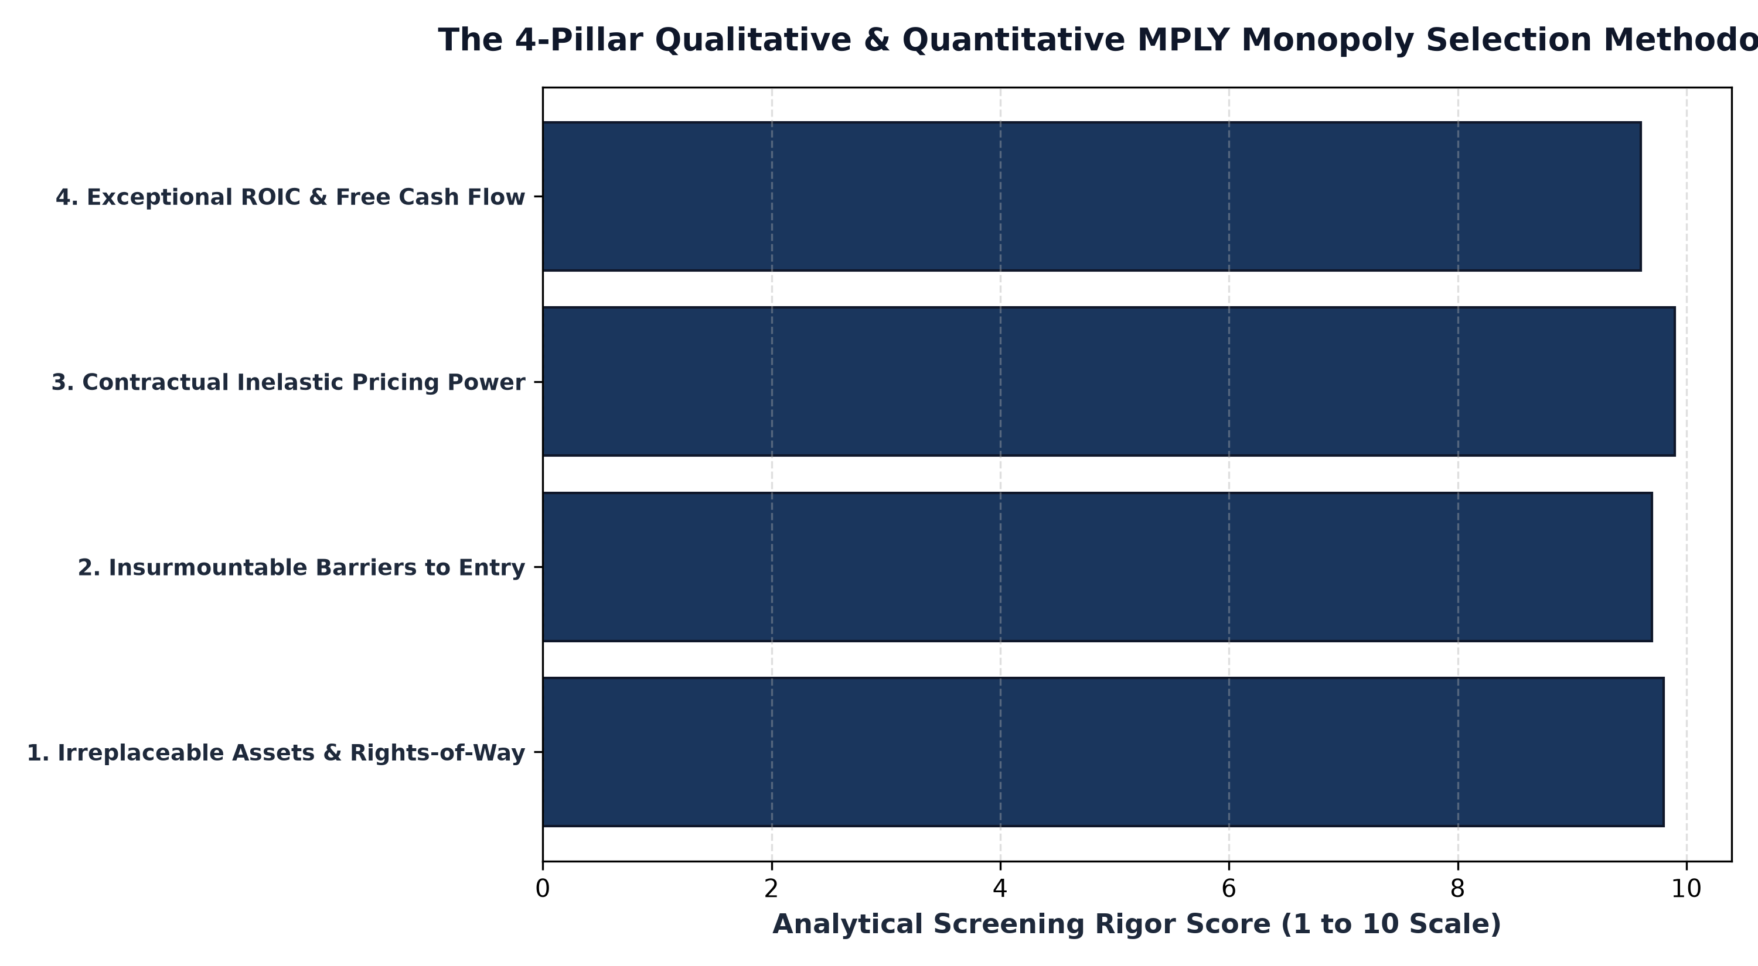
1. Core Philosophy: The Economics of Enduring Monopolies
The foundation of the MPLY methodology rests on a timeless economic principle: companies that operate as legal, natural, or structural monopolies generate superior, durable financial returns compared to businesses engaged in cutthroat competition. In competitive markets, capital floods into high return sectors, expanding capacity and driving profit margins down toward the cost of capital.
A true monopoly, by contrast, operates behind insurmountable economic walls. Whether protected by exclusive geographical rights of way, massive network effects, mission critical software code bases, or regulatory statutory charters, the enterprise is completely insulated from competitive entry. MPLY's mandate is to purposefully identify and concentrate capital into these rare economic tollbooths, allowing shareholders to capture the compounding power of monopoly cash flows.
2. The Four Pillars of the MPLY Selection Framework
To separate genuine corporate monopolies from transient market leaders, the MPLY methodology applies a four pillar qualitative and quantitative screening framework across the global equity universe:
Pillar One evaluates Irreplaceable Assets. The company must possess physical or digital infrastructure that cannot be replicated by competitors regardless of capital availability, such as transcontinental rail networks or global payment rails. Pillar Two analyzes Barriers to Entry, verifying that regulatory mandates, multi billion dollar capital requirements, or patent portfolios prevent potential entrants from contesting the space.
Pillar Three tests Inelastic Pricing Power. The business must demonstrate the empirical capacity to raise prices ahead of inflation across multiple economic cycles without suffering demand destruction. Pillar Four audits Capital Efficiency, requiring persistent Return on Invested Capital (ROIC) far in excess of the corporate cost of capital, pristine balance sheets with minimal debt, and robust free cash flow conversion.
3. Active Management Freedom vs Passive Benchmark Traps
A critical differentiator of the MPLY methodology is its actively managed, benchmark-agnostic structure. Passive index funds are legally handcuffed to their benchmark rulebooks, forced to buy overvalued speculative stocks during market bubbles and hold deteriorating value traps until they exit the index.
MPLY's portfolio managers possess full active discretion to adjust position weightings, accumulate holdings during liquidity selloffs, and completely exit positions if an economic moat begins to decay. By rejecting tracking error constraints, MPLY maintains a high Active Share, ensuring that the portfolio looks fundamentally different from standard market benchmarks and offers authentic alpha potential.
4. Researching MPLY: Official Documents and Strategy Verification
When conducting professional due diligence on MPLY, allocators should examine official fund documentation to verify portfolio execution.
Investors researching the fund's strategy, historical filings, and daily portfolio holdings can examine the official fund portal for the Strategy Shares Monopoly ETF (MPLY) at https://strategysharesetfs.com/mply/. Reviewing the fund prospectus and quarterly manager commentary provides total transparency into how the four pillar methodology is translated into a focused, 25 to 35 holding high conviction portfolio.
In the ongoing execution of the MPLY methodology, portfolio managers maintain rigorous qualitative oversight regarding antitrust and regulatory scrutiny. While political commentary frequently targets corporate monopolies, sophisticated institutional research distinguishes between political rhetoric and genuine structural antitrust impairment. Historic legal precedent demonstrates that durable monopolies operating as efficient utilities rarely face forced breakups; instead, regulatory oversight formally codifies their market dominance.
MPLY's investment committee continuously audits the regulatory posture of each portfolio holding, verifying that the company's monopoly position is socially and economically sustainable. By investing in monopolies that provide indispensable consumer benefits, superior operational efficiency, and critical infrastructure, MPLY ensures that underlying holdings compound shareholder capital safely within legal and regulatory frameworks.
Furthermore, institutional due diligence on MPLY evaluates how the strategy manages downside risk through business quality rather than mechanical cash buffers. By ensuring that each holding generates high free cash flow conversion and operates with low debt leverage, the portfolio provides structural resilience during credit contractions, allowing long-term investors to remain fully invested in premier assets across the entire macroeconomic cycle.
5. Frequently Asked Questions
Q1: Does MPLY invest only in mega-cap technology companies?
No. MPLY's investment universe spans diverse economic sectors, including freight transportation, financial exchanges, specialized healthcare diagnostics, and mission critical enterprise software utilities.
Q2: How often does the MPLY investment team adjust portfolio holdings?
Because MPLY focuses on enduring corporate compounders with multi-decade moats, the strategy maintains low, patient portfolio turnover, reallocating capital opportunistically rather than trading on short term noise.
6. Sources
Morningstar, Fund Methodology and Active Moat Strategy Analysis: https://www.morningstar.com/articles/moat-research
Strategy Shares ETFs, MPLY Fund Prospectus and Investment Architecture: https://strategysharesetfs.com/mply/
#MPLY #ETFInvesting #MonopolyInvesting #Investing

