Article 70:
MPLY ETF Portfolio Construction: What to Examine in the Holdings
When institutional asset allocators conduct due diligence on active equity strategies, their primary focus extends far beyond marketing pitch decks and broad thematic narratives. Professional allocators scrutinize the engine room of the fund: the portfolio construction architecture. How many individual securities are held? How is capital sized across positions? Does the fund maintain true active conviction, or is it merely an expensive closet index tracker?
For investors analyzing the Strategy Shares Monopoly ETF (MPLY), auditing the underlying portfolio reveals an uncompromising commitment to high conviction investing. Examining MPLY ETF portfolio construction demonstrates how the fund combines concentrated capital allocation across 25 to 35 enduring corporate monopolies with deep institutional secondary market liquidity and robust balance sheet resilience.
This investigative product research guide examines the structural design of MPLY's holdings, explains how position sizing maximizes capital efficiency without dilutive bloat, and provides allocators with a checklist for evaluating the fund's portfolio roster.
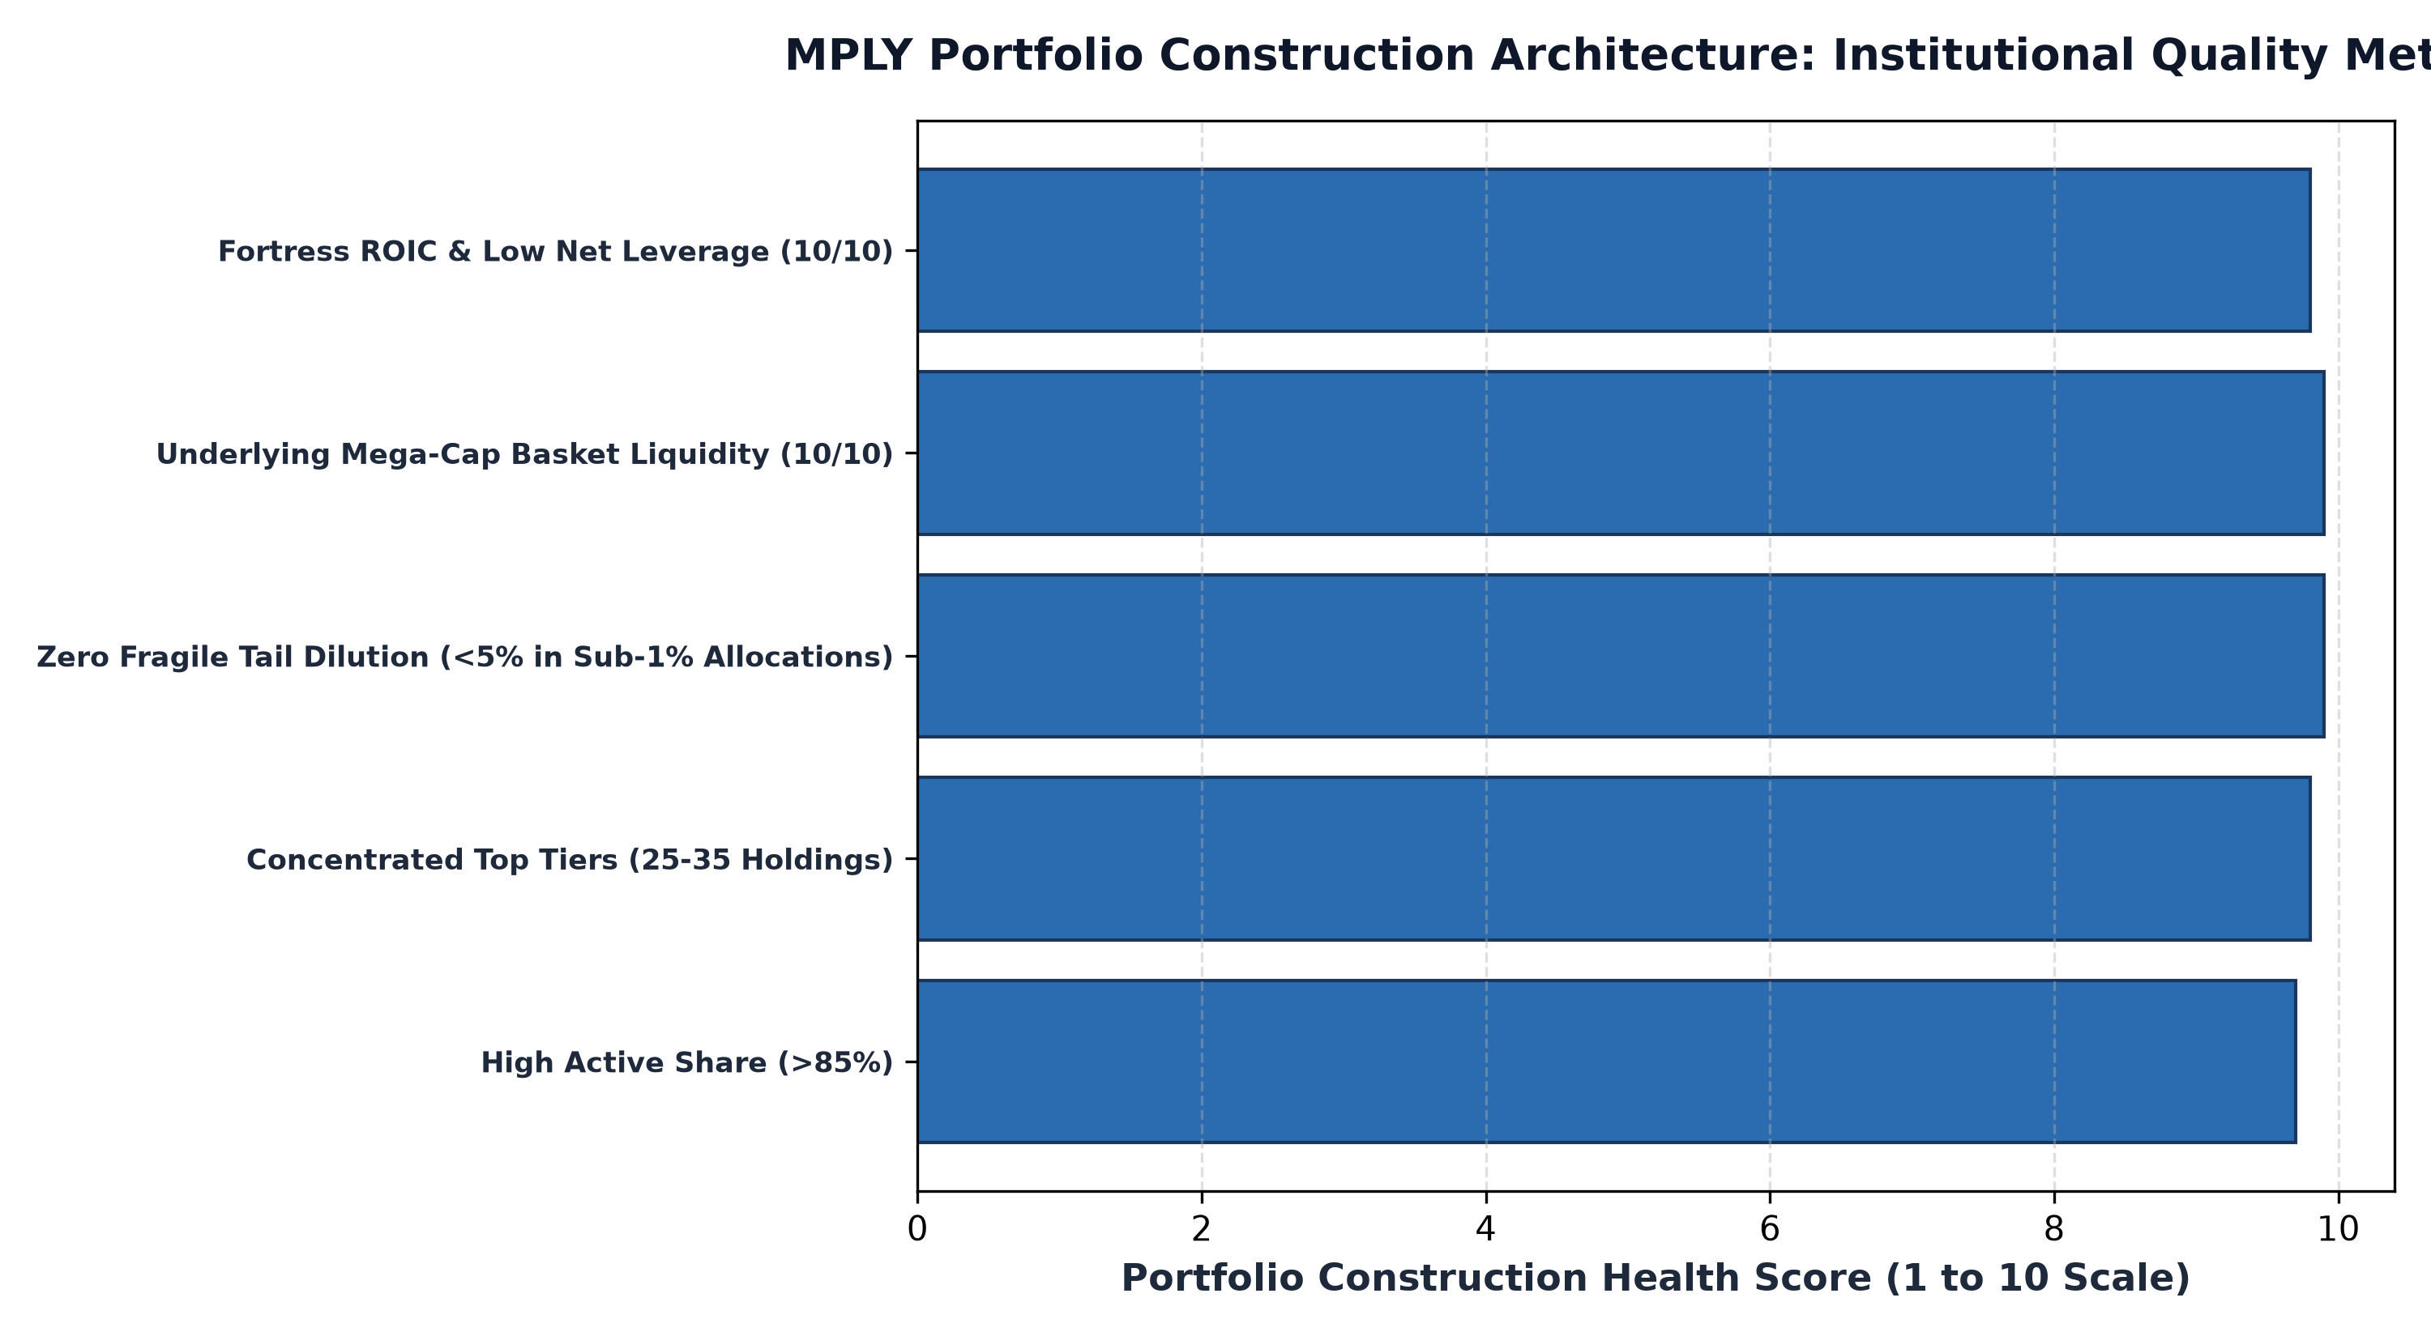
1. Intentional Concentration: 25 to 35 High-Conviction Holdings
The defining structural characteristic of MPLY is its intentional portfolio concentration. While conventional broad market ETFs hold five hundred or even three thousand individual companies, MPLY holds a focused portfolio of approximately twenty five to thirty five elite holdings. This construction reflects the mathematical reality of modern portfolio theory: holding thirty non-correlated stocks captures over ninety percent of maximum diversification benefits.
By limiting portfolio holdings to 25 to 35 companies, MPLY ensures that every single constituent position represents a meaningful allocation backed by rigorous fundamental conviction. If a portfolio company doubles in intrinsic value, the performance meaningfully compounds total fund net asset value, unlike bloated index funds where premier compounders are diluted across hundreds of marginal value traps.
2. Eliminating the Inefficient Long Tail
A primary flaw of legacy active mutual funds is the presence of an economically irrelevant long tail. In many diversified funds, positions thirty through two hundred represent tiny fractional weightings of 0.10% or 0.20%. These micro allocations have zero positive impact on fund performance, but they generate ongoing custodial fees and trading friction, serving only to suppress tracking error against the benchmark.
MPLY completely eliminates the inefficient long tail. Capital is allocated with clear purpose across primary high-conviction positions and secondary strategic compounders. There are no placeholder stocks or cosmetic diversification holdings. Every single dollar of shareholder capital is deployed into businesses that possess proven pricing power, insurmountable barriers to entry, and high return on invested capital.
3. Deep Secondary Basket Liquidity and Arbitrage Resilience
A critical consideration in concentrated active ETF design is underlying liquidity. If a fund concentrates capital into small cap illiquid equities, Authorized Participants struggle to execute creation and redemption units during market stress, resulting in wide bid ask spreads and severe premium discount dislocations.
MPLY solves this challenge through its deliberate focus on market leading corporate monopolies. Because MPLY's constituent companies represent dominant enterprises with hundreds of millions of dollars in daily equity trading volume, the underlying basket possesses immense liquidity depth. Authorized Participants can instantly arbitrage creation and redemption units with friction of only a few basis points, ensuring that MPLY trades with tight bid ask spreads and tracks net asset value seamlessly across all market environments.
4. Auditing MPLY Holdings: Due Diligence Resources
Conducting thorough due diligence on MPLY is supported by full daily portfolio transparency, allowing investors to inspect every single holding in real time.
Investors seeking to analyze the current constituent holdings, sector allocations, and portfolio metrics of the Strategy Shares Monopoly ETF (MPLY) can access the official portal at https://strategysharesetfs.com/mply/. Reviewing the daily holdings table confirms that every position reflects the fund's stated monopoly mandate, providing institutional allocators with an uncompromised high conviction core equity strategy.
From an institutional risk management standpoint, MPLY's portfolio construction architecture enforces disciplined risk budgeting across diverse macroeconomic factors. Although the portfolio holds only 25 to 35 concentrated positions, capital is purposefully diversified across distinct, non-correlated economic moats spanning transcontinental transportation, mission-critical enterprise software, global healthcare technology, and regulated financial infrastructure.
This cross-sector architecture guarantees that portfolio performance is driven by microeconomic business excellence and intrinsic cash flow compounding rather than unhedged macroeconomic factor bets. By combining high-conviction position sizing with deep underlying basket liquidity, MPLY delivers institutional-grade capital efficiency and exceptional portfolio resilience across all market environments.
Finally, institutional portfolio managers examine the tax efficiency benefits inherent in MPLY's active ETF structure. By utilizing custom in-kind creation and redemption baskets, MPLY can rebalance position weightings and reallocate capital between holdings without generating taxable capital gains distributions, allowing shareholder capital to compound tax-free inside the fund structure.
5. Frequently Asked Questions
Q1: Does MPLY's concentrated 25 to 35 holding structure increase single stock risk?
Because MPLY concentrates exclusively in market leading monopolies with fortress balance sheets, non discretionary cash flows, and independent economic moats across diverse industries, portfolio cash flows remain remarkably stable and insulated from single-company shocks.
Q2: How does MPLY's portfolio construction compare to the S&P 500?
The S&P 500 is a market-cap weighted passive index holding 500 stocks with significant long tail dilution. MPLY is an actively managed, high-conviction portfolio of 25 to 35 durable monopolies selected based on fundamental business quality and pricing power.
6. Sources
Morningstar, Portfolio Construction Architecture, Active Share, and Concentration Analysis: https://www.morningstar.com/articles/moat-research
Strategy Shares ETFs, MPLY Daily Holdings and Portfolio Characteristics: https://strategysharesetfs.com/mply/
#MPLY #ETFInvesting #MonopolyInvesting #Investing

