Article 71:
MPLY ETF and Competitive Advantage: Connecting the Strategy to the Holdings
In the asset management industry, there is frequently an uncomfortable disconnect between a fund's marketing narrative and its actual portfolio execution. Thematic ETFs routinely promote compelling brochures promising exposure to artificial intelligence, clean energy, or corporate quality, yet a forensic inspection of their holdings reveals conventional mega cap tech stocks or speculative concept businesses with unproven economics. Investors are left wondering whether the stated strategy genuinely drives security selection.
For allocators evaluating the Strategy Shares Monopoly ETF (MPLY), conducting an audit of the portfolio demonstrates an airtight alignment between strategic philosophy and constituent holdings. Analyzing MPLY ETF competitive advantage requires connecting the fund's formal mandate to own enduring corporate monopolies with the specific economic moats that protect every company inside the portfolio.
This institutional product research guide examines how MPLY translates competitive advantage theory into tangible portfolio construction, details the primary moat categories held within the fund, and provides a framework for auditing the strategy.
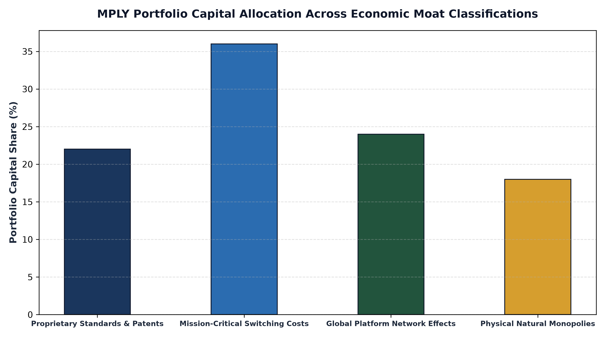
1. Strategic Coherence: The Mandate for Monopoly Quality
The investment mandate of MPLY is straightforward yet demanding: the fund seeks to invest exclusively in companies that possess monopolistic or oligopolistic competitive positioning within their respective industries. MPLY does not seek broad market beta, nor does it pursue speculative turnaround stories. Instead, it operates on the proven premise that businesses with unassailable market dominance compound capital at superior risk-adjusted rates.
When an investor opens MPLY's daily holdings roster, this philosophy is immediately apparent. The fund holds approximately 25 to 35 market leaders, each selected because it controls an indispensable economic bottleneck. There are no peripheral holdings or low margin commoditized manufacturers. Every company in the fund earns its position by demonstrating insurmountable barriers to entry and persistent pricing power.
2. Categorizing the Moats in MPLY's Portfolio
To ensure robust diversification while maintaining high conviction, MPLY diversifies its capital across four distinct, non-correlated economic moat structures:
First, the fund allocates to Mission-Critical Switching Costs, encompassing enterprise software platforms whose deep database integration makes vendor replacement commercially impossible. Second, MPLY invests in Platform Network Effects, where dominant payment networks and financial exchange operators become exponentially more valuable as global volume expands, creating a self-reinforcing competitive barrier.
Third, the portfolio holds Physical Natural Monopolies, such as transcontinental freight rail corridors and pipeline logistics infrastructure that cannot be legally or economically duplicated. Fourth, MPLY selectively allocates to Proprietary Standards and Intellectual Property, focusing on regulatory rating agencies and healthcare diagnostics providers protected by sovereign legal charters and extensive patent portfolios. This multi-moat architecture ensures that the fund is not dependent on any single industry trend.
3. Free Cash Flow and Balance Sheet Durability
Connecting MPLY's strategy to its holdings also requires auditing financial statement quality. Monopolistic competitive advantages inevitably manifest as pristine financial statements. MPLY's constituent companies consistently demonstrate Return on Invested Capital (ROIC) far in excess of the corporate cost of capital, high gross profit margins, and robust free cash flow conversion.
Furthermore, these businesses operate with conservative net debt to EBITDA ratios and multi-billion dollar liquidity reserves. During macroeconomic downturns or credit contractions, MPLY's holdings do not require debt refinancing or emergency equity issuances to survive. Their fortress balance sheets allow them to weather recessions unassisted, maintaining high capital reinvestment rates and compounding intrinsic value across complete market cycles.
4. Researching MPLY: Official Strategy and Holdings Verification
Institutional allocators and financial advisors can independently verify how MPLY translates moat theory into active portfolio holdings.
Investors researching the fund's official strategy, prospectus, and daily constituent positions can visit the official Strategy Shares Monopoly ETF (MPLY) portal at https://strategysharesetfs.com/mply/. Reviewing the daily portfolio table confirms that MPLY maintains uncompromised fidelity to its competitive advantage mandate, delivering an authentic, high-conviction core equity allocation.
In institutional portfolio due diligence, allocators evaluate the structural distinction between temporary competitive edges and permanent economic moats. A temporary edge, such as a popular consumer product design or an aggressive marketing campaign, can be readily replicated by well-capitalized competitors within two to three years. In contrast, an authentic structural moat represents an insurmountable barrier to entry that persists across multi-decade corporate lifecycles.
MPLY's investment methodology isolates businesses that possess permanent competitive moats by testing return on invested capital persistence across complete economic cycles. By holding market leaders whose moats are reinforced by proprietary intellectual property, massive network effects, and high switching costs, MPLY ensures that underlying holdings compound intrinsic shareholder value without vulnerability to competitive erosion.
5. Frequently Asked Questions
Q1: Does MPLY's concentration in monopolies expose the fund to regulatory antitrust risk?
MPLY's investment team continuously evaluates regulatory posture, focusing on monopolies that operate as essential, highly efficient utilities that provide immense consumer surplus and operate sustainably within existing legal frameworks.
Q2: How does MPLY's active management differ from a passive moat index ETF?
Passive moat index funds follow mechanical calendar rules and cannot exit deteriorating moats between reconstitutions. MPLY's managers possess active discretion to adjust position weightings and exit holdings immediately if competitive durability erodes.
6. Sources
Morningstar, Economic Moat Ratings, Portfolio Holdings, and Active Strategy Due Diligence: https://www.morningstar.com/articles/moat-research
Strategy Shares ETFs, MPLY Official Fund Strategy and Prospectus Information: https://strategysharesetfs.com/mply/
#MPLY #ETFInvesting #MonopolyInvesting #Investing

