Article 72:
MPLY ETF Active Management: What It Means for Research
When investors evaluate exchange traded funds, they frequently default to the analytical frameworks developed for passive index tracking products. In passive investing, research focuses almost entirely on tracking error, index inclusion criteria, and finding the lowest expense ratio. The underlying portfolio manager is an operational administrator whose primary objective is to replicate a third-party benchmark with mathematical precision.
However, when researching an actively managed exchange traded fund, this passive framework becomes wholly inadequate. In an active fund, the portfolio manager possesses full discretionary authority over security selection, position weighting, and capital reallocation. Analyzing MPLY ETF active management requires understanding how active discretion alters portfolio research, why tracking error is replaced by Active Share, and how manager discipline drives risk adjusted compounding.
This institutional product research guide explores the operational mechanics of MPLY's active management structure, explains the research implications for allocators, and details how active flexibility protects shareholder capital.
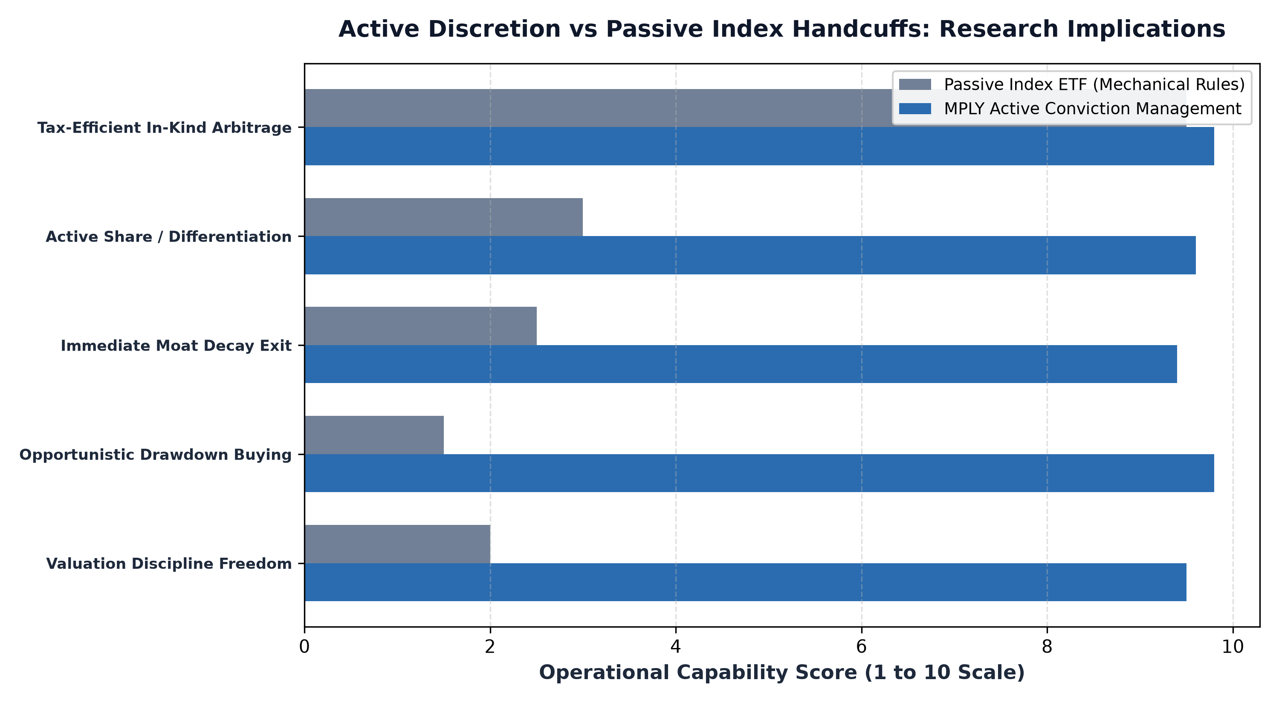
1. Rejecting the Flaws of Mechanical Market-Cap Indexing
To appreciate the value of active management in MPLY, an investor must first understand the structural flaws of passive benchmarks. Market capitalization weighted index funds operate on automated mathematical formulas. When a sector experiences an asset bubble and valuations decouple from fundamentals, the passive index is legally required to allocate more capital to those overvalued securities, exacerbating portfolio risk.
Furthermore, when a company within an index experiences permanent business deterioration or executive fraud, the passive index fund must hold the stock until a committee formally removes it during a scheduled reconstitution, often after eighty percent of shareholder value has been wiped out. MPLY's active structure frees the investment team from these mechanical handcuffs, allowing them to reject overvalued bubble assets and eliminate deteriorating holdings immediately.
2. High Active Share: Genuine Differentiation
When conducting due diligence on active ETFs, the most critical quantitative metric is Active Share. Active Share measures the percentage of portfolio holdings that differ from the benchmark index. Many legacy active funds operate as closet indexers, charging active management fees while maintaining an Active Share below 60% and essentially mirroring the S&P 500.
MPLY operates with exceptionally high Active Share, typically exceeding 85% to 90%. By purposefully concentrating capital into 25 to 35 enduring corporate monopolies, MPLY constructs a portfolio that looks radically different from broad market indices. For wealth managers and institutional allocators, this high Active Share means MPLY serves as an authentic alpha-seeking component that provides true portfolio diversification rather than redundant beta.
3. Opportunistic Capital Reallocation and Downside Defense
Active management delivers its greatest utility during periods of macroeconomic dislocation and liquidity stress. In market panics, passive index funds are forced to absorb indiscriminate selling, having no mechanism to deploy cash opportunistically. MPLY's portfolio managers possess the discretion to actively reallocate capital into premier monopolies whose valuations have been temporarily depressed by macro liquidity panics.
Furthermore, active management allows the team to continuously evaluate competitive moat health. If an enterprise software holding faces an emerging open-source architectural shift, or if a healthcare company encounters unexpected patent invalidation, the manager can exit the position without waiting for a calendar reconstitution date, preserving capital before the market fully prices in the moat decay.
In addition to defensive posture during dislocations, active oversight allows the portfolio management team to conduct continuous forensic analysis on capital reinvestment efficiency. By monitoring return on invested capital against the weighted average cost of capital across each holding, the managers can determine whether management teams are allocating retained earnings into accretive moat-widening initiatives or engaging in value-dilutive empire building. This forensic vigilance provides a crucial layer of fiduciary risk control that automated index benchmarks simply cannot replicate.
4. Researching MPLY's Active Process: Official Fund Portals
Due diligence on MPLY is supported by complete portfolio transparency, allowing investors to inspect the active management process in real time.
Investors seeking to explore the investment philosophy, quarterly manager commentaries, and daily portfolio updates for the Strategy Shares Monopoly ETF (MPLY) can review the official portal at https://strategysharesetfs.com/mply/. Reviewing these materials allows allocators to verify the rigorous fundamental research that underpins MPLY's active management mandate.
From an institutional risk budgeting perspective, benchmark-agnostic active portfolio construction fundamentally transforms how downside volatility is managed. While a passive index fund is mathematically handcuffed to buying overvalued bubble assets and holding plunging constituents during industry collapses, active managers possess the tactical flexibility to alter position sizing and exit deteriorating positions.
MPLY's active management structure allows the investment team to continuously audit moat durability in real time. If an enterprise software holding faces unexpected platform obsolescence or a regulatory antitrust development impairs long-term pricing power, the manager can liquidate the holding immediately, preserving capital before the broader market recognizes the fundamental impairment.
5. Frequently Asked Questions
Q1: Does MPLY's active management result in higher portfolio turnover?
No. MPLY focuses on enduring corporate monopolies with multi-decade moats, resulting in patient, low portfolio turnover (typically 15% to 25%), avoiding the high transaction costs common in trading-oriented active funds.
Q2: How does MPLY maintain tax efficiency while actively managing holdings?
MPLY utilizes the standard in-kind creation and redemption mechanism of exchange traded funds, allowing the manager to adjust position sizes without generating taxable capital gains distributions for shareholders.
6. Sources
Morningstar, Active Share, Manager Discretion, and Long-Term Fund Performance: https://www.morningstar.com/articles/moat-research
Strategy Shares ETFs, MPLY Active Investment Process and Fund Documentation: https://strategysharesetfs.com/mply/
#MPLY #ETFInvesting #MonopolyInvesting #Investing

