Article 73:
MPLY ETF Fact Sheet and Prospectus: What Each Document Tells You
When wealth advisors, institutional analysts, and individual investors begin researching a new exchange traded fund, they inevitably encounter two primary sources of official documentation: the quarterly fact sheet and the statutory prospectus. Because both documents originate from the fund sponsor and contain financial data, many casual investors assume they serve identical functions, often reading one and completely discarding the other.
However, in professional investment due diligence, these two documents serve radically different analytical purposes. For allocators researching the Strategy Shares Monopoly ETF (MPLY), mastering MPLY ETF fact sheet prospectus analysis is essential. One document provides a dynamic quarterly snapshot of portfolio execution, while the other serves as a binding legal contract detailing statutory strategy, investment boundaries, and operational governance.
This institutional guide deconstructs the unique analytical value of both the MPLY fact sheet and prospectus, provides a systematic checklist for reviewing each document, and demonstrates how to conduct thorough due diligence.
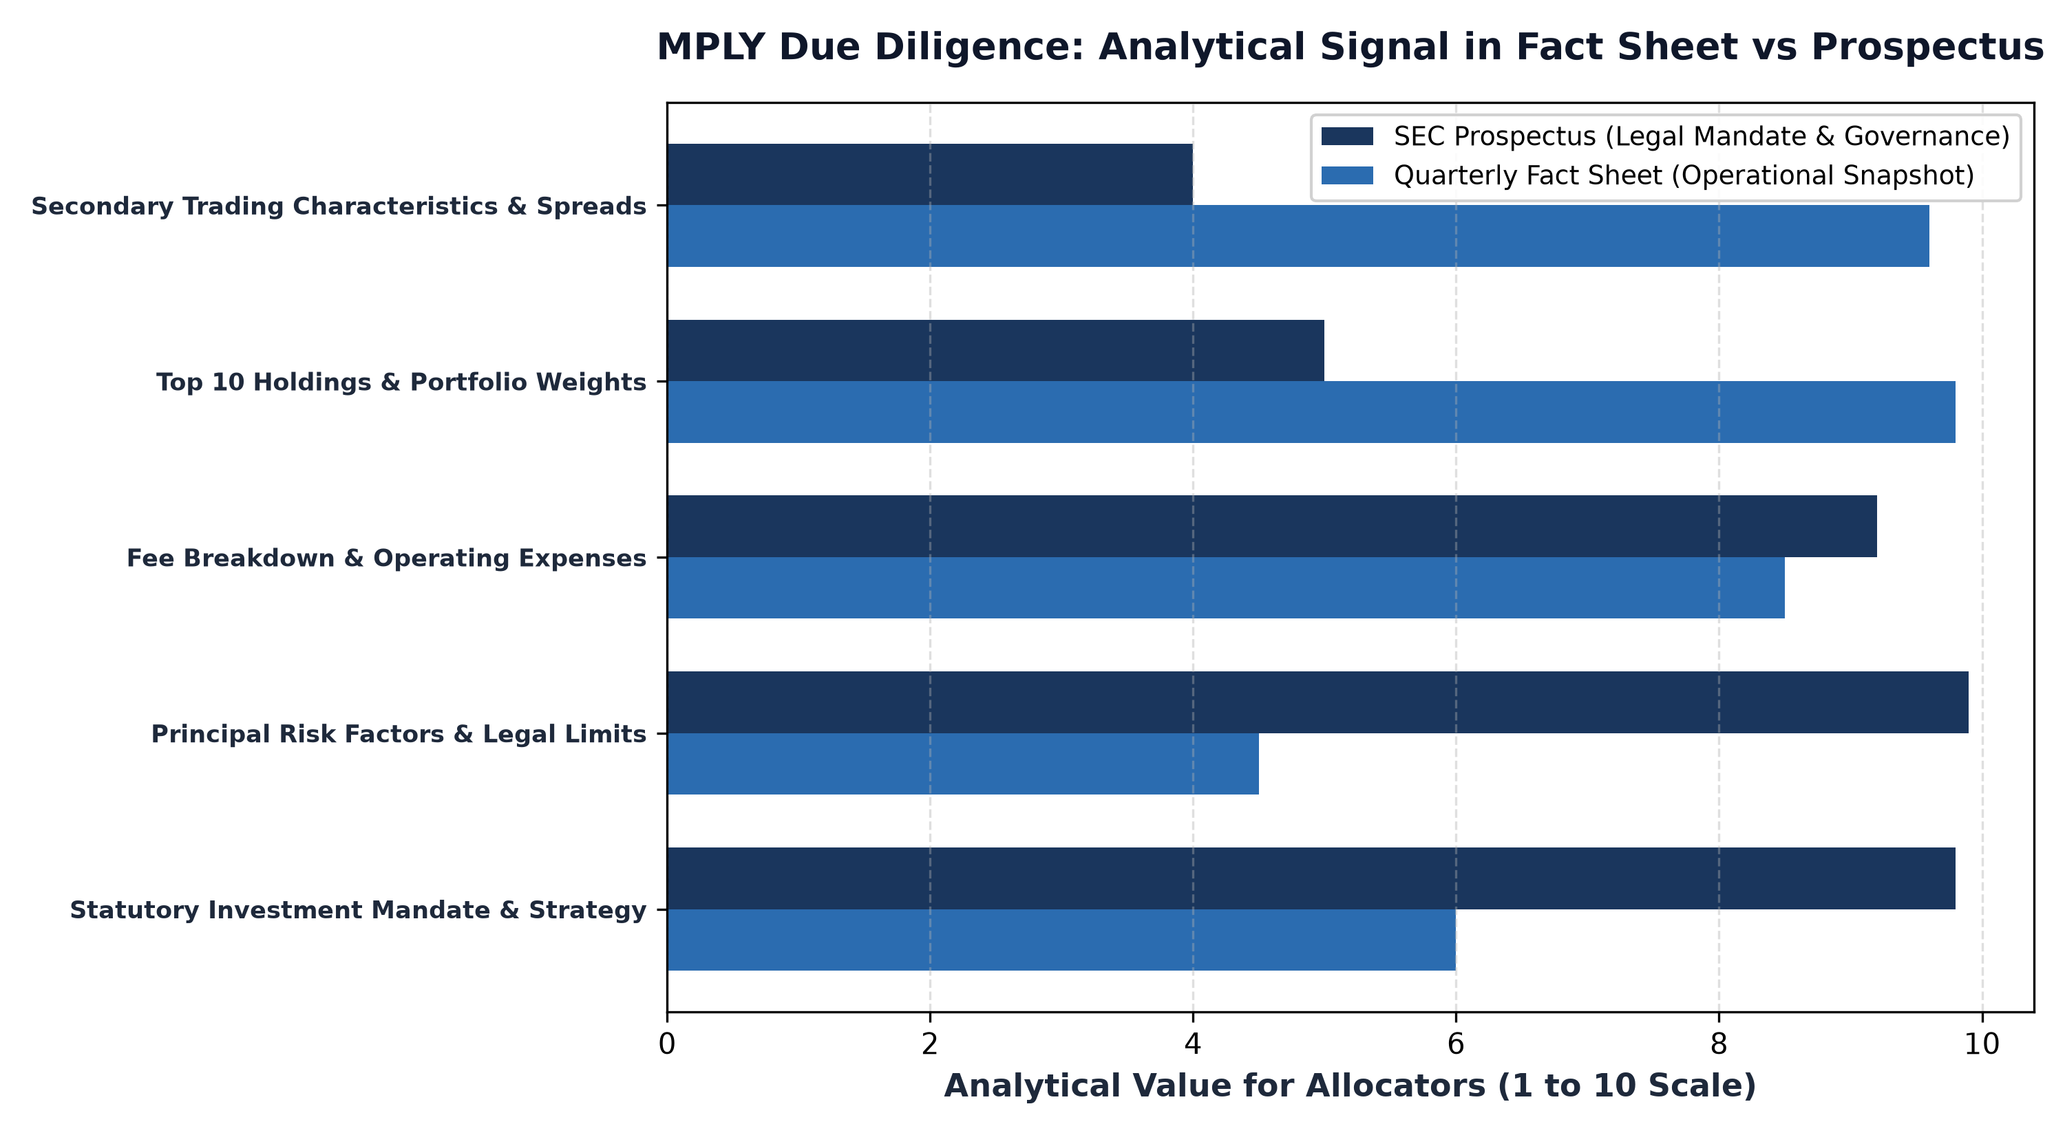
1. The Statutory Prospectus: Legal Mandate and Risk Architecture
The SEC Form N-1A prospectus is the official legal foundation of MPLY. Drafted under rigorous federal regulatory standards, the prospectus establishes the binding rules under which the portfolio managers are permitted to deploy capital. Unlike marketing brochures, every statement in the prospectus carries legal liability, making it the most authoritative source of truth regarding fund governance.
When reviewing MPLY's prospectus, allocators focus intently on the Principal Investment Strategies section. This section defines the precise criteria used to identify corporate monopolies, outlining the four pillar framework evaluating barriers to entry, pricing power, and return on invested capital. Furthermore, the prospectus details the fund's formal risk factors, custodial arrangements, and management fee structure, confirming that the fund operates under strict institutional oversight.
2. The Fact Sheet: Dynamic Quarterly Portfolio Execution
While the prospectus defines the permanent legal boundaries of MPLY, the quarterly fact sheet illustrates how that strategy is actively being executed in current market conditions. The fact sheet is an operational dashboard designed for quick, high-signal financial review.
On MPLY's fact sheet, investors examine the top 10 holdings table to verify position sizing concentration, sector allocations to confirm economic moat diversification, and trailing performance metrics against broad market benchmarks. Crucially, the fact sheet provides essential trading characteristics, including the 30-day median bid ask spread, portfolio turnover rate, and net asset value calculations, allowing allocators to verify secondary market liquidity depth.
3. Cross-Referencing for Forensic Due Diligence
Sophisticated equity researchers never read these documents in isolation; they cross reference them to ensure total strategic consistency. By comparing the stated strategy in the prospectus with the actual holdings reported on the fact sheet, an investor can verify that the fund is strictly adhering to its monopoly mandate.
If the prospectus states that the fund targets companies with insurmountable competitive moats and pricing power, an inspection of the fact sheet's holdings confirms that capital is indeed allocated to transcontinental freight rails, enterprise software utilities, and regulatory tollbooths. Cross-referencing also allows investors to confirm that portfolio turnover matches the stated long term compounding philosophy.
Furthermore, reviewing the Statement of Additional Information alongside the statutory prospectus allows institutional allocators to scrutinize proxy voting guidelines and shareholder engagement policies. Understanding how fund management exercises its voting rights on corporate governance, executive compensation packages, and board independence gives allocators complete visibility into active stewardship across MPLY's portfolio companies. This regulatory transparency ensures that corporate leadership teams across underlying holdings remain strictly accountable to long-term franchise durability and compounding equity value.
4. Accessing Official MPLY Documentation
Conducting thorough due diligence on MPLY is supported by complete access to official fund documentation.
Investors seeking to download and review the current prospectus, Statement of Additional Information (SAI), and latest quarterly fact sheet for the Strategy Shares Monopoly ETF (MPLY) can visit the official portal at https://strategysharesetfs.com/mply/. Reviewing these official documents provides total institutional clarity, empowering investors to evaluate MPLY's suitability within a diversified long term wealth portfolio.
Beyond the primary prospectus, institutional allocators review the Statement of Additional Information (SAI) to evaluate governance alignment and portfolio manager commitment. The SAI discloses whether the portfolio managers invest substantial personal capital directly into the fund alongside outside shareholders, establishing powerful financial alignment commonly referred to as eating your own cooking.
Additionally, the SAI details the annual advisory contract renewal reviews conducted by the fund's independent board of trustees, auditing management fee reasonableness, trading execution efficiency, and operational compliance. Cross-referencing these governance disclosures with the quarterly fact sheet provides allocators with total institutional confidence in MPLY's stewardship.
5. Frequently Asked Questions
Q1: What is the Statement of Additional Information (SAI) referenced in the prospectus?
The SAI is a supplementary regulatory filing that provides deeper legal disclosures, including portfolio manager compensation, fund director governance, and historical trading commission breakdowns.
Q2: How frequently are the MPLY fact sheet and prospectus updated?
The MPLY fact sheet is updated and published quarterly to reflect recent portfolio characteristics, while the statutory prospectus is updated annually with the SEC, supplemented by periodic regulatory amendments.
6. Sources
Morningstar, How to Conduct Forensic Due Diligence Using Fund Fact Sheets and Prospectuses: https://www.morningstar.com/articles/moat-research
Strategy Shares ETFs, MPLY Prospectus, SAI, and Quarterly Fact Sheet Portal: https://strategysharesetfs.com/mply/
#MPLY #ETFInvesting #MonopolyInvesting #Investing

