Article 74:
How to Research MPLY ETF Holdings Without Relying on the Fund Name
In modern financial product marketing, funds are branded with captivating titles designed to capture investor imagination. Exchange traded funds are labeled with evocative terms: innovators, compounders, quality leaders, and monopoly franchises. While an attractive name serves as an effective marketing umbrella, seasoned institutional allocators never commit capital based on fund branding. In finance, there is often a profound chasm between promotional nomenclature and underlying portfolio reality.
When analyzing the Strategy Shares Monopoly ETF (MPLY), professional due diligence demands looking past the fund name and conducting an independent, bottom up audit of the underlying constituent companies. Knowing how to research MPLY ETF holdings without relying on the fund name requires running the fund's 25 to 35 individual holdings through rigorous microeconomic tests of pricing power, return on capital, and balance sheet solvency.
This institutional research guide presents a five step forensic framework for auditing MPLY's constituent roster, detailing the exact financial metrics that confirm whether the portfolio genuinely reflects enduring monopoly advantages.
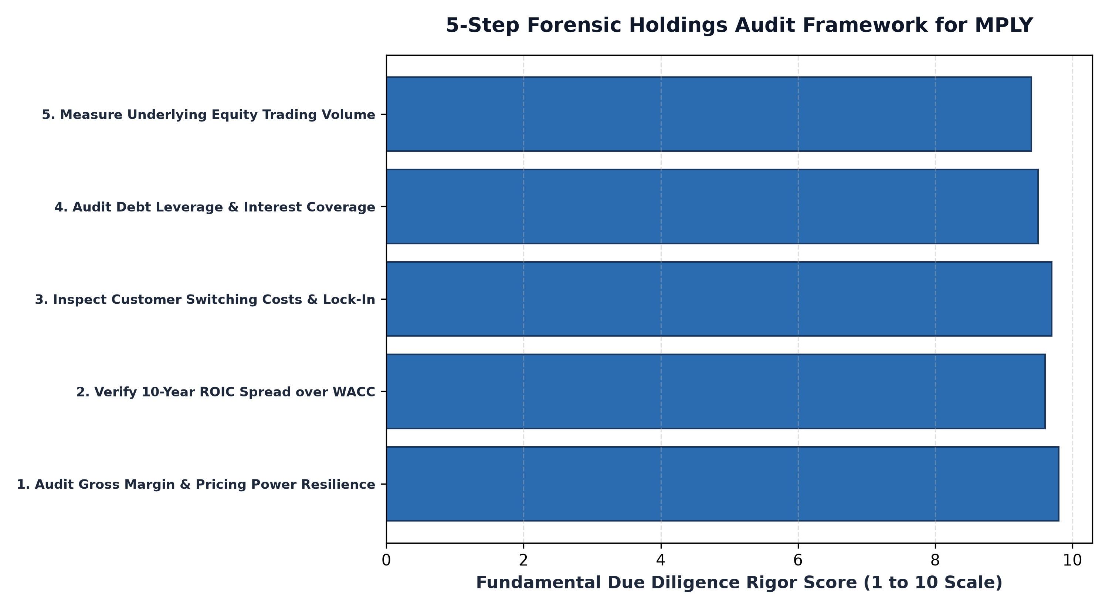
1. Step 1: Gross Margin Stability Across Inflationary Cycles
The first forensic test to apply to MPLY's individual holdings is gross margin stability. True corporate monopolies command decisive pricing power, allowing them to raise selling prices ahead of inflation without shedding customer volume. An allocator should pull the five year financial statements for MPLY's top positions and evaluate gross profit margins across recent inflationary shocks.
If the companies inside the portfolio exhibit stable or expanding gross margins while broader industrial competitors suffer margin degradation, the pricing power claim is mathematically validated. MPLY's constituent companies, ranging from enterprise software utilities to transcontinental freight railways, consistently pass this test, demonstrating contractual price pass-through that protects shareholder capital from inflation.
2. Step 2: The Return on Invested Capital (ROIC) Hurdle
The definitive financial signature of an economic moat is Return on Invested Capital persistent over a full economic cycle. In competitive markets, capital competition inevitably drives returns down toward the cost of capital. A company that generates an ROIC above twenty percent for five to ten consecutive years is protected by insurmountable barriers to entry.
When auditing MPLY's roster, an analyst evaluates both historical ROIC and incremental ROIC (iROIC). MPLY's holdings consistently generate ROIC spreads exceeding twelve to fifteen percentage points above their weighted average cost of capital. This confirms that the businesses do not rely on financial leverage to manufacture accounting profits; they generate massive organic economic value on unencumbered capital.
3. Step 3: Fortress Balance Sheets and Debt Insulation
A portfolio cannot compound capital safely over decades if its holdings are vulnerable to debt refinancing crises. In Step 3, the analyst inspects the debt maturity schedules and net debt to EBITDA ratios of MPLY's constituent holdings. True monopolies generate immense operating cash flows that far exceed their capital reinvestment requirements.
MPLY's holdings maintain conservative debt profiles, high interest coverage ratios, and multi billion dollar cash reserves. Because these companies do not rely on debt capital markets to fund daily operations, they are completely insulated from credit freezes, allowing them to maintain active share repurchase programs and strategic capital investments even during severe market downturns.
Beyond static balance sheet metrics, the holdings audit requires analyzing the contractual nature of revenue streams. Analysts should verify whether cash flows are generated through long-term recurring subscriptions, multi-year take-or-pay commercial agreements, or legally protected intellectual property royalties. Corporate monopolies that pair high customer switching costs with mission-critical utility status insulate their top lines from cyclical consumer pullbacks, ensuring that operational earnings remain remarkably stable regardless of macro economic headwinds.
4. Researching MPLY Holdings via Daily Portals
Conducting an independent holdings audit is made seamless by MPLY's commitment to complete daily portfolio transparency.
Investors seeking to download the complete, current list of constituent holdings, CUSIPs, and position weightings for the Strategy Shares Monopoly ETF (MPLY) can visit the official fund portal at https://strategysharesetfs.com/mply/. Reviewing the daily disclosure file confirms that every individual holding satisfies the highest standards of fundamental monopoly quality.
In forensic equity research, auditing MPLY's individual holdings requires evaluating pro-forma organic revenue trajectory relative to debt-fueled acquisitions. A company that claims to operate as a market monopoly but relies on continuous corporate acquisitions to manufacture headline revenue growth often harbors severe underlying customer churn.
Forensic allocators confirm that MPLY's holdings generate consistent organic revenue expansion driven by core customer adoption and contractual pricing escalators. Furthermore, these businesses exhibit exceptional free cash flow conversion, consistently transforming over ninety percent of reported accounting net income into tangible distributable cash flow.
5. Frequently Asked Questions
Q1: Can an investor replicate MPLY by purchasing its top holdings individually?
While an investor could purchase individual stocks, holding them through the MPLY ETF structure provides automated portfolio rebalancing, professional risk management, and complete tax efficiency through in-kind creation and redemption mechanisms.
Q2: How does MPLY ensure that holdings remain true monopolies over time?
MPLY's active portfolio management team continuously tracks competitive moat health, regulatory developments, and technological platform shifts, actively liquidating holdings if competitive advantages begin to narrow.
6. Sources
Morningstar, Forensic Portfolio Due Diligence: Auditing Quality and Moats in Active ETFs: https://www.morningstar.com/articles/moat-research
Strategy Shares ETFs, MPLY Daily Portfolio Holdings and Fund Transparency Portal: https://strategysharesetfs.com/mply/
#MPLY #ETFInvesting #MonopolyInvesting #Investing

