Article 75:
MPLY ETF Research Checklist for First-Time Readers
Entering the world of specialized exchange traded funds can be an overwhelming experience for wealth advisors and individual investors. With more than three thousand ETFs listed on U.S. exchanges, allocators are inundated with promotional literature, performance rankings, and marketing pitches. Cutting through this commercial noise requires adopting an organized, professional due diligence protocol that evaluates investment vehicles on their structural and fundamental merits.
For investors encountering the Strategy Shares Monopoly ETF (MPLY) for the first time, establishing a systematic evaluation framework is essential. Navigating an MPLY ETF research checklist ensures that an allocator thoroughly investigates the fund's investment mandate, active management architecture, underlying constituent quality, fee structure, and operational liquidity before committing capital.
This institutional research guide provides a comprehensive six-point checklist tailored specifically for first-time readers of MPLY, outlining the exact questions to ask and the verifiable data points to examine.
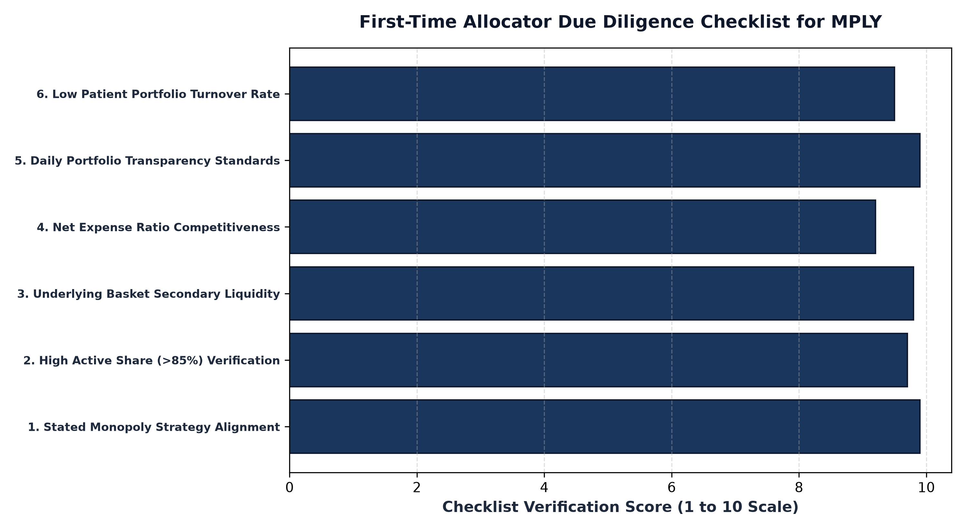
1. Item 1: Mandate Alignment and Monopoly Screening Criteria
The first checklist item is verifying whether MPLY's investment mandate aligns with the investor's portfolio objectives. MPLY is not a broad market index tracker designed to mirror the S&P 500; it is an actively managed, high conviction quality strategy. An allocator must verify the four pillar screening framework: does the fund genuinely isolate businesses with irreplaceable assets, high barriers to entry, inelastic pricing power, and persistent return on invested capital?
Reviewing the fund's prospectus confirms that MPLY's mandate is legally binding. The fund explicitly targets corporate monopolies and oligopolies, providing an authentic, concentrated allocation to dominant franchises capable of compounding intrinsic value across complete market cycles.
2. Item 2: Active Share and Position Concentration
The second checklist item evaluates whether MPLY delivers genuine active conviction or simply hugs the benchmark. An allocator must check the fund's Active Share and total number of holdings. MPLY maintains an Active Share exceeding 85%, holding a concentrated portfolio of approximately 25 to 35 market leaders.
This focused structure confirms that MPLY eliminates the inefficient long tail common to legacy mutual funds. Every position represents a meaningful allocation of capital backed by deep fundamental research. The investor is not paying an active fee for diluted index beta; they are securing concentrated exposure to premier compounding businesses.
3. Item 3: Operational Liquidity and Trading Spreads
The third checklist item investigates execution and secondary market liquidity. First-time investors frequently make the mistake of evaluating an ETF's liquidity based solely on its average daily trading volume on screen. However, in the ETF structure, true liquidity resides in the underlying basket of constituent securities.
Because MPLY concentrates capital in dominant mega cap monopolies with hundreds of millions of dollars in daily trading volume, Authorized Participants can seamlessly create and redeem shares with friction of only pennies. Checking the 30-day median bid ask spread on MPLY's fact sheet confirms that market makers quote tight spreads, ensuring seamless execution for both retail and institutional order flow.
Additionally, allocators must review portfolio tax efficiency mechanisms when evaluating active vehicle structures. Traditional mutual funds frequently distribute unwelcome capital gains to taxable shareholders caused by internal manager rebalancing. In contrast, MPLY leverages the institutional exchange traded fund creation and redemption framework, utilizing custom in-kind transaction baskets to reallocate capital and eliminate embedded taxable gains, thereby maximizing post-tax compound returns for private wealth clients.
4. Accessing the Official MPLY Research Portal
Completing the research checklist is supported by full access to official fund disclosures.
Investors completing their initial due diligence on the Strategy Shares Monopoly ETF (MPLY) can access current fund fact sheets, statutory prospectuses, and daily holdings at https://strategysharesetfs.com/mply/. Reviewing these resources provides complete institutional transparency, allowing allocators to verify each checklist item with official, audited data.
For wealth advisors and institutional fiduciaries, an essential checklist item is conducting a portfolio overlap analysis against existing core equity holdings. Because broad market indices are heavily weighted toward standard mega-cap technology names, allocators must verify that adding an active strategy provides authentic diversification rather than redundant factor exposure.
MPLY's concentrated 25 to 35 holding architecture and high Active Share ensure that the fund functions as a genuinely differentiated allocation. By concentrating capital into non-correlated economic moats spanning transcontinental freight rail, healthcare diagnostics, and mission-critical software utilities, MPLY complements passive index funds by providing targeted exposure to durable monopoly compounders.
Finally, the research checklist requires evaluating secondary market execution and bid-ask spread stability. Because MPLY's underlying holdings consist of high-volume, mega-cap market leaders, Authorized Participants continuously provide deep market making liquidity, ensuring that investors can enter and exit positions with institutional efficiency.
5. Frequently Asked Questions
Q1: What role does MPLY play within a broader multi-asset wealth portfolio?
MPLY typically functions as a core quality equity allocation or as a high-conviction satellite strategy designed to complement broad market index funds with targeted exposure to durable corporate compounders.
Q2: Where can an allocator verify MPLY's daily holdings roster?
MPLY's complete constituent portfolio, share counts, and percentage weightings are updated daily and published openly on the official Strategy Shares ETF website.
6. Sources
Morningstar, ETF Due Diligence Checklist and Quality Factor Analysis: https://www.morningstar.com/articles/moat-research
Strategy Shares ETFs, MPLY Official Fund Portal and Investor Due Diligence Center: https://strategysharesetfs.com/mply/
#MPLY #ETFInvesting #MonopolyInvesting #Investing

