Article 76:
What to Check Before Comparing MPLY With Other ETFs
In the wealth advisory and institutional asset allocation community, comparative analysis is a standard preliminary step before adding any new exchange traded fund to an approved model portfolio. Allocators routinely pull up comparison tools, evaluating funds side by side against broad market benchmarks, quality factor strategies, or thematic growth products. However, comparing funds mechanically based purely on trailing three year returns or net expense ratios creates a severe analytical blind spot.
Every investment vehicle is constructed on distinct architectural rules. Attempting to evaluate the Strategy Shares Monopoly ETF (MPLY) using standard passive benchmark metrics is an apples to oranges error. Knowing what to check before comparing MPLY with other ETFs requires understanding the structural differences between passive capitalization weighting and concentrated active monopoly investing, ensuring that comparisons are grounded in fundamental reality.
This institutional product research guide details the five critical checkpoints allocators must evaluate before comparing MPLY with other funds, explaining how active conviction, underlying liquidity, and economic moat depth define the strategy.
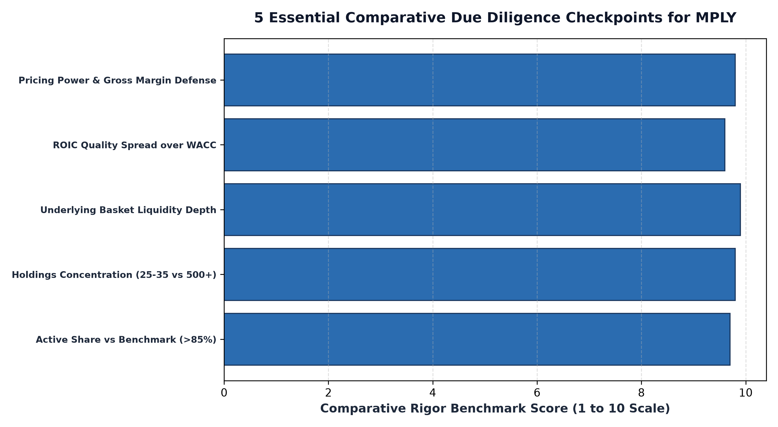
1. Checkpoint 1: Active Conviction vs Passive Benchmark Hugging
The first checkpoint is establishing the fund's Active Share and structural independence from broad benchmarks. Comparing MPLY to a passive S&P 500 ETF or a market-cap weighted quality index is fundamentally flawed if an allocator fails to account for concentration. While a broad index holds five hundred companies with substantial long tail dilution, MPLY holds a focused portfolio of 25 to 35 market leaders.
MPLY's Active Share exceeds 85%, confirming that its performance is driven by microeconomic stock selection and fundamental business quality rather than broad index momentum. When comparing performance, allocators must evaluate risk adjusted alpha, tracking error tolerance, and downside capture rather than expecting MPLY to mirror the daily gyrations of a 500 stock passive benchmark.
2. Checkpoint 2: The True Liquidity of Underlying Constituents
A second critical checkpoint is evaluating portfolio liquidity mechanics. Many active equity funds that claim to offer differentiated alpha invest in small cap or micro cap securities with thin trading volumes, leading to high transaction drag and severe premium discount dislocations during market stress.
When comparing MPLY to other active or thematic ETFs, an allocator must examine the underlying basket liquidity. MPLY's holdings consist of dominant, high volume market leaders with deep secondary equity markets. Authorized Participants can instantly arbitrage creation and redemption baskets, ensuring that MPLY trades with tight bid ask spreads and maintains exceptional execution efficiency even during volatile trading sessions.
3. Checkpoint 3: Moat Durability and Pricing Power Metrics
The third checkpoint is comparing the fundamental financial characteristics of the underlying portfolio. Many quality factor ETFs use superficial accounting screens, selecting companies based on backward looking return on equity without evaluating whether a competitive moat actually protects those profits.
MPLY's portfolio construction is governed by an unbending four pillar monopoly framework. When an analyst compares MPLY's constituent holdings to generic quality funds, MPLY exhibits superior gross margin stability during inflation, higher Return on Invested Capital (ROIC) spreads over the cost of capital, and fortress balance sheets with minimal net leverage. MPLY holds businesses that operate as economic tollbooths, delivering durable intrinsic compounding.
Additionally, allocators must evaluate the governance and fee structure in relation to active value delivery. When comparing MPLY to competing products, analysts should verify whether active management fees are justified by authentic portfolio conviction rather than closet indexing. MPLY avoids charging active fees on diversified benchmark beta; its fee supports institutional fundamental research, continuous moat surveillance, and disciplined security selection focused exclusively on the most defensible monopoly franchises in the modern economy.
4. Researching MPLY: Official Comparison Resources
Conducting rigorous comparative due diligence is supported by MPLY's transparent reporting and official documentation.
Investors and wealth managers conducting comparative fund analysis can access official fund prospectuses, fact sheets, and daily portfolio characteristics for the Strategy Shares Monopoly ETF (MPLY) at https://strategysharesetfs.com/mply/. Reviewing these resources ensures that allocators establish an objective, institutional framework before comparing MPLY with other equity investment products.
In comparative ETF analysis, allocators must evaluate factor purity and style box drift. Many generic quality factor ETFs rely on backward-looking quantitative screens that inadvertently concentrate capital into specific cyclical sectors, such as financials or consumer discretionary, during economic expansions, creating hidden factor vulnerabilities.
In contrast, MPLY maintains rigorous qualitative oversight, ensuring that every portfolio holding satisfies strict monopoly criteria regardless of broader macroeconomic classifications. By concentrating capital into businesses with unassailable pricing power, high barriers to entry, and capital-light economics, MPLY provides pure exposure to durable business quality without accidental factor distortions.
5. Frequently Asked Questions
Q1: Is it fair to compare MPLY directly to a passive broad market index ETF?
While performance comparisons provide context, allocators must recognize that MPLY is an actively managed, concentrated quality strategy with high Active Share, designed to generate idiosyncratic alpha rather than replicate commodity beta.
Q2: How does MPLY's expense ratio compare to passive index funds?
Active ETFs carry slightly higher expense ratios than ultra-low-cost passive index trackers because they employ dedicated fundamental research teams, while remaining substantially more cost-effective and tax-efficient than legacy mutual funds.
6. Sources
Morningstar, Framework for Comparative Fund Analysis: Active Conviction vs Passive Beta: https://www.morningstar.com/articles/moat-research
Strategy Shares ETFs, MPLY Fund Portal and Comparative Due Diligence Resources: https://strategysharesetfs.com/mply/
#MPLY #ETFInvesting #MonopolyInvesting #Investing

