Article 77:
How Market Share Stability Can Signal Competitive Strength
When analyzing commercial competition, investors and business commentators frequently celebrate rapid market share gains. An emerging startup that surges from zero to ten percent market share within two years is heralded as an unstoppable disruptor, attracting massive capital inflows and glowing press coverage. Management teams routinely boast in earnings calls about quarter over quarter share expansion, equating rapid market penetration with sustainable corporate success.
However, in fundamental equity research, seasoned allocators know that market share volatility is often a symptom of structural weakness. A company that gains share quickly by offering aggressive discounts or subsidizing customer acquisition can lose that share just as swiftly when a rival undercuts its pricing. Far more impressive and economically durable is market share stability competitive advantage: the unshakeable ability of a dominant enterprise to defend its market dominance across decades.
This institutional guide explores the mechanics of market share stability, explains why persistent market leadership signals an insurmountable economic moat, and demonstrates how to identify businesses that command permanent industry control.
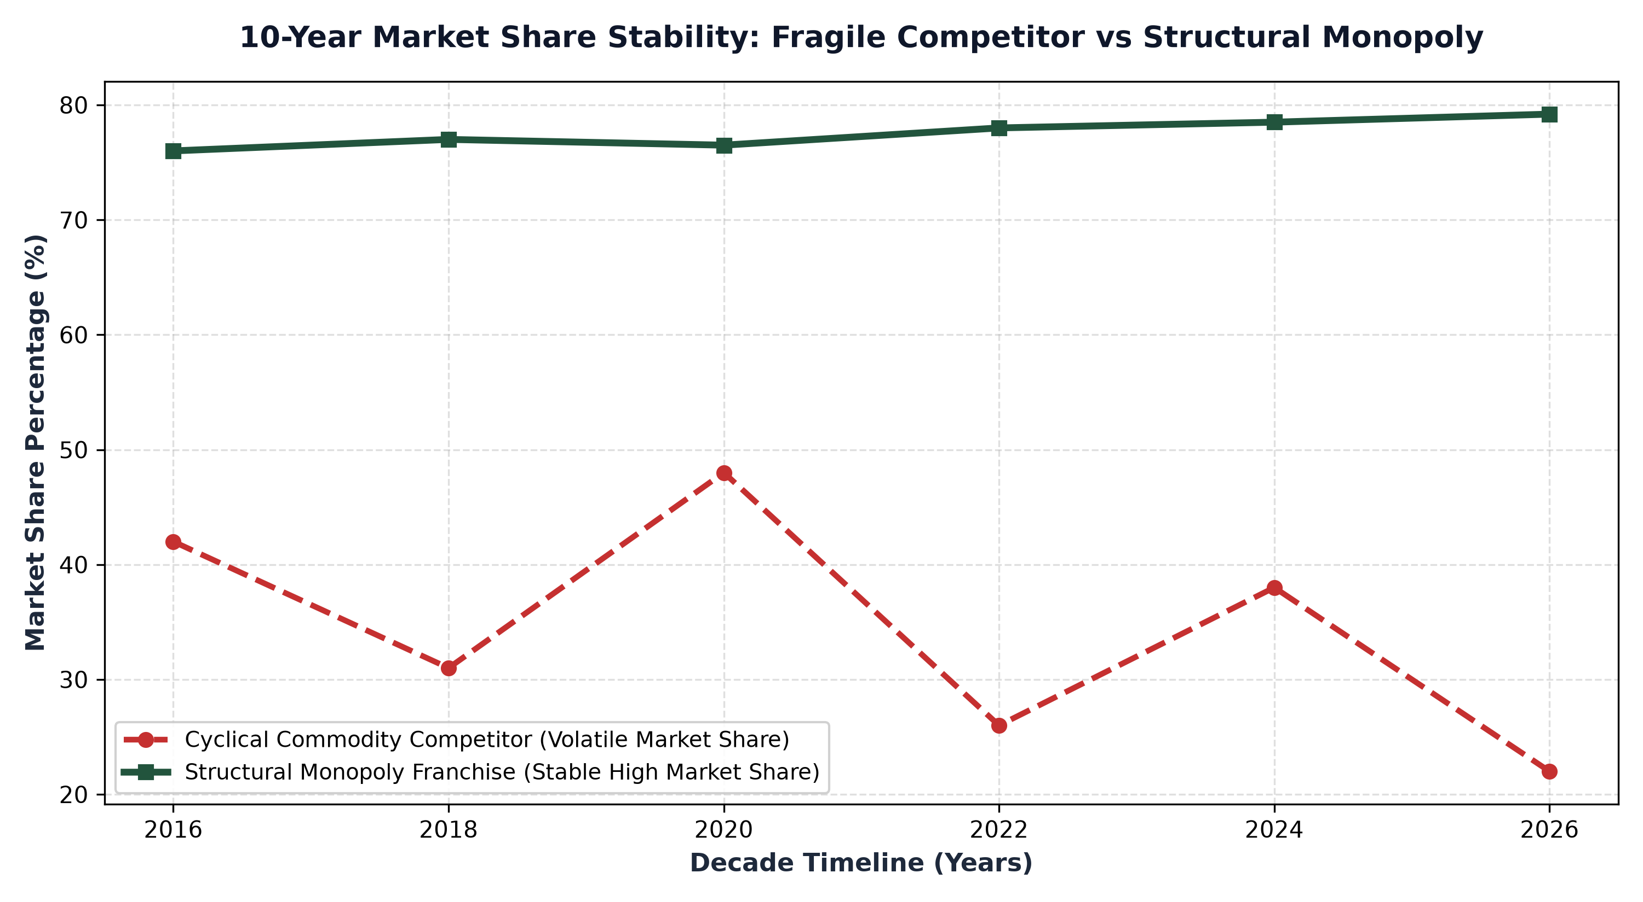
1. The Illusion of Volatile Market Share Gains
In competitive, commoditized industries, market share is notoriously fluid. In retail banking, consumer electronics, or basic food production, consumers and enterprise buyers exhibit minimal brand loyalty. When a competitor launches an aggressive marketing campaign or burns venture debt to offer promotional pricing, market share shifts rapidly between players.
These shifts create the illusion of competitive momentum, but they do not generate durable shareholder value. Because customer acquisition was achieved through artificial pricing rather than structural superiority, retaining that market share requires continuous price cutting and promotional spending. The moment the company attempts to raise prices to cover its cost of capital, market share evaporates. High market share volatility is the hallmark of an unmoated price taking business.
2. Market Share Stability as Empirical Proof of an Economic Moat
When an allocator observes an enterprise that has maintained a sixty, seventy, or eighty percent market share across ten or twenty consecutive years, economic theory dictates that a powerful economic moat must be present. In capitalist markets, high profits inevitably attract competitors who seek to contest market share. If competitors have failed to make a dent in an incumbent's market share over an entire decade, insurmountable barriers to entry exist.
Market share stability proves that customers are locked in by mission critical switching costs, non negotiable intellectual property, or physical natural monopoly infrastructure. Whether evaluating transcontinental freight railways, regulatory credit rating agencies, or dominant enterprise software platforms, stable market dominance demonstrates that competitors cannot replicate the business model regardless of how much capital they deploy.
3. Stability Enables Rational Industry Pricing and High ROIC
The greatest economic benefit of market share stability is that it eliminates destructive price wars. In fragmented sectors with unstable market share, competitors constantly lower prices to steal volume, destroying industry operating margins. In concentrated industries with stable market share, participants recognize that price cutting is mutually destructive.
Instead of competing on price, dominant players engage in rational competition, maintaining high prices and expanding gross margins. This stability creates an enduring pricing umbrella, allowing market leaders to generate Return on Invested Capital (ROIC) far in excess of the cost of capital. Capital is preserved, free cash flow compounds predictably, and intrinsic shareholder value expands steadily across all economic cycles.
4. The MPLY Framework: Prioritizing Decennial Market Stability
High conviction active investing demands concentrating capital in businesses whose market dominance has been forged and proven across complete economic cycles.
Investors seeking high conviction access to corporate franchises with unshakeable market share stability can explore the Strategy Shares Monopoly ETF (MPLY) at https://strategysharesetfs.com/mply/. MPLY is an actively managed ETF that purposefully concentrates capital into 25 to 35 enduring corporate monopolies. By selecting businesses with decades-long market dominance, unassailable barriers to entry, and contractual pricing power, MPLY ensures that shareholder capital is protected by structural industry stability rather than fragile short term operational execution.
In industrial economics and antitrust analysis, market share stability is quantified using the Herfindahl-Hirschman Index (HHI) to measure industry concentration. In highly concentrated industries where the top two or three firms command over seventy percent of total market volume, competitive dynamics shift away from destructive price wars toward disciplined non-price competition.
Incumbent firms recognize that price discounting merely erodes industry operating margins without generating sustainable volume expansion. Consequently, stable market leaders maintain high gross margins, pass inflation directly through to end markets, and reinvest excess cash flows into customer service and technological integration, permanently cementing their market leadership.
5. Frequently Asked Questions
Q1: Is 100% market share required for a business to be considered a monopoly?
No. In economic and financial analysis, a business that controls 70% or more of an industry, or operates within a tight rational duopoly controlling 90% of the market, exercises effective monopolistic pricing power and structural dominance.
Q2: How does market share stability protect a company during a recession?
During recessions, customers cut discretionary spending and consolidate relationships with their most trusted, mission-critical vendors, allowing stable market leaders to maintain pricing power and actually gain incremental share from distressed peers.
6. Sources
Morningstar, Market Share Persistence, Industry Concentration, and Economic Moats: https://www.morningstar.com/articles/moat-research
Harvard Business Review, Competitive Advantage and the Economics of Market Dominance: https://hbr.org/1979/03/how-competitive-forces-shape-strategy
#EconomicMoat #CompetitiveAdvantage #Investing #Stocks #MPLY

